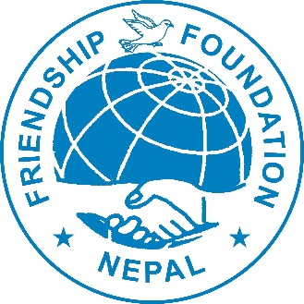
Friendship Foundation Nepal
(FFN)

“Volunteers do not necessarily have the time; they have the heart.”
– Elizabeth Andrew
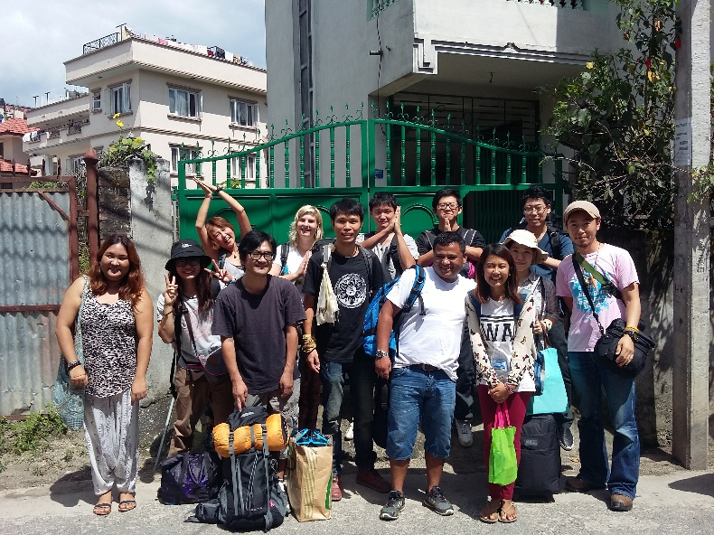

Contents
(1) INTRODUCTION 3
1.1 Background 3
(1.2) Friendship Foundation Nepal 3
(1.3) Goals 4
(1.4) What to bring: 4
(1.5) Extra activities: 4
(1.6) Pick up and traveling: 4
(1.7) Accommodation and food: 4
(1.8) Special notes 4
(1.9) International work camp in Nepal 5
(2) PROJECT DESCRIPTIONS 6
(2.1) Banepa Work Camps 6
(2.2) Daman International work camp 6
(2.3) Pokhara International work camp 7
(2.4) Sankhu International work camp ……………………. ……………….7
(3) Contact Us 7
(4) PICTURES 8

1.1 Background
Volunteering in Nepal has a long and rich history, deeply rooted in community service, social work, and cultural exchange. The movement gained momentum in the 1950s and 1960s with the arrival of international aid agencies focused on development initiatives such as building schools and hospitals, providing healthcare and education, and supporting rural economic growth.
By the 1970s and 1980s, global volunteer organizations began sending volunteers to Nepal to contribute to various community development projects, including infrastructure development, agricultural support, and healthcare services for underserved communities.
Since then, volunteering in Nepal has continued to expand, offering diverse opportunities in areas such as environmental conservation, disaster relief, and cultural exchange programs. Volunteers engage in projects ranging from teaching English to disadvantaged children and working on conservation initiatives in national parks to providing medical assistance in rural regions.
Beyond making a meaningful impact, volunteering in Nepal offers individuals the chance to develop valuable skills, immerse themselves in Nepali culture, and foster connections with local communities. It also provides a unique opportunity to gain firsthand insights into Nepal’s challenges and opportunities while building lasting friendships.

1.2 Friendship Foundation Nepal (FFN)
Established in 1991, Friendship Foundation Nepal (FFN) aims to introduce Nepal to the world through international cooperation and promote its development through volunteer work. The organization is dedicated to fostering cross-cultural understanding and global citizenship by connecting volunteers with local communities.
Volunteering serves as a powerful tool for building bridges between cultures. By working alongside Nepalese communities, volunteers gain a deeper appreciation of Nepali culture and traditions while sharing their own perspectives and experiences. This exchange helps cultivate trust, friendship, and mutual respect, contributing to a more peaceful and harmonious world.
FFN hosts volunteers for durations ranging from two weeks to ten months, depending on the project. To date, the organization has welcomed over 3,000 volunteers from across the globe. Through collaborations with local organizations and communities, FFN identifies urgent needs and implements sustainable solutions, making a significant impact on Nepal's development.

1.3 Goals
FFN is committed to multiple objectives aimed at fostering community development and cultural exchange. Some of its key goals include:
- Coordinating relief efforts and activities in disaster-affected areas.
- Assisting in development and construction programs.
- Organizing eco-friendly initiatives and mitigating the effects of natural disasters.
- Promoting friendship and cooperation among Nepali youth.
- Preserving and promoting Nepal’s cultural heritage through events and conservation efforts to introduce Nepali culture to the world.

1.4 What to Bring
Volunteers should bring the following essential items:
- Clothing: Seasonal clothes, work clothes, raincoats (for summer), and warm layers for winter.
- Gear: Sleeping bags, sturdy work shoes, gloves.
- Personal Items: Musical instruments, games, recipes, and pictures of your home country.
- Educational Supplies: Pencils, pens, books, notebooks, and textbooks for local children (these can also be purchased in Kathmandu).
- Attitude: A positive mindset, respect for local culture, and an open mind.

1.5 Extra Activities
For those interested in exploring Nepal before or after the project, FFN can assist in finding reliable travel companies upon request. However, participation in additional travel is entirely optional.

1.6 Pickup and Travel
- Volunteers will be picked up from Tribhuban International Airport upon arrival, provided that they have shared their travel details in advance.
- Those arriving independently can travel directly to the Hotel Hanna in Thamel.
- All volunteers will travel together with camp leaders. Therefore, it is recommended to arrive in Kathmandu at least one day before the project starts.
- If a volunteer arrives late, they will be responsible for arranging their own travel to the project site. FFN staff will assist in finding the right transportation.

1.7 Accommodation and Food
- Volunteers will stay in simple accommodations with local host families.
- They will receive three traditional Nepalese meals per day, primarily consisting of Dal Bhat (lentils soup and rice) and Tarkari (vegetables).
- Volunteers will take turns cooking and assisting with household chores.
- Cold water showers are available.

1.8 Special Notes
- Volunteers must be 18 years or older to participate.
- Nepalese society is culturally sensitive; therefore, intimate relationships, including sexual activity, are strictly prohibited in the work camp.
- The use of drugs or marijuana is strictly forbidden. Volunteers will be immediately dismissed from the program without exception.
- Respect for fellow volunteers and local customs is expected at all times.

(1.9) International work camp in Nepal

Camp location | Date | Type of work |  | Remarks
Sankhu | 01-14/05/2026 | Art and craft /physical |  | Sku-01
Makwanpur | 16-30/05/2026 | Agriculture |  | MAK-01
Sankhu | 01-14/06/2026 | Education/culture |  | Sku -02
Makwanpur | 16-30/06/2026 | Physical/manual |  | MAK-02
Banepa | 01-14/07/2026 | forest community |  | BNp-1
Makwanpur | 16-30/07/2026 | Plantation/Agriculture |  | MAK-03
Sankhu | 01-14/08/2026 | education/physical |  | SKU-03
Makwanpur | 1630/08/2026 | Agriculture /education | MAK-04
Sankhu | 01-14/09/2026 | Education |  | sku-04
Makwanpur | 16-30/09/2026 | Plantation/education |  | MAK-05
Pokhara | 20-30/09/2026 | Elders home/physical |  | Pok-01
Sankhu | 01-14/10/2026 | Art and culture |  | SKU-05
Pokhara | 20-30/10/2026 | Elder’s home |  | POK_02
Sankhu | 01-14/11/2026 | Art and craft |  | SKU-06
Makwanpur | 01-14/12/2026 | Education/Physical |  | MAK-06
Banepa | 16-30/12/2026 | Forest community |  | BNP-02
Makwanpur | 20/12/2026 to 02/01/2027 | Christmas and New Year |  | MAK-07
Pokhara | 20-30/01/2027 | Elder’s home |  | POK_02
Pokhara | 01-10/02/2027 | Elder’s home |  | POK_03
Makwanpur | 16-28/02/2027 | Agriculture/physical |  | MAK-08
Banepa | 01-14/03/2027 | Forest community |  | BNp-03
Sankhu | 16-30/04/2027 | Education |  | sku-04

2. PROJECT DESCRIPTIONS

2.1 International Work Camp in Banepa

Background
Volunteer project: The project activities take place around Banepa - a beautiful town at 1500m altitude, surrounded by the green hills and panoramic views of the Himalayan range, just an hour bus ride from Kathmandu. Nature is all around and the air here is far better than in the bustling capital. Still Banepa offers amenities like restaurants with Wi-Fi, pharmacies, grocery stores and to top it all off, a beautiful old town. From here, field trips to a variety of places are possible, for example ancient Hindu temples, various trekking opportunities and all the sights of the Kathmandu valley are not far away. In this project, we are helping the forest community and the Senagal village of Kavre district nearby Banepa. After the earthquake, a lot of buildings were destroyed, and the local population needs help in rebuilding the village. We'll be assisting in developing effective agricultural methods; we will do environmental awareness and forest conservation work; we'll work together with local people to build a multi-purpose community house that can be used for various activities or for shelter in case of emergency.

Work
- Decorating a senior home, organizing daily activities for seniors, and creating a garden near the community house
- Empowering women by providing skill development opportunities to help them enter the job market
- Establishing a fire line (firebreak) around the community forest to prevent wildfires
- Make gardening surrounding the Hindu temple in Banepa village where hundreds of people come and pray spend their free time to talk and searing their life experience each other’s.

Language
English

Fee
Participation fee: 275 €
- Office registration: 50 €
- Project donation: 50 €
- Food and accommodation: 150 €
- Local transportation: 25 €
What is include? :
- Food and Accommodation: Nepali Standard at a local host family – 3 meals a day
- Transportation: Airport pick up and pick up and drop to the working community site
- Materials for the work camp and community development projects support
- Local volunteers' support cost
- FFN T-shirt and certificate of participation
- 24-hour emergency support
- Admin cost for the FFN

REGISTRATION
All the registration formalities will be completed during the orientation meeting. This will consist of understanding and signing a contract and paying the project fee. Please note that the project fee will be collected during the orientation meeting. Please kindly provide us a photocopy of your passport and of your visa as well as a passport 2 copy of your passport size photo. FFN will issue a volunteer identity card for you.
WHERE WILL YOUR MONEYGO?
We are a non-profit organization enabling us to keep our prices as affordable as possible. We did not get any support from the government of Nepal or from any other foreign agency. The main source of income available for FFN is the project fee that is collected from the volunteers. So your fee will goes for the different way. Food & accommodation, Salary for the staff, camp leaders and including office rent, telephone, internet, supplies, electricity, water, maintaining the website, folders and leaflets.

2.2 International Work Camp in Makwanpur

Volunteer project: We have been operating in Daman since 2012. Daman is quite isolated and most people are farmers, living a traditional life, as they have done for generations. However, times are changing and the community has a severe lack of funds to keep up with the rapid changes that Nepal is undergoing.
Knowledge of other cultures and the ability to speak English are vital skills for young Nepalese people. Many look forward to a future in the tourism business, and therefore the ability to communicate effectively with foreigners will increase their chances of having a better life once they leave the village.

We also believe that our volunteers benefit a lot from staying in Daman. Living in a completely different culture with local hosts and adjusting to their conditions is an unforgettable experience. Teaching locals to think in new and different ways is to their benefit, learning from their unique way of life is yours.
Our main aim is therefore to make life easier and more enjoyable particularly for the youth in Daman by giving them better prospects for the future through improving the facilities and the teaching at the local high school, where volunteers will mainly paint and decorate classrooms. Besides the educational and manual work in the school, the volunteers will also help with some construction and agriculture tasks in the community.
Language: English
Free time activities: Makwanpur offers beautiful nature, inviting you to take a hike for some spectacular views. While trekking the Daman Hill (about 2500 m), you can see more than 10 Highest peaks of the Himalayan range. Volunteers can go hiking to the local hilltop Patal or to Markhu to enjoy the Himalayan panorama. They can visit neighboring villages and temples, the historical Chitlang palace, or Chitwan National Park (150 km from Palung).
Accommodation: In Daman, the volunteers have the unique opportunity to stay with a local family. This is great way to gain an insight into the Nepalese culture and enjoy the friendliness of the people here. Please bring your own sleeping bag. Volunteers will have three traditional meals a day, mostly the Nepalese national dish Dhal Bhat and Tarkari. Showers with cold water are available. You can enjoy probably the finest view of the Himalayas extending on a good day from Dhaulagiri in the west to Mount Everest in the east.

Arrival and orientation:
Volunteers are requested to arrive in Kathmandu one day before the project starts. Details about the local host, the project and the travel arrangements will be provided. Volunteers will travel together from Kathmandu to the project site in Daman by bus.
Location:
Daman is a small village in the Thaha Municipality, Makwanpur District, Bagmati Province in central Nepal. It lies about 100 km southwest of Kathmandu, at an elevation of about 2,322 meters (7,620 feet) above sea level. Daman is renowned for its panoramic views of the Himalayan Mountain range, providing visitors with stunning vistas of peaks like Annapurna, Manaslu, Ganesh Himal, Langtang, Dorje Lakpa, and others on clear days.
Age range: 18
Camp fee: 275 Euro
Camp leder
Mr. Salik Ram Bartaula

2.3 International Work Camp in Pokhara
Volunteer project:
Pokhara is located 200 km (120 miles) west of the capital Kathmandu. The city is on the Shore of Phewa Lake, and sits at an elevation of approximately 822m. It is the country's largest metropolitan city in terms of area. The city also serves as the headquarters of Kaski District.
Volunteers are needed to support the daily tasks at an old age home, located 25 km from the city center of Pokhara. Volunteers will engage in various activities for the benefit of the elderly residents including manual work, construction tasks, cleaning the home, preparing food, cultural exchange, all the while connecting with the local community. Join us in the breathtaking city of Pokhara to make a difference and create unforgettable memories!
Language: English
Accommodation:
Simple accommodation with a local family. Volunteers will enjoy three traditional meals a day, mostly the Nepalese traditional Dhal Bhat and Tarkari. Showers are available with cold water. Please bring your sleeping bag.
Arrival and orientation:
Volunteers are requested to arrive in Kathmandu one day before the project starts. Details about the local host, the project and the travel arrangements will be provided. All volunteers will travel together from Kathmandu to Pokhara by bus.
Location:
Pokhara is a metropolitan city located in central Nepal, and serves as the capital of Gandaki Province. It is the second largest city after Kathmandu and is known as the country's "capital of tourism".
Age range: 18 and over
Extra fee: 275 Euro
Camp leaders : Mr. Hari Ghimire

(2.4) International work camp in Sankhu
Volunteer project: Sanku is a beautiful historic and religious small town in Kathmandu district, about 20 km South West from Kathmandu central. Sankhu is a popular destination for international volunteers. Major attractions of Sankhu are the rich Newari culture and the friendly local people. Sankhu is located in the northeast Kathmandu Valley, close to the Sali Nadi River. It is listed as a World Heritage of UNESCO and is famous for the Swastani temple and the Holi River, and for the Hindu and Bajrajogini temples.
Sankhu has faced substantial challenges since being added to the tentative World Heritage List in 2008. The 2015 earthquakes inflicted catastrophic damage, destroying over 65% of its buildings, displacing more than 2,000 residents, and exacerbating an ongoing trend of outmigration. Although some restoration efforts have been undertaken, much work remains to revive Sankhu’s cultural heritage and restore a sense of community. The preservation of its unique history and architecture is crucial for the long-term resilience of this significant site.

Objectives of the project:
• To foster intercultural exchange, dialogue, and understanding between different cultures.
• To enhance international volunteers' knowledge of living conditions in other parts of the world.
• To improve participants' understanding of development projects.
• To encourage volunteers to share their experiences about different cultures, living conditions, and development projects in Nepal.
• To provide Nepalese youth with the opportunity to learn from international volunteers about life, culture, and academic/technical knowledge.
Volunteer activities:
• Cultural exchange program: High school students will engage in a cultural exchange with the volunteers, fostering mutual understanding and sharing experiences.
• Exploration of Newari traditions: Participants will learn about the traditional Newari lifestyle, enriching their cultural understanding.
• Environmental awareness initiatives: Programs will address environmental issues like global warming. Volunteers will organize paper and plastic collection drives and teach the local community about proper waste disposal methods.
• Heritage site cleaning: Volunteers will clean the Bajrayogini and Shree Swasthani Temples to promote cultural heritage preservation.
• Day hiking to Nagarkot: Participants will enjoy a hike to Nagarkot, experiencing rural life and the stunning Himalayan view.
• Educational exchange: Nepalese students will gain insight into international education systems, while both Nepalese students and international volunteers will participate in cultural, dance, and art activities.
Language: English
Free time activities:
Participants will enjoy a number of sightseeing opportunities: Sali Nadi, Shree Swasthani Mata Temple and Bajrayogini Temple, Sankhu city, a one-day hike
Accommodation:
In a community center room or a homestay with local people. Volunteers need to bring their own sleeping bag. Volunteers will get three meals a day including the Nepalese dish called Dal Bhat, i.e. Dal (soup of lentil or beans) and Bhat (cooked rice) with Tarkari (cooked vegetables). This is the staple diet of the Nepalese.
Arrival and orientation:
Volunteers are requested to arrive in Kathmandu one day before the project starts. Details about the local host, the project and the travel arrangements will be provided. Volunteers will travel together from Kathmandu to the project site in Sankhu by bus.
Location: Sankhu, Kathmandu district
Age range: 18 and over
Extra fee: 275 Euro
Contact detail of the camp leader
1.Mr.Anup Shrestha camp leader and principle of the school shree Bgawati seconday school sankarapura- 6,Sankhu Kathmandu Nepal
Mobile number : +977-9851151749

(3) Contact Us
Frinendship Foundation Nepal (FFN)
Tokha7, Prayasnagar, Kathmandu Nepal
Telephone: +977-9851047543/9841278216
E-mail: nifcnepal@gmail.com
Website: www.theffn.org

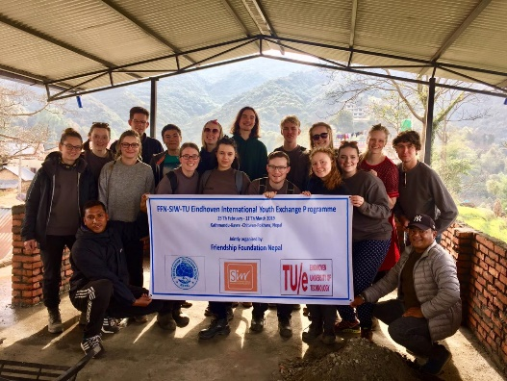
(4) PICTURES

