CONCF-33402A-ESC

PROTECTING HERITAGE 1

CLERMONT-L’HERAULT
01/05 - 15/05

RENO / ENVI
14 vols
18-30
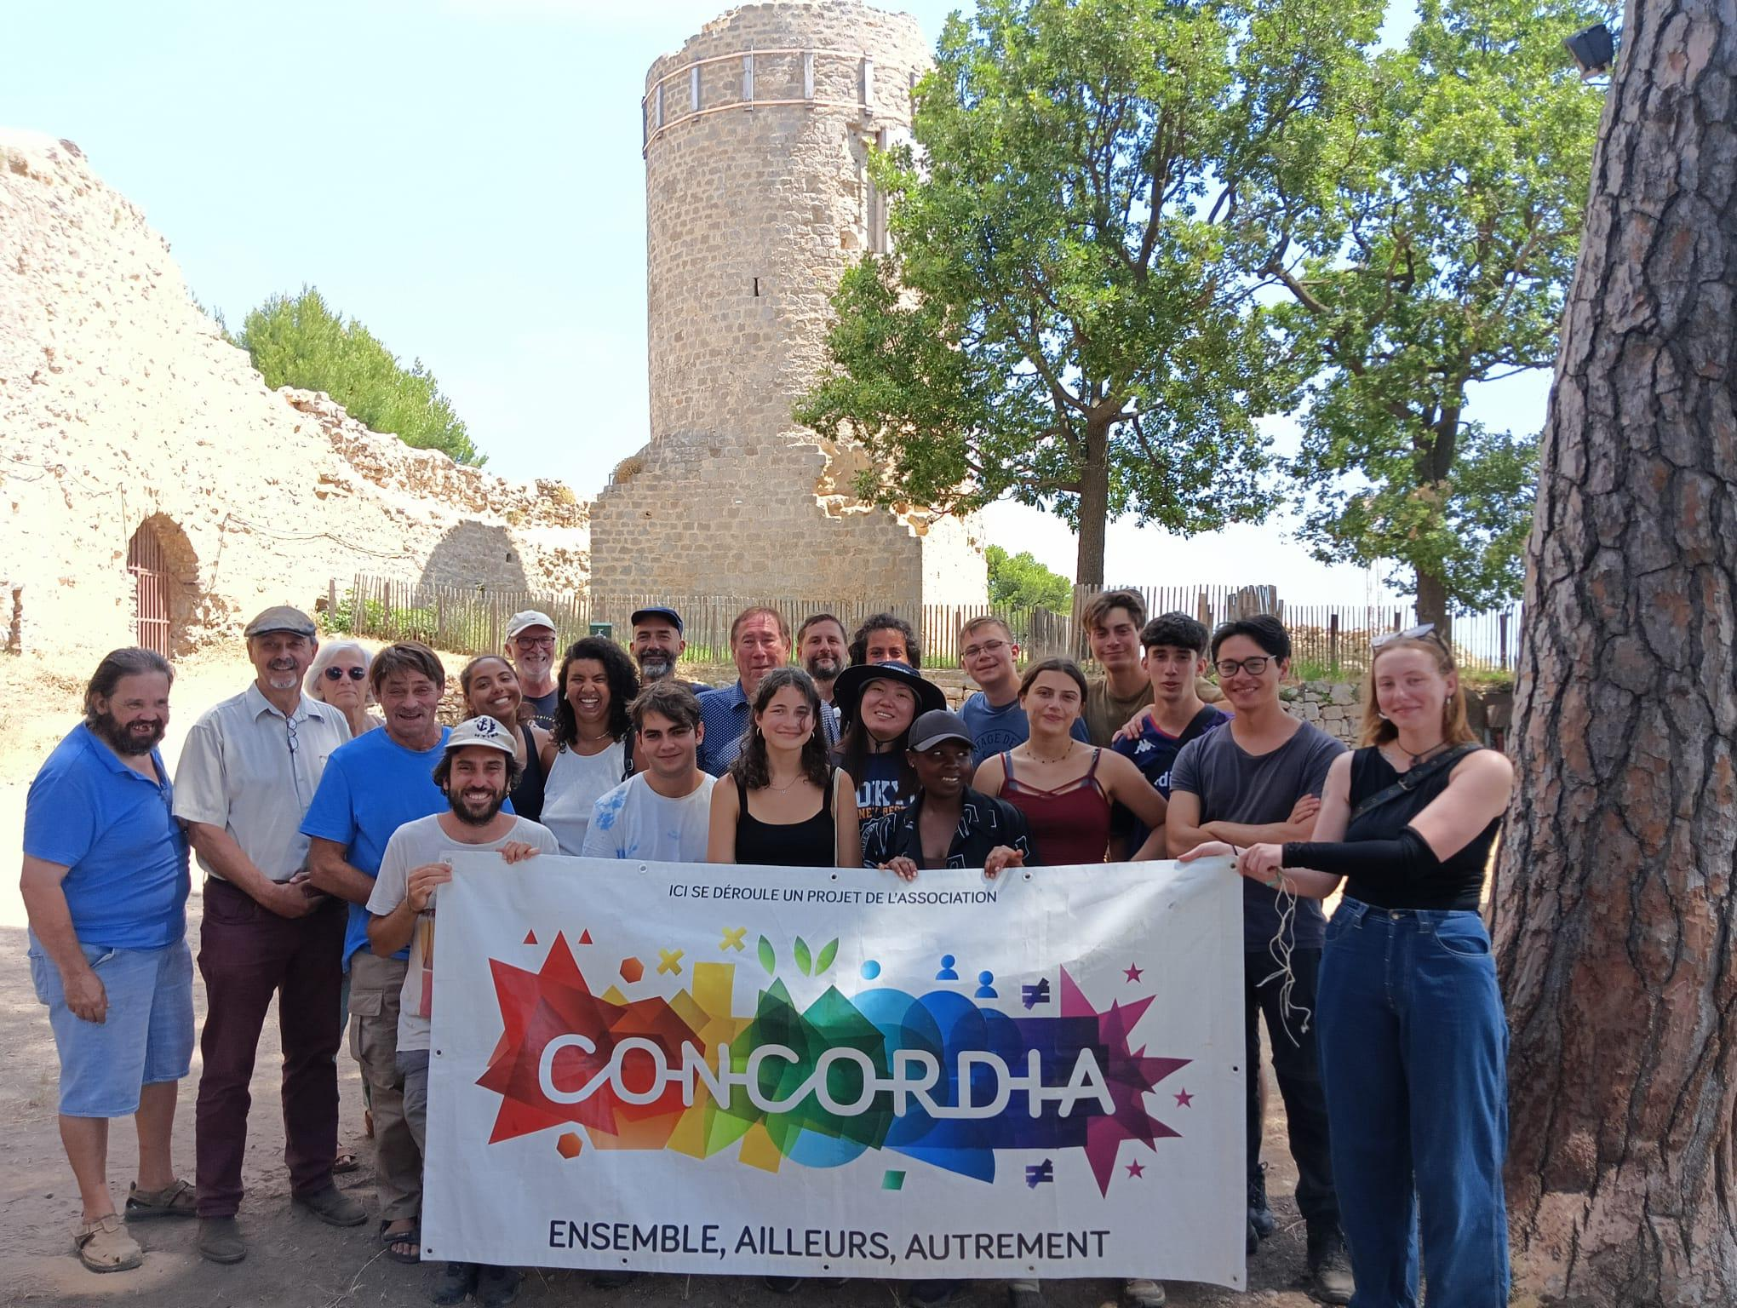

Project and Work:
Do you love heritage and nature and want to make yourself useful ? Come and help restore the stone huts along the trails of Clermont-l'Hérault.
The municipality wants to maintain its trails on the hill overlooking the town for the enjoyment of hikers. Discover the rich heritage of the municipality, such as the capitelles (dry stone huts). Your work will consist of enhancing the site by renovating these capitelles, carrying out small landscaping works, and installing engaging signage.
This work is essential for maintaining the trail while allowing visitors, walkers, and curious people to come and discover this rich heritage. An edifying experience that combines ancestral know-how, creativity, and intercultural encounters !
Accommodation and food:
You will be accommodated in individual tents provided by Concordia in the grounds of the Château des Guilhem, which offers stunning views of the city. You must bring your own camping mattress and sleeping bag. Toilets will be available in the castle outbuildings, and showers will be provided by the sports clubs.
A large tent will be set up as a living space with a dining area. Community life will be at the heart of the experience: you will share daily tasks and prepare meals together. A budget will be given to the activity team, and you will help with shopping and meal preparation, focusing on healthy, local produce.
Partner:

Since 2015, we have had a very strong partnership with the town of Clermont-l'Hérault and local associations that promote the discovery of local heritage.
Our delegation's offices are located in the town. We carry out several volunteer projects aimed at young people in the area. We work closely with volunteers from local heritage preservation associations. This project, which involves showcasing dry stone huts along the communal path, contributes to promoting the town's heritage.
Location and leisure:
Clermont-l'Hérault is a charming little town located north of Montpellier in the south of France. Enjoying a Mediterranean climate and a remarkable natural environment (Lake Salagou, the rivers of the Gorges de l'Hérault nearby), it also has a rich cultural heritage with its castle and cathedral.
In the heart of a preserved setting, you can enjoy outdoor activities and make cultural and festive discoveries.

Special requirements and remarks:
Remember to bring gloves, clothing, and sturdy shoes for the workday. Also remember to bring your sunglasses, a hat, sunscreen, your swimsuit, and a beach towel! The days can be hot, but the nights can be cool. If you wish, you can also bring music or a typical object from your country/region to share your culture with the other participants.
This project is supported by the program European Solidarity Corps for young people between 18 and 30 years. It is open to all volunteers that fit the ESC criteria.
The participation to the ESC volunteering teams is subjects to several principles and conditions, presented on the ESC webpage: https://europa.eu/youth/solidarity/mission_en
- Volunteers do not have to pay any fee (no sending, nor participation fee) to attend the project;
- Volunteers need to enroll in the PASS, the European Solidarity Corps Portal; Concordia France will organise their matching, on the online system, with the volunteering project;
- Volunteers will receive pocket money, calculated on basis of 8€/day, once they arrive on the project in France;
- Volunteers will receive a financial support for their travel, according to a maximum amount established in accordance with their travel distance and upon the presentation of original tickets;
Volunteers will have to complete a participation report, submitted online through the portal.

Time and directions to Meeting Place:
Clermont l’Hérault bus station in the afternoon.

Closest train station / airport :
Montpellier

