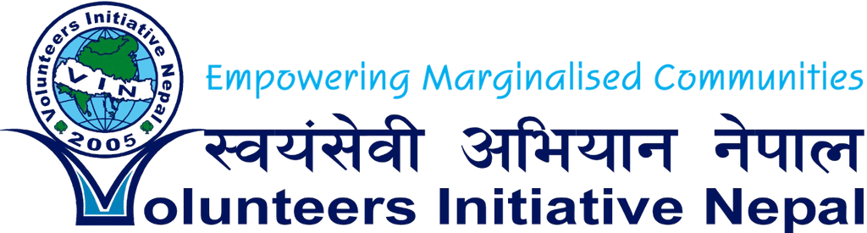
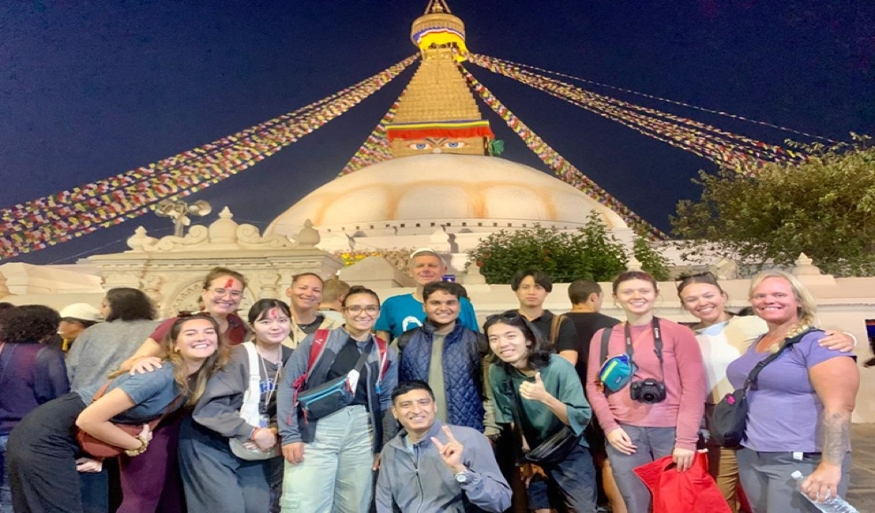

VIN WORKCAMP(STV) PROJECTS 2026

VIN WORKCAMP(STV) PROJECTS 2026

Contents
Volunteers Initiative Nepal (VIN) 2
Our Mission 3
General information about the workcamp: 4
Placement Support Process: 5
Accommodation: 5
Requirements: 5
Participation Fee: 5
Why Okhaldhunga and extra transportation fee: 5
The Participation Fee Covers: 6
What's excluded? 6
Meeting point: 6
Airport: 6
Leisure Activities: 6
VIN Workcamp List 2026 7
Project details 10
Project 1: Children’s Winter Camp – Empowering Kids through Education, Sports & Culture – (EDU, SPOR & CULT) 10
Project 2: Environmental Stewards: Preserving Our Common Home (ENVI, EDU, MANU) 15
Project 3: Creative Minds Library Camp: Inspiring Learning Through Stories and Innovation (KIDS, EDU, CULT) 19
Project 4: Caring Hands Camp: Supporting Nepal’s Elderly with Love and Care (MANU, CULT) 23
Project 5: Youth Empowerment & Festival of Colors Camp: Transforming Skills, Celebrating Culture (EDU, CULT, FESTIVE) 27
Project 6: PERMA LIFE Nepal Holi Festival – Festival of color.: Sustainable Farming and Cultural Colors in Nepal (ENVI, AGRI, MANU) 29
Project 7: Children’s Summer Camp (KIDS, EDU, SPOR & CULT) 33
Project 8: Raising Peace Campaign (EDU, CULT) 37
Project 9: Art & crafts with Children (ARTS, KIDS) 41
Project 10: Library & Festive Camp (EDU, SOCI, FESTIV MANU) 45
Project 11: Creative Classrooms: Enhancing Schools and Inspiring Young Minds & Festive Camp (KIDS, EDU CULT) 50
Project 12: Health and Wellness (HEALTH, EDU) 56
Project 13: Celebrate the Power of Volunteering: Join Us for International Volunteer Day in Nepal!" (MANU, EDU) 59
Project 14 Sign and Smile- Deaf Children's Support Project (KIDS, EDU, CULT) 63
Some pictures 68

Volunteers Initiative Nepal (VIN)
Founded in 2005, Volunteers Initiative Nepal (VIN) is a non-religious, non-political, non-profit NGO committed to empowering marginalized communities in Nepal. With a diverse team of development workers, educators, social activists, and professionals, VIN focuses on community-driven projects that bring together local and international volunteers.

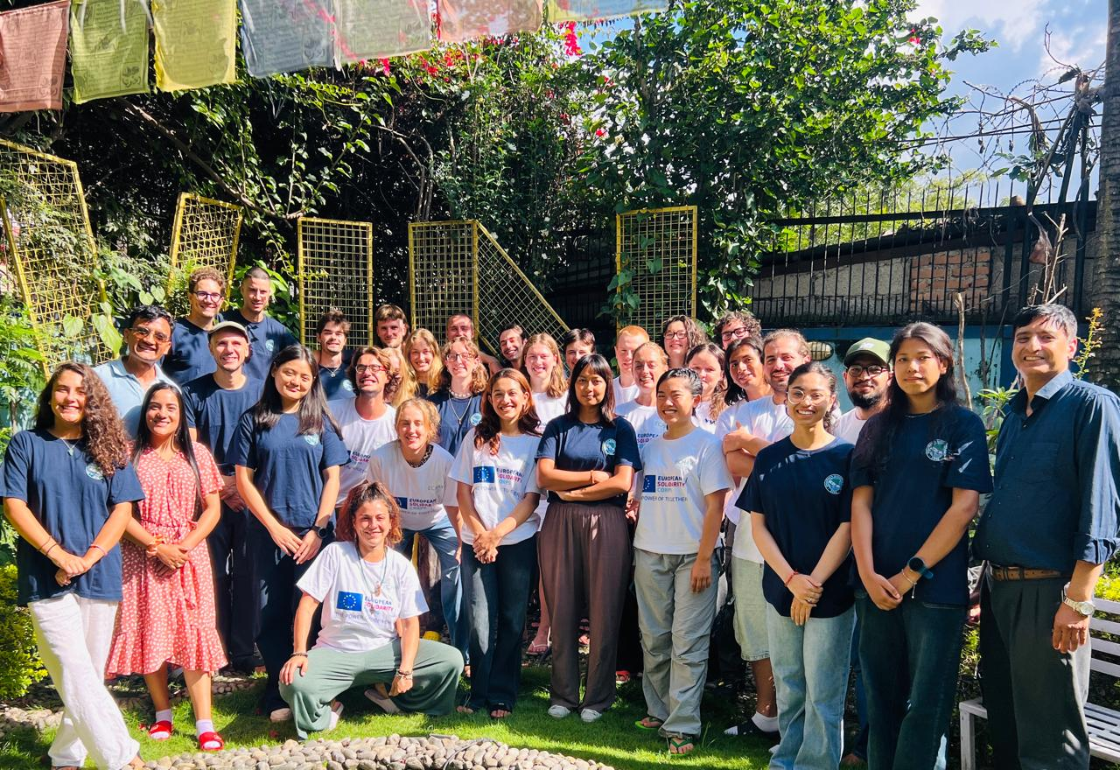
Our mission is to create positive change through inclusive and holistic development programs. We work across four key areas: Education, Health & Environment, Economy, and Infrastructure. Through six core empowerment programs Women’s Empowerment, Children’s Development, Youth Empowerment, Public Health, Environment Conservation, and Disaster Risk Reduction we aim to improve lives and contribute to achieving the UN Sustainable Development Goals (SDGs).

Our Mission
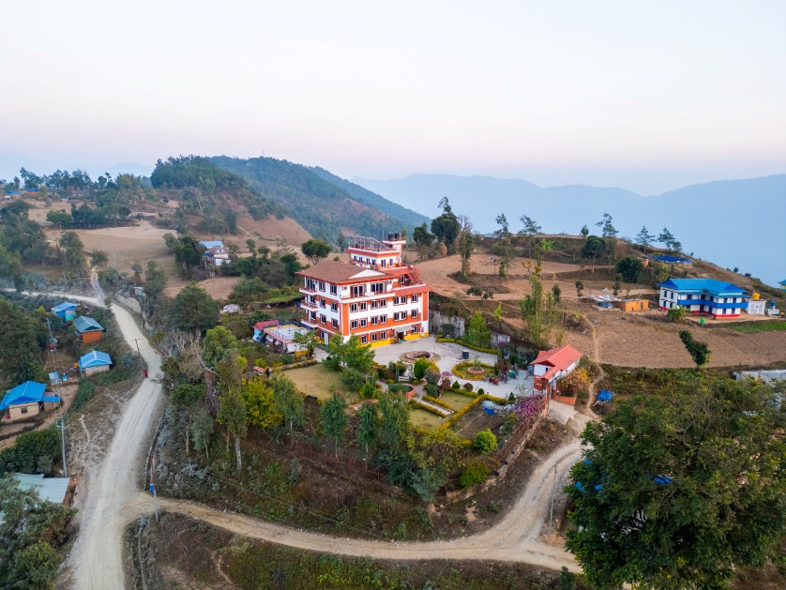
VIN's mission is to Our mission is to empower marginalized communities through equitable, inclusive, and holistic development programs.
The primary objectives of VIN

To improve the essential public health condition of the community, people

To empower women to improve their quality of life

To facilitate children's development & protect child rights

To cultivate skills in youth and engage them in development activities.
- To Conserve, promote, and protect the environment and culture for the future generation
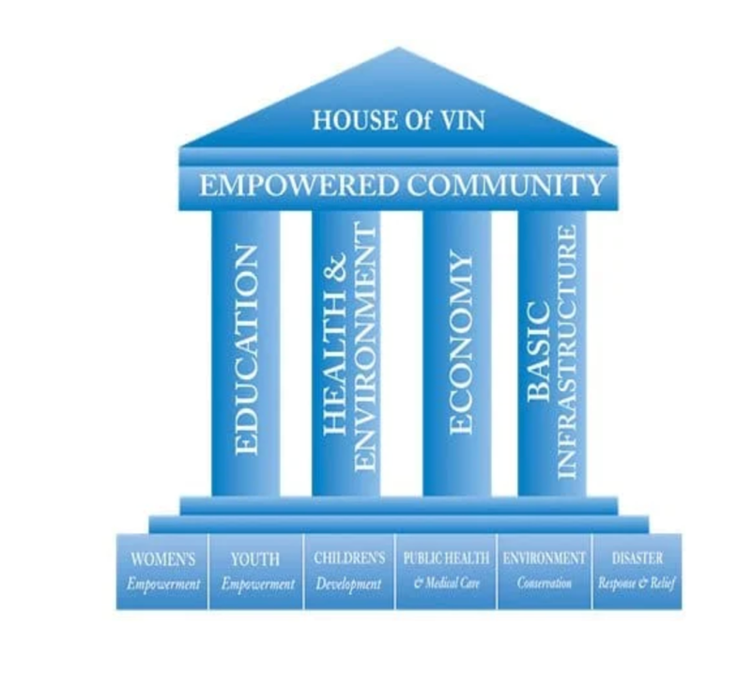
- To minimize the risk of natural disasters and provide relief and safety to vulnerable communities

These objectives are achieved through the engagement of young people and solidarity activities focusing on sustainable development goals, social inclusion, and equal opportunities.
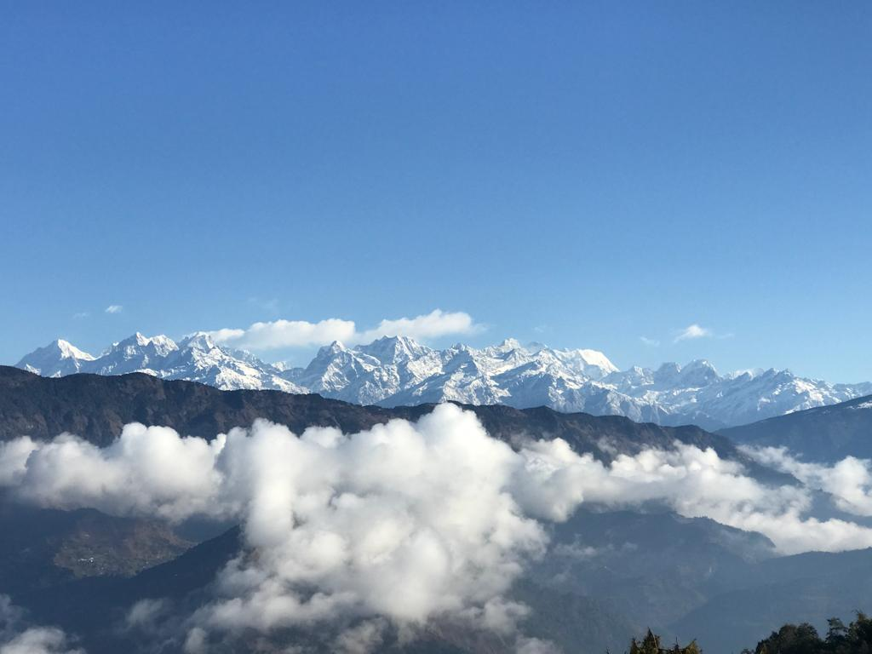
VIN believes in the four pillars of development: Education, Health and Environment, Economy, and basic infrastructure. We have implemented six programs: women's empowerment, Children's Development, Youth Empowerment, Public Health and Medical Care, Environment Conservation, and Disaster Response and relief. VIN mobilizes local and international community and office volunteers, positively impacting the programs.

VIN has fully applied a holistic approach in humanitarian activities (equal focus on Education, Health & Environment, Economy, and Basic infrastructure development) to community empowerment. Through our initiatives, over 370k people directly benefitted.

General information about the workcamp:

VIN organizes international work camps where participants from different countries work on community-based projects. These projects typically focus on education, environmental conservation, cultural exchange, health, and infrastructure development. Our work camps are usually short-term (1–3 weeks).

Participants contribute their time, skills, and energy to the project while experiencing cultural exchange and learning from each other. The projects foster global understanding, teamwork, and sustainable development.

Placement Support Process:

The first day of the program is dedicated to arrival/welcoming day/. Upon arrival, each volunteer is greeted by VIN’s local staff at the airport and taken to the VIN hostel for their stay. The second day features a comprehensive orientation at the VIN office in Kathmandu. This session covers important topics such as cultural tips, basic Nepali survival phrases, health and safety advice, preparation for project activities and planning, and an introduction to VIN’s mission and work. The volunteers are accommodated to host families/hostel.

A Nepali camp leader will guide volunteers throughout the work camp, and VIN supervisors will make periodic visits to provide follow-up and support. Volunteers can always contact VIN for immediate assistance if they encounter any issues during the camp. On the final day, volunteers will complete a detailed work report, fill out an exit form, and participate in an exit interview and feedback session with VIN executives to share their experiences and suggestions.

Accommodation:
The volunteers will stay with the host family/hostel identified by VIN. The living facilities are simple and basic. Male and female volunteers will share the same living area with separate rooms. The volunteers sleep on simple beds/mattresses. Please bring your sleeping bag.

Requirements:
- Basic English should be spoken among the participants
- Physically sound as per the project requirements.

Participation Fee:
The participation fee is 270 Euros (+30 Euro for transportation in Kathmandu. 100 Euro for Okhaldhunga, 100 Euro for Sindhuli, 50 Euro for Lapsephedi ), which is to be paid on arrival at the VIN Office.

Why Okhaldhunga and extra transportation fee:
- It takes one day (250 km) car/bus rough and paved drive from Kathmandu.
- The beautiful Himalayan region is close to Mt. Everest.
- It lacks development and basic infrastructure.
- It is a very needy local area waiting for development.
- Welcoming community and rich in culture.
- Simple lifestyle and smiling people.
- Lovely environment and up and downhill.
- Good and enough support from local staff and community people.
- Volunteers will feel they have contributed to the needy and poor community.

The Participation Fee Covers:
- Food and Accommodation: Nepali Standard at a local host family – 3 meals a day
- Transportation: Airport pick up and pick up and drop to the working community site
- Materials for the work camp and community development projects support
- Local volunteers' support cost
- VIN T-shirt and certificate of participation
- 24-hour emergency support
- VIN admin cost.

What's excluded?

Airfare, VISA, Travel medical insurance, return airport transfer, personal travel and weekend activities, and other personal expenses.

Meeting point:
One of the VIN staff will pick up volunteers from the airport. Please send your flight details to VIN on time so we can send your name card and VIN logo to our staff.
If you want to explore the country earlier, you can take a pre-paid taxi at the airport, or VIN can help you with that. You can arrive at the VIN office on the first day.

Airport:
Tribhuwan International Airport, Kathmandu

Leisure Activities:
You can go sightseeing at various sites around the community. VIN also organizes weekend travel tours to Chitwan Jungle Safari, Pokhara, and Nagarkot at an additional cost if you are interested.

VIN Workcamp List 2026
Code | Name of Project | Location | Date | Type | Total Vols. | Male | Female | Age
VINWC26-01 | Children’s Winter Camp – Empowering Kids Through Education, Sports & Culture | Kathmandu | 16-27 Jan 2026 | KIDS, EDU, SPOR & CULT | 14 | 7 | 7 | 18+
VINWC26-02 | Art and craft with children | Kathmandu | 10 -21 Feb 2026 | ARTS, KIDS, EDU | 14 | 7 | 7 | 18+
VINWC26-03 | Youth Empowerment and Festival of Color Camp. | Kathmandu | 26 Feb – 09 March 2026 | EDU FESTIVE | 14 | 7 | 7 | 18+
VINWC26-04 | PERMA LIFE Nepal Holi Festival – Festival of color. | Okhaldhunga | 26 Feb – 10 March 2026 | ENVI, AGRI, MANU, FESTIVE | 14 | 7 | 7 | 18+
VINWC26-05 | Caring Hands Camp | Lapsephedi Kathmandu | 15- 26 March 2026 | MANU, CULT, ENVI | 14 | 7 | 7 | 18+
VINWC26-06 | Creative Minds Library Camp: Inspiring Learning Through Stories and Innovation | Okhaldhunga | 5 - 17 April 2026 | KIDS, EDU, CULT | 14 | 7 | 7 | 18+
VINWC26-07 | Caring Hands Camp | Lapsephedi Kathmandu | 15- 26 April 2026 | MANU, CULT, ENVI | 14 | 7 | 7 | 18+
VINWC26-08 | Sign and Smile- Deaf children Support Project | Sindhuli | 12-24 May 2026 | ENVI, EDU, MANU | 14 | 7 | 7 | 18+
VINWC26-09 | PERMA LIFE Nepal | Okhaldhunga | 12-24 May 2026 | ENVI, AGRI, MANU, | 14 | 7 | 7 | 18+
VINWC26-10 | Art and crafts with children | Kathmandu | 10-22 June 2026 | ARTS, KIDS, EDU | 14 | 7 | 7 | 18+
VINWC26-11 | PERMA LIFE Nepal | Okhaldhunga | 10-22 June 2026 | ENVI, AGRI, MANU | 14 | 7 | 7 | 18+
VINWC26-12 | Children’s Summer Camp | Okhaldhunga | 09-21 July 2026 | KIDS, EDU, SPOR & CULT | 14 | 7 | 7 | 18+
VINWC26-13 | PERMA LIFE Nepal | Okhaldhunga | 09-21 July 2026 | ENVI, AGRI, MANU | 14 | 7 | 7 | 18+
VINWC26-14 | Health and Wellness | Kathmandu | 09 -20 July 2026 | ARTS, KIDS, EDU | 14 | 7 | 7 | 18+
VINWC26-15 | Children’s Summer Camp | Okhaldhunga | 16 -28 July 2026 | KIDS, EDU, SPOR & CULT | 16 | 8 | 8 | 18+
VINWC26-16 | PERMA LIFE Nepal | Okhaldhunga | 16 -28 July 2026 | ENVI, AGRI, MANU | 14 | 7 | 7 | 18+
VINWC26-17 | Environmental Stewards: Preserving Our Common Home | Kathmandu | 12-23 August 2026 | ENVI, EDU, MANU | 14 | 7 | 7 | 18+
VINWC26-18 | Sign and Smile- Deaf children Support Project | Sindhuli | 12-23 August 2026 | KIDS, EDU, CULT | 14 | 7 | 7 | 18+
VINWC26-19 | Library  & Festive Camp | Kathmandu | 03 - 15 September 2026 | EDU, SOCI, KIDS, MANU, CULT | 14 | 7 | 7 | 18+
VINWC26-20 | Creative Classrooms: Enhancing Schools and Inspiring Young Minds & Festive Camp | Okhaldhunga | 03 - 15 September 2026 | KIDS, CULT | 14 | 7 | 7 | 18+
VINWC26-21 | Raising Peace Campaign | Kathmandu | 27 Sep – 08 Oct 2026 | EDU, CULT | 14 | 7 | 7 | 18+
VINWC26-22 | Caring Hands Camp | Lapsephedi Kathmandu | 26 Oct – 06 Nov 2026 | MANU, CULT, ENVI | 14 | 7 | 7 | 18+
VINWC26-23 | Celebrate the Power of Volunteering | Kathmandu | 25 Nov – 6 Dec 2026 | MANU, EDU, FESTIV | 14 | 7 | 7 | 18+
VINWC26-24 | PERMA LIFE Nepal | Okhaldhunga | 06 – 19 Dec 2026 | ENVI, AGRI, MANU | 14 | 7 | 7 | 18+
VINWC27-01 | Children’s Winter Camp – Empowering Kids Through Education, Sports & Culture | Kathmandu | 11-22 Jan 2027 | KIDS, EDU, SPOR & CULT | 14 | 7 | 7 | 18+
VINWC27-02 | Art and craft with children | Kathmandu | 09 -20 Feb 2027 | ARTS, KIDS, EDU | 14 | 7 | 7 | 18+

Project details

Project 1: Children’s Winter Camp – Empowering Kids through Education, Sports & Culture – (EDU, SPOR & CULT)

Code | Name of Project | Location | Date | Type | Total Vols. | Male | Female | Age
VINWC26-01 | Children’s Winter Camp – Empowering Kids Through Education, Sports & Culture | Kathmandu | 16-27 Jan 2026 | KIDS, EDU, SPOR & CULT | 14 | 7 | 7 | 18+
VINWC27-01 | Children’s Winter Camp – Empowering Kids Through Education, Sports & Culture | Kathmandu | 11-22 Jan 2027 | KIDS, EDU, SPOR & CULT | 14 | 7 | 7 | 18+

Background: Unlocking Potential through Winter Camps
The Children’s Winter Camp is a transformative initiative by VIN to foster the overall development of children in Nepal. This program is part of our broader Children’s Development Program, which seeks to protect children’s rights and provide access to quality education, essential life skills, and health education. In many schools throughout Nepal, education centers primarily on exams and rote memorization, leaving little room for creativity, leadership, and personal development.
This gap becomes even more pronounced in disadvantaged communities, where children may miss out on recreational opportunities during school breaks. Our Children’s Winter Camp aims to close this gap by providing a safe, structured, and enjoyable environment for children aged 5 to 12. They can explore their creativity, develop leadership skills, and forge lasting friendships here.
The program explicitly targets underprivileged children whose families may lack the resources to take them on vacations during school breaks. Through creative activities, team-building exercises, and cultural exchanges, these camps provide children with a unique opportunity to grow and develop in ways that extend beyond the classroom.
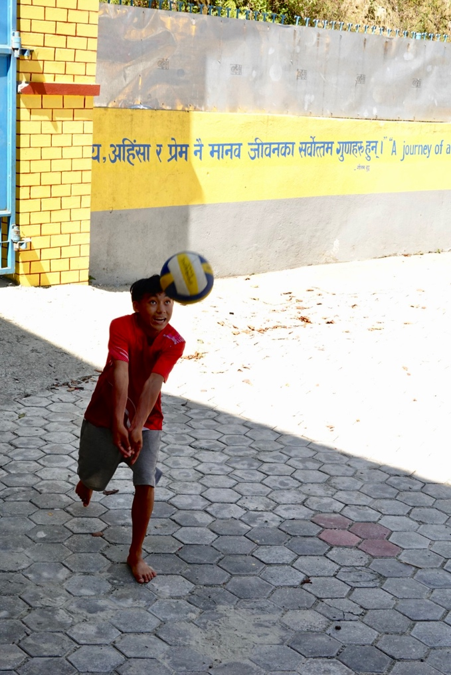
Why Is This Winter Camp Important?
Winter camps provide children an invaluable opportunity to develop their social, emotional, mental, and creative skills in a safe and supportive environment. These camps are significant for children in rural communities with limited access to organized extracurricular activities.
We aim to instill essential life skills such as teamwork, leadership, communication, and confidence by engaging children in creative workshops, physical activities, and cultural experiences. Through these camps, children enjoy a productive vacation while developing the personal skills they need to thrive.
Furthermore, the program promotes cross-cultural exchange. Local and international volunteers work together to interact with the children, sharing knowledge and learning from each other.
Key Objectives
- Holistic Child Development: During their winter vacation, children aged 5 to 12 should have the opportunity for social, emotional, physical, and creative growth.
- Cross-Cultural Understanding: Foster friendship, solidarity, and understanding between local and international volunteers.
- Cultural Immersion: Offer volunteers and children the chance to experience and appreciate Nepalese culture and traditions.
Activities & Workshops
During Winter Camp, children will participate in a wide range of fun and educational activities to foster their overall development. Volunteers will lead children through engaging sessions that support their growth in several key areas.

Physical Activities & Health
- Yoga & Stretching: Promote flexibility, relaxation, and overall well-being.
- Sports & Fitness: Simple fitness routines and fun team sports can help children build physical strength and teamwork.
Team Building & Communication
- Group Games & Challenges: Develop children’s social and communication skills by encouraging collaboration through team-building activities.
- Collaborative Projects: Foster teamwork through creative group tasks, such as collaborative art or problem-solving exercises.
Creative Development
- Arts & Crafts Workshops: Inspire creativity through hands-on activities like painting, drawing, and crafting.
- Origami & Paper Crafts: Develop children’s fine motor skills while encouraging creativity through fun paper-folding exercises.
Performing Arts & Confidence Building
- Singing, Dancing & Drama: Help children build confidence and express themselves through fun performing arts activities like music, drama, and dance.
- Music & Rhythm Workshops: These workshops introduce children to basic music skills, rhythm, and performance, enhancing their self-expression.
Outdoor Exploration & Environmental Education
- Nature Walks & Hikes: Explore the local natural environment through walks and hikes, while teaching children about environmental sustainability.
- Outdoor Play: Encourage physical activity and appreciation of nature through fun outdoor games and exploration.
Language & Communication Skills
- Language Lessons: Improve children’s language skills through new vocabulary, basic conversational phrases, and exposure to English Language.
Location: Tarakeshwor, Kathmandu
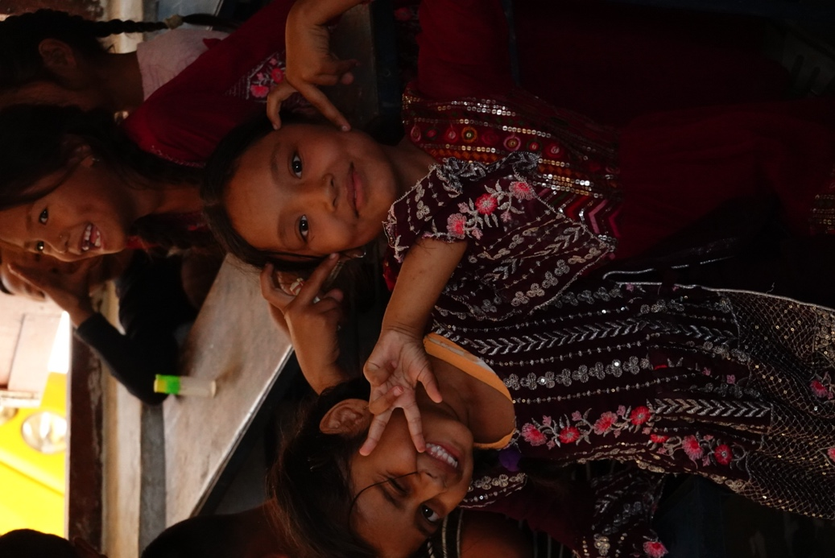
The community is located in Tarakeshwor Municipality, a scenic area on the outskirts of Kathmandu. Situated about 10-12 km from the main ring road to Balaju, this rural hills, fields, and forests surround area, making it an ideal location for outdoor activities and cultural immersion.
Participation Fee & How to Apply
The fee for the Winter Camp is 270 Euros (+30 Euros for transportation), payable upon arrival at the VIN Office. To apply, submit your Volunteer Exchange Form (VEF) to the organization you are sending it to. Once we receive your form, we will send you a detailed information sheet and acceptance letter.

Frequently Asked Questions (FAQs)

What age group is the Winter Camp designed for?
The camp is specifically designed for children aged 5 to 12 years.
How do international volunteers contribute to the camp?
International volunteers bring diverse skills and cultural perspectives, helping to facilitate creative workshops, team-building activities, and cultural exchange. Their engagement enriches the experience for both children and local volunteers.
What are the benefits for the children?
Children will develop essential life skills, including creativity, leadership, teamwork, and communication. They will also gain confidence, improve social skills, and have fun in a supportive environment.
Why is Jitpurphedi an excellent location for this camp?
The natural surroundings of Jitpurphedi provide a peaceful setting for outdoor activities and exploration. The community’s rural charm offers a unique opportunity for cultural immersion away from the hustle and bustle of Kathmandu.
Join VIN's Children’s Winter Camp and help empower the next generation of leaders in Nepal. By volunteering, you’ll help children develop key life skills and contribute to a cross-cultural exchange that fosters global understanding and solidarity. Your participation will make a lasting impact!

Project 2: Environmental Stewards: Preserving Our Common Home (ENVI, EDU, MANU)
Code | Name of Project | Location | Date | Type | Total Vols. | Male | Female | Age
VINWC26-17 | Environmental Stewards: Preserving Our Common Home | Kathmandu | 12-23 August 2026 | ENVI, EDU, MANU | 14 | 7 | 7 | 18+

Background: Tackling Environmental Challenges in Nepal
Environmental protection is one of the most pressing global issues today, and Nepal is no exception. Rapid urbanization, increased consumption, and changing lifestyles have created significant challenges, especially in waste management. Solid waste management in urban and rural areas is one of the most urgent concerns, as it actively affects the environment, public health, and local communities.
In many of VIN's working areas, including schools, improper waste disposal—such as food scraps and other materials is a serious problem. This leads to littering, health risks, and pollution, especially in vulnerable areas like Jitpurphedi, Kavresthali, and Okharpauwa near Kathmandu. Poor waste management affects urban and rural communities, contributing to environmental degradation, soil contamination, and health issues. Children are particularly vulnerable, suffering from respiratory diseases, skin infections, and gastrointestinal illnesses as a result of exposure to waste.
Non-biodegradable waste (NBW) is one of the key contributors to environmental harm. NBW accumulates in large quantities in rural areas, impacting agricultural productivity and local farmers' livelihoods. As this waste pollutes agrarian land, it reduces its ability to sustain crops, affecting the food security of families and communities.
Why Waste Management Matters
Addressing these waste management issues is crucial to preserve Nepal’s environment and ensure public health. By adopting sustainable practices such as waste segregation, recycling, and composting, communities can transform waste into a valuable resource rather than a harmful by-product.
Under the “Environmental Stewards: Preserving Our Common Home” project, VIN aims to empower local communities to take action on waste management. By raising awareness and providing practical solutions, the project will help create cleaner, greener environments and improve public health.
Key Objectives
- Reduce water, land, and air pollution through environmental education and community cleaning activities.
- Empower communities to adopt sustainable waste management practices, including reducing, reusing, and recycling.
- Raise awareness about the importance of environmental conservation and its long-term benefits for public health and sustainability.
Activities & Work

Waste Management & Clean-Up Campaigns
- Community Clean-Up Campaigns: Volunteers will work with local communities to organize clean-up drives. These activities will focus on clearing waste from public spaces, reducing litter, and creating cleaner environments.
Waste Management Training
- 3R Principles (Reduce, Reuse, and Recycle): Train local communities on effective waste management using the 3R principles. This will include waste segregation, recycling, composting techniques, and proper waste disposal methods.
- Composting Training: Volunteers will guide households on creating compost at home using organic waste. This method reduces waste and provides organic fertilizer for better agricultural practices.
Sustainable Agriculture Training
- Kitchen Garden Training: Promote sustainable farming by teaching local households how to create kitchen gardens. This activity will empower families to grow their vegetables, reduce the need for external supplies, and contribute to better nutrition.
Location: Tarakeshwor, Kathmandu
The project will take place in Tarakeshwor Municipality, on the outskirts of Kathmandu. Around 10-12 km from the main ring road to Balaju, this rural hills, fields, and forests surround area, providing a perfect setting for environmental conservation and community engagement.
Participation Fee & How to Apply
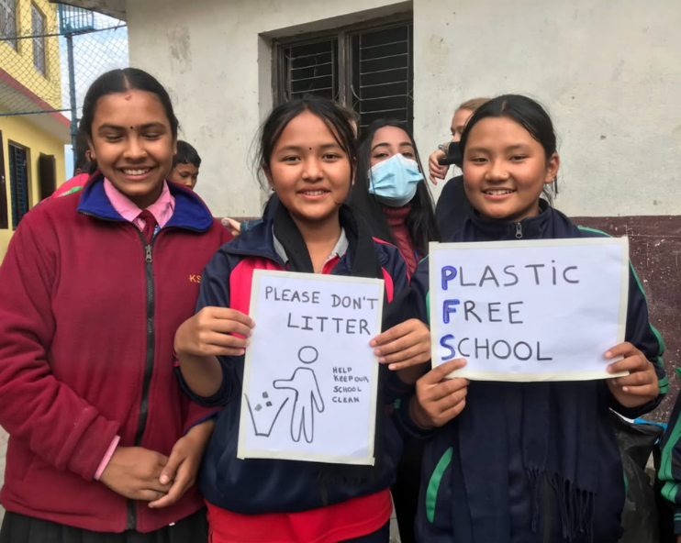
The participation fee for the Environmental Stewards program is 270 Euros (+30 Euros for transportation), payable upon arrival at the VIN Office.
To participate, complete and submit the Volunteer Exchange Form (VEF) through the sending organization. Once we receive the form, you will receive a detailed information sheet and an acceptance letter.

Frequently Asked Questions (FAQs)

What is the focus of this project?
The project focuses on solid waste management, pollution control, and sustainable agricultural practices in rural communities near Kathmandu. Volunteers will help raise awareness and train locals in waste segregation, recycling, composting, and kitchen garden creation.
Why is waste management critical in Nepal?
Improper waste management in Nepal contributes to significant environmental degradation, health risks, and land contamination. Addressing these issues is crucial for creating cleaner and healthier communities.
Who can volunteer for this project?
This project is open to individuals 18 and older passionate about environmental conservation and community work. Volunteers will work closely with local communities to implement sustainable solutions.
How does this project help local communities?
The project aims to reduce pollution, improve public health, and promote a cleaner environment for future generations by empowering communities with the knowledge and skills to manage their waste sustainably.
Join us as an Environmental Steward and help preserve Nepal’s natural beauty for generations. Your involvement will directly impact the environment and the lives of local communities. We can create a cleaner, greener, and more sustainable future!

Project 3: Creative Minds Library Camp: Inspiring Learning Through Stories and Innovation (KIDS, EDU, CULT)

Code | Name of Project | Location | Date | Type | Total Vols. | Male | Female | Age
VINWC26-06 | Creative Minds Library Camp: Inspiring Learning Through Stories and Innovation | Okhaldhunga | 5 - 17 April 2026 | KIDS, EDU, CULT | 14 | 7 | 7 | 18+

Background: A Center for Learning and Empowerment

The NaraTika Community Learning Center (NTCLC), nestled in the serene hills of Nisankhe, Okhaldhunga, is a transformative hub for education, creativity, and community development. Designed to support disadvantaged communities,
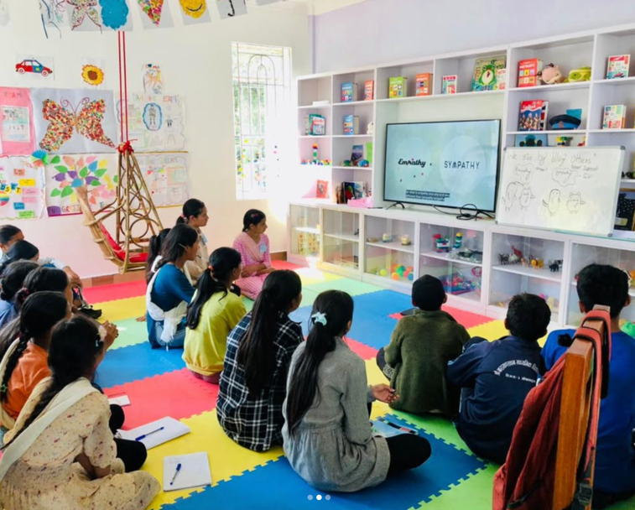
NTCLC offers:

A vibrant children’s center (ages 3–8).
An extensive library for readers aged eight and above.
Multi-functional spaces, including a computer lab, seminar hall, and training rooms for workshops and events.

The center incorporates sustainable practices, features a permaculture-inspired vegetable garden, and fosters lifelong learning. Volunteers are pivotal in energizing the center's mission by engaging in creative and educational activities that inspire young minds.
Volunteers bring the magic of storytelling, interactive learning, and artistic expression to children through the Creative Minds Library Camp while enhancing literacy and life skills in a dynamic, supportive environment.
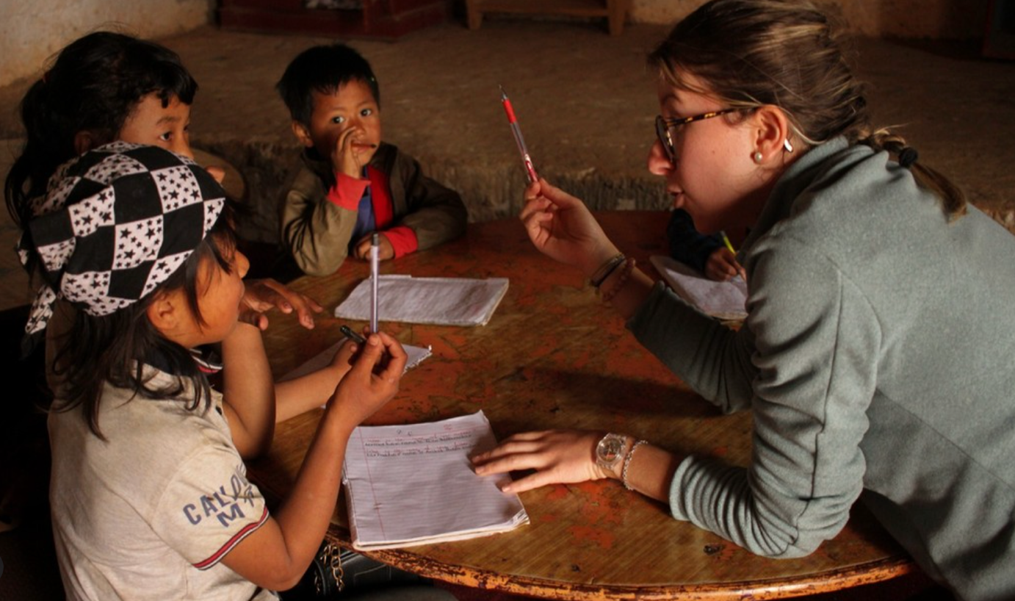

Objectives of the project:

Ignite a love for reading and promote literacy through storytelling and library activities.
Foster creativity and self-expression via arts, crafts, and writing workshops.
Equip children with critical thinking, teamwork, and communication skills through engaging, hands-on activities.

Volunteer Activities

As a volunteer, you will engage in meaningful and enjoyable activities that make a lasting impact:

Storytelling and Literacy

Lead interactive storytelling sessions to spark imagination and instill moral values and cultural appreciation.
Organize and catalog library resources to improve accessibility.
Create a child-friendly reading environment that encourages curiosity and learning.

Creative and Educational Workshops

Conduct art and craft sessions to stimulate creativity and hands-on learning.
Help children write stories, poems, or journals, fostering their writing and self-expression skills.
Use songs, rhymes, and games to teach basic English in a fun, interactive way.

Skill Development

Organize critical thinking games to enhance problem-solving and logic.
Teach life skills such as teamwork, empathy, and effective communication through storytelling and group discussions.

Community Engagement

Lead mobile reading sessions at local schools, extending the joy of learning beyond the center.
Support cleaning and gardening initiatives to maintain a welcoming and eco-friendly learning space.

Location: Nisankhe, Okhaldhunga

The center is located in Siddhicharan Municipality, Ward 2, Okhaldhunga district, approximately 250 km from Kathmandu. A scenic 8-10-hour jeep ride takes you through Nepal’s stunning hills and fertile fields.
For more information about NTCLC and its programs, visit www.ntchc.org.

Participation Fee

The program fee is 270 Euros (+ 100 Euros for transportation), payable upon arrival at the VIN Office.

Application Process

Please complete the Volunteer Exchange Form (VEF) through your sending organization. Once received, VIN will provide a detailed information sheet and an acceptance letter.

Why Join the Creative Minds Library Camp?

Please make a Difference: Help children overcome literacy barriers while fostering creativity and confidence.
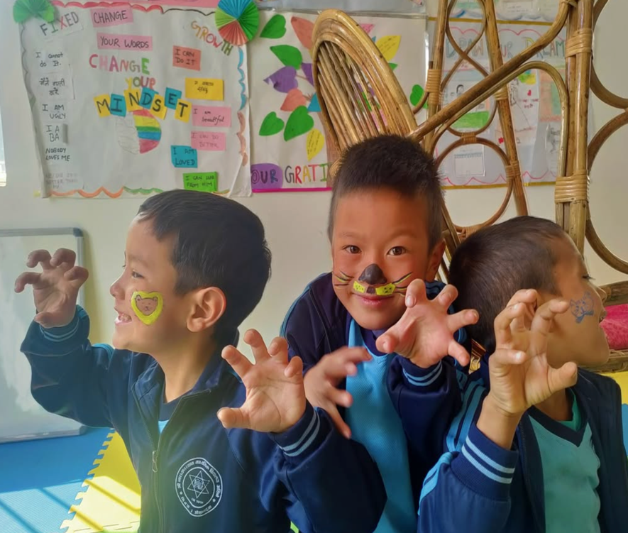
Experience Cultural Immersion: Engage with Nepalese communities and experience the country’s rich traditions and breathtaking landscapes.

Learn and Grow: Develop your education, leadership, and intercultural communication skills.
Join us in creating a world where stories inspire change, creativity flourishes, and learning never stops!

Volunteer Now: Be the spark that lights young minds and makes learning a joyful adventure!

Project 4: Caring Hands Camp: Supporting Nepal’s Elderly with Love and Care (MANU, CULT)

Code | Name of Project | Location | Date | Type | Total Vols. | Male | Female | Age
VINWC26-05 | Caring Hands Camp | Lapsephedi Kathmandu | 15- 26 March 2026 | MANU, CULT, ENVI | 14 | 7 | 7 | 18+
VINWC26-07 | Caring Hands Camp | Lapsephedi Kathmandu | 15- 26 April 2026 | MANU, CULT, ENVI | 14 | 7 | 7 | 18+
VINWC26-22 | Caring Hands Camp | Lapsephedi Kathmandu | 26 Oct – 06 Nov 2026 | MANU, CULT, ENVI | 14 | 7 | 7 | 18+

Background: Caring Hands Camp: Supporting Nepal’s Elderly with Love and Care
Why Does This Workcamp Matter?
Nepal’s elderly population is growing, yet many seniors face isolation, neglect, and poverty. As traditional family structures shift and younger generations migrate for work, older adults are often left alone, struggling with physical and emotional challenges.
The Caring Hands Camp offers a unique chance to make a real difference in the lives of these seniors. You will help improve their well-being while experiencing Nepal’s rich culture and natural beauty.
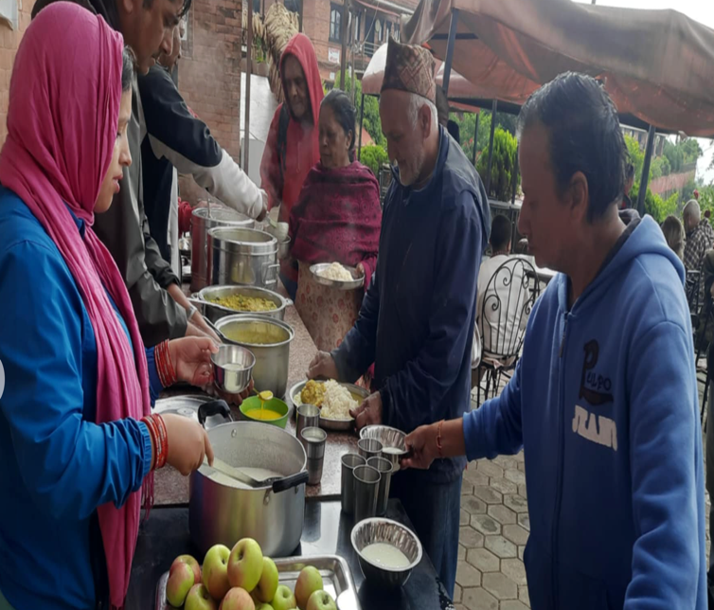
What Is the Caring Hands Camp?

This work camp focuses on providing care, comfort, and companionship to elderly residents in Nepal. Volunteers work with local caregivers to enhance seniors’ daily lives by assisting with health checks, hygiene, social activities, and sustainable farming.
Key Objectives
- Support elderly individuals in their daily activities, enhancing comfort and happiness.
- Build friendships and understanding among local and international volunteers.
- Foster cultural appreciation through immersive experiences in Nepalese traditions.
What Will You Do?
As a volunteer, your tasks will include:
Health and Hygiene Support
- Assist nurses in health checks, first aid, and general elderly care.
- Help maintain personal hygiene for seniors, promoting their well-being.
Social and Recreational Activities
- Organize fun and engaging events like games, storytelling, or music sessions.
- Encourage social interaction to combat loneliness and create joyful moments.
Household and Environmental Support
- Prepare meals and ensure sanitation standards.
- Assist with cleaning and organizing living spaces.
- Contribute to farming activities that provide fresh, nutritious food for the community.

Where Is It Located?
The camp is held at elderly care center in Lapsephedi, a peaceful village 40 kilometers northeast of Kathmandu. Set in the foothills of the Himalayas, this community offers:
- Stunning views of terraced fields and lush greenery.
- A serene environment perfect for cultural immersion and personal growth.
Who Can Join?
This workcamp welcomes anyone aged 18+, whether you are:
- A student seeking hands-on experience in caregiving.
- A professional looking for a meaningful vacation.
- Someone passionate about helping seniors and learning about new cultures.

What Are the Benefits?

Make a Lasting Impact
Your work will bring joy, comfort, and dignity to Nepal’s elderly residents.
Learn and Grow
Gain experience in caregiving, team collaboration, and cultural exchange.
Discover Nepal
Immerse yourself in Nepalese culture, traditions, and the breathtaking Himalayan landscape.
Participation Fee
The program fee is 270 Euros, plus 50 Euros for transportation, payable upon arrival.
This covers:
- Accommodation and meals during your stay.
- On-site orientation and support.
How to Apply
Please complete the Volunteer Exchange Form (VEF) through your sending organization. Once you submit it, we will send you a detailed information sheet and an acceptance letter.
FAQs
Do I need experience in elderly care?
No prior experience is required. Training and guidance will be provided during the camp.
What should I bring?
Comfortable clothing, personal hygiene items, and a willingness to learn and help are essential.
Is this work camp safe?
Yes! You’ll have local staff to ensure a safe and rewarding experience.
Join the Caring Hands Camp Today
Make a difference in the lives of Nepal’s elderly people while gaining unforgettable memories and cultural experiences.
Volunteer Now: Your compassion can transform lives.

Project 5: Youth Empowerment & Festival of Colors Camp: Transforming Skills, Celebrating Culture (EDU, CULT, FESTIVE)

Code | Name of Project | Location | Date | Type | Total Vols. | Male | Female | Age
VINWC26-03 | Youth Empowerment and Festival of Color Camp. | Kathmandu | 26 Feb – 09 March 2026 | EDU FESTIVE | 14 | 7 | 7 | 18+

Project Background:

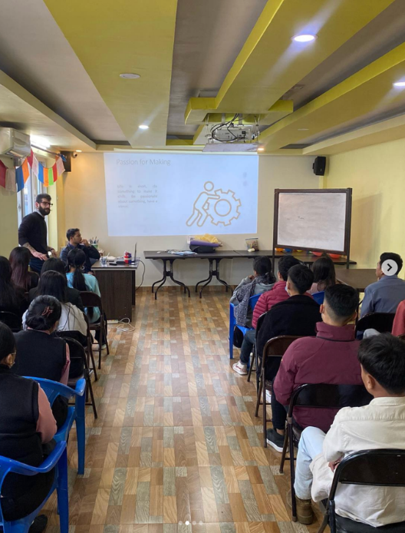
Why Join This Unique Camp?
This Youth Empowerment & Festival of Colors Camp offers a life-changing opportunity to support Nepalese youth while experiencing the vibrant Holi Festival. You’ll help young people develop skills to succeed and celebrate the joy of community and culture through one of Nepal’s most colorful and exciting traditions.
What Makes This Camp Special?

Part 1: Youth Empowerment
In Nepal, many young people struggle to find opportunities to grow personally and professionally. Even those with education often lack critical life skills like public speaking, teamwork, and decision-making. By participating in this camp, you’ll help young people unlock their potential to become active and productive members of society.
Through interactive sessions and training, you’ll guide youth in areas like:
- Leadership and teamwork skills.
- Effective communication for personal and professional growth.
- Entrepreneurship basics, helping them turn ideas into action.
Part 2: Celebrate Holi – The Festival of Colours
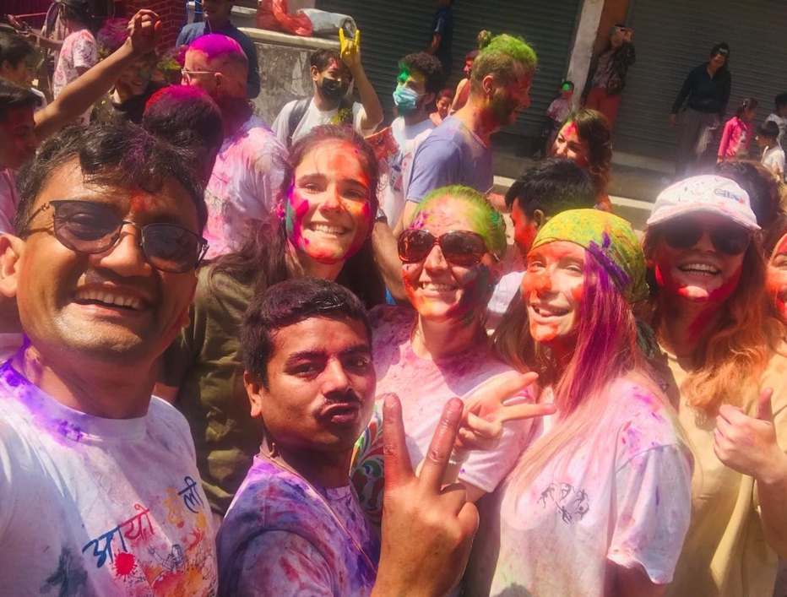
Immerse yourself in Nepal’s most joyous and colorful festival—Holi! This ancient Hindu celebration marks the arrival of spring and the triumph of good over evil. People throw colored powder and water, sing, dance, and share food. You’ll join the local community to:
- Plan and prepare for Holi festivities.
- Experience traditional Nepalese music, dance, and food.
- Spread positive energy while enjoying the playful fight with colors.

What Will You Do?
As a volunteer, you will:
- Lead interactive workshops on life skills, including public speaking, teamwork, and communication.
- Help local youth improve their confidence and problem-solving abilities.
- Participate in planning and celebrating the Holi Festival with the community.
- Share cultural experiences and build connections with local and international participants.

Where Is It?
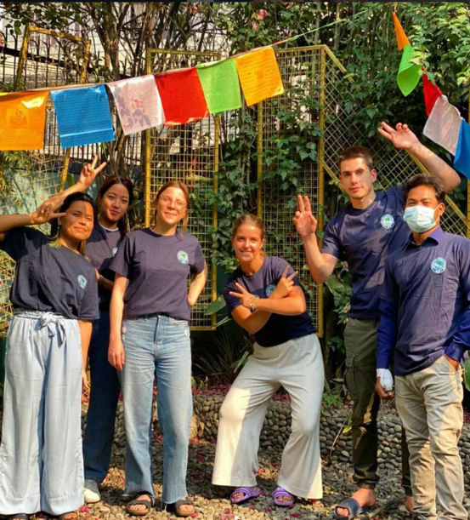
This camp is held in Jitpurphedi, a peaceful village in the Tarakeshwor Municipality near Kathmandu. It is surrounded by lush hills, fields, and woods and offers a serene and beautiful setting for work and cultural immersion.
Who Can Join?
Anyone aged 18+ who is:
- Passionate about empowering youth.
- Interested in cultural exchange and community building.
- Ready to have fun while making a difference?
Why Is Youth Empowerment Important?
Nepal’s youth make up nearly 41% of the population. Yet, many lack the skills to compete in the job market or become community leaders. Empowering them will create a brighter future for individuals and the entire nation.
Participation Fee
- 270 Euros, plus 30 Euros for transportation (payable upon arrival).
This includes:
- Accommodation and meals during your stay.
- Orientation, training materials, and on-site support.

Project 6: PERMA LIFE Nepal Holi Festival – Festival of color.: Sustainable Farming and Cultural Colors in Nepal (ENVI, AGRI, MANU)
Code | Name of Project | Location | Date | Type | Total Vols. | Male | Female | Age
VINWC26-04 | PERMA LIFE Nepal Holi Festival – Festival of color. | Okhaldhunga | 26 Feb – 10 March 2026 | ENVI, AGRI, MANU, FESTIVE | 14 | 7 | 7 | 18+
VINWC26-09 | PERMA LIFE Nepal | Okhaldhunga | 12-24 May 2026 | ENVI, AGRI, MANU, | 14 | 7 | 7 | 18+
VINWC26-11 | PERMA LIFE Nepal | Okhaldhunga | 10-22 June 2026 | ENVI, AGRI, MANU | 14 | 7 | 7 | 18+
VINWC26-13 | PERMA LIFE Nepal | Okhaldhunga | 09-21 July 2026 | ENVI, AGRI, MANU | 14 | 7 | 7 | 18+
VINWC26-16 | PERMA LIFE Nepal | Okhaldhunga | 16 -28 July 2026 | ENVI, AGRI, MANU | 14 | 7 | 7 | 18+
VINWC26-24 | PERMA LIFE Nepal | Okhaldhunga | 06 – 19 Dec 2026 | ENVI, AGRI, MANU | 14 | 7 | 7 | 18+

Introduction: A Unique Blend of Sustainability and Culture
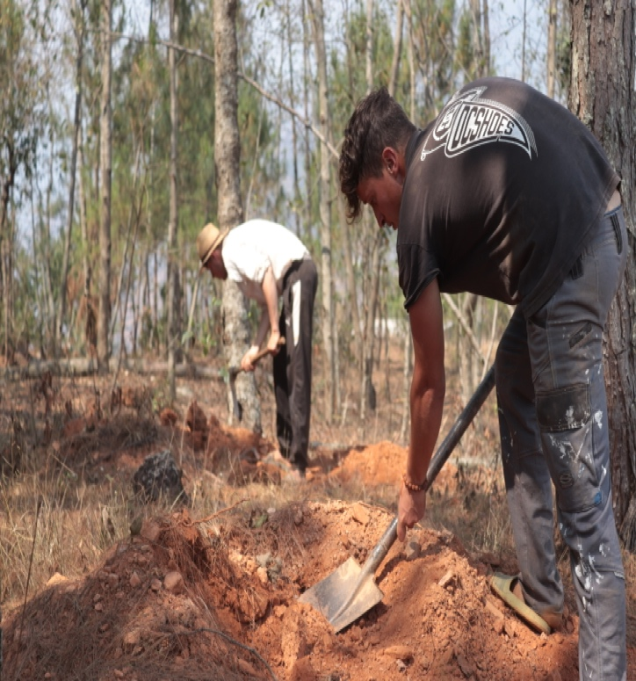
Embark on a transformative journey in the serene Himalayan foothills of Nepal. Participate in hands-on permaculture farming, learn sustainable agricultural practices, and celebrate the vibrant Holi Festival (March camp only) with the local community.
Whether passionate about environmental conservation, interested in cultural traditions, or simply looking to make a difference, this camp is your gateway to meaningful experiences and lasting impact.
Why Join This Camp?
- Support Sustainability: Contribute to sustainable farming practices using permaculture principles.
- Celebrate Culture: Immerse yourself in the joy and colors of Nepal’s iconic Holi Festival (March camp).
- Hands-On Learning: Gain practical skills in eco-friendly farming and organic composting.
- Explore Nature: Discover the beauty of Nepal’s hilly landscapes and community life.
- Make a Difference: Empower local farmers while fostering connections with people worldwide.
Part I: PERMA LIFE – Sustainable Food Production

What is Permaculture?
Permaculture is a sustainable farming approach that integrates agricultural ecosystems with natural processes. By applying 12 permaculture principles, we can restore the environment and empower communities for a resilient future.
Why Nepal?
Nepal’s agricultural sector supports 80% of the population, contributing nearly 39% of the GDP. However, farmers face challenges from climate change, including drying water sources, new pests, shifting crop cycles, and unpredictable weather.
At this camp, volunteers will work directly with local farmers trained by Volunteers Initiative Nepal (VIN) to address these challenges using sustainable practices.
What you will do:
- Farm Design: Plan and structure farms following permaculture principles.
- Cultivate Crops: Engage in planting, weeding, irrigating, and harvesting.
- Organic Composting: Assist in creating eco-friendly fertilizers.
- Observe and Interact: Learn by doing and sharing knowledge with local farmers.
Part II: Holi Festival – Festival of color (March Camp Only)
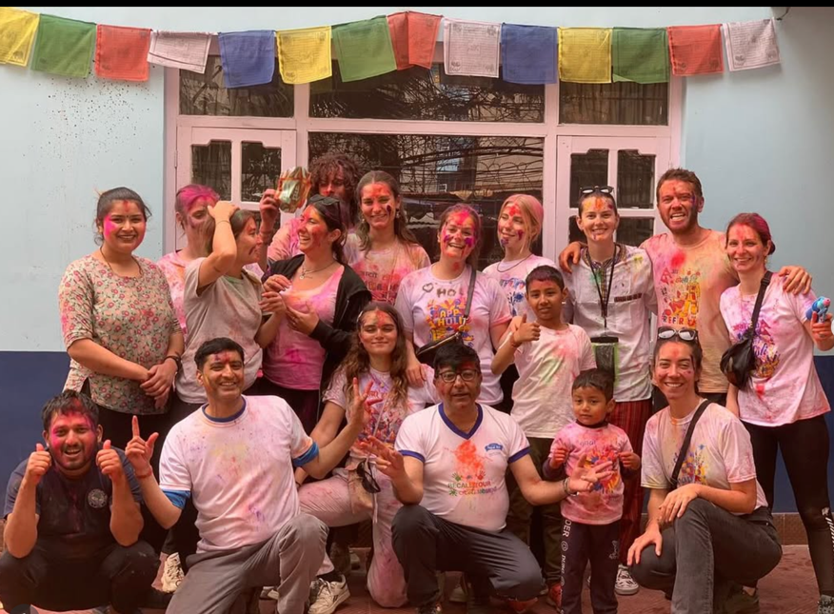
What is Holi?
Holi, known as the Festival of Colors, is one of Nepal’s most vibrant celebrations. It marks the victory of good over evil, the arrival of spring, and gratitude for a good harvest.

Highlights of the Holi Celebration:
- Color and Joy: Throw colored powders and water as a gesture of goodwill and joy.
- Music and Dance: Join the locals singing, dancing, and celebrating in open spaces.
- Cultural Immersion: Learn the cultural and historical significance of this age-old festival.
- Food and Fun: Share festive delicacies and forge meaningful connections.
Location Details:
Siddhicharan Municipality, Ward 2, Nisankhe
- Nestled in Okhaldhunga district, about 250 km from Kathmandu.
- Accessible via local jeep (8–10 hours).
- Scenic hills, fertile farmland, and dense forests surround it.
For more details about the region, visit www.ntchc.org.
Participation Fee
- 270 Euros + 100 Euros transportation cost
- The fee covers accommodation, meals, and project materials.
- Payable upon arrival at the VIN Office in Kathmandu.

How to Apply
- Submit your completed Volunteer Exchange Form (VEF) through your sending organization.
- Receive approval and a detailed info sheet with an acceptance letter from VIN.
FAQs
1. Do I need prior experience in farming?
No prior experience is necessary! Training and guidance will be provided.
2. Can I join without attending the Holi Festival?
Yes, you can choose a camp outside March to focus solely on permaculture activities.
3. What should I bring?
Comfortable work clothes, sturdy shoes, gloves, sunscreen, and festive attire (for Holi).

Experience, Impact, and Memories Await!

Join us in Nisankhe, Okhaldhunga, for a rewarding sustainable farming experience and cultural exploration. Create a meaningful impact, make new friends, and bring back cherished memories of Nepal’s rich traditions and natural beauty.

Project 7: Children’s Summer Camp (KIDS, EDU, SPOR & CULT)

Code | Name of Project | Location | Date | Type | Total Vols. | Male | Female | Age
VINWC26-12 | Children’s Summer Camp | Okhaldhunga | 09-21 July 2026 | KIDS, EDU, SPOR & CULT | 14 | 7 | 7 | 18+
VINWC26-15 | Children’s Summer Camp | Okhaldhunga | 16 -28 July 2026 | KIDS, EDU, SPOR & CULT | 16 | 8 | 8 | 18+

Children’s Camp in Nepal: A Unique Adventure of Fun, Learning, and Cultural Exchange
Are you ready for an incredible adventure in the heart of Nepal? Join the Children’s Camp in Okhaldhunga and be part of a transformative experience for you and the children. This camp offers a perfect blend of creativity, learning, and cultural exchange that will leave lasting memories.
About the Project
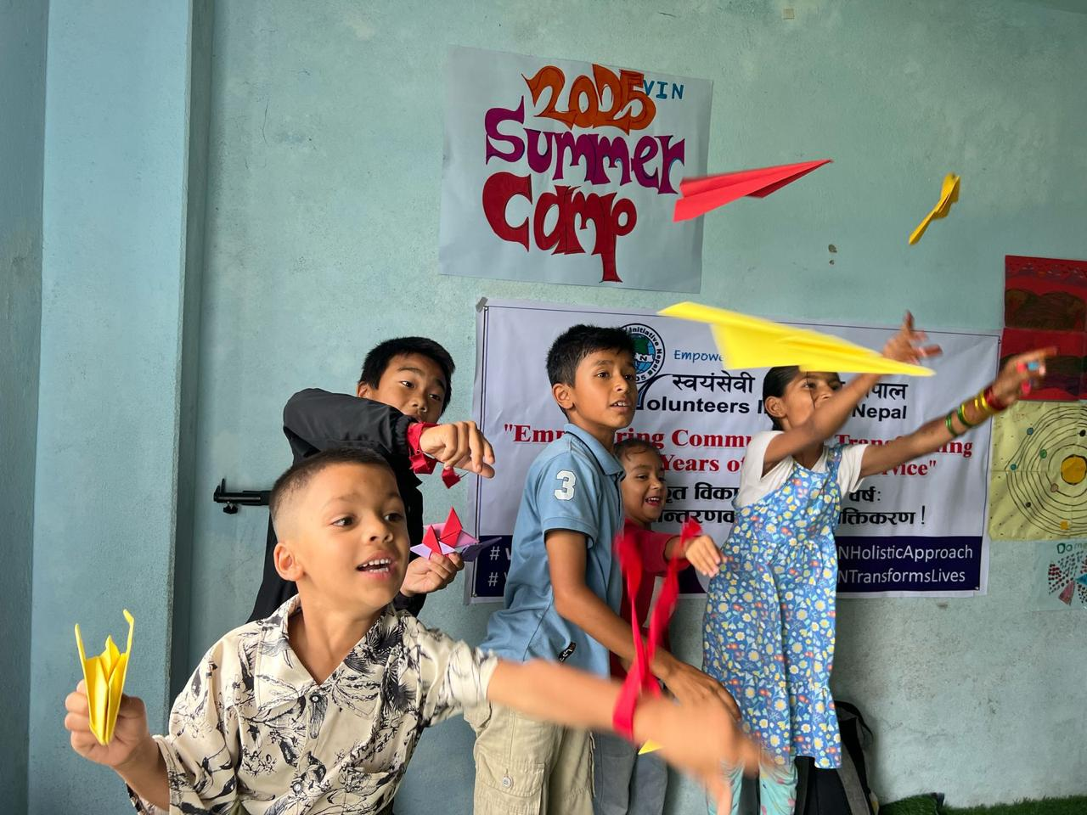
In Nepal, many children cannot explore their creativity or develop key life skills due to limited resources and a school system focused mainly on exams. Parents, often working long hours, can’t always provide the space for children to express themselves freely.
That’s where this camp comes in! Organized by Volunteers Initiative Nepal (VIN), this program gives children aged 5-12 the opportunity to learn, grow, and develop in a supportive, fun environment.
The Goal of the Camp:
- Promote overall development: Focus on social, emotional, physical, and creative growth.
- Foster connections: Build friendships between local and international volunteers, bridging cultural gaps.
- Cultural immersion: Allow participants to experience Nepal’s vibrant culture and traditions.
This project is part of VIN’s more significant effort to improve children's rights and access to quality education in rural Nepal, especially in the Okhaldhunga district.

What Makes This Camp Special?

1. A Creative and Safe Space for Children
The camp helps children discover their talents through art, music, and physical activities, allowing them to thrive beyond traditional schoolwork.
2. Cultural Exchange
From traditional dances to local crafts, participants can experience Nepalese culture firsthand, creating bonds with the children and local communities.
3. A Beautiful Location
Nestled in the hilly terrain of Okhaldhunga, the camp’s location offers a serene and peaceful environment perfect for outdoor activities and reflection.
Activities You’ll Facilitate

Morning Energizers
- Physical Fitness: Start the day with yoga, stretching, and simple exercises.
- Sports Fun: Football, volleyball, tug-of-war, and more, helping kids build teamwork and physical endurance.
Creative Workshops
- Art and Crafts: Kids will create drawings, paintings, origami, and other crafts that spark their imagination.
- Performing Arts: Drama, dance, singing, and music sessions to build confidence and encourage self-expression.
Outdoor Adventures
- Nature Walks: Take the children on hikes through the beautiful hills and forests of Okhaldhunga, teaching them about the environment.
Language Learning
- Help kids improve their communication skills by teaching simple English phrases and basic vocabulary.
Team Building and Games
- Organize games that promote social skills, leadership, and teamwork.
Location
The camp is located in Siddhicharan Municipality, Ward 2, Nisankhe, in the Okhaldhunga district, about 250 km from Kathmandu.
- Travel time: 8–10 hours by local jeep.
- Setting: A peaceful, hilly region surrounded by lush forests and fertile fields, offering a unique and scenic environment for kids to play and learn.
Participation Fee
The fee for the camp is 270 Euros with an additional 100 Euros for transportation (payable upon arrival at the VIN Office). This fee covers:
- Accommodation
- Meals
- Camp materials
- Local transport to the accommodation form Kathmandu-Okhaldhunga-Kathmandu
- Support from VIN staff
Important Note: If fewer than four participants register, the camp may be relocated to a nearby community near Kathmandu for better logistics.
What You’ll Gain
- Friendship: Make friends from all over the world while working alongside local volunteers.
- Cultural Immersion: Dive deep into Nepalese culture, from learning traditional dances to tasting local food.
- Personal Growth: Experience the joy of helping children and growing as a leader and volunteer.
- Adventure: Explore Nepal’s natural beauty and create unforgettable memories in a unique setting.
FAQs
1. Who can join the camp?
Anyone who loves working with children and is interested in learning about Nepal’s culture can join. No prior experience in teaching is required, just a passion for making a difference!
2. What happens if there are fewer than four participants?
If fewer than four people join, the camp will be held in a nearby community in the Kathmandu area.
How to Join?
- Fill out the Volunteer Exchange Form (VEF) with your sending organization.
- After submission, wait for the acceptance letter and detailed information sheet from VIN.
- Pack your bags and get ready for an exciting, meaningful journey!
Make a Difference in Nepal—Sign Up Today!

Project 8: Raising Peace Campaign (EDU, CULT)

Code | Name of Project | Location | Date | Type | Total Vols. | Male | Female | Age
VINWC26-21 | Raising Peace Campaign | Kathmandu | 27 Sep – 08 Oct 2026 | EDU, CULT | 14 | 7 | 7 | 18+

Join the Raising Peace Campaign: Say "NO" to Violence Against Women in Nepal

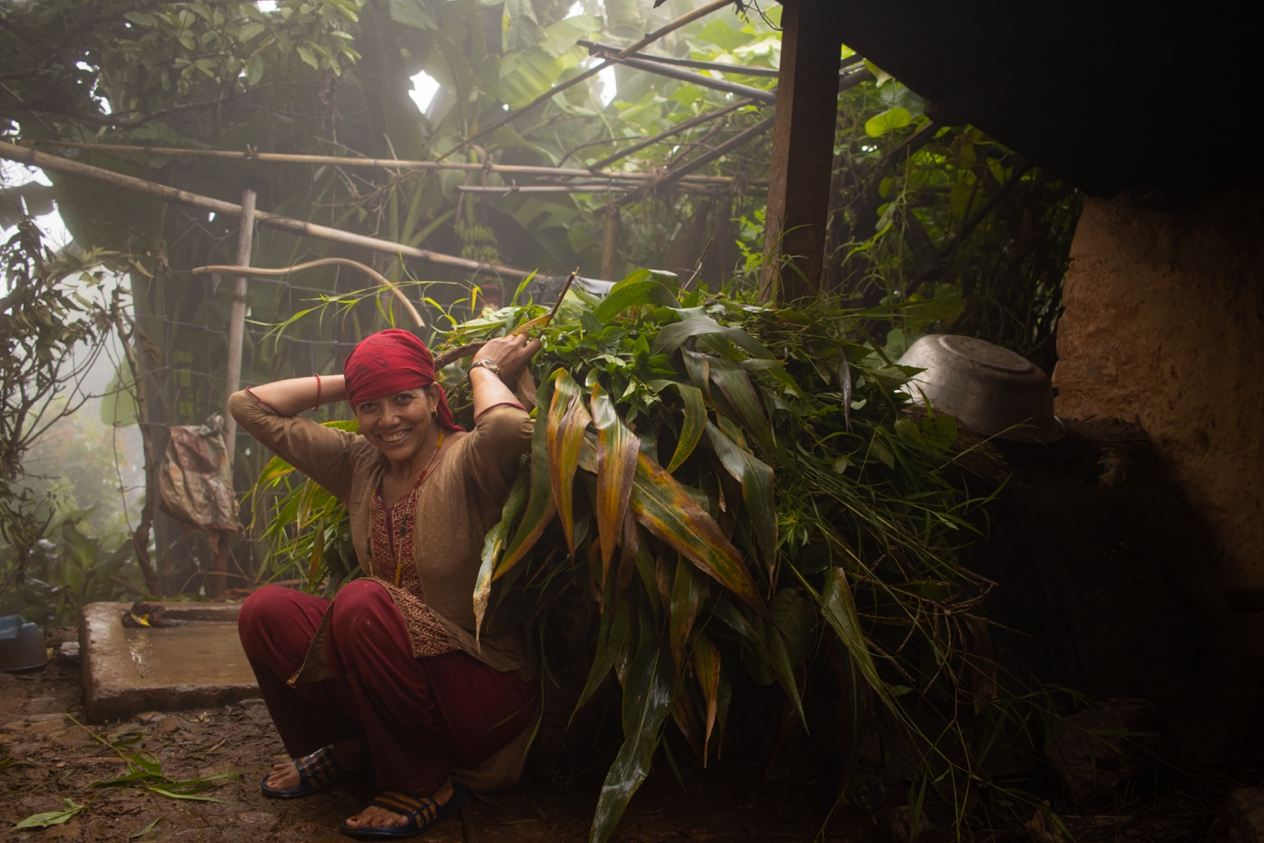
Do you believe in a world free of violence? You can help make that dream a reality by joining the Raising Peace Campaign in Nepal. This campaign is designed to raise awareness about the ongoing violence against women and girls in Nepali society and to empower local communities to take action.
About the Campaign
In Nepal, violence against women and girls remains a serious and often hidden problem. It is reported that one-third of married women face emotional, physical, or sexual violence from their spouses. Beyond this, thousands of girls and women are trafficked into forced labor or prostitution each year. Around 5,000 to 12,000 girls aged 10 to 20 are trafficked annually, with 75% of them being under 18 years old. Sadly, many of these women are forced into prostitution.
There are many forms of violence that women and girls face in Nepal, including:
- Sexual abuse, incest, and rape, often committed by family members.
- Trafficking and forced prostitution.
- Neglect that can even lead to death.
- Feticide and infanticide are often due to gender preference.
- Dowry demands and wife abuse.
This campaign will educate the community on human rights and violence against women, empowering them to make a stand for change.
What Makes This Campaign Special?

  - Powerful Awareness Campaigns: The campaign will deliver strong messages of empowerment, such as "Say 'NO' to Violence against Women through public drama performances." These performances will draw attention to the issue and spark conversation.

2. Interactive Public Forums: We will organize open forums in public spaces where community members can interact and discuss women’s violence, its problems, and its solutions. This space will allow open dialogue and learning and empower everyone to take action.

3. Education and Empowerment: We aim to educate both men and women about women's rights and help them understand how to implement these rights in their daily lives. We can foster lasting change by bringing human rights education directly to the community.

Objectives of the Campaign
- Raise Awareness: Spread awareness in the local community about violence against women and its damaging effects.
- Promote Women’s Rights: Educate people about women’s rights and how to implement and protect them at the local level actively.
- Empower the Community: Engage local leaders, teachers, women’s groups, and teenage girls to spread peace and equality.
Activities You’ll Be Part of
1. Awareness Sessions
We will conduct awareness sessions for both men and women to educate them about the different forms of violence women face and how everyone can help stop it.
2. Public Forums for Interaction
Organize interactive discussions in public spaces where community members can share their thoughts and ideas about women’s violence, the problems faced, and possible solutions.
3. Educational Material Development
Develop and distribute educational materials highlighting women’s rights and providing tools for fighting violence.
Location
This campaign will take place in Tarakeshwor Municipality, located just 10-15 km from Kathmandu. The area is surrounded by beautiful hills, fields, and forests, offering a peaceful backdrop for engaging with the local community.
Participation Fee
To join the Raising Peace Campaign, the participation fee is 270 Euros plus an additional 30 Euros for transportation. (payable upon arrival at the VIN Office). This fee covers:
- Accommodation during the campaign.
- Meals for the duration of your stay.
- Camp materials
Note: After submitting your Volunteer Exchange Form (VEF), you will receive an acceptance letter and further details about the campaign.

Why You Should Join
- Make a Real Impact: Help raise awareness about the crucial issue of violence against women and girls in Nepal.
- Cultural Exchange: Learn about Nepalese culture, traditions, and women's challenges in this beautiful country.
- Personal Growth: Become a voice for change and make a tangible difference in the lives of local women and girls.
- Community Empowerment: Empower local leaders and communities to take action and create a safer environment for women.

Who can participate in the campaign?
Anyone passionate about ending violence against women and girls is welcome to join, regardless of background. The campaign is open to international volunteers who want to make a meaningful impact.
Be Part of the Change!
Join the Raising Peace Campaign and help raise awareness about the importance of women’s rights and ending violence against women in Nepal. Through education, dialogue, and collective action, we can create lasting change and empower communities to protect women and girls. Sign up today and make a difference!

Project 9: Art & crafts with Children (ARTS, KIDS)

Code | Name of Project | Location | Date | Type | Total Vols. | Male | Female | Age
VINWC26-02 | Art and craft with children | Kathmandu | 10 -21 Feb 2026 | ARTS, KIDS, EDU | 14 | 7 | 7 | 18+
VINWC26-10 | Art and crafts with children | Kathmandu | 10-22 June 2026 | ARTS, KIDS, EDU | 14 | 7 | 7 | 18+
VINWC27-02 | Art and craft with children | Kathmandu | 09 -20 Feb 2027 | ARTS, KIDS, EDU | 14 | 7 | 7 | 18+

Art & Crafts with Children: A Creative Journey in Nepal

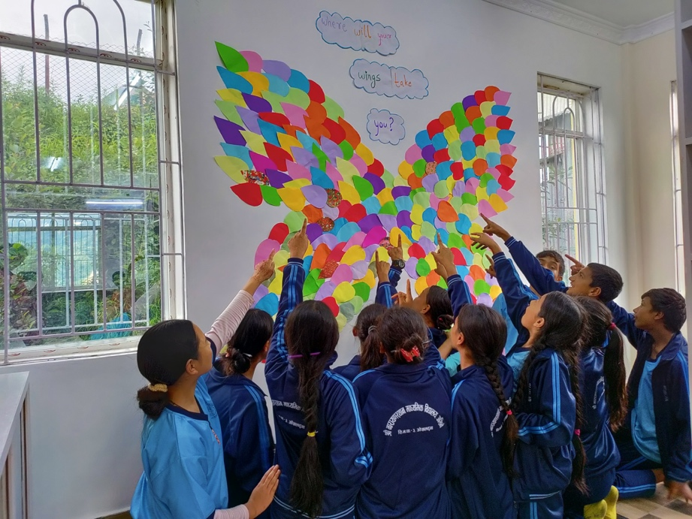
Are you passionate about creativity and want to make a difference in children’s lives? Join Nepal's Art & Crafts with Children program, where you will help inspire the next generation to express themselves through art. This project offers a unique opportunity to engage with local children and encourage creativity while experiencing Nepal's rich culture through the Program.
Art is more than painting on a canvas. It is a powerful tool for self-expression and personal growth. In this program, you will help children of all ages develop their creativity, improve their fine motor skills, and gain confidence as they engage in fun and educational art activities.
When children engage in arts and crafts, they create and develop skills that will benefit them throughout their lives. Whether painting, drawing, crafting, or dancing, art allows children to express their feelings, explore their imaginations, and build community connections.

What’s Special About This Program?
1. Creativity and Fun
Children love to get creative with art and crafts! Whether painting, drawing, or crafting, these activities provide a natural opportunity free play and self-expression. Creating something from scratch boosts children’s confidence and gives them a sense of achievement.
2. Development of Key Skills
Art and crafts support children's development in multiple areas, including:
- Fine motor skills through activities like painting, cutting, and shaping.
- Cognitive development by experimenting with colors, shapes, and materials.
- Emotional expression, as children can convey their feelings through art, which helps them feel calmer and more confident.
3. Cultural Exchange
As a volunteer, you’ll teach arts and crafts from your cultural perspective while learning about Nepal's unique artistic traditions. You will also have able exchange ideas, learn from the local community, and create a cross-cultural bond that will enrich you and the children.
Objectives of the Program
- Develop Creativity: Encourage children to express themselves through arts and crafts, helping them to think creatively and build problem-solving skills.
- Promote Friendship and Solidarity: Foster understanding and collaboration between local young volunteers and cross-national volunteers, promoting cultural exchange and unity.
Program Activities

1. Art Sessions
Develop and lead fun, creative sessions where children can:
- Draw, paint, and create crafts based on themes or their interests.
- Express themselves artistically, exploring their emotions and ideas.
2. Craft Projects
Organize activities like:
- Origami: Teaching children the art of paper folding to create animals, shapes, and other crafts.
- Collage Making: Using materials like paper, fabric, and other creative items to create colorful collages.
- Dance and Music: Engage children in the art of movement, dance, and creating rhythms to enhance their creativity and physical expression.
Location
The program takes place in Tarakeshwor Municipality, about 10-12 km from the main ring road to Balaju, Kathmandu. Stunning hills, fields, and woods, providing a peaceful and inspiring environment, surround the area.
Participation Fee
To participate in the Art & Crafts with Children program, the participation fee is 270 Euros plus 30 Euros for transportation. This fee covers:
- Accommodation during your stay.
- Meals for the duration of your program.
- Materials and supplies for arts and crafts sessions.
Payment is due upon your arrival at the VIN Office.
Why You Should Join
- Make a Lasting Impact: By helping children develop their creativity, you will empower them to express themselves and build their confidence.
- Cultural Immersion: Experience the vibrant culture of Nepal while contributing to meaningful community development.
- Personal Growth: Gain valuable skills in teaching, art, and cross-cultural communication while making a difference in the lives of children.
- Develop Connections: Build lasting relationships with children, local volunteers, and other international participants.
Make a Creative Difference in Nepal
FAQs
1. Who can join this program?
The program is open to all volunteers who are passionate about art and want to work with children. No prior experience in teaching or the arts is required—just an enthusiasm for creativity and a willingness to share your skills.
2. What should I bring with me?
Please bring comfortable clothes suitable for working with children and any personal items you need. If you have art supplies, please bring them, although basic materials will be provided.
3. How do I sign up?
To join, complete the Volunteer Exchange Form (VEF) and submit it to the organization you are sending it to. Once we receive it, we will send you an acceptance letter and additional details.
Join the Art & Crafts with Children program and help inspire creativity in the hearts of children in Nepal. We can build confidence, develop essential skills, and connect across cultures through art. Sign up today and share your passion for creativity with the next generation!

Project 10: Library & Festive Camp (EDU, SOCI, FESTIV MANU)

Code | Name of Project | Location | Date | Type | Total Vols. | Male | Female | Age
VINWC26-19 | Library  & Festive Camp | Kathmandu | 03 - 15 September 2026 | EDU, SOCI, KIDS, MANU, CULT | 14 | 7 | 7 | 18+

Library & Festive Camp Project: A Cultural and Educational Experience in Nepal
Are you ready for an enriching volunteer experience that combines education, culture, and community? Join the Library & Festive Camp Project in Nepal, where you will engage with local children in the Jitpurphedi community, located just outside Kathmandu. Through this unique opportunity, you will help improve literacy, promote cultural exchange, and celebrate one of Nepal’s most cherished festivals.
Part I: Library Camp

About the Library Project
Libraries are essential spaces for learning, growth, and self-expression. Unfortunately, many schools in Nepal lack properly managed libraries and the resources necessary to develop students' reading and writing skills. Through this project, we aim to improve library facilities and educate children and teachers about effectively using libraries for learning.
The Library Camp will be organized in partnership with local schools. Volunteers will assist with creating and managing library spaces. You will be directly involved in maintaining the library, organizing materials, and facilitating activities that engage students with its resources.
Objectives
- Work to improve the library management system in schools and promote its use among children and teachers.
- Help children develop their reading and writing skills.
- Encourage students to enjoy learning through creative and interactive library-based activities.
Key Activities
- Library Maintenance: Clean, organize, and maintain library spaces to create a welcoming and functional learning environment.
- Resource Organization: Sort and catalog books and other materials in a proper order for easy access.
- Room Decoration: Paint and decorate the library room to make it more appealing and engaging for children.
- Library Training: Conduct training sessions for children and teachers to ensure effective library use. This includes teaching them how to find books, use library resources, and maintain the library.
- Reading & Writing Activities: Organize reading and writing activities involving children in creatively using library resources.
- Library Promotion: Plan and execute campaigns to raise awareness about the importance of libraries and encourage their regular use.
Desired Volunteer Skills
Volunteers with skills in arts and crafts, sports, music, dance, drama, or experience working with children are highly encouraged to apply. Your creativity and enthusiasm will be key to making the library an engaging and educational space for children.

Part II: Festive Camp - Teej Celebration

About Teej Festival
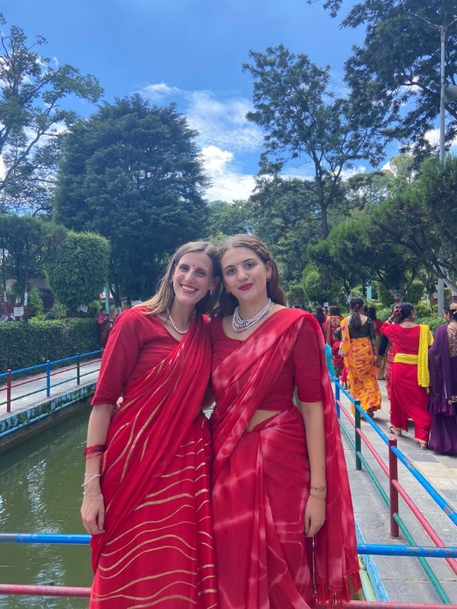
Teej is a significant cultural festival celebrated by Nepali women. It symbolizes marital happiness and well-being, marked by vibrant celebrations that include fasting, feasting, singing, dancing, and various rituals. Married women celebrate Teej to ensure their husbands’ health and longevity while seeking purification for a good life.
In the Festive Camp, volunteers will participate in the Teej celebration in the Jitpurphedi community. Women wear traditional red sarees, sing folk songs, and dance energetically during this event. You will have the chance to interact with the local women during these festivities and experience Nepali culture firsthand.
Objectives
- Understand the importance of the Teej festival in Nepali culture and how it is celebrated.
- Participate in the cultural exchange, gaining insight into Nepali traditions while sharing your own.
- Celebrate the festival with local women and take part in the joyous festivities.
Key Activities
- Celebrate Teej with Local Women: Join the community in celebrating Teej, dancing, singing, and sharing in the festivities with local women.
- Cultural Exchange: Engage in cultural activities that allow you to exchange traditions and learn about the significance of Teej, including rituals and artistic practices.
- Dance Participation: Dance with the local women, joining them in their traditional celebrations and helping create a fun, collaborative atmosphere.
Teej Festival Overview
- Dar Khane Din: a grand feast marks the first day of Teej, during which women gather to enjoy a special meal.
- Primary Fasting Day: Women often fast without food or water, but some consume liquids and fruit on the second day.
- Rituals of Purification: On the third day, women perform rituals, including the critical puja, and consume solid food after the ceremony.
- Rishi Panchami: The final day involves purifying mud from the sacred Datiwan bush, after which women are forgiven for their sins.
Location
The project location is in Tarakeshwor Municipality, about 10-12 km from the main ring road to Balaju, Kathmandu. Beautiful hills, fields, and forests, offering a peaceful backdrop for community engagement and cultural exchange, surround the area.
Participation Fee
To participate in the Library & Festive Camp project, the participation fee is 270 Euros, plus an additional 30 Euros for transportation. This fee covers:
- Accommodation during your stay.
- Meals for the duration of your program.
- Transportation to and from the project site.
- Materials for library and festival activities.
Payment is due upon arrival at the VIN Office.
Note: You will receive a detailed information sheet and an acceptance letter after submitting your Complete Volunteer Exchange Form (VEF).

Why You Should Join
- Cultural Immersion: Engage deeply with Nepali culture by participating in the Teej festival and learning about traditional customs.
- Educational Impact: Help improve literacy and library skills in local schools, impacting children’s education.
- Community Engagement: Work alongside local teachers and community members, fostering vigorous cultural exchanges.
- Unique Experience: Experience vibrant celebrations and fun educational activities in the heart of Nepal and create lasting memories.
FAQs
1. Who can join this program?
The program invites volunteers for winter testing in education, culture, and community development. This program will be unique if you have experience working with children, teaching arts and crafts, or participating in cultural exchange.
2. What should I bring with me?
Please bring comfortable clothing for working with children and participating in cultural activities. Also, if you have personal items or art materials, please bring them. Basic materials for the library and activities will be provided.
3. How do I sign up?
To join, complete the Volunteer Exchange Form (VEF) and submit it to the organization you are sending. After that, you will receive an acceptance letter with more details.
Make a Difference in Nepal!
Join the Library & Festive Camp Project to share your passion for education and culture while experiencing the warmth and beauty of Nepali traditions. Sign up today and help create lasting change in the lives of children and women in the Jitpurphedi community!

Project 11: Creative Classrooms: Enhancing Schools and Inspiring Young Minds & Festive Camp (KIDS, EDU CULT)

Code | Name of Project | Location | Date | Type | Total Vols. | Male | Female | Age
VINWC26-20 | Creative Classrooms: Enhancing Schools and Inspiring Young Minds & Festive Camp | Okhaldhunga | 03 - 15 September 2026 | KIDS, CULT | 14 | 7 | 7 | 18+

Creative Classrooms & Festive Celebration: Volunteer Abroad in Nepal and Make a Difference
Are you looking for an exciting opportunity to volunteer abroad? Join us at the Creative Classrooms work camp in Nepal, where you’ll help enhance schools and inspire young minds. In addition, you’ll experience a unique cultural exchange while celebrating Teej, one of Nepal’s most vibrant festivals. This work camp is your chance to make a meaningful impact while immersing yourself in Nepal's rich traditions.
Why Volunteer in Nepal?
Nepal has stunning landscapes, a rich culture, and warm-hearted people. However, it also faces challenges, especially in rural areas like Okhaldhunga. Many schools in this region lack essential resources, and children from disadvantaged communities often miss a quality education. That’s where you come in!
By volunteering with VIN (Volunteers Initiative Nepal), you will directly contribute to community service in Nepal by helping improve educational facilities and teaching children in creative, fun ways. In this work camp, you will help create a child-friendly learning environment while gaining a deep understanding of Nepali culture and traditions.
Part I: Creative Classrooms – Enhancing Schools and Inspiring Young Minds

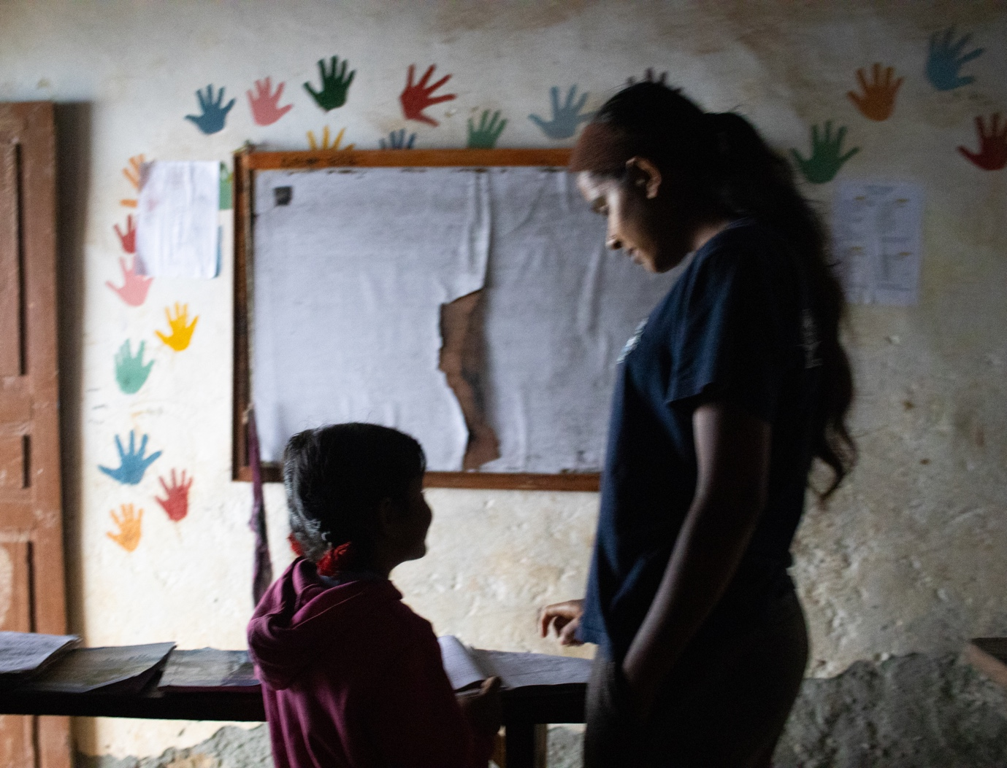
The Project Background:
Okhaldhunga, located in Nepal’s stunning Everest Region, is known for its natural beauty and cultural richness. However, due to its remote location, it faces challenges such as poor infrastructure and limited access to education. Schools in this region often lack proper classrooms, teaching materials, playgrounds, and even basic facilities like drinking water.
The Creative Classrooms Workcamp aims to change this. As a volunteer, you’ll help transform classrooms by painting and decorating them, renovating school areas, and creating an engaging space where children can learn and grow. Your efforts will make a real difference for children aged 6-12 from poor and marginalized communities.
What Will You Do?
- Classroom Renovation: You will help paint and decorate classrooms to make them more vibrant and welcoming.
- Creative Teaching: Volunteer to teach Basic English and Mathematics through fun activities like art, music, and games.
- Health & Hygiene Awareness: Educate children about the importance of health and hygiene using engaging methods.
- Environmental Protection: Teach kids about protecting the environment through fun, creative activities.
- Cultural Exchange: You will meet local families, engage in community activities, and learn about Nepal's culture while sharing your own.
Why it is Special:
- Hands-on Experience: You will actively help improve local schools and contribute to a lasting change.
- Creative Learning: Instead of traditional teaching methods, you will use art, music, and games to make learning fun and interactive.
- Community Impact: Your work will directly benefit children in need, helping them get the education they deserve.
- Cultural Exchange: By living and working with local people, you’ll experience real Nepal, build friendships, and gain a deeper understanding of its culture.
Part II: Festive Camp – Celebrate Nepal’s Teej Festival

Celebrate with the Locals:
One of the highlights of this work camp is the chance to experience Teej, a beautiful festival celebrated by Nepali women. Teej is all about love, devotion, and celebrating marriage. It’s a time when women come together to sing, dance, and share meals to honor marital happiness and good health.
What Will You Do?
- Teej Festival: Celebrate Teej with the local women, participate in traditional dances, and join in the fun and festivities.
- Cultural Exchange: Learn about Teej, its significance, and how it is celebrated across Nepal.
- Community Bonding: Build lasting connections with local women and gain a deeper understanding of Nepali culture.
Why it’s Special:
- Unique Cultural Immersion: Celebrating Teej with the locals is an experience you’ll never forget. It’s a chance to join in the merriment of one of Nepal’s most important festivals.
- Festive Spirit: Decked out in red sarees and bangles, the women of Nepal create a colorful and lively atmosphere. You’ll be part of something truly special.
- Memorable Experiences: Participate in cultural rituals, share stories, and enjoy authentic Nepali food and music.
Location: Siddhicharan Municipality – The Heart of Okhaldhunga
Our work camp is in Siddhicharan Municipality, nestled in the beautiful Okhaldhunga district, with stunning hills and fertile fields surrounding this remote area. The region is famous for its natural beauty and faces numerous challenges due to its isolation. Volunteers in this area can significantly impact local education and community life.
Participation Fee:
Participation fee is 270 Euros plus an additional 100 Euros for transportation to cover your travel expenses to the remote location.
What’s Included:
- Accommodation and meals during the camp.
- Support from the VIN team.
Frequently Asked Questions about Volunteering in Nepal:

1. What is volunteering in Nepal like?
Volunteering in Nepal offers a chance to immerse yourself in local culture while making a tangible impact. You’ll engage in community service, help improve local schools, and learn about Nepali traditions.
2. Do I need teaching experience to volunteer in the Creative Classrooms camp?
No! While some teaching experience is helpful, it’s not necessary. The focus is on making learning fun through creative activities. Your enthusiasm and willingness to learn will be enough to inspire the kids.
3. What’s the cultural exchange like in Nepal?
Cultural exchange in Nepal is a rich and rewarding experience. You’ll meet local families, learn about Nepali traditions, and share your own culture in return. Festivals like Teej offer a unique way to connect with the local community.
4. How can I prepare for my volunteering experience in Nepal?
It’s helpful to learn a bit about Nepali culture, basic Nepali phrases, and the challenges of rural life. Being open-minded, patient, and respectful of local customs will help you get the most out of your experience.
- A chance to contribute to a meaningful cause.
Join the Creative Classrooms & Festive Camp Today!
Are you ready to make a difference and experience the true essence of Nepal? Whether you’re excited to volunteer abroad, positively impact education, or engage in cultural exchange, this work camp has it all. Don’t miss the opportunity to help transform schools, teach children, and celebrate the Teej festival with the vibrant community in Okhaldhunga.

Project 12: Health and Wellness (HEALTH, EDU)

Code | Name of Project | Location | Date | Type | Total Vols. | Male | Female | Age
VINWC26-14 | Health and Wellness | Kathmandu | 09 -20 July 2026 | ARTS, KIDS, EDU | 14 | 7 | 7 | 18+

Health and Wellness Workcamp: Volunteer Abroad to Transform Communities in Nepal
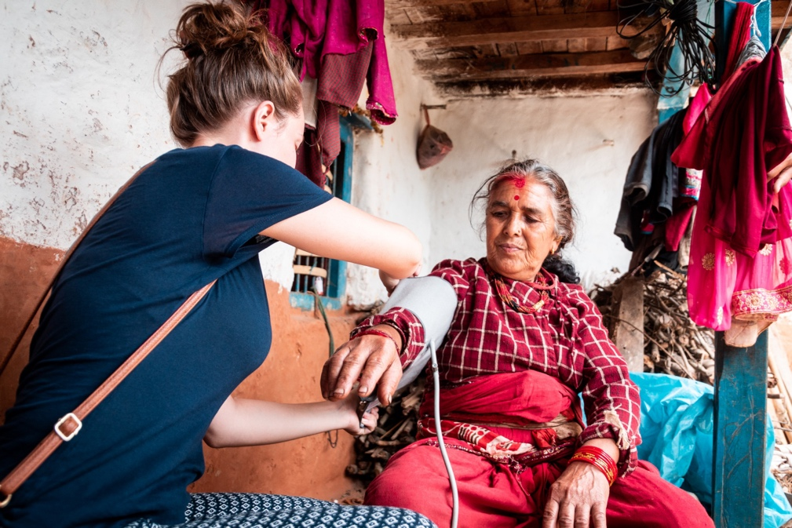
Are you ready to positively impact a community's health and wellness? Join us for the Health and Wellness Workcamp in Nepal, where you will help raise awareness about hygiene, sanitation, and healthy living in rural areas. This work camp allows you to volunteer abroad and contribute to lasting change in the lives of many while experiencing Nepal’s rich culture and breathtaking landscapes.

Why Nepal Needs Your Help:
Nepal faces significant challenges in public health, with over 25% of its population living below the poverty line. Many rural communities lack access to clean water, proper sanitation, and adequate hygiene practices. Approximately 20% of Nepal’s population does not have access to safe drinking water, and only a tiny percentage of households have adequate sanitation. This situation leaves the population vulnerable to health risks, especially children, who suffer the most from waterborne diseases and malnutrition.
By volunteering for this workcamp, you’ll directly contribute to improving public health by raising awareness of WASH (Water, Sanitation, and Hygiene) practices, providing education on disease prevention, and supporting the development of more resilient communities.
What Will You Do in the Health and Wellness Workcamp?

Educating Communities About Safe Health Practices
The main objective of this workcamp is to disseminate knowledge about sanitation, hygiene, and health to the local community. You will collaborate closely with residents, particularly youth and children, to help them grasp the significance of clean water and proper sanitation.
- Raise Awareness About WASH Standards: You will educate people in rural areas about safe water practices and the prevention of waterborne diseases.
- Promote Healthy Hygiene Habits Help communities understand the importance of personal hygiene, like handwashing and using clean drinking water.
- Organize Cleanliness Drives: You will participate in or lead clean-up campaigns in schools and neighborhoods to promote a cleaner, healthier environment.
- Employ Creative Tools for Education: Volunteers will utilize enjoyable and inventive methods to educate the community. You can design posters, banners, and videos to convey vital health messages. Slogans, images, and educational resources will further engage individuals and enhance awareness.
Innovative Solutions for Local Challenges
You are invited to share innovative ideas and solutions to address local health and wellness challenges. Whether you are developing new educational materials or planning a workshop, your contributions will foster lasting change in the community.
Where Will You Work?
The Health and Wellness Workcamp occurs in Jitpurphedi, a Tarakeshwor Municipality community near Kathmandu. It is about 10-12 km from Kathmandu’s main ring road.
This village, surrounded by stunning hills, fields, and forests, provides a tranquil setting to engage with locals and enhance their lives. You will fully immerse yourself in the rural lifestyle of Nepal while supporting its social development. It is an excellent opportunity to experience Nepal’s natural beauty while making a meaningful impact.
A Unique Volunteering Experience
- Cultural Exchange: You’ll experience the daily life of a Nepali village and share your own culture and experiences with the locals.
- Community Impact: Your work will directly improve the health and wellness of the people in Jitpurphedi and beyond.
- Personal Growth: Working in a rural environment will challenge you and foster your personal development as you make new friends and acquire valuable skills.
Participation Fee
The participation fee for the Health and Wellness Workcamp is 270 Euros (plus an additional 30 Euros for transportation).
This covers:
- Accommodation in a local guesthouse or with a host family.
- Meals during your stay.
- Transportation to and from the work camp location.
- Ongoing support from the VIN team.
What is Not Included?
You will need to cover your personal expenses and travel costs to Nepal. However, the VIN team will guide you through the process and help you with any necessary preparations.
Join the Health and Wellness Workcamp Today!
This work camp is for you if you want to make a difference, experience a new culture, and help improve health and wellness in a rural Nepali community. Volunteering in Nepal will be a life-changing experience for you and the people you will help.

Project 13: Celebrate the Power of Volunteering: Join Us for International Volunteer Day in Nepal!" (MANU, EDU)

Code | Name of Project | Location | Date | Type | Total Vols. | Male | Female | Age
VINWC26-23 | Celebrate the Power of Volunteering | Kathmandu | 25 Nov – 6 Dec 2026 | MANU, EDU, FESTIV | 14 | 7 | 7 | 18+

Celebrate International Volunteer Day in Nepal: A Workcamp to Recognize Volunteers and Foster Community Impact
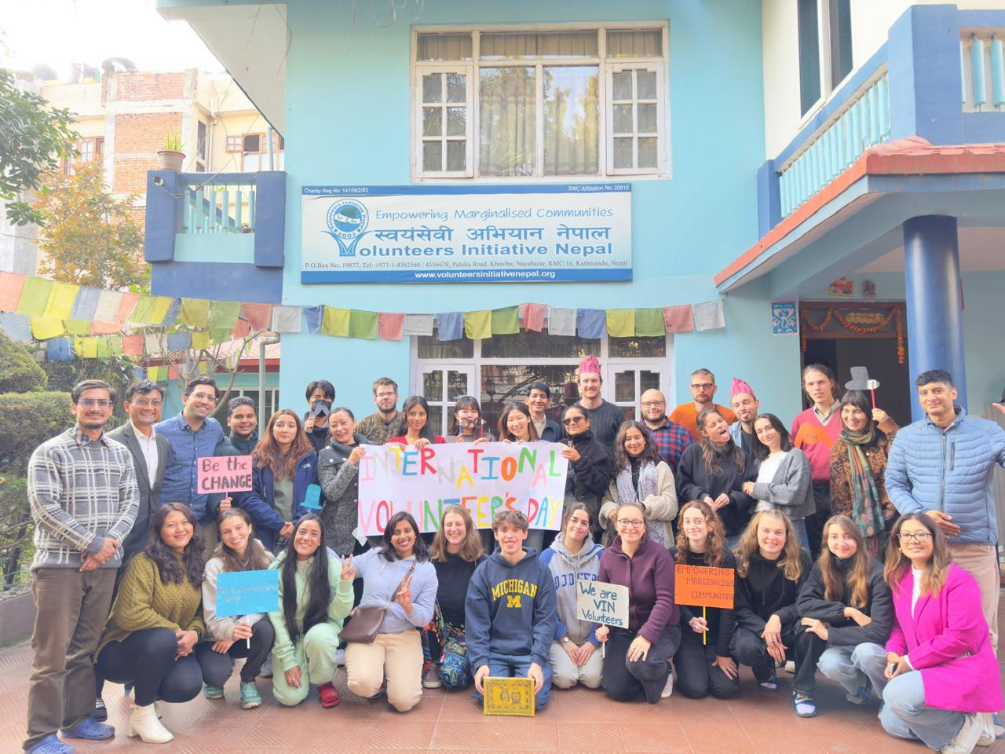
Volunteering is powerful! It can change lives and shape communities for the better. Join us in Nepal to celebrate International Volunteer Day, where you will be part of a vibrant event that honors volunteers and their incredible contributions to community development. By joining this work camp, you will help recognize the hard work of local and international volunteers and raise awareness about the importance of volunteerism in making a social impact.
Why International Volunteer Day Matters
Every year, volunteers from all around the world come together to celebrate their dedication to improving communities. The United Nations created International Volunteer Day (IVD) to honor volunteers and highlight their contributions to global development. It’s a day to raise awareness about the power of volunteerism and how it can drive positive change in communities.
In Nepal, where many communities face limited resources and access to education and healthcare, the role of volunteers is even more crucial. Volunteers contribute to community-driven development projects.
What You Will Do

Raise Awareness about Volunteerism
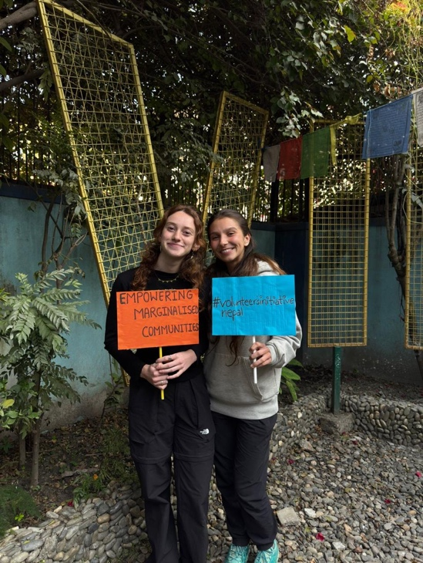
During this work camp, you will help spread the word about how vital volunteerism is for social development. You will have the chance to give a presentation on volunteerism, explaining why it’s critical for communities, especially in rural areas. Volunteers are often the backbone of many projects that aim to improve health, education, and the environment.
Plan and Celebrate International Volunteer Day
Next, you will play a key role in organizing the International Volunteer Day celebrations. You will work with a team of international and national volunteers to plan an unforgettable day full of meaningful activities.
- Create Fun and Engaging Activities: You will plan exciting games, quizzes, and fun arts activities. These activities will highlight the role of volunteers and create a sense of community among all participants.
- Celebrate with the Community: Organize local celebrations, such as performances, art exhibitions, and games that reflect the spirit of volunteering.
Connect with Local and International Volunteers
This event brings together people from different cultures and backgrounds to celebrate the power of volunteering. You will work with local Nepalese volunteers and international volunteers who have traveled to Nepal to make a difference. Together, you will share stories, experiences, and ideas about how volunteerism has helped improve the world.
Project location:
This exciting work camp will take place in 10-15 km from Kathmandu) a peaceful community in Tarakeshwor Municipality on the outskirts of Kathmandu. Surrounded by beautiful hills, fields, and woodlands, the site allows youth to connect with nature while you work.
Why Should You Join?

Celebrate Volunteerism in Nepal
This work camp is a unique opportunity to celebrate the spirit of volunteering and contribute to a cause that positively impacts Nepali communities. By participating in this event, you will help show how volunteering drives change and how it is a key tool for community development.
Learn About Nepali Culture
You will also experience the country’s rich culture by volunteering in Nepal. You will connect with local people, share stories, and work together to celebrate International Volunteer Day. This experience will enrich your understanding of volunteerism and the local communities in Nepal.

How to Participate
To join this work camp, there is a participation fee of 270 Euros (plus 30 Euros for transportation). This fee covers:
- Accommodation in a local guesthouse or with a host family.
- Meals during your stay.
- Transportation to and from the work camp location.
Frequently Asked Questions

1. Do I need prior volunteer experience to join this workcamp?
No experience is necessary! This workcamp is open to all volunteers who are passionate about helping others and celebrating the role of volunteerism. The VIN team will provide support and guidance during your time in Nepal.
2. What kind of activities will I be involved in?
You will help organize the International Volunteer Day celebrations by planning fun games, arts and crafts, quizzes, and educational presentations. You will also work with other volunteers to celebrate the day and raise awareness about the importance of volunteering.
3. Is volunteering in Nepal safe?
Yes! Nepal is a safe destination for volunteers. The VIN team ensures you are well-prepared and supported throughout your stay. You will also experience Nepali culture in a safe and welcoming environment.
4. What are the benefits of volunteering in Nepal?
Volunteering in Nepal is a rewarding experience. You will make a tangible impact on the community, learn about a different culture, and meet like-minded people. In addition, you will leave with memories and skills that will last a lifetime.
Join Us for International Volunteer Day!
If you’re passionate about volunteerism and want to celebrate the power of volunteers in Nepal, join us for this exciting workcamp. You’ll make a real difference while learning and growing as a volunteer. Do not miss this incredible opportunity to volunteer abroad and experience the joy of working together to create positive change.

Project 14 Sign and Smile- Deaf Children's Support Project (KIDS, EDU, CULT)

Code | Name of Project | Location | Date | Type | Total Vols. | Male | Female | Age
VINWC26-08 | Sign and Smile- Deaf Children's Support Project | Sindhuli | 12-24 May 2026 | KIDS, EDU, CULT | 14 | 7 | 7 | 18+
VINWC26-18 | Sign and Smile- Deaf Children's Support Project | Sindhuli | 12-23 August 2026 | KIDS, EDU, CULT | 14 | 7 | 7 | 18+
Sign & Smile – Deaf Children Support Project
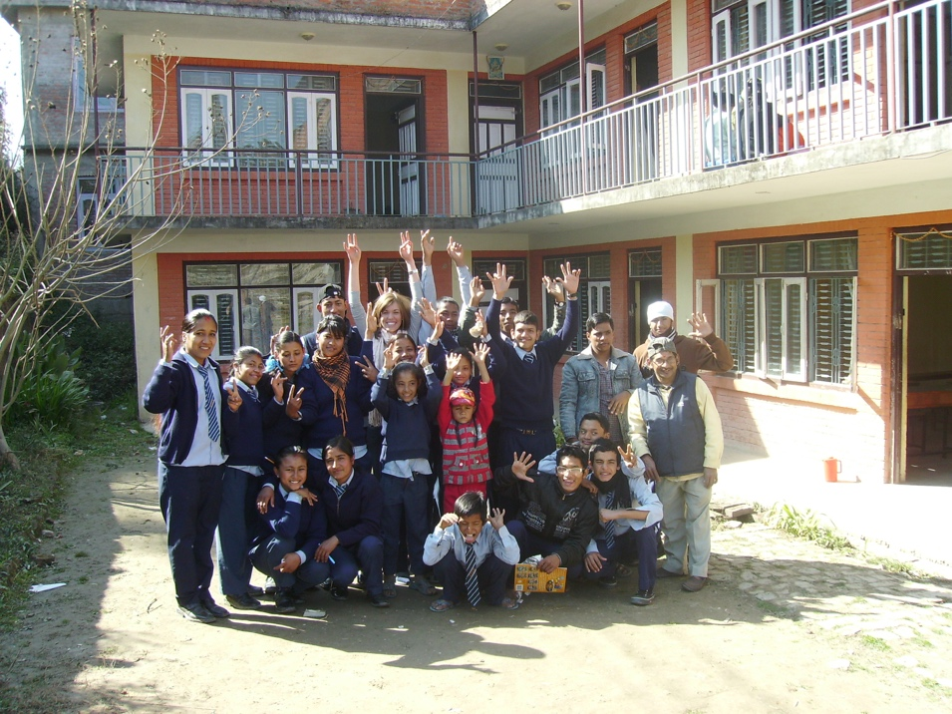
Teaching and Supporting Deaf Children in Nepal
Deaf children deserve equal opportunities to learn, express themselves, and grow with confidence. The Sign & Smile – Deaf Children Support Project invites international volunteers to take part in a meaningful learning and cultural exchange experience while supporting deaf children in rural Nepal.
By joining this workcamp, you will help create a child-friendly learning environment, support teachers, and engage in fun, educational, and developmental activities with deaf students.
Why the Sign & Smile Project Matters
Shree Navajyoti Deaf Secondary School, located in Kamalamai Municipality-6, Jasedamar, Sindhuli, is a special school for deaf children. Since its establishment in 2006, it has been offering essential education to students from different districts of the country.
The school currently has 205 students from Nursery to Grade 12 and is supported by around 20 dedicated teachers and staff. Because many students come from distant districts, the school also provides hostel facilities to ensure they have a safe place to stay while studying.
Volunteers play an important role in strengthening the school’s mission. They can support classroom learning, assist teachers in daily activities, and help create a more engaging and inclusive school environment for deaf children.
What You Will Do
1. Engage in Fun, Educational, and Creative Learning
- You will conduct interactive sessions and activities that support the holistic development of deaf children. Activities may include:
- Sharing stories through visual and expressive methods
- Creative drawing and writing
- Personal health and hygiene awareness sessions
- Teaching basic English and Mathematics
- Organizing sports, games, art, and fun group activities
2. Support Teachers in a Dynamic School Setting
- Assist teachers in classrooms from Nursery to Grade 12, depending on your interest and comfort. Support includes:
- Helping manage classroom activities
- Assisting with lessons and group work
- Using visual communication and sign language
- Learning and practicing Nepali/English Sign Language through daily interaction
3. Improve the School Environment
- Help create a more inclusive and friendly learning space through:
- Painting and decorating classrooms
- Cleaning and beautifying the school compound

Project Location
- The project takes place in the Sindhuli District of Bagmati Province.
- 1.8 km east of Sindhuli Madi Bazar. Approximately 134 km southeast of Kathmandu
- Situated in a peaceful rural setting with traditional Nepali landscapes
Why You Should Join
- Make a Life-Changing Impact
Your presence directly supports deaf children who often have limited access to resources. You help improve their confidence, communication skills, and learning opportunities.
- Learn Nepali/English Sign Language
Volunteers often find this the most rewarding part of their experience. You will practice sign language daily with students and teachers.
- Experience Authentic Nepali Culture
Living with a local family or in the hostel offers a deep cultural exchange. You will share meals, stories, and traditions with the community.
- Gain Personal & Professional Growth
Improve your teaching, communication, creativity, and interpersonal skills while making a meaningful impact.
Placement Support Process
- Arrival & Orientation
VIN staff welcomes you at Tribhuvan International Airport.
Orientation includes: - Organizational information, Nepali culture and custom, survival Nepali language lesson, Health and safety, project orientation, and preparation
- Travel to the Project Site
Travel by bus or jeep (6–7 hours)
Guided by a Nepali camp leader, Continuous contact and support from VIN staff
- During the Workcamp
Regular teacher and staff guidance
Exit report and feedback session at the end
- Accommodation
Volunteers will stay with a local host family
Facilities are simple and basic
Shared rooms (3–5 per room)
Separate rooms for males and females
Simple beds (bring your sleeping bag)
- Language / Skills Needed
Basic English
Openness to learning sign language
Love for children and creativity
No previous teaching experience required (if you know sign language, it will be more beneficial)
Participation Fee
270 Euros plus 100 Euros for transportation (Payable at the VIN office upon arrival)
- Fee Covers
Accommodation & 3 meals per day , Airport pickup & project transportation, Materials for renovation and activities , Local volunteer support ,VIN T-shirt & participation certificate , 24/7 emergency support , Administrative costs
- Not Included
Flights, visa, insurance , Return airport drop, Weekend tours ,Personal expenses, Weekend & Leisure Activities
Frequently Asked Questions
1. Do I need teaching experience/ sign language skills?
No, just enthusiasm and willingness to learn. (Sign language can be additional support)
2. Is the area safe?
Yes. Our staff and the community ensure a safe, friendly environment.
3. What will I learn?
You’ll gain teaching skills, sign language, Nepali cultural insights, and experience working with deaf children.
Join the Sign & Smile Workcamp!
If you're passionate about inclusion, education, and cultural exchange, this project offers a truly meaningful opportunity.
Support deaf children, learn sign language, and experience Nepal like never before.

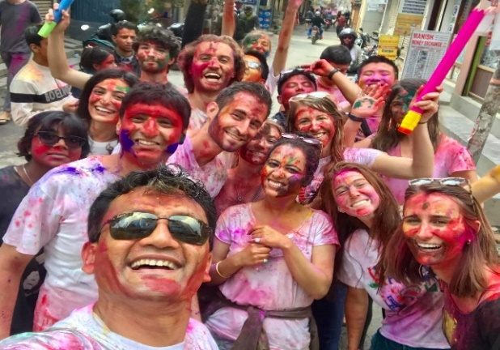
Some pictures
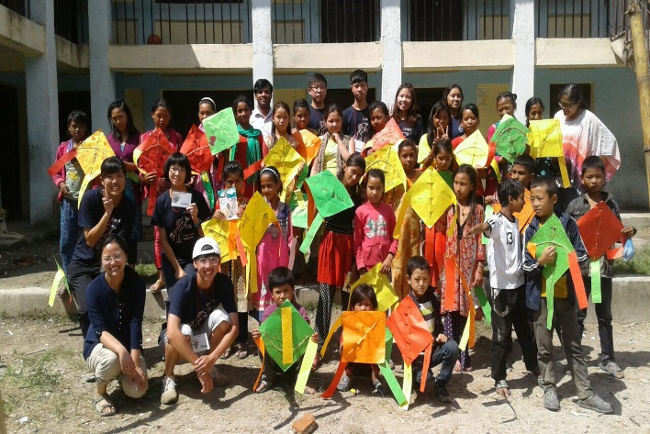
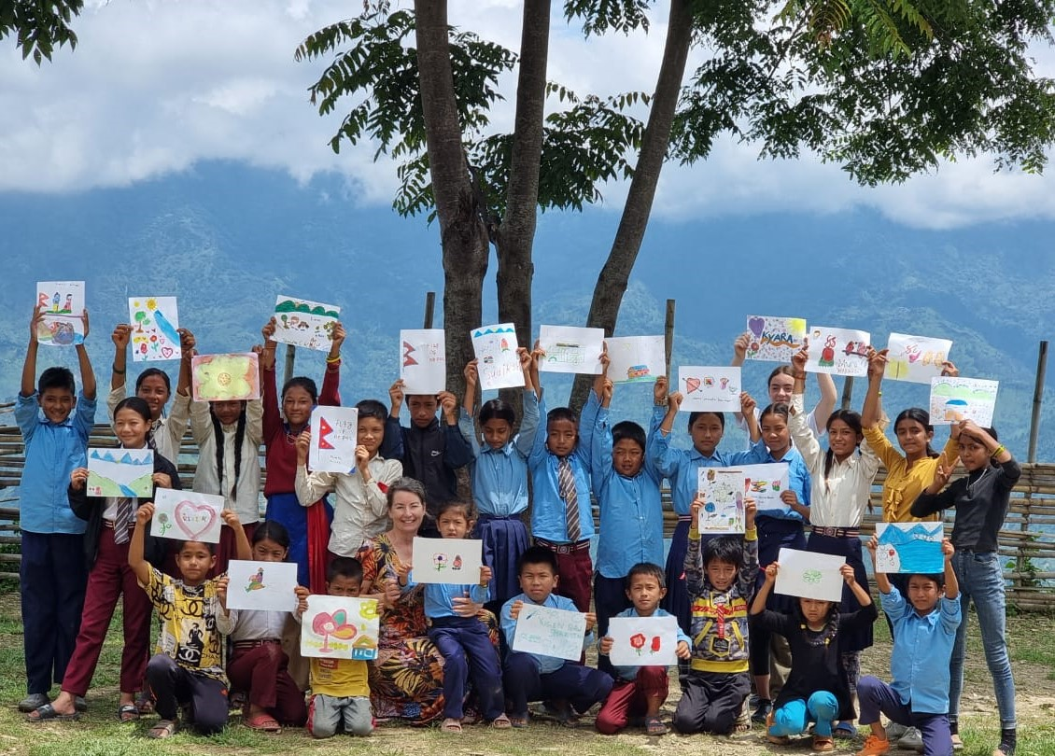
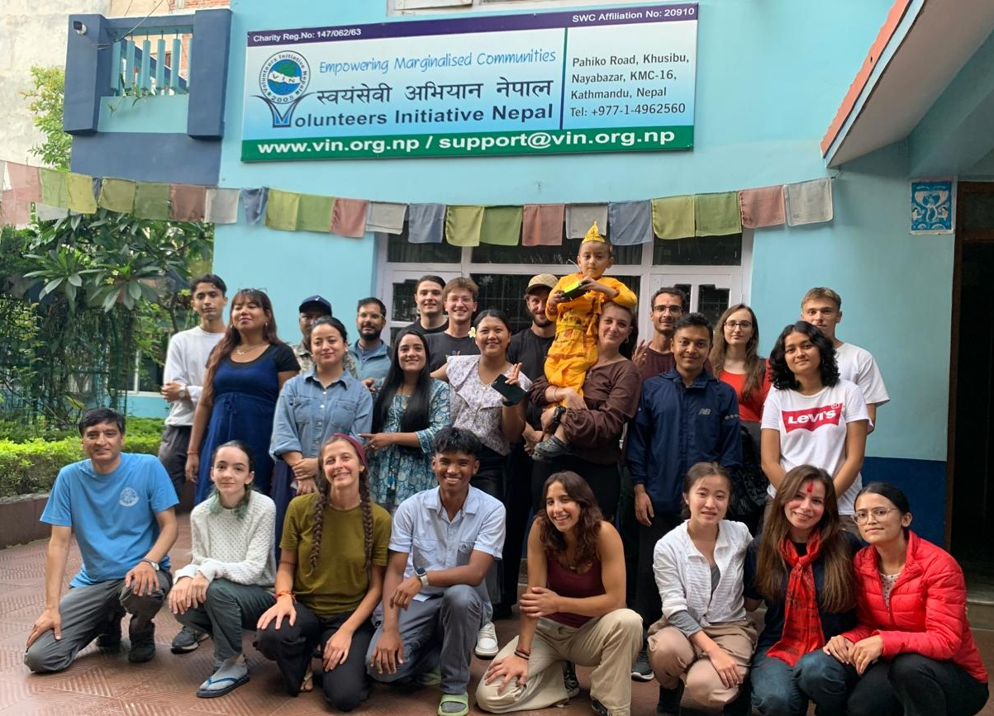

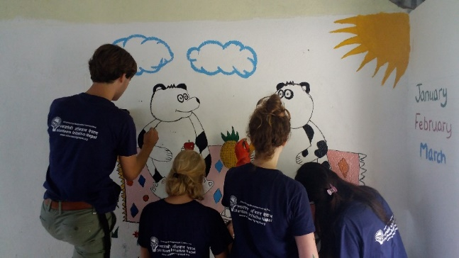
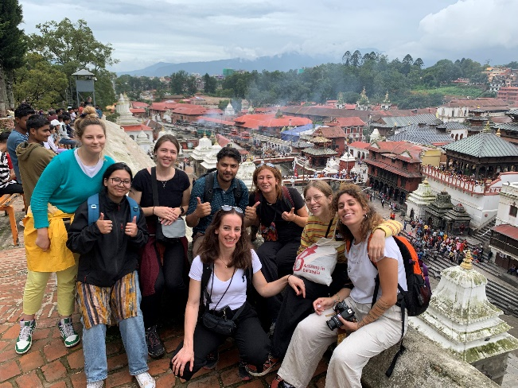
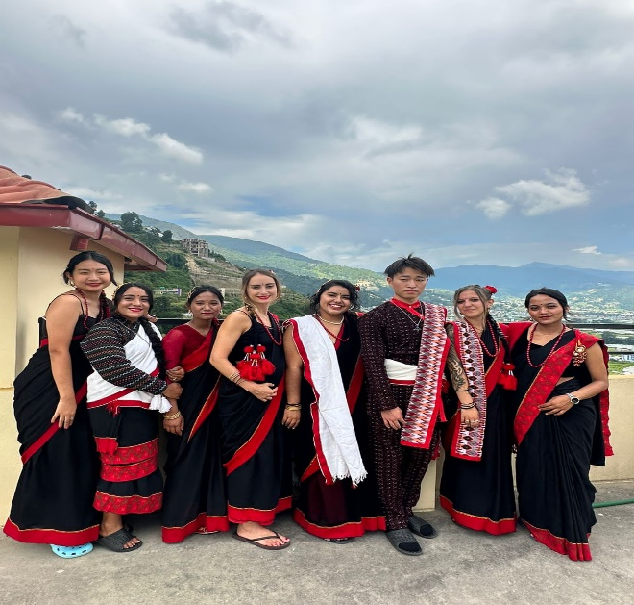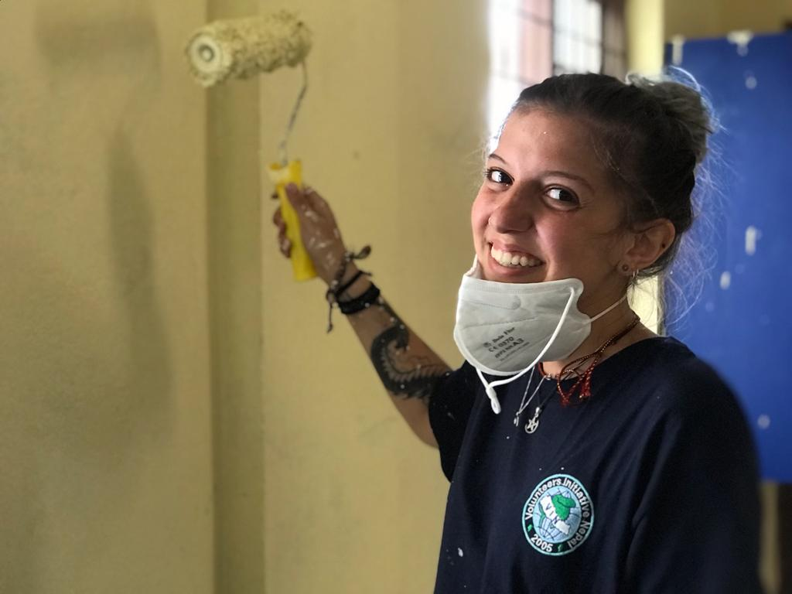
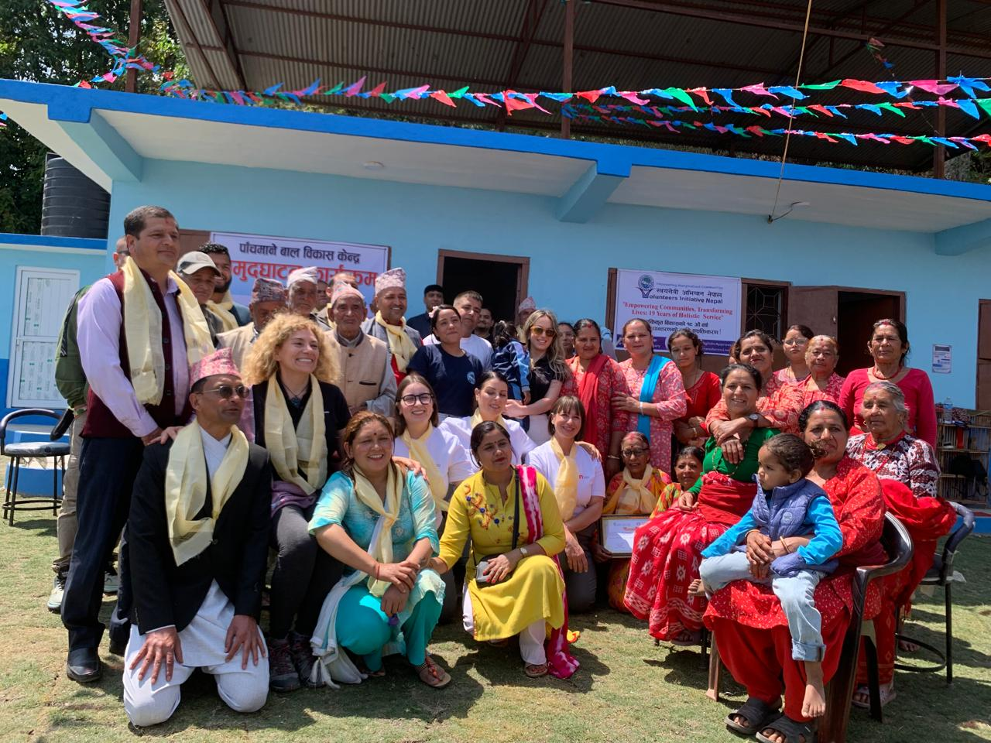
Thank you.

