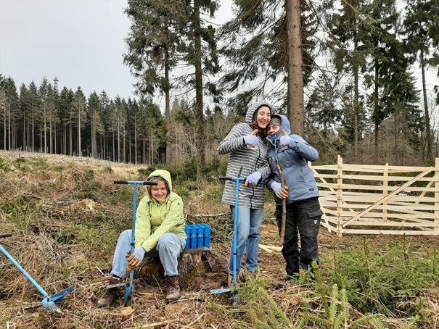

Project name: Active for future- help to plant trees!

2026 Ingelheim I

Project code: ijgd 26329
From: 09.04.2026 To: 23.04.2026
Primary Work Type: ENVI Environmental
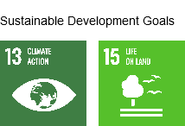

Project Location City: city forest Ingelheim, Rhineland-Palatinate; Koblenz 45km, Mainz 60km

Description of the partner organizing/hosting the project:
The ijgd has been organising volunteer service programmes since 1949. We are an independent, non-profit association for international youth work, a recognised independent youth welfare organisation, and one of the largest and oldest workcamp organisations in Germany. Each year, we assist around 5,000 young people into volunteer work in Germany and abroad. We give them the opportunity to be creative, act in solidarity, take responsibility for themselves, and discover their own true potential and strengths. Our principles: Ecological learning, voluntary contribution, self-organisation, social development, intercultural learning, gender equality, anti-racism/anti-discrimination and political education Follow us on Instagram ijgd_workcamps Facebook @ijgd.workcamps

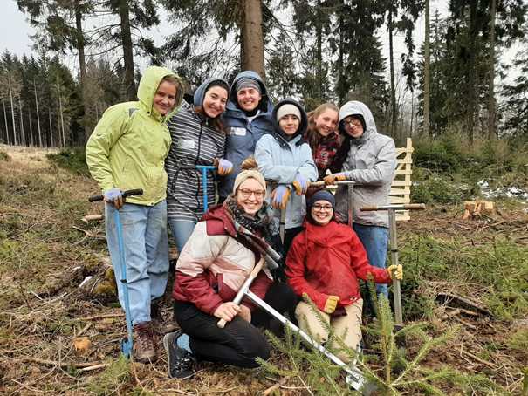

Description of work:
Highlights: Group feeling in the middle of the forest! Active for future- help to plant trees
Are you a nature lover? Then this is the perfect workcamp for you! Here you will have the opportunity to spend 2 weeks working and living in the forest. Your main task will be to plant trees as part of an active contribution to conservation! You will also be helping out with several other conservation tasks, such as forest maintenance, constructing and repairing protective fences, and preserving the biotopes in the area. By working on these activities, you will also learn a lot about the ecosystem of a forest!

Description of accommodation and food:
Highlight: comfortable accommodation,
You will be living in the leisure centre, which is located in the middle of the forest. Meals are prepared by the house: Breakfast, a warm lunch and in the evening there is a “cold” dinner with bread and sausage, cheese, spread. Please state any intolerances during registration.
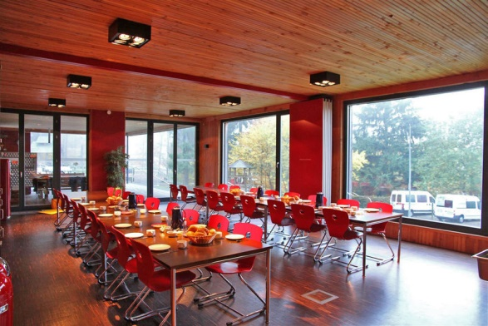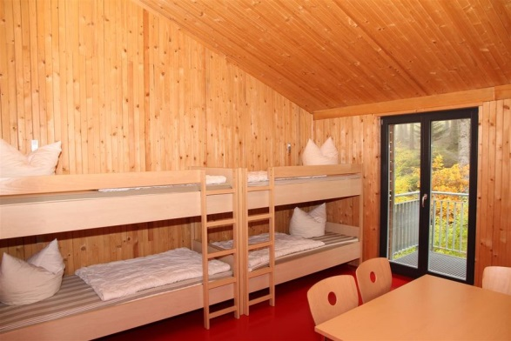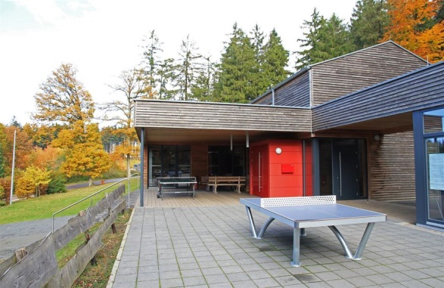

Description of location and leisure:
Highlight numerous weekend excursions: Frankfurt, Cologne, Mainz and much more.
You will be living in a beautiful accommodation building in the middle of the forest, where you can barbecue together in the evening and sit around the campfire. There will be a minibus available for your group, so that you can get to know the beautiful surroundings and drive to local attractions such as the swimming pool, the animal park or the climbing area. You will also be able to take trips to the river Rhine, to Koblenz, to Mainz or to Frankfurt during the camp. The nearest town to your accommodation is Bingen, which also offers several different sights and attractions.

Total volunteers: 9
Volunteers below 18 years: 0
Minimum age required for participation: 18
Maximum age required for participation: 26
Extra Fee (if any): -
Language 1: English Language 2:
Participation of volunteers with disabilities: no
Vegetarian food available?: yes
Description of any specific requirements Interest in working in the nature!
You will receive more detailed information after confirming your registration and at least 2 week before the start of the camp with the specific info sheet for your camp.
Nearest International airport: Frankfurt am Main (FRA) international, Frankfurt Hahn is not an option ist to far away.
Nearest terminal (train or bus station): Bingen-HBF
We would like to invite you to travel as environmentally friendly as possible. If you have the option to go by train, bus, carshare or bicycle that can be a great first step for you to become a climate steward.
Meeting point and time: Since there is no bus connection to the accommodation, you will be picked up on THURSDAY 9 of APRIL at 2 p.m. and 6 p.m. at the train station in Bingen HBF. For any late arrival you can contact the group leaders, you will get their mobile number 10 days before the Camp starts.
Check the website of Deutsche Bahn for the best times and to book your tickets: https://www.bahn.com/en.

