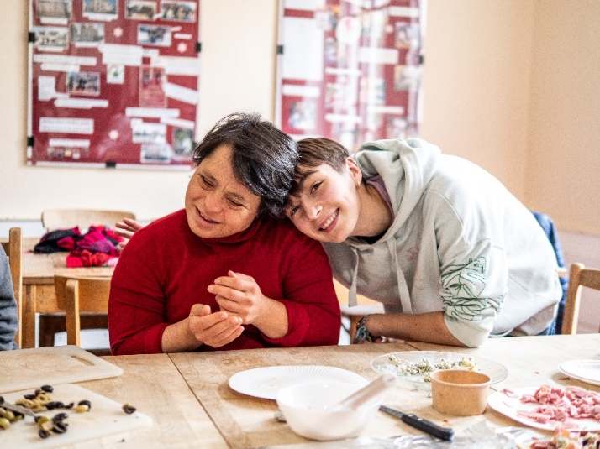
A voluntary service at l’Arche in France
L’Arche
L’Arche is a living community where people with and without learning disabilities share their daily life with the mission to build a world where everyone belongs. This simple yet beautiful approach puts the development of mutual relationships at the heart of the project. Living in an Arche community means becoming part of a family.
©François Becker - 2023
The volunteers’ tasks and missions
- Learning how to assist residents in their daily lives (e. g. getting up - going to bed...)
- Proposing activities, outings and sharing good times
- Participate in the organisation and services of the household
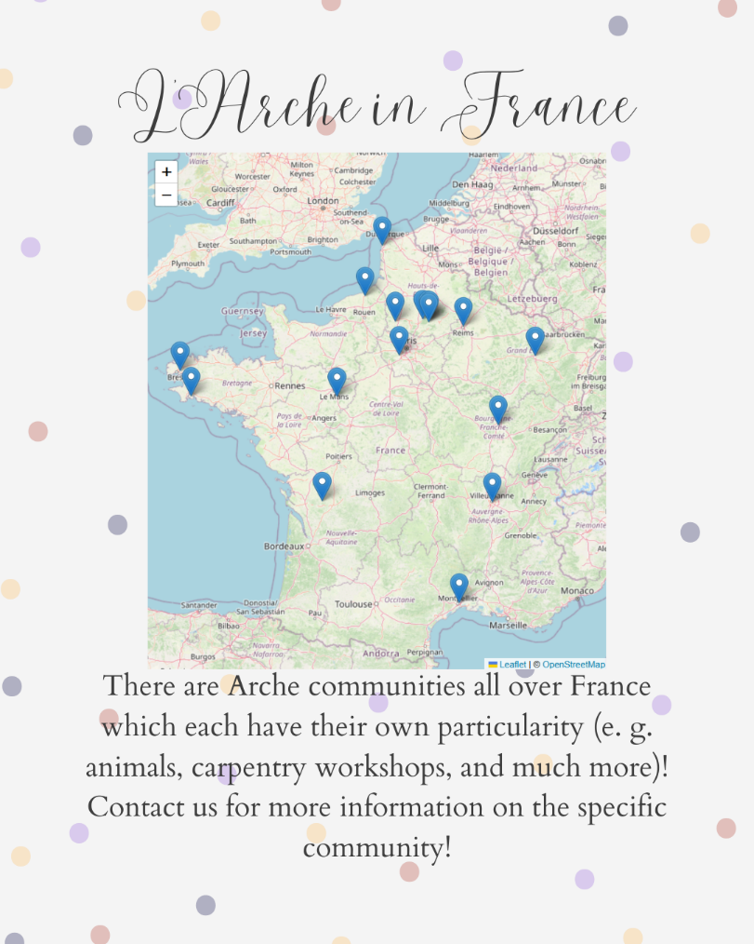
- Helping the team by participating in joint reflection
There are Arche communities all over France which each have their own particularity (e. g. animals, carpentry workshops, and much more). For more information on the specific community, interested young people are invited to contact ICE (contact below).
Conditions
- Be 18-25 years old
- Be a citizen of the European Union
- Be open-minded and ready to help
Benefits
- Food and accommodation
- Monthly indemnity of 504,98 euros from the French state.
- Social security
- Training as part of the Service Civique
- Personalised support
- French language course
Duration
For European volunteers, a voluntary service at l'Arche normally lasts one year, from 01/09/2025 until 20/08/2026. Immediately before the start of the service, the volunteers are expected to take part in a two-week preparation that we organise in Niederbronn-les-Bains, Alsace.
Exceptions can be discussed with us so that we can inquire with the respective community whether, for example, a shorter period of service is possible. However, the service lasts at least 6 months.
The French language
Knowledge of French is not a precondition. Of course, it is easier for the volunteer to communicate if they already have some knowledge of French as not everyone in France speaks English. It can be frustrating in the beginning to not be able to express oneself in French. To help the volunteers with the language, French courses are an important part of the two-week preparation. During their service, the volunteers are expected to do their best to improve their knowledge of French, and due to our agreement with the hosting sites, volunteers receive French lessons as part of their working hours.
Travel costs
The travel costs to Niederbronn-les-Bains, to the hosting site and the journey home after the service are not covered, they have to be paid for by the volunteer. For the one or two other seminars organised by ICE-RF, travel costs are covered.
Contact
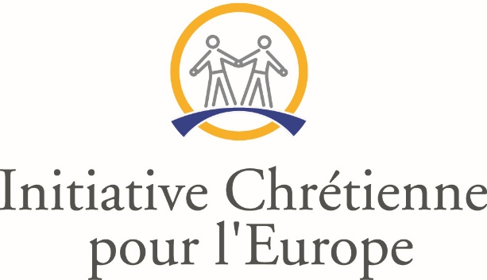
Feel free to contact ICE for more information!
www.servicevolontaire.com
E-Mail: ice@servicevolontaire.com
Telephone: +33 (0)3 88 94 20 76
Instagram: ice_reseau_francophone
TikTok: ice_reseau_francophone
Facebook: Initiative Chrétienne pour l’Europe

