2025 IWO KOREA
International Exchange Program

Connect People and Community

WE

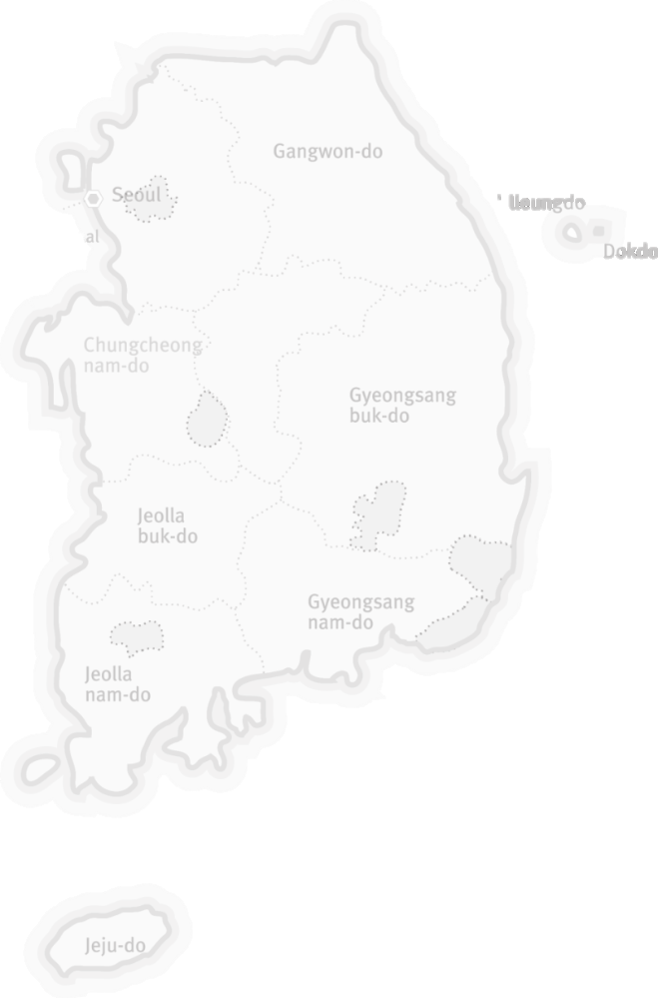

International Workcamp Organization

1. Introduction about IWO

IWO is a non-profit and non-governmental organization established in 1999 to promote world peace, global citizenship, youth and community development, and cultural exchange through international voluntary service. We had been an Executive committee member of CCIVS (Coordinating Committee for International Voluntary Service) at UNESCO Paris, and are a member of NVDA (Network for Voluntary Development in Asia), and a member of Alliance (Alliance of European voluntary service organizations).

1.1 Our Vision
IWO dreams for youth to make contribution to the Global community through international voluntary service and intercultural exchange.

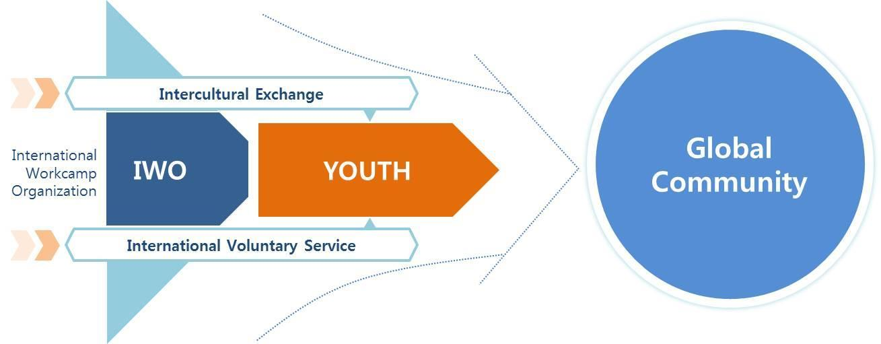

We believe that we can promote world peace by contributing to mutual respect and capacity for peaceful coexistence among all countries. We offer the youth of all countries the opportunities with international voluntary service projects to understand the cultural differences and diversity of each society. We believe that youth is our bright future in this world.

1.2 Our Activities
Our International Voluntary Service Projects offer young people opportunities to participate in community-based projects in over 70 countries worldwide. The projects differ widely ranging from nature conservation, restoration, education, and construction to projects that are more socially based including work with adults and children with special needs, teaching or organizing youth & children's holiday schemes. Our main activities include.

* GLOBAL Education *
- Growing and training youth and volunteers
- Leading a new paradigm in the field of non-formal education
- Organizing international voluntary service projects
- Building intercultural programs
- Arranging international conferences and seminars
- Learning and understanding diverse culture

1.3 Our Aims
The main purpose of IWO STV and MTV projects is the so-called ‘Glocalization’ which is to bring the world to Korea and provide opportunities for international exposure. Hence, the projects may enhance the cultural interchange between the local residents and international volunteers and also influence positively the host organization and local community by actively fulfilling the missions of each project.

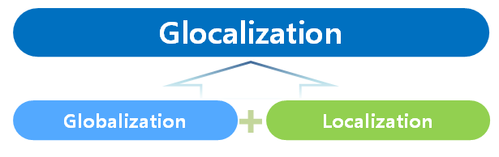

- To provide opportunities to locals so that they can understand other countries and cultures by building friendship with volunteers.
- To help international volunteers understand Korean culture and learn to respect
differences and diversity.
- To empower the locals to support civil associations and non-governmental organizations.
- To encourage volunteers to have an active attitude toward responsibility for the
environment, youth and society.
- To promote voluntary service activities in cooperation with local communities and NGOs.

2. General conditions of projects

All projects cooperate with local NGOs, local governments, civil society and local volunteers. The locals are pleased with and welcome the international volunteers who have the different cultural, social and educational backgrounds.

Short Term Volunteer Projects (Workcamps)

1) Number of Volunteers & Duration
- IWO hosts 10-25 volunteers on each workcamp. Each project will have 4-10 Korean participants (Including 1~2 Korean camp leaders) and 10-25 international participants.
- The number of volunteers may alter depending on each project.
- Duration of the project is 6 to 12 days.

2) Project Coordinator
- Each project has 1~2 camp leaders who have been trained by IWO. They will coordinate the group to achieve the goals of each project. And, the Korean participants also prepare for the project with IWO before the international participants arrive in Korea.

3) Accommodation & Food
- Meals and accommodation are provided during the project
- Rooms will be shared among participants and sleep on the floor with a mattress (Based on Korean culture)
- However, participants may have to cook for themselves by turn with given budget. It would bring pleasure to taste different food from different countries.
- Participants are responsible for keeping the accommodation clean during the project at all times because there will be locals visiting the project sites often.
- If volunteers have a unique dietary requirement, they should inform them in advance and they have to prepare for themselves in case the local can’t support them.

4) Free Time
- Participants are responsible for organizing their own free time with the camp leaders during free days. Host organizations will share information about local attractions with the participants.

5) Insurance
- IWO provides insurance for accidents during the project only. (No dental clinic, illness, 3rd party’s liability compensation). It covers only a percentage of the cost (co-pay) at a maximum 40% as per the insurance regulation for foreigners in KOREA.
- Therefore, participants MUST bring their insurance for health, travel and the 3rd party’s liability compensation. The first aid kit is provided in the project site and recommend to bring own medicines too if necessary.

6) Transportation
- Korea has a convenient public transportation network over the country; therefore, all participants are advised to arrive at Incheon International Airport regardless of the location of their project site.
- By taking a subway and an airport bus, participants can conveniently arrive from the airport to Seoul. There are many convenient public transportation systems from Seoul to each project site.

7) Participation fee
- None

8) Financial Support
- Participant can get the transportation (Round-trip Ferry tickets) after the meeting point.

8) General Requirements
- The primary language is English.
- Be motivated and open-minded to local cultures.
- Be flexible and be ready for sudden changes in the program according to the local situation.
- Participants aged from 19 to 40 years are acceptable. Exceptions may be negotiated.
- Volunteers should be fully aware that this is NOT a vacation trip nor cheap travel.
- Verbal and physical sexual harassment and discrimination is a serious crime.
- Smoking is allowed only in a designated area in each project site.
- No illegal drugs are allowed in Korea.
- No drinking alcohol is allowed when you are with children or even in a youth centre.

1. Workcamp Project List

No. | Code | Title | Location | Date | Type | No. of  Vols. | Age  Limit
1 | IWO-72 | Dochodo | Shinan | 13 JUL – 19 JUL | CULT/EDU | 25 | 19+

2. Workcamp Description

IWO-72 | Dochodo-WHV | Shinan | 13 JUL – 19 JUL | CULT/EDU | 20 vols

Did you know that there are about 3,000 islands in Korea? These islands are filled with various stories. For instance, it was an island where foreigners first visited Korea, and one of the presidents received the Nobel Peace Prize in Korea. Many people have considered islands as isolated places because they are separated from the mainland and historically seen as remote destinations. However, from a different point of view, we can consider islands as the first gateways in Korean history to accept foreign and diverse cultures. They were such open-minded places to embrace diverse cultures and values.
Here, we can discover the cultural heritage from a global-local perspective. From islands where foreign cultures were first embraced, we aim to promote global values and cultural heritage, and introduce the values brought by international volunteers to the island residents. Join us for a meaningful adventure!

Work: The main goal is to promote the hidden history, nature, and culture of the islands from an international perspective.

As part of the program, youth from 15 countries will engage in cultural exchange activities with local teenagers. Participants will introduce their countries through food, games, art, clothing, photography, and more. These sessions will help local youth expand their global understanding.

In addition, participants will carry out community service by delivering lunch boxes to elderly residents living alone and supporting them with basic home maintenance tasks. These visits offer opportunities to listen to their life stories, share values, and even exchange meals with flavors from around the world.

Environmental activities are also a key part of the program. Participants will join a plogging (trash-picking while walking) activity along the island's coasts and in the tidal flats. They will also take part in experiential learning sessions to explore and understand the ecological significance of the tidal flats, which are designated as UNESCO World Natural Heritage.

Participants will compete in a creative island promotion SNS challenge, using storytelling and social media content to share the charm and global significance of the islands with the world. Through these experiences, participants will immerse themselves in authentic island life, engage in meaningful cultural exchanges, and contribute to sustainable community development.

Dochodo (Docho Island)
Dochodo Island is a small island located in the southwestern corner of Korea, within the Sinan region. It is known for its stunning tidal flats (Getbol) which are designated as World heritage sites in 2022. This site exhibits a complex combination of geological, oceanographic and climatological conditions that have led to the development of coastal diverse sedimentary systems.

Location:
Dochodo: https://maps.app.goo.gl/U1VBuPsZSjExs9NeA

Transportation:
Participants will meet at Mokpo KTX Station. The train or bus runs frequently from Seoul to Mokpo a day. It takes about 2 and a half hours by KTX train(Fast train). After gathering at the station, all participants will move together to the project site by the bus and ferry. The transportation fee from meeting point to project site by chartered bus and ferry will be covered by the Host organization. It will take about 35 minutes by ferry from the port to the project site.

General information of island:
https://youtu.be/-2LPmSuGHL4?si=wbKM_ova-WzCjkh9

Roles |  | Staffs | E-mail
Outgoing | STV, MTV | Mrs. Imagine | iwo@1.or.kr
Incoming | STV, MTV | Mr. Yonghan KIM | connect1@1.or.kr
* Emergency contact : +82-(0)10-2205-5708
International Workcamp Organization
B-1710, 583 Yangcheon-ro, Gangseo-gu, Seoul, 07547, Republic of Korea
Tel : +82-(0)2-330-2419
Email :connect1@1.or.kr
Website : www.workcamp.org

