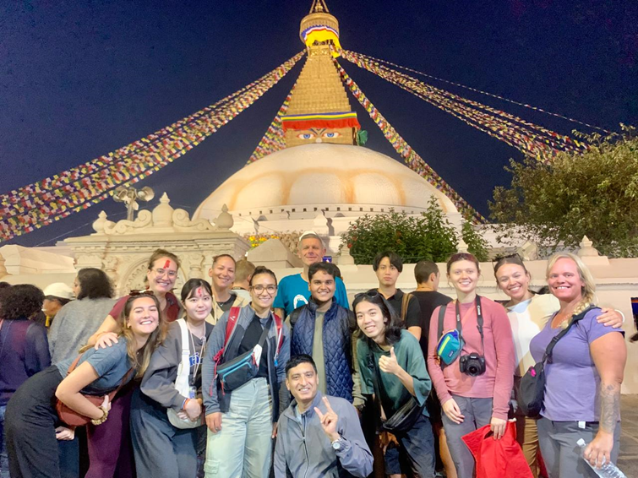

VIN WORKCAMP(STV) PROJECTS

2025

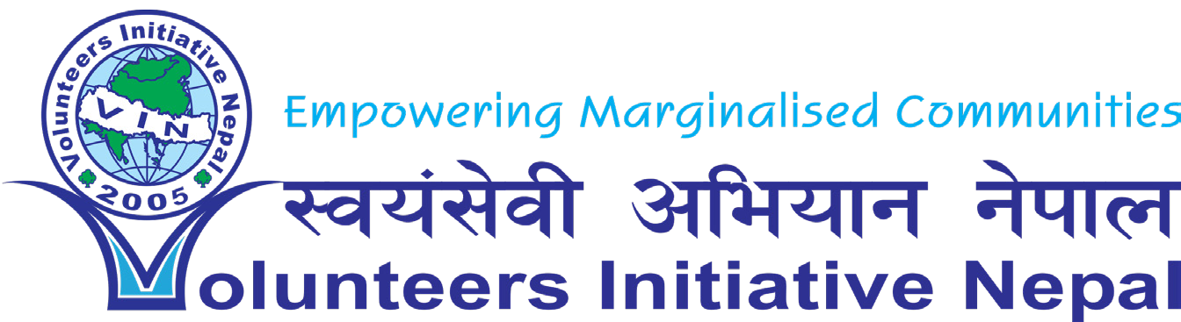

**Volunteers Initiative Nepal (VIN)**

[www.volunteersinitiativenepal.org](http://www.volunteersinitiativenepal.org)

Ph.: +977- 1- 4962560

Contents

Volunteers Initiative Nepal (VIN) 2

Our Mission 3

General information about the workcamp: 4

Placement Support Process: 4

Accommodation: 5

Requirements: 5

Meeting point: 6

Airport: 6

Leisure Activities: 6

VIN Workcamp List 2025 7

PROJECT DETAILS 9

Project 1: Children’s Winter Camp – Empowering Kids through Education, Sports & Culture – (EDU, SPOR & CULT) 9

Project 2: Environmental Stewards: Protecting Nepal's Future (ENVI, EDU, MANU) 11

Project 3: Creative Minds Library Camp: Inspiring Learning through Stories and Innovation (KIDS, EDU, CULT) 13

Project 4: Caring Hands Camp: Supporting Nepal’s Elderly with Love and Care 16

(MANU, CULT) 16

Project 5: Youth Empowerment & Festival of Colors Camp: Transforming Skills, Celebrating Culture (EDU, CULT, FESTIVE) 17

Project 6: Permaculture & Holi Festival- Festival of Color: Sustainable Farming and Cultural Colors in Nepal (ENVI, AGRI, MANU) 20

Project 7: Children’s Summer Camp (KIDS, EDU, SPOR & CULT) 23

Project 8: Raising Peace Campaign (EDU, CULT) 24

Project 9: Art & crafts with Children (ARTS, KIDS) 26

Project 10: Library & Festive Camp (EDU, SOCI, FESTIV MANU) 28

Project 11: Creative Classrooms: Enhancing Schools and Inspiring Young Minds & Festive Camp (KIDS, EDU CULT) 31

Project 12: Health and Wellness (HEALTH, EDU) 34

Project 13: Social Event - International Volunteer Day celebration (MANU, EDU) 36

Some pictures 38

# Volunteers Initiative Nepal (VIN)

Established in 2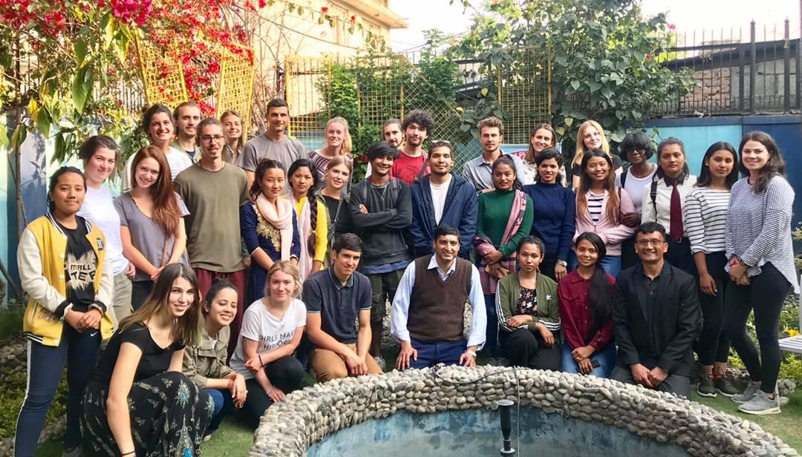005, Volunteers Initiative Nepal (VIN) is a non-profit, non-governmental organization that takes a comprehensive approach to community development. It assists Nepal’s most marginalized populations. VIN recruits numerous local and international volunteers each year to achieve this objective. Our primary mission is to improve the quality of life for underprivileged individuals through community empowerment, using volunteering as our strategy for development initiatives.

# Our Mission

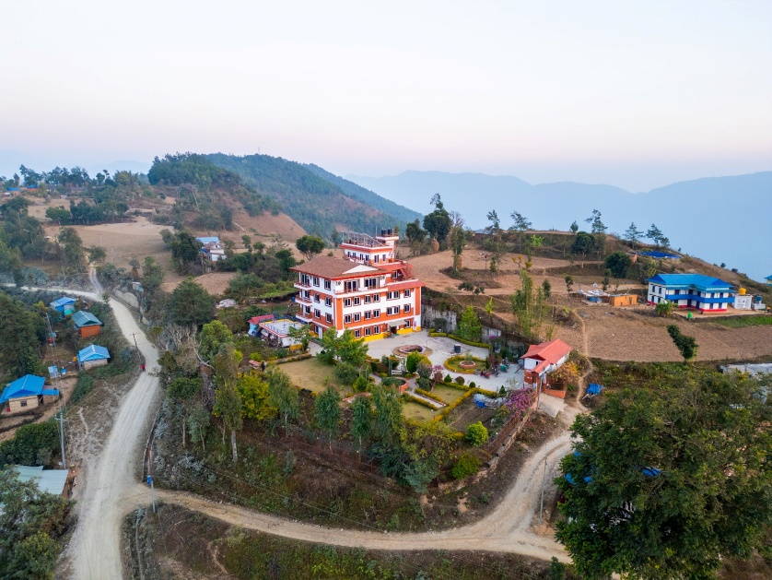VIN's mission is to Our mission is to empower marginalized communities through equitable, inclusive, and holistic development programs.

The primary objectives of VIN

#### To improve the essential p**ublic health** condition of the community, people

#### To empower women to improve their quality of life

#### To facilitate children's development & protect child rights

#### To cultivate skills in youth and engage them in development activities.

* To Conserve, promote, and protect the environment and culture for the future generation
* To minimize the risk of natural disasters and provide relief and safety to vulnerable communities

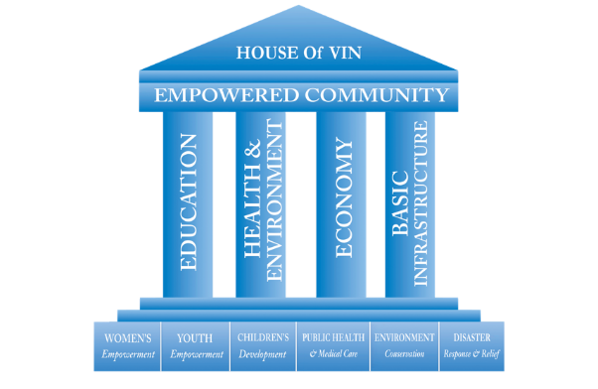These objectives are achieved through the engagement of young people and solidarity activities focusing on sustainable development goals, social inclusion, and equal opportunities.

VIN believes in the four pillars of development: Education, Health and Environment, Economy, and basic infrastructure. We have implemented six **programs**: women's empowerment, Children's Development, Youth Empowerment, Public Health and Medical Care, Environment Conservation, and Disaster Response and relief. VIN mobilizes local and international community and office volunteers, positively impacting the programs.

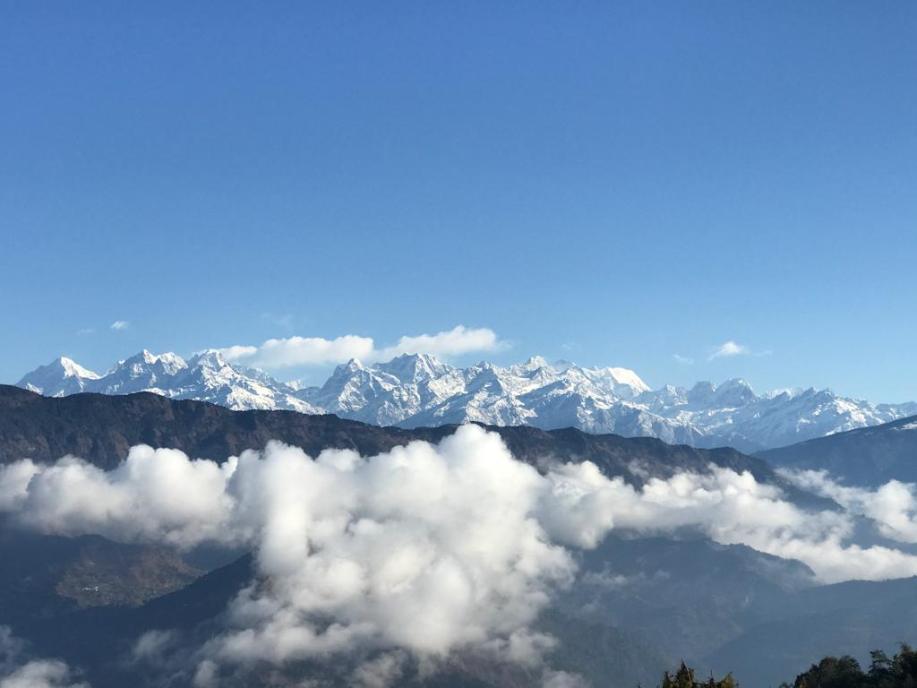

VIN has fully applied a holistic approach in humanitarian activities (equal focus on Education, Health & Environment, Economy, and Basic infrastructure development) to community empowerment. Through our initiatives, over 370k people directly benefitted.

# General information about the work camp:

VIN organizes international work camps where participants from different countries work on community-based projects. These projects typically focus on education, environmental conservation, cultural exchange, health, and infrastructure development. Our work camps are usually short-term (1–3 weeks).

Participants contribute their time, skills, and energy to the project while experiencing cultural exchange and learning from each other. The projects foster global understanding, teamwork, and sustainable development.

# Placement Support Process:

The first day of the program is dedicated to arrival/welcoming day/. Upon arrival, each volunteer is greeted by VIN’s local staff at the airport and taken to the VIN hostel for their stay. The second day features a comprehensive orientation at the VIN office in Kathmandu. This session covers important topics such as cultural tips, basic Nepali survival phrases, health and safety advice, preparation for project activities and planning, and an introduction to VIN’s mission and work. The volunteers are accommodated to host families/hostel.

A Nepali camp leader will guide volunteers throughout the work camp, and VIN supervisors will make periodic visits to provide follow-up and support. Volunteers can always contact VIN for immediate assistance if they encounter any issues during the camp. On the final day, volunteers will complete a detailed work report, fill out an exit form, and participate in an exit interview and feedback session with VIN executives to share their experiences and suggestions.

# Accommodation:

The volunteers will stay with the host family/hostel identified by VIN. The living facilities are simple and basic. Male and female volunteers will share the same living area with separate rooms. The volunteers sleep on simple beds/mattresses. Please bring your sleeping bag.

# Requirements:

* Basic English should be spoken among the participants
* Physically sound as per the project requirements.

**Participation Fee:**

The participation fee is 270 Euros (+30 Euro for transportation in Kathmandu. 100 Euro for Okhaldhunga, 100 Euro for Sindhuli, 50 Euro for Lapsephedi ), which is to be paid on arrival at the VIN Office.

***Note: If Volunteers arrive early than the start date they can book VIN Hostel which is affordable; It costs 16 Euros per night including three meals and 6 Euros per night excluding meals.***

**Why Okhaldhunga and extra transportation fee:**

* It takes one day (250 km) car/bus rough and paved drive from Kathmandu.
* The beautiful Himalayan region is close to Mt. Everest.
* It lacks development and basic infrastructure.
* It is a very needy local area waiting for development.
* Welcoming community and rich in culture.
* Simple lifestyle and smiling people.
* Lovely environment and up and downhill.
* Good and enough support from local staff and community people.
* Volunteers will feel they have contributed to the needy and poor community.

**The Participation Fee Covers:**

* Food and Accommodation: Nepali Standard at a local host family – 3 meals a day
* Transportation: Airport pick up and pick up and drop to the working community site
* Materials for the work camp and community development projects support
* Local volunteers' support cost
* VIN T-shirt and certificate of participation
* 24-hour emergency support
* VIN admin cost.

**What's excluded?**

Airfare, VISA, Travel medical insurance, return airport transfer, personal travel and weekend activities, and other personal expenses.

# Meeting point:

One of theVIN staff will pick up volunteers from the airport. Please send your flight details to VIN on time so we can send your name card and VIN logo to our staff.

If you want to explore the country earlier, you can take a pre-paid taxi at the airport, or VIN can help you with that. You can arrive at the VIN office on the first day.

# Airport:

Tribhuwan International Airport, Kathmandu

# Leisure Activities:

You can go sightseeing at various sites around the community. VIN also organizes weekend travel tours to Chitwan Jungle Safari, Pokhara, and Nagarkot at an additional cost if you are interested.

# VIN Workcamp List 2025

|  |  |  |  |  |  |  |  |  |
| --- | --- | --- | --- | --- | --- | --- | --- | --- |
| **Code** | **Name of Project** | **Location** | **Date** | **Type** | **Total Vols.** | **Male** | **Female** | **Age** |
| VINWC25-01 | Children’s Winter Camp – Empowering Kids Through Education, Sports & Culture | Kathmandu | 16-27 Jan 2025 | KIDS, EDU, SPOR & CULT | 14 | 7 | 7 | 18+ |
| VINWC25-02 | Environmental Stewards: Preserving Our Common Home | Kathmandu | 10 -21 Feb 2025 | ENVI, EDU, MANU | 12 | 6 | 6 | 18+ |
| VINWC25-03 | Youth Empowerment and Festival of Color Camp. | Kathmandu | 06 – 17 March 2025 | EDU FESTIVE | 14 | 7 | 7 | 18+ |
| VINWC25-04 | Permaculture (Sustainable food production) & **Holi Festival – Festival of color**. | Okhaldhunga | 06 – 18 March 2025 | ENVI, AGRI, MANU, FESTIVE | 14 | 7 | 7 | 18+ |
| VINWC25-05 | **Caring Hands Camp** | Lapsephedi Kathmandu | 3 - 14 April 2025 | MANU, CULT, ENVI | 14 | 7 | 7 | 18+ |
| VINWC25-06 | **Creative Minds Library Camp: Inspiring Learning Through Stories and Innovation** | Okhaldhunga | 3 - 14 April 2025 | KIDS, EDU, CULT | 14 | 7 | 7 | 18+ |
| VINWC25-07 | Environmental Stewards: Preserving Our Common Home | Kathmandu | 08-19 May 2025 | ENVI, EDU, MANU | 14 | 7 | 7 | 18+ |
| VINWC25-08 | Permaculture (Sustainable food production) | Okhaldhunga | 08-19 May 2025 | ENVI, AGRI, MANU, | 14 | 7 | 7 | 18+ |
| VINWC25-09 | Art and crafts with children | Kathmandu | 09-20 June 2025 | ARTS, KIDS, EDU | 14 | 7 | 7 | 18+ |
| VINWC25-10 | Permaculture (Sustainable food production)& | Okhaldhunga | 09 - 21 June 2025 | ENVI, AGRI, MANU | 14 | 7 | 7 | 18+ |
| VINWC25-11 | Children’s Summer Camp | Okhaldhunga | 09-21 July 2025 | KIDS, EDU, SPOR & CULT | 14 | 7 | 7 | 18+ |
| VINWC25-12 | Permaculture (Sustainable food production) | Okhaldhunga | 09-21 July 2025 | ENVI, AGRI, MANU | 14 | 7 | 7 | 18+ |
| VINWC25-13 | Art and crafts with children | Kathmandu | 09 -20 July 2025 | ARTS, KIDS, EDU | 14 | 7 | 7 | 18+ |
| VINWC25-14 | Children’s Summer Camp | Okhaldhunga | 17 -28 July 2025 | KIDS, EDU, SPOR & CULT | 16 | 8 | 8 | 18+ |
| VINWC25-15 | Permaculture (Sustainable food production) | Okhaldhunga | 17 -28 July 2025 | ENVI, AGRI, MANU | 14 | 7 | 7 | 18+ |
| VINWC25-16 | Environmental Stewards: Preserving Our Common Home | Kathmandu | 11-22 August 2025 | ENVI, EDU, MANU | 14 | 7 | 7 | 18+ |
| VINWC25-17 | **Creative Minds Library Camp: Inspiring Learning Through Stories and Innovation** | Okhaldhunga | 11-23 August 2025 | KIDS, EDU, CULT | 14 | 7 | 7 | 18+ |
| VINWC25-18 | Health and Wellness | Kathmandu | 03-14 August 2025 | HEALTH, EDU | 14 | 7 | 7 | 18+ |
| VINWC25-19 | Library  & Festive Camp | Kathmandu | 21 Aug - 01 September 2025 | EDU, SOCI, KIDS, MANU, CULT | 14 | 7 | 7 | 18+ |
| VINWC25-20 | Creative Classrooms: Enhancing Schools and Inspiring Young Minds & Festive Camp | Okhaldhunga | 21 Aug - 02 September 2025 | KIDS, CULT | 14 | 7 | 7 | 18+ |
| VINWC25-21 | Raising Peace Campaign | Kathmandu | 08 Sep – 20 Sep 2025 | EDU, CULT | 14 | 7 | 7 | 18+ |
| VINWC25-22 | **Caring Hands Camp** | Lapsephedi Kathmandu | 08 – 19 Oct 2025 | MANU, CULT, ENVI | 14 | 7 | 7 | 18+ |
| VINWC25-23 | Permaculture (Sustainable food production) | Okhaldhunga | 08 Sep – 20 Sep 2025 | ENVI, AGRI, MANU | 14 | 7 | 7 | 18+ |
| VINWC25-24 | Celebrate the Power of Volunteering | Kathmandu | 25 Nov – 6 Dec 2025 | MANU, EDU, FESTIV | 14 | 7 | 7 | 18+ |
| VINWC25-25 | Permaculture (Sustainable food production) | Okhaldhunga | 07 – 18 Dec 2025 | ENVI, AGRI, MANU | 14 | 7 | 7 | 18+ |
| VINWC26-01 | Children’s Winter Camp – Empowering Kids Through Education, Sports & Culture | Kathmandu | 16-27 Jan 2026 | KIDS, EDU, SPOR & CULT | 14 | 7 | 7 | 18+ |
| VINWC26-02 | Art and craft with children | Kathmandu | 10 -21 Feb 2026 | ARTS, KIDS, EDU | 14 | 7 | 7 | 18+ |

# PROJECT DETAILS

## Project 1: Children’s Winter Camp – Empowering Kids through Education, Sports & Culture – (EDU, SPOR & CULT)

|  |  |  |  |  |  |  |  |  |
| --- | --- | --- | --- | --- | --- | --- | --- | --- |
| Code | Name of Project | Location | Date | Type | Total Vols. | Male | Female | Age |
| VINWC25-01 | Children’s Winter Camp – Empowering Kids Through Education, Sports & Culture | Kathmandu | 16-27 Jan 2025 | KIDS, EDU, SPOR & CULT | 14 | 7 | 7 | 18+ |
| VINWC26-01 | Children’s Winter Camp – Empowering Kids Through Education, Sports & Culture | Kathmandu | 16-27 Jan 2026 | KIDS, EDU, SPOR & CULT | 14 | 7 | 7 | 18+ |

**Background/Project: The** Children's Development Program is a crucial initiative within VIN's Integrated Community Development Approach. It seeks to safeguard the rights of all children by ensuring access to quality basic education, fostering essential life skills like creativity and leadership, and offering health and hygiene services.

Within the Children's Development Program, VIN conducts various projects, including Children's Clubs (CC), Early Childhood Development (ECD), School Attendance (which includes Teacher Development, Parenting Education, School Infrastructure Development, and Child Sponsorship), and Child Care.

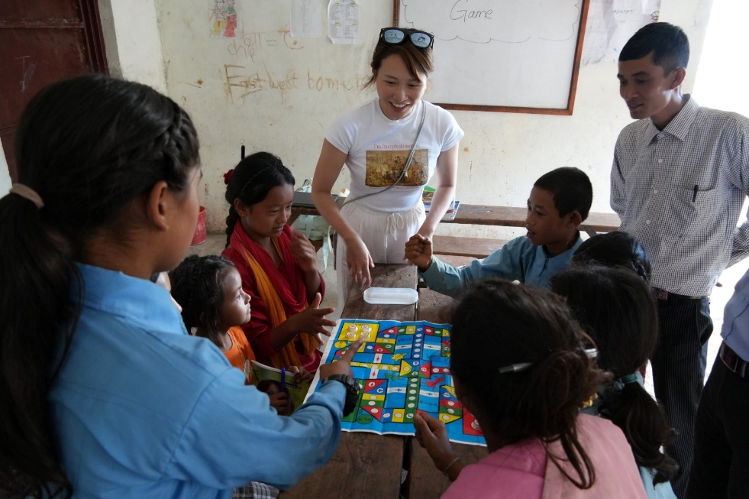In Nepal, schools concentrate mainly on exams and often overlook the importance of developing essential life skills like creativity and leadership in children. Teachers prioritize reading and writing, which leads to **rote learning**. Consequently, creativity and children's unique differences often go unrecognized.

Many children miss chances to socialize and express their creativity because of their parents' demanding work schedules. These camps are crucial in offering life skills development opportunities for children aged 5 to 12.

We primarily aim to assist disadvantaged communities, as these families often cannot afford to take their children on vacations during winter and summer breaks. Children usually lack a proper structure and environment at home or school to nurture their innate talents.

Children's camps during winter and summer breaks provide excellent settings for exploring their natural skills, such as creativity and leadership. In these camps, national and international volunteers will facilitate engaging and creative activities for the children in the areas where VIN operates.

**Objectives:**

* The goal is to offer children aged 5 to 12 a unique opportunity for overall development, focusing on their social, emotional, physical, mental, and creative growth while ensuring they have a fun and productive vacation.
* To foster friendship, understanding, and solidarity between local young volunteers and international volunteers.
* To provide a chance to experience and appreciate Nepalese culture and traditions through cultural immersion.

**Work / Activities:**

Volunteers can engage children in various fun and educational activities during a winter camp and promote overall development.

**Physical Exercises:** To promote health and well-being, exercise yoga, stretching, sports, or simple fitness routines.

**Team-Building Sessions:** Organize games and group challenges to encourage collaboration, communication, and social skills.

**Creative Workshops:** To encourage creativity and self-expression, lead sessions in drawing, coloring, painting, crafting, and origami.

**Performing Arts:** Teach singing, dancing, drama, and music to boost confidence, enhance creativity, and provide entertainment.

**Outdoor Exploration:** Plan hikes, nature walks, or outdoor play to combine learning with physical activity and appreciation of the environment.

**Language Teaching:** To help children improve their communication skills, teach them new vocabulary, practice conversational language, or introduce basic phrases in different languages.

**Location:**

**Jitpurphedi community is located in Tarakeshwor Municipality, on the outskirts of Kathmandu District. It is 10-15 km from the main ring road to Balaju, Kathmandu, covered with hills, fields, and woods.**

**Participation Fee:** The fee is 270 Euros (+30 Euros for transportation), payable upon arrival at the VIN Office.

[The detailed info sheet and acceptance letter will be sent from VIN after we receive your Complete Volunteer Exchange Form (VEF) from the sending organization.]

# Project 2: Environmental Stewards: Protecting Nepal's Future (ENVI, EDU, MANU)

|  |  |  |  |  |  |  |  |  |
| --- | --- | --- | --- | --- | --- | --- | --- | --- |
| Code | Name of Project | Location | Date | Type | Total Vols. | Male | Female | Age |
| VINWC25-02 | Environmental Stewards: Preserving Our Common Home | Kathmandu | 10 -21 Feb 2025 | ENVI, EDU, MANU | 12 | 6 | 6 | 18+ |
| VINWC25-07 | Environmental Stewards: Preserving Our Common Home | Kathmandu | 08-19 May 2025 | ENVI, EDU, MANU | 14 | 7 | 7 | 18+ |
| VINWC25-16 | Environmental Stewards: Preserving Our Common Home | Kathmandu | 11-22 August 2024 | ENVI, EDU, MANU | 14 | 7 | 7 | 18+ |

**Background/Project:**

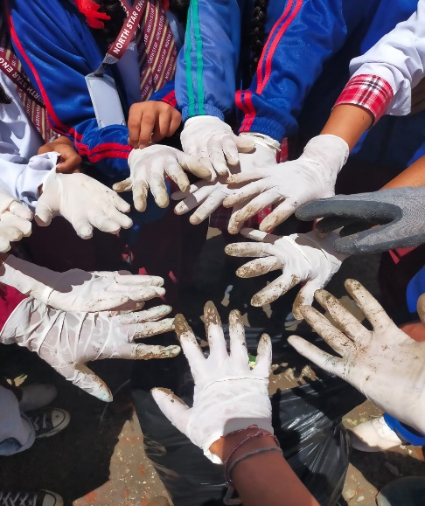Environmental protection ranks among the most urgent priorities in the modern world. Key aspects include tackling solid waste management issues in urban and rural Nepal, significantly impacting the environment and public health. Solid waste, a by-product of human activities, is increasing due to rapid urbanization, improved living standards, and changing consumption patterns. Effective waste management can turn it into a valuable resource, while poor handling leads to severe environmental degradation and health hazards.

In VIN’s working communities, including schools, improper waste disposal, such as food remains and other materials, is a significant problem. These issues contribute to littering and elevate the potential for public health crises. Children are particularly vulnerable to the adverse effects of poor waste management, facing risks such as respiratory problems from dumping site dust, diarrhea, skin diseases, and eye infections.

The prevalence of non-biodegradable waste (NBW) exacerbates the issue, particularly in urban and semi-urban areas. In Nepal, the challenge of NBW is especially evident in rural regions like Jitpurphedi, Kavresthali, and Okharpauwa, located near Kathmandu. This waste causes environmental degradation and impacts agricultural land, diminishing productivity and disrupting farmers' livelihoods who rely on local produce to support their families and livestock.

Preventing the build-up of NBW in communities is crucial, as it worsens sanitation-related diseases and degrades land quality. Tackling solid waste management issues in urban and rural Nepal necessitates prioritizing sustainable practices like waste segregation, recycling, and composting.

Under the theme “Environmental Stewards: Preserving Our Common Home,” this project aims to empower communities to adopt proactive waste management strategies. This initiative seeks to mitigate waste-related issues, improve public health, and promote Nepal's cleaner, greener future by raising awareness, encouraging sustainable practices, and implementing community-driven efforts.

**Objective:**

* Prevent and control water, land, and air pollution through environmental education and cleaning activities.

**Activities:-**

* Organize the waste management /Community clean-up campaign involving community people.
* Train local people on garbage management using the 3R principles: Reduce, Reuse, Recycle (segregation, disposal, domestic methodology for making compost fertilizer, etc.)
* Develop a kitchen garden concept and train the households to implement it.

**Location:**

**Jitpurphedi community is located in Tarakeshwor Municipality, on the outskirts of Kathmandu District. It is 10-15 km from the main ring road to Balaju, Kathmandu, covered with hills, fields, and woods.**

**Participation Fee:** The fee is 270 Euros (+30 Euros for transportation), payable upon arrival at the VIN Office.

[The detailed info sheet and acceptance letter will be sent from VIN after we receive your Complete Volunteer Exchange Form (VEF) from the sending organization.]

# Project 3: ****Creative Minds Library Camp: Inspiring Learning through Stories and Innovation**** (KIDS, EDU, CULT)

|  |  |  |  |  |  |  |  |  |
| --- | --- | --- | --- | --- | --- | --- | --- | --- |
| Code | Name of Project | Location | Date | Type | Total Vols. | Male | Female | Age |
| VINWC25-06 | **Creative Minds Library Camp: Inspiring Learning Through Stories and Innovation** | Okhaldhunga | 3 - 14 April 2025 | KIDS, EDU, CULT | 14 | 7 | 7 | 18+ |
| VINWC25-17 | **Creative Minds Library Camp: Inspiring Learning Through Stories and Innovation** | Okhaldhunga | 11-23 August 2025 | KIDS, EDU, CULT | 14 | 7 | 7 | 18+ |

**Background/Project:**

VIN constructed and opened the NaraTika Community Learning Center (NTCLC) in the tranquil village of Nisankhe, Okhaldhunga. This ambitious project is designed to support learners of all ages. It features a dedicated children’s center for children aged 3 to 8, a library for those aged eight and older, and facilities that include training rooms, a conference hall that accommodates 200 people, a workspace for 16-20 individuals, and a dormitory for 50-60 people.

The center features restrooms and showers for both men and women, a lobby, a computer lab, and a multipurpose seminar hall that offers extensive resources to support learning and community 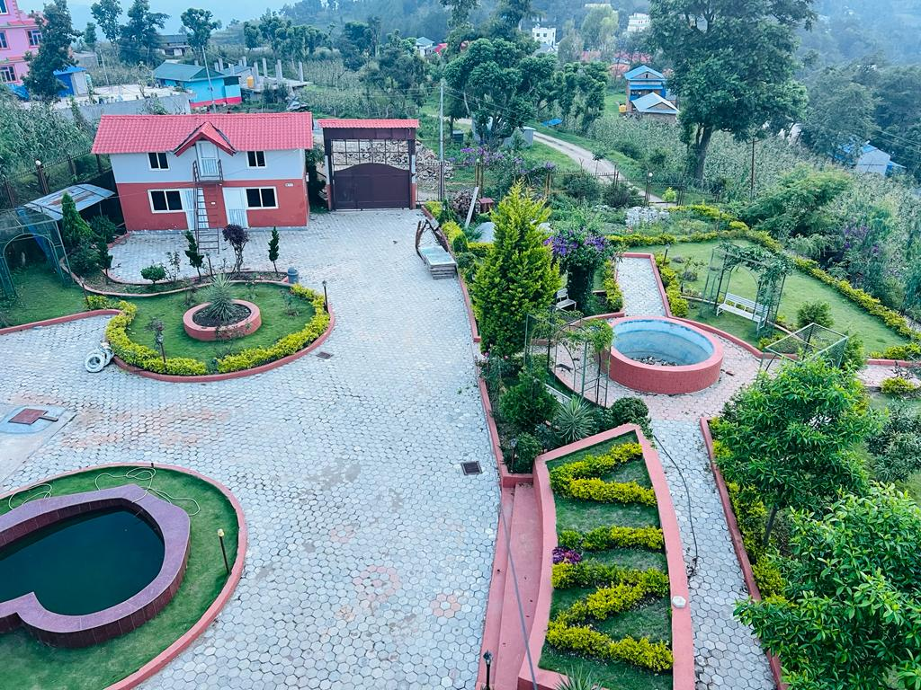development.

NTCLC is a dynamic hub for education, empowerment, and sustainable practices. It promotes lifelong learning and innovation and includes a vegetable farming plot developed using permaculture techniques, emphasizing environmental sustainability.

The center seeks to enhance literacy, creativity, and skill development for children, youth, women, and adults through its diverse programs and interactive learning space. It is looking for volunteers and interns to assist with the NaraTika Community Learning Center, which serves the underprivileged communities of Okahldhunga. This could be your ideal volunteer opportunity if you enjoy gardening, farming, painting, or other activities.

Volunteers at the "**Creative Minds Library Camp**: Enriching Young Minds Through Learning, Sparking Smiles" engage children aged 5 to 16 with interactive storytelling sessions that ignite their imaginations and cultivate a love for reading.

They organize library resources, create a welcoming reading environment, and establish catalog systems to enhance accessibility. Volunteers share stories to convey moral values, cultural traditions, and life skills while assisting children in overcoming literacy challenges. Activities such as mobile reading sessions, creative arts workshops, and support in writing stories or poems foster self-expression and creativity.

Additionally, volunteers deliver engaging English lessons through songs and rhymes, introduce educational games to foster critical thinking and teach teamwork, empathy, and communication skills through dynamic discussions. Storytelling and reading challenges further inspire children, making the camp a fulfilling and enjoyable experience.

**Objective:**

To enhance the literacy, creativity, and life skills of children aged 5-16 by fostering a love for reading, promoting self-expression through storytelling and arts, and providing opportunities to develop critical thinking, teamwork, and communication skills in a supportive and engaging environment.

**Work:**

* Conduct engaging storytelling sessions for children aged 5-16 to spark their imagination and instill a love for reading.
* 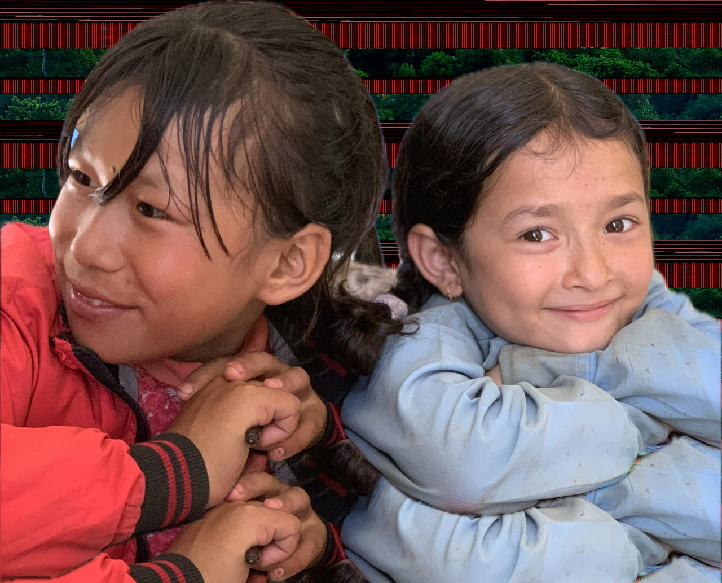Sort and catalog books to create an accessible library system. Design and decorate a welcoming, child-friendly reading space.
* Organize cleaning campaign in building and manage garden area.
* Visit local schools to organize mobile reading activities.
* Facilitate art and craft sessions to encourage creativity and self-expression.
* Help children write short stories, poems, or journals to develop their writing skills.
* Conduct games that promote critical thinking and problem-solving skills.
* Teach Basic English through songs, rhymes, and interactive activities.
* Use storytelling and discussions to teach moral values, teamwork, empathy, and communication skills.

**Location:**

Siddhicharan Municipality Ward 2 is located in Nisankhe, within the Okhaldhunga district, about 250 km from Kathmandu. A local jeep can transport you there in approximately 8 to 10 hours. This area highlights the beauty of Nepal’s hilly and mountainous landscape, surrounded by forests and fertile fields. For more information about the region and its development initiatives, visit [www.ntchc.org](http://www.ntchc.org).

**Participation Fee:** The total fee is 270 Euros, plus an additional 100 Euros for transportation, payable upon arrival at the VIN Office.

[The detailed info sheet and acceptance letter will be sent from VIN after we receive your Complete Volunteer Exchange Form (VEF) from the sending organization.]

# Project 4: ****Caring Hands Camp: Supporting Nepal’s Elderly with Love and Care****

## (MANU, CULT)

|  |  |  |  |  |  |  |  |  |
| --- | --- | --- | --- | --- | --- | --- | --- | --- |
| Code | Name of Project | Location | Date | Type | Total Vols. | Male | Female | Age |
| VINWC25-05 | **Caring Hands Camp** | Lapsephedi Kathmandu | 3 - 14 April 2025 | MANU, CULT, ENVI | 14 | 7 | 7 | 18+ |
| VINWC25-22 | **Caring Hands Camp** | Lapsephedi Kathmandu | 08 – 19 Oct 2025 | MANU, CULT, ENVI | 14 | 7 | 7 | 18+ |

**Background/Project:**

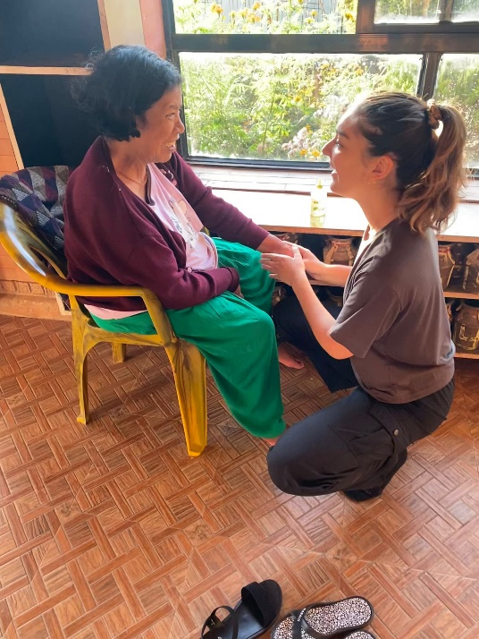 The concept of elder care has emerged relatively recently in Nepal, coinciding with shifts in familial structures and societal dynamics. As job opportunities disperse families, older adults increasingly find themselves marginalized, isolated, and neglected. Few care homes cater to older people throughout Nepal, highlighting a significant gap in support services.

Defined as individuals aged 60 and older, the elderly population in Nepal faces significant challenges, mainly related to poverty and lack of resources. A staggering majority cope with the lasting consequences of lifelong deprivation, worsened by factors such as limited access to education, inadequate healthcare, poor nutrition, reduced social status, widespread discrimination, and difficulties with physical mobility.

Traditionally, family structures in Nepal have upheld the responsibility of caring for older people within extended family homes. However, the landscape is evolving rapidly, characterized by smaller family units and increased participation of women and youth in the labor force. Additionally, migration from rural areas to urban centers or abroad in search of employment has further strained family bonds, leaving many older individuals isolated and struggling with loneliness.

Approximately 30% of Nepal's elderly population lives below the poverty line, struggling to meet their basic needs due to financial limitations and resources.

The standard health challenges faced by Nepal's elderly population include high rates of non-communicable diseases such as hypertension, diabetes, and arthritis. Additionally, respiratory illnesses like chronic obstructive pulmonary disease (COPD) are common, mainly due to factors such as indoor air pollution from traditional cooking methods. Studies indicate that approximately 40% of elderly individuals in Nepal experience social isolation, which arises from factors including changing family dynamics, the migration of younger generations for work, and a lack of community support systems designed to meet the needs of older adults.

These figures underscore the need for comprehensive support systems and initiatives to address the multifaceted challenges faced by Nepal's elderly population.

To address these issues, VIN organizes camps where volunteers can participate in this Elder Care project. The volunteers provide comprehensive support to elderly individuals in their daily activities, including health management, personal hygiene, and household cleaning, which helps enhance their well-being, happiness, and comfort.

**Objectives:**

* To provide comprehensive support to elderly individuals in their day-to-day activities, including health management, personal hygiene, and household cleaning, to enhance their overall well-being, happiness, and comfort in daily living.
* To promote friendship, understanding, and solidarity among local young volunteers and cross-national volunteers.
* To provide an opportunity to understand and appreciate the Nepalese culture and traditions via cultural immersion.

**Work / Activities:** Drawing from your experience, you will participate in various activities to support elderly individuals. This includes helping nurses care for sick, elderly individuals, performing health checks, and administering first aid as needed.

Additionally, you will act as a caretaker, ensuring the well-being and comfort of elderly residents. Your responsibilities will also include assisting with food preparation and maintaining sanitation standards. You will organize social and recreational activities to encourage engagement and happiness among the elderly residents. You will coordinate cleaning and possibly farming tasks to sustain a conducive living environment for the elderly home.

**Location: The Lapsephedi Community is located northeast of Kathmandu. Nestled amidst the serene foothills of the Himalayas, it offers a picturesque landscape characterized by lush greenery, terraced fields, and breathtaking mountain vistas. The community is approximately 40 kilometers from Kathmandu.**

**Participation Fee:** The fee is 270 Euros (+50 Euros for transportation), payable upon arrival at the VIN Office.

[The detailed info sheet and acceptance letter will be sent from VIN after we receive your Complete Volunteer Exchange Form (VEF) from the sending organization.]

# Project 5: ****Youth Empowerment & Festival of Colors Camp: Transforming Skills, Celebrating Culture**** (EDU, CULT, FESTIVE)

|  |  |  |  |  |  |  |  |  |
| --- | --- | --- | --- | --- | --- | --- | --- | --- |
| Code | Name of Project | Location | Date | Type | Total Vols. | Male | Female | Age |
| VINWC25-03 | Youth Empowerment and Festival of Color Camp. | Kathmandu | 06 – 17 March 2025 | EDU FESTIVE | 14 | 7 | 7 | 18+ |

**Part I: Youth Empowerment**

Youth from all countries represent the true wealth and future of their nations. In Nepal, young people comprise approximately 20.8 percent of the total population (ages 16-25), while 40.68 percent fall within the 16-40 age group. Despite being educated, they struggle to compete in the job market due to a lack of life skills and vocational training. Life skills enhance young people's well-being and help them develop into active and productive members of their communities.

For instance, the WHO defines life skills as “abilities for adaptive and positive behavior that empower individuals to handle the demands and challenges of everyday life effectively.” On the other hand, UNICEF describes them as a “broad range of psycho-social and interpersonal skills that can help individuals make informed decisions, communicate effectively, and develop coping and self-management abilities that may contribute to living a healthy and productive life.”

Youth empowerment is one of the significant programs in VIN’s Integrated Community Development Approach. It aims to empower youth socially and economically through education, life skills development, and entrepreneurship training. VIN welcomes volunteers worldwide to assist youth with life skills training, personality development, entrepreneurship training, and other related activities.

**Part II: Celebration of Holi Festival**

**Holi, also known as the Festival of Colors, is one of the most celebrated festivals in Nepal. It** symbolizes the triumph of good over evil and the arrival of spring. During this vibrant occasion, Nepalese people and foreign tourists joyfully toss dry powder and colored water at each other to convey their heartfelt blessings and good wishes. It also serves as a time to express gratitude for a plentiful harvest.

Holi is an ancient Hindu festival that has become popular among non-Hindus in various South Asian regions and communities beyond Asia. During the celebration, people gather with family, friends, and even rivals to toss colored powders at one another, laughing and chatting before enjoying delicious Holi food and drinks. This joyful display of colors occurs on open streets, in parks, and outside temples and buildings. Groups play drums and other musical instruments, moving from location to location to sing and dance.

The volunteers prepare and celebrate the Holi festival in the community.

**Objective:**

* To provide unique opportunities to today's youth to improve both in personal and professional life.
* To promote friendship, understanding, and solidarity among local and cross-national volunteers/youths.
* To provide opportunities for understanding and appreciation of the Nepalese culture and traditions via cultural immersion.

**Activities:-**

* Prepare and conduct different life skill sessions on public speaking/relation, team building and group work, communication skills, etc.
* Celebration of the festival of colors with positive energy in the community.

**Location:**

**Jitpurphedi community is located in Tarakeshwor Municipality, on the outskirts of Kathmandu District. It is about 10-15 km from the main ring road to Balaju, Kathmandu, surrounded by hills, fields, and woods.**

**Participation Fee:** The fee is 270 Euros (+30 Euros for transportation), payable upon arrival at the VIN Office.

[The detailed info sheet and acceptance letter will be sent from VIN after we receive your Complete Volunteer Exchange Form (VEF) from the sending organization.]

## Project 6: Permaculture & Holi Festival- Festival of Color: Sustainable Farming and Cultural Colors in Nepal (ENVI, AGRI, MANU)

|  |  |  |  |  |  |  |  |  |
| --- | --- | --- | --- | --- | --- | --- | --- | --- |
| Code | Name of Project | Location | Date | Type | Total Vols. | Male | Female | Age |
| VINWC25-04 | Permaculture (Sustainable food production) &  **Holi Festival – Festival of color**  . | Okhaldhunga | 06 – 18 March 2025 | ENVI, AGRI, MANU, FESTIVE | 14 | 7 | 7 | 18+ |
| VINWC25-08 | Permaculture (Sustainable food production) | Okhaldhunga | 08-19 May 2025 | ENVI, AGRI, MANU, | 14 | 7 | 7 | 18+ |
| VINWC25-10 | Permaculture (Sustainable food production)& | Okhaldhunga | 09 - 21 June 2025 | ENVI, AGRI, MANU | 14 | 7 | 7 | 18+ |
| VINWC25-12 | Permaculture (Sustainable food production) | Okhaldhunga | 09-21 July 2025 | ENVI, AGRI, MANU | 14 | 7 | 7 | 18+ |
| VINWC25-15 | Permaculture (Sustainable food production) | Okhaldhunga | 17 -28 July 2025 | ENVI, AGRI, MANU | 14 | 7 | 7 | 18+ |
| VINWC25-23 | Permaculture (Sustainable food production) | Okhaldhunga | 08 Sep – 20 Sep 2025 | ENVI, AGRI, MANU | 14 | 7 | 7 | 18+ |
| VINWC25-25 | Permaculture (Sustainable food production) | Okhaldhunga | 07 – 18 Dec 2025 | ENVI, AGRI, MANU | 14 | 7 | 7 | 18+ |

**Background/Project:**

**Part I: Permaculture (Sustainable food production)**

VIN’s Environmental and Conservation Programs raise community awareness of critical environmental issues and develop effective solutions. VIN runs various ecological projects that aim to conserve, promote, and protect the environment and culture while preventing, mitigating, and controlling water, land, and air pollution to enhance the health, safety, and welfare of current and future generations. We utilize permaculture for sustainable farming and have been teaching and implementing it since 2018. We believe that permaculture plays a vital role in restoring the entire ecosystem!

Agriculture provides subsistence and employment for 80% of Nepal's population, accounting for approximately 39 % of the total GDP. The sector's development is crucial for empowering those who rely on it and for the national economy.

Since Nepal is in the Himalayan region, climate change has significantly impacted the country. Water sources are drying up, new types of moths and insects have emerged, and the timing of crop cultivation has shifted. Unexpected climate changes, unpredictable rainfall, droughts, and more are the consequences of global warming that Nepalese farmers are facing.

**12 Principles of Permaculture**

* **Observe and interact**—Let’s slow down and appreciate our surroundings and others. Let’s also slow down and interact with others in real life, not on our phones.
* **Catch and store energy—**Relax to restore balance and energy. This means associating with those who bring positive energy and doing things that bring joy and energize me, like running and learning.
* **Obtain a yield. In permaculture, t**his might mean planting to create the most food. The food is the reward. In life, we can work to obtain an intrinsic or extrinsic reward. These rewards need not be strictly financial. Perhaps the reward makes a difference in your client’s life or makes your coworker’s day a little easier.
* **Apply self-regulation and accept feedback.** Self-regulation or self-control allows us to be accountable and empowers us. Feedback helps us improve, which will help us excel at work.
* 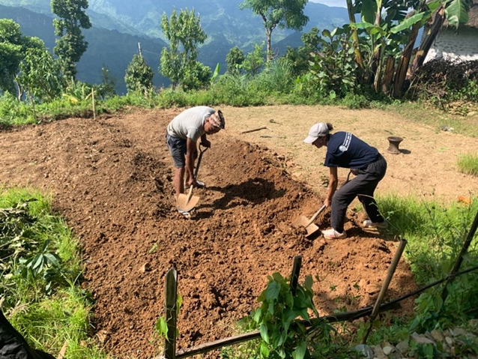**Use and value renewable resources and services and produce no waste-** These principles are common tips for living an eco-friendly lifestyle and creating a more sustainable world.
* **Design from patterns to details**- Permaculture calls for standing back and observing patterns in nature and society and then filling in the details; this might also make for a more efficient and logical way to work.
* **Integrate rather than segregate, use, and value diversity—**These principles perfectly describe how we should all live in harmony with each other. We should integrate everyone into our communities and value diversity.
* **Use small and slow solutions.** Permaculture uses small and slow solutions because they are easier to manage than more prominent solutions and allow for the use of local resources, leading to more sustainable outcomes. While this may not always be feasible—sometimes, we need significant and fast solutions to solve some of society’s most critical problems—this principle can be a valuable problem-solving tool.
* **Use edges and value the marginal.** Permaculture suggests that the interface between things is where the most interesting things happen. These are often the system's most valuable, diverse, and productive parts. For example, extending a community garden onto an edge near an unused railway might be a good idea. In life and work, we can use our resources more effectively, including the edges.
* **Creatively use and respond to change—**This principle requires no explanation, but it remains essential in life and works in a changing world. To remain a viable and sustainable business and to live well, we must be resilient and creatively work with change.

Using these principles, we can create a better life and a better world by caring for the earth and caring for people.

**Part II: Celebration of Holi Festival (VINWC25-04)**

**Holi, also known as the Festival of Colors, is one of the most popular festivals in Nepal. It** celebrates the triumph of good over evil and the arrival of spring. Throughout this vibrant festival, Nepalese people and foreign tourists throw dry powder and colored water at each other to express their blessings and good wishes. Additionally, Holi is a way to thank God for a bountiful harvest.

Holi is an ancient Hindu religious festival that has gained popularity among non-Hindus in many parts of South Asia and various communities outside of Asia. During the festival, people gather with family, friends, and even rivals to throw colored powders at one another, share laughter and gossip, and enjoy Holi delicacies, food, and drinks. The festivities, filled with color and joy, occur in the open streets, parks, and outside temples and buildings. Groups carry drums and other musical instruments, moving from place to place as they sing and dance.

The volunteers prepare and celebrate the Holi festival (festival of colors) in the community.

**Work- Permaculture**

As a volunteer, you will collaborate with the farmer’s VIN, which specializes in permaculture. The work is typically hands-on, and you’ll design the farm according to permaculture principles, including cultivating crops, weeding, irrigating, gathering materials, digging, and creating beds.

Support farmers in making organic fertilizers like compost.

Observe, interact, learn and implement.

**Location:**

Siddhicharan Municipality Ward 2 is located in Nisankhe, Okhaldhunga district, approximately 250 km from Kathmandu. A local jeep can reach it in 8-10 hours. This region showcases the beauty of Nepal’s hilly and mountainous terrain, surrounded by woods and fertile fields. For more information about the area and its development initiatives, visit [www.ntchc.org](http://www.ntchc.org).

**Participation Fee:** The fee is 270 Euros (+ 100 Euros for transportation), payable upon arrival at the VIN Office.

[The detailed info sheet and acceptance letter will be sent from VIN after we receive your Complete Volunteer Exchange Form (VEF) from the sending organization.]

## Project 7: Children’s Summer Camp (KIDS, EDU, SPOR & CULT)

|  |  |  |  |  |  |  |  |  |
| --- | --- | --- | --- | --- | --- | --- | --- | --- |
| Code | Name of Project | Location | Date | Type | Total Vols. | Male | Female | Age |
| VINWC25-11 | Children’s Summer Camp | Okhaldhunga | 09-21 July 2025 | KIDS, EDU, SPOR & CULT | 14 | 7 | 7 | 18+ |
| VINWC25-14 | Children’s Summer Camp | Okhaldhunga | 17 -28 July 2025 | KIDS, EDU, SPOR & CULT | 16 | 8 | 8 | 18+ |

**Background/Project:** Children's Development is one of the major programs in VIN's Integrated Community Development Approach. The Goal of the Children's development program is to protect the rights of all children by providing them access to basic quality education, developing their life skills & providing access to health services through community health programs.

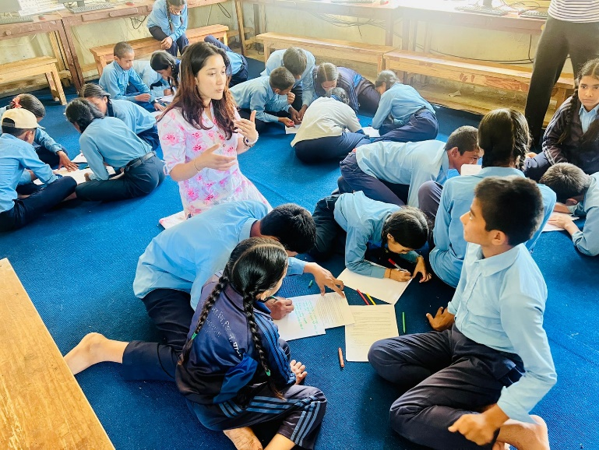Even recently, schools in Nepal have focused on examinations and done little to develop students' creativity. Teachers only focus on reading and writing—**rote learning**. Children's creativity is not explored. Due to parents' busy work schedules, most children do not have the opportunity to socialize and be creative. Such camps are essential to provide opportunities for socialization and creativity for children (aged 6-12).

At VIN’s working area in Okhaldhunga, children lack the proper structure and environment to develop their innate talents at home or school. Children's camp (in winter and summer) is one of the best places to explore their natural talents and creativity. At this work camp, national and international volunteers facilitate different fun and creative activities for the target children where VIN works.

**Objectives:**

* The goal is to offer children aged 5 to 12 a unique opportunity for overall development, focusing on their social, emotional, physical, mental, and creative growth while ensuring they have a fun and productive vacation.
* To foster friendship, understanding, and solidarity between local young volunteers and international volunteers.
* To provide a chance to experience and appreciate Nepalese culture and traditions through cultural immersion.

**Work / Activities:**

Volunteers can engage children in fun and educational activities during a Summar camp and promote overall development.

**Physical Exercises:** To promote health and well-being, exercise yoga, stretching, sports, or simple fitness routines.

**Team-Building Sessions:** Organize games and group challenges to encourage collaboration, communication, and social skills.

**Creative Workshops:** Facilitate drawing, coloring, painting, crafting, and origami sessions to inspire creativity and self-expression.

**Performing Arts:** Teach singing, dancing, drama, and music to boost confidence, enhance creativity, and provide entertainment.

**Outdoor Exploration:** Plan hikes, nature walks, or outdoor play to combine learning with physical activity and appreciation of the environment.

**Language Teaching:** To help children improve their communication skills, teach them new vocabulary, practice conversational language, or introduce basic phrases in different languages.

**Location:** Okhaldhunga district is 250 km from Kathmandu. Traveling by bus takes 8-9 hours. The region is hilly and mountainous, surrounded by woods and fields.

**Location:**

Siddhicharan Municipality Ward 2 is located in Nisankhe, Okhaldhunga district, approximately 250 km from Kathmandu. A local jeep can reach it within hours. This region showcases the beauty of Nepal’s hilly and mountainous terrain, surrounded by woods and fertile fields. For more information about the area and its development initiatives, visit [www.ntchc.org](http://www.ntchc.org).

**Participation Fee:** The fee is 270 Euros (+ 100 Euros for transportation), payable upon arrival at the VIN Office.

**Note: If we receive fewer than four participants, we will organize this Work camp in another community near Kathmandu.**

(The detailed info sheet and acceptance letter will be sent from VIN after we receive your Complete Volunteer Exchange Form (VEF) from the sending organization)

## Project 8: Raising Peace Campaign (EDU, CULT)

|  |  |  |  |  |  |  |  |  |
| --- | --- | --- | --- | --- | --- | --- | --- | --- |
| Code | Name of Project | Location | Date | Type | Total Vols. | Male | Female | Age |
| VINWC25-21 | Raising Peace Campaign | Kathmandu | 08 Sep – 20 Sep 2025 | EDU, CULT | 14 | 7 | 7 | 18+ |

**Background/Project:**

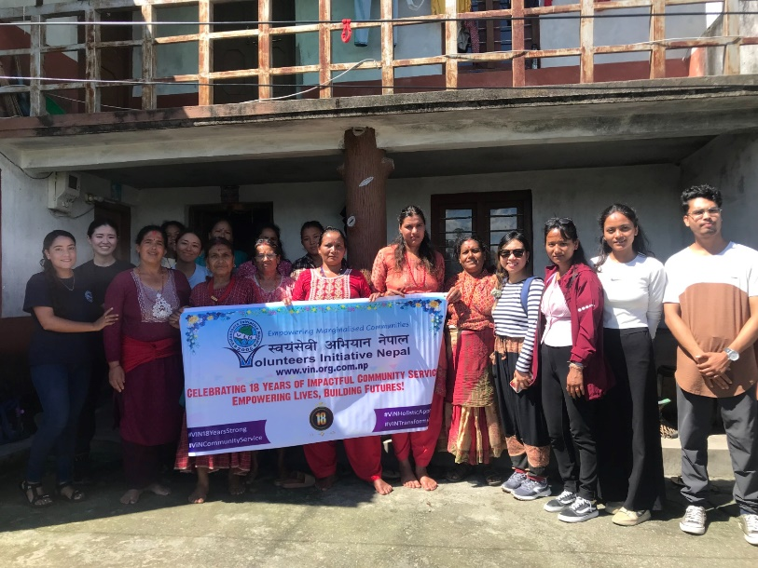Historically, violence against women and girls has been widespread in Nepali society but is still an unreported problem in Nepal. It is reported that one-third of married women have experienced emotional, physical, or sexual violence from their spouse in their marital relationship. The women experience violence when trafficked into forced labor or prostitution. Between 5,000 and 12,000 girls and women aged 10 to 20 years of age are trafficked every year, 75 percent of whom are below 18 years of age, and the majority of whom are sold into forced prostitution.

In Nepal, there exist six kinds of violence against women and girls, mainly sexual abuse, incest, and rape by family members and others; recruitment by family members into prostitution; neglect by family members, even to the point of death, feticide, and infanticide, dowry demand and wife abuse.   
  
This project aims to provide human rights education from professionals through awareness-raising campaigns to people, especially women and girls. Different activities like Drama performance education in public with the message of 'Say "NO" to Violence against Women' will be conducted. A forum in a public place for interaction with local community people is organized to have interaction on Women's Violence, problems, and their solutions.  The target population is community leaders, teachers, women's groups, and teenage girls. It aims to develop peace and protect human rights.

**Objectives:**

* To raise awareness in the local community against violence among women.
* Aware people of women's rights and implement those at the local level.

**Work and activities:**

* Conduct awareness sessions for men and women about violence among women
* Organize an open forum in a public place for interaction with local community people on women's violence, problems, and their solutions.
* Develop educational materials.

**Location:**

**Jitpurphedi community is located in Tarakeshwor Municipality, on the outskirts of Kathmandu District. It is 10-15 km from the main ring road to Balaju, Kathmandu, covered with hills, fields, and woods.**

**Participation Fee:** The fee is 270 Euros (+30 Euros for transportation), payable upon arrival at the VIN Office.

[The detailed info sheet and acceptance letter will be sent from VIN after we receive your Complete Volunteer Exchange Form (VEF) from the sending organization.]

## Project 9: Art & crafts with Children (ARTS, KIDS)

|  |  |  |  |  |  |  |  |  |
| --- | --- | --- | --- | --- | --- | --- | --- | --- |
| Code | Name of Project | Location | Date | Type | Total Vols. | Male | Female | Age |
| VINWC25-09 | Art and crafts with children | Kathmandu | 09-20 June 2025 | ARTS, KIDS, EDU | 14 | 7 | 7 | 18+ |
| VINWC25-13 | Art and crafts with children | Kathmandu | 09 -20 July 2025 | ARTS, KIDS, EDU | 14 | 7 | 7 | 18+ |
| VINWC26-02 | Art and crafts with children | Kathmandu | 10 -21 Feb 2026 | ARTS, KIDS, EDU | 14 | 7 | 7 | 18+ |

**Art & crafts with Children**

Art is often considered the process or product of deliberately arranging elements to appeal to the senses or emotions. It encompasses various human activities, creations, and ways of expression, including music, literature, film, sculpture, and paintings.

Children of all ages love arts and crafts. They love getting creative and messy and admiring their masterpieces when they are finished. The great thing about arts and crafts is that they aid children's development in many other areas.

When children manipulate a paintbrush, their fine motor skills improve. They experiment with materials and dabble in science. Most importantly, when kids feel good while creating, art helps boost their self-confidence. This unrestricted exploration helps children form brain connections, learn, and have fun. It is a natural activity that supports this free play in children.

Art and craft are fundamental to our everyday lives, and encouraging children to learn about them will only benefit them as they grow older. Art can help children develop **feeling**s, while craft can develop **thinking** and **coordination** skills. Art communicates a familiar story that can bring us all together as humans. Art is essential because other humans are essential, allowing us to understand each other.

This project was developed to improve children's creativity. It aids children in thinking creatively and learning to connect with their imagination. Creativity can make children happier. Children express their emotions through arts and crafts, which makes them feel calmer and happier. Art and crafts projects are excellent for children's development. They allow children to 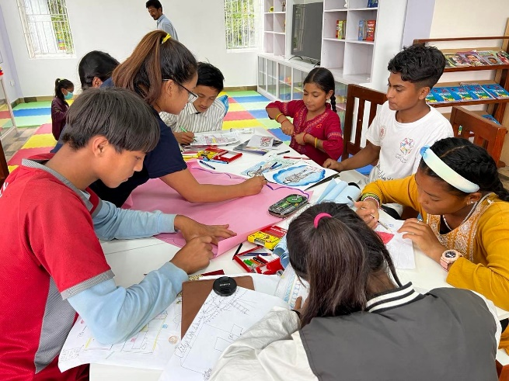practice their skills, such as coordination (e.g., cutting and shaping), understanding shapes and colors, and exploring their hidden interests and talents.

Both ways can bring about positive life-enhancing change for you and the Nepalese people. As a volunteer, you will be given the unique opportunity to teach arts and crafts of your choice and learn the trade through the artistic lens of the Nepalese people. Arts and crafts would also include dance. Here's your chance to make a creative difference in Nepal through art.

**Objective:**

* To allow children to develop their creativity through arts and crafts.
* To promote friendship, understanding, and solidarity among local young volunteers and cross-national volunteers.
* Understand the importance of the Holi festival and know how it is celebrated.

**Activities: -**

* Develop and conduct a session for the children to draw, paint, create gifts and crafts, or express themselves artistically.
* Organize the activities of origami, collage work, music, dance, etc.

**Location :**

**Jitpurphedi community is located in Tarakeshwor Municipality, on the outskirts of Kathmandu District. It is about 10-15 km from the main ring road to Balaju, Kathmandu, surrounded by hills, fields, and woods.**

**Participation Fee:** The fee is 270 Euros (+30 Euros for transportation), payable upon arrival at the VIN Office.

[The detailed info sheet and acceptance letter will be sent from VIN after we receive your Complete Volunteer Exchange Form (VEF) from the sending organization.]

## Project 10: Library & Festive Camp (EDU, SOCI, FESTIV MANU)

|  |  |  |  |  |  |  |  |  |
| --- | --- | --- | --- | --- | --- | --- | --- | --- |
| Code | Name of Project | Location | Date | Type | Total Vols. | Male | Female | Age |
| VINWC25-19 | Library  & Festive Camp | Kathmandu | 21 Aug - 01 September 2025 | EDU, SOCI, KIDS, MANU, CULT | 14 | 7 | 7 | 18+ |

**Background/Project:**

**Part I -Library**

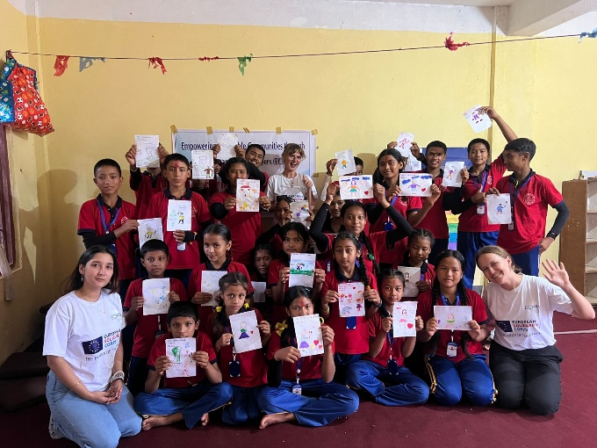A library is a collection of sources of information and similar resources made accessible to a specific community/school for reference or borrowing. It provides physical or digital access to material, a physical building or room, a virtual space, or both. Learners are at the center of learning in the library. In Nepal, there is not enough training for teachers and children on using a library. So, through this camp, volunteers will organize teaching and learning activities using library resources. It's an enjoyable and creative way of learning.

Work camps will be organized with the cooperation of local community schools under VIN's children's development program and working together with local teachers/children/ villagers.

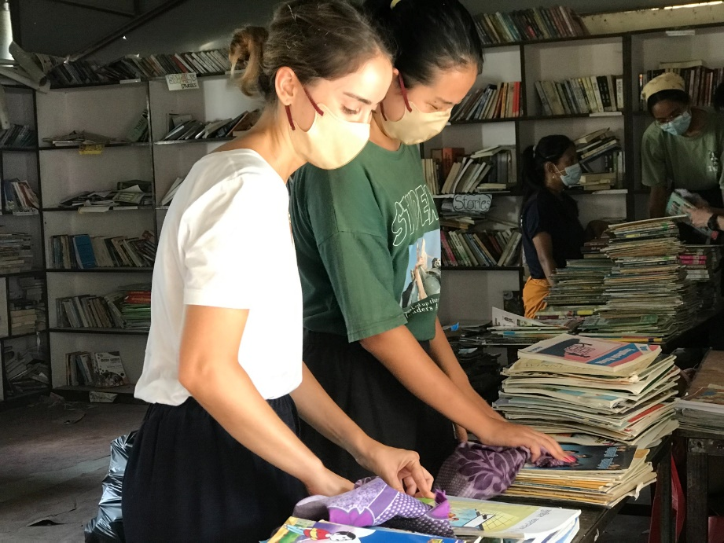The schools where we are conducting camps lack a library and other infrastructure facilities. Some schools have some collections, but they are poorly managed and used. The rooms are poorly painted, and books are not arranged properly. Children are not taught the skills of using a library and its importance.

Volunteers will manage the library, organize activities with schoolchildren, and conduct classes on library management and use. The library camp will help children develop reading and writing skills. Volunteers with abilities in sports, arts and crafts, music, dance, drama, and outdoor group games are welcome.

Through this project, we want to ensure that every student has the opportunity to learn, enjoy reading, and create new knowledge and understanding using a library.

**Objectives:**

* To work for a children's development project and exchange experience
* Help the school manage its library and teach children to use it regularly.
* To promote the library.

**Work:**

* Clean and maintain the library.
* Arrangement of resources in the library and record them in proper order.
* Paint and decorate the library room.
* Conduct the session with children and teachers to ensure the appropriate use of the library.
* Organize different reading and writing activities with children using the library.
* Conduct different activities to promote the library.

**Part II Festive Camp**

**Teej celebration**

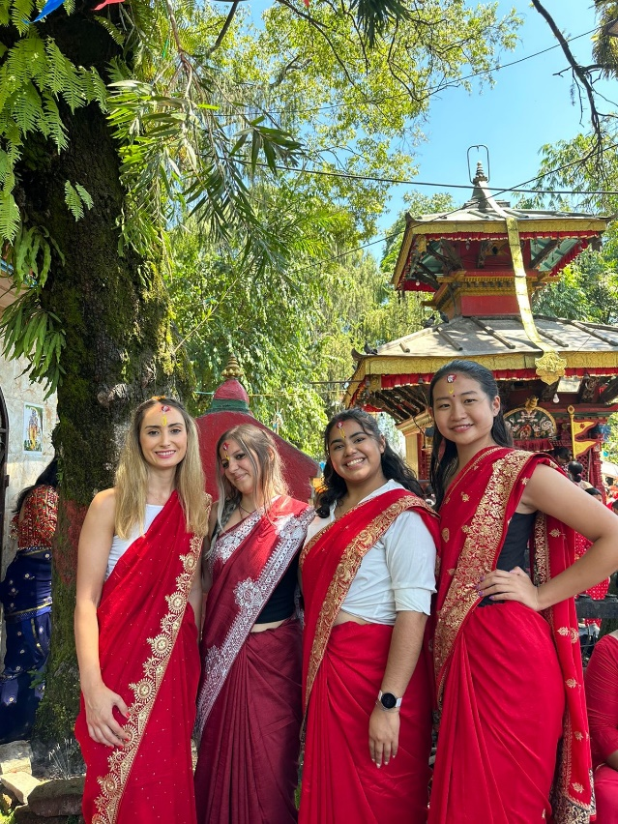Teej is a festival celebrated by Nepali women for the long life of their husbands and the long and firm relationship between them until the death of this life and all the lives to come. Teej is observed for marital happiness, the well-being of spouse and children, and the purification of one’s body and soul. Teej is the most famous festival among Nepali women. Teej is a tiny red insect that emerges from the soil during the rainy season. It is said Teej got its name from the same red insect. That is why Teej is celebrated in Red.

Decked up in red sarees, red tika, and bangles, women sing and dance to traditional folk songs for days. It is especially significant for married women when they get a special invitation to visit their maternal home and feast. It is a sight to behold at the Pashupatinath temple, where thousands of women draped in Red and green throng the temple's premises. Observers can take photos of these women dancing merrily, where foreigners, especially women tourists, are sometimes requested to participate in the merry-making.

The eve (first day of Teej) is called Dar Khane Din. This evening, the grand feast takes place. The grand feast is called "Dar."

The second day is Teej's primary day (fasting day). Some women take it very rigid. They even live without a piece of food and drops of water, while some others take liquid and fruit.

On the third day, women get up early at dawn, get cleaned, and do the puja again. Only after this puja do women take solid food.

The fourth and final day is called Rishi Panchami.  After completing the previous day's pooja, women pay homage to various deities and bathe with red mud found on the roots of the sacred Datiwan bush and its leaves. This act of purification is the final ritual of Teej, after which women are considered forgiven for all their sins."

**Objective:**

* Understand the importance of the Teej festival and know how it is celebrated.
* Understanding of Nepali culture and participating in the celebration.

**Activities: -**

* To celebrate Teej with women who have positive energy in the community.
* Participate in dancing with the community women
* Cultural exchange

**Location:**

**Jitpurphedi community is located in Tarakeshwor Municipality, on the outskirts of Kathmandu District. It is 10-15 km from the main ring road to Balaju, Kathmandu, covered with hills, fields, and woods.**

**Participation Fee:** The fee is 270 Euros (+30 Euros for transportation), payable upon arrival at the VIN Office.

[The detailed info sheet and acceptance letter will be sent from VIN after we receive your Complete Volunteer Exchange Form (VEF) from the sending organization.]

## Project 11: Creative Classrooms: Enhancing Schools and Inspiring Young Minds & Festive Camp (KIDS, EDU CULT)

|  |  |  |  |  |  |  |  |  |
| --- | --- | --- | --- | --- | --- | --- | --- | --- |
| **Code** | **Name of Project** | **Location** | **Date** | **Type** | **Total Vols.** | **Male** | **Female** | **Age** |
| VINWC25-20 | Creative Classrooms: Enhancing Schools and Inspiring Young Minds & Festive Camp | Okhaldhunga | 21 Aug - 02 September 2025 | KIDS, EDU CULT | 14 | 7 | 7 | 18+ |

**Background/Project:**

**Part I- Creative Classrooms: Enhancing Schools and Inspiring Young Minds**

Okhaldhunga, District of the Himalayas - This small paradise is in the Everest Region. It is located in the North-East part of Nepal. Okhaldhunga is one of the most beautiful places in Nepal. If Okhaldhunga is viewed with a sacred vision, it has numerous fascinating sights. VIN's Project site (Taluwa, Bhadaure, and Thulachhap communities) is southeast of the district headquarters, Okhaldhunga. From Kathmandu, the bus route is about 250 km, a rough trip that takes one day (7-9 hrs). In Okhaldhunga, VIN implements an integrated approach to community development.

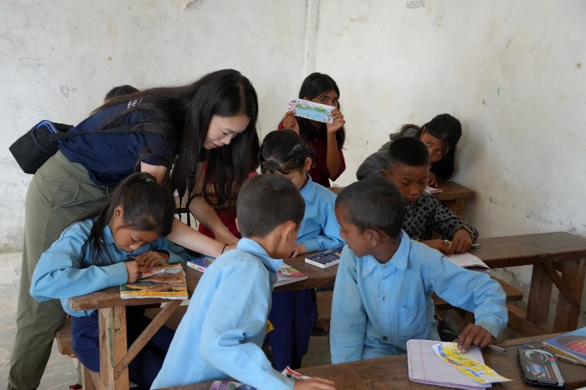Because of its geographical situation, Okhaldhunga has limited developmental activities and facilities. Unlike Kathmandu, it has several illiterate people. Okhaldhunga lacks proper education facilities. Due to this, young people move from Okhaldhunga to other cities like Kathmandu or fly abroad to secure appropriate education. There are schools, but they don't impart quality education. Not many people complete high school due to poverty, lack of good schools and resources, and geographical remoteness.

According to VIN's baseline survey, only 91.56% of children have been attending school regularly, but 1.44% of children are not regularly in school. Similarly, 10.42% of students drop out of school. 2.99% of families are well aware of child rights, and 20.69% know a fair amount about child rights. But, 76.30% of families do not know anything about child rights. Most children who drop out are involved in household work, field/farm work, household plowing, agriculture labor, collecting grass/firewood, grazing cattle, etc.

“Creative Classrooms: Enhancing Schools and Inspiring Young Minds”Work camps will be organized with local community schools and stakeholders to create a child-friendly teaching and learning environment. Most schools lack basic infrastructure, such as buildings, educational materials, playgrounds, and drinking water. Volunteers can make a big difference in the daily lives of these children by providing the necessities listed above and educating them in fun and creative ways.

The work camp will also teach children from poor and marginalized communities about Basic English, mathematics, Health, and Hygiene in formal and non-formal schools. Environmental protection through creative learning methods like art, music, games, house visits, and local meetings will also be held with people as part of intercultural learning and health and hygiene awareness. In addition, volunteers will also get a chance to participate in simple renovation work at local schools and engage in activities. Volunteers will witness and participate in the cultural programs with the local community as part of the cultural exchange.

**Objectives:**

* To create a child-friendly learning environment for the children of Okhaldhunga by developing resources and educational activities;
* To provide children from disadvantaged communities a unique opportunity for overall development (social, emotional, physical, mental, and creativity) & provide a fun time for children aged 6-12.
* To promote friendship, understanding, and solidarity among local, young, national, and international volunteers.

**Work:** Paint and decorate the classrooms. Renovate school areas, walls, etc. Teach students Basic English and mathematics. Play sports, Teach Basic English and mathematics, health and hygiene, and environmental protection through creative learning methods like art, music, games, etc.

**Part II Festive Camp**

**Teej celebration**

Teej is a festival celebrated by Nepali women for the long life of their husbands and the long and firm relationship between them until the death of this life and all the lives to come. Teej is observed for marital happiness, the well-being of spouse and children, and the purification of one’s body and soul. Teej is the most famous festival among Nepali women. Teej is a tiny red insect that emerges from the soil during the rainy season. It is said Teej got its name from the same red insect. That is why Teej is celebrated in Red.

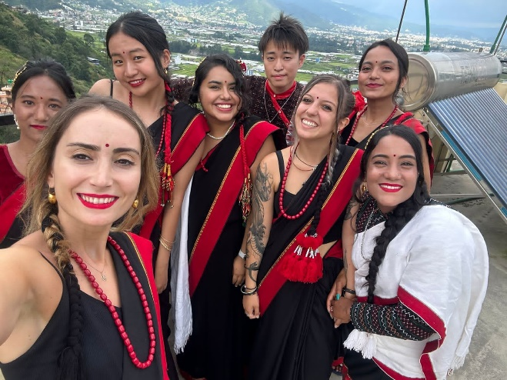Decked up in red sarees, red tika, and bangles, women sing and dance to traditional folk songs for days. It is especially significant for married women when they get a special invitation to visit their maternal home and feast. It is a sight to behold at the Pashupatinath temple, where thousands of women draped in Red and green throng the temple's premises. Observers can take photos of these women dancing merrily, where foreigners, especially women tourists, are sometimes requested to participate in the merry-making.

The eve (first day of Teej) is called Dar Khane Din. This evening, the grand feast takes place. The grand feast is called "Dar."

The second day is Teej's primary day (fasting day). Some women take it very rigid. They even live without a piece of food and drops of water, while some others take liquid and fruit.

On the third day, women get up early at dawn, get cleaned, and do the puja again. Only after this puja do women take solid food.

The fourth and final day is called Rishi Panchami.  After completing the previous day's pooja, women pay homage to various deities and bathe with red mud found on the roots of the sacred Datiwan bush and its leaves. This act of purification is the final ritual of Teej, after which women are considered forgiven for all their sins."

**Objective:**

* Understand the importance of the Teej festival and know how it is celebrated.
* Understanding of Nepali culture and participating in the celebration.

**Activities: -**

* To celebrate Teej with women who have positive energy in the community.
* Participate in dancing with the community women
* Cultural exchange

**Location:**

Siddhicharan Municipality Ward 2 is located in Nisankhe, Okhaldhunga district, approximately 250 km from Kathmandu. A local jeep can reach it in 8-10 hours. This region showcases the beauty of Nepal’s hilly and mountainous terrain, surrounded by woods and fertile fields. For more information about the area and its development initiatives, visit [www.ntchc.org](http://www.ntchc.org).

**Participation Fee:** The fee is 270 Euros (+ 100 Euros for transportation), payable upon arrival at the VIN Office.

* **Note: If we receive fewer than four participants, we will organize this Work camp in another community near Kathmandu.**

(The detailed info sheet and acceptance letter will be sent from VIN after we receive your Complete Volunteer Exchange Form (VEF) from the sending organization)

## Project 12: Health and Wellness (HEALTH, EDU)

|  |  |  |  |  |  |  |  |  |
| --- | --- | --- | --- | --- | --- | --- | --- | --- |
| Code | Name of Project | Location | Date | Type | Total Vols. | Male | Female | Age |
| VINWC25-18 | Health and Wellness | Kathmandu | 03-14 August 2025 | HEALTH, EDU | 14 | 7 | 7 | 18+ |

Nepal faces significant challenges as a developing country, with over 25% of its population living below the poverty line. Ranked 145th on the Human Development Index, the government has a life expectancy of 70.7 years. Malnutrition affects 29% of children under the age of five, and access to health and sanitation facilities remains severely limited. In many rural and underserved communities, awareness of proper hygiene practices is minimal, with only 12% of poor households having adequate sanitation facilities. Furthermore, about 5.6 million people, or 20% of the population, lack access to clean drinking water, creating additional health risks.

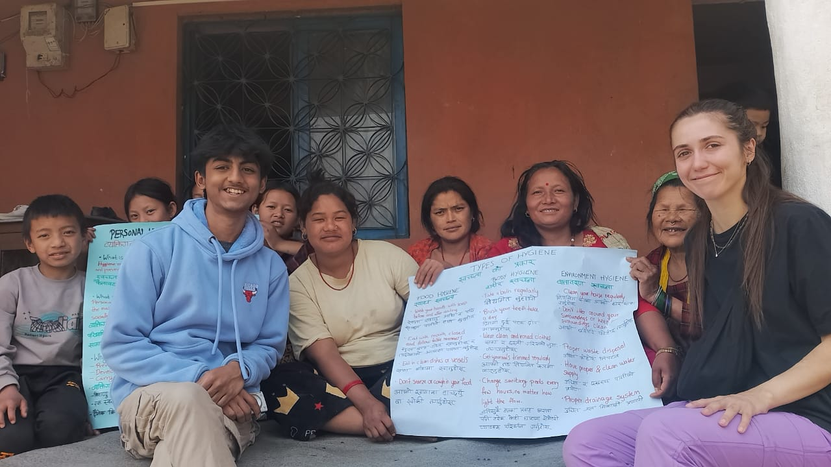Sanitation, hygiene, and access to safe water are crucial for improving health outcomes and fostering social and economic development. These factors are integral to achieving the Sustainable Development Goal of equitable sanitation for all. Without them, communities remain vulnerable to WASH-related diseases exacerbated by poor garbage disposal practices. These issues threaten public health and harm the environment. There is an urgent need for education and advocacy campaigns to raise awareness and drive lasting change in water, sanitation, and hygiene practices.

Through its project, Volunteers Initiative Nepal (VIN) aims to address these challenges by educating local communities, particularly children, about health, hygiene, and sanitation. Volunteers will raise awareness about WASH standards and prepare communities for future pandemic management. They will work with youth and rural populations, using innovative approaches and tools designed in consultation with the VIN team to ensure they meet the specific needs of the local context.

**Objectives:**

To enhance community awareness and practices related to water, sanitation, hygiene (WASH), and health standards by educating rural populations and youth, fostering sustainable behavior changes, and reducing the prevalence of health-related diseases.

To strengthen community resilience and preparedness for future health challenges through volunteer-led advocacy, innovative tools, and targeted capacity-building programs tailored to local needs

**Work and activities:**

Volunteers will play a key role in educating and raising awareness among youth, children, and rural communities about water, sanitation, and hygiene (WASH). They are encouraged to bring innovative ideas and develop tools tailored to the local context in consultation with the VIN team.

* Educating communities about safe water practices and preventing waterborne diseases.
* Raising awareness about health, hygiene, and sanitation in schools and the community.
* Organizing cleanliness drives in schools and neighborhoods to promote a cleaner environment.
* Utilizing creative mediums such as charts, slogans, posters, banners, T-shirts, quotes, videos, films, photographs, and discussions effectively engages and educates villagers.

**Location:**

**Jitpurphedi community is located in Tarakeshwor Municipality, on the outskirts of Kathmandu District. It is about 10-15 km from the main ring road to Balaju, Kathmandu, surrounded by hills, fields, and woods.**

**Participation Fee:** The fee is 270 Euros (+30 Euros for transportation), payable upon arrival at the VIN Office.

[The detailed info sheet and acceptance letter will be sent from VIN after we receive your Complete Volunteer Exchange Form (VEF) from the sending organization.]

## Project 13: Social Event - International Volunteer Day celebration (MANU, EDU)

|  |  |  |  |  |  |  |  |  |
| --- | --- | --- | --- | --- | --- | --- | --- | --- |
| Code | Name of Project | Location | Date | Type | Total Vols. | Male | Female | Age |
| VINWC25-24 | Social Event - International Volunteer Day celebration | Kathmandu | 25 Nov – 6 Dec 2024 | MANU, EDU, FESTIV | 14 | 7 | 7 | 18+ |

**Background/Project:**

International Volunteer Day is a chance for individual volunteers, communities, and organizations to promote their contributions to development at the local, national, and international levels. By combining United Nations (UN) support with a grassroots mandate, International Volunteer Day is a unique opportunity for people and volunteer-involving organizations to work with government agencies, non-profit institutions, community groups, academia, and the private sector.

The United Nations General Assembly adopted the International Volunteer Day for Economic and Social Development through resolution on 17 December 1985.

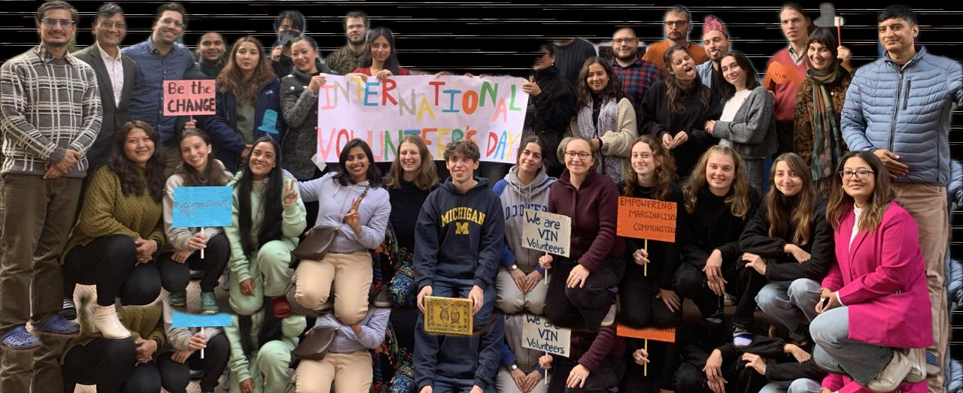Every year, VIN celebrates International Volunteer Day with specific activities to get international and national volunteers involved. This day is celebrated to recognize each volunteer's contributions through their work.

**Objectives:**

To promote awareness and recognition of volunteerism as a powerful tool for community development and social impact.

To foster collaboration among volunteers and stakeholders at local, national, and international levels, highlighting the contributions of volunteers to economic and social development.

**Work and activities:**

* Make a presentation on Volunteerism
* Arrangement for the Volunteer Day
* Plan and implement unique activities (Arts, quizzes, games, fun activities) during the International Volunteer Day

**Location:**

**Jitpurphedi community is located in Tarakeshwor Municipality, on the outskirts of Kathmandu District. It is about 10-15 km from the main ring road to Balaju, Kathmandu, surrounded by hills, fields, and woods.**

**Participation Fee:** The fee is 270 Euros (+30 Euros for transportation), payable upon arrival at the VIN Office.

[The detailed info sheet and acceptance letter will be sent from VIN after we receive your Complete Volunteer Exchange Form (VEF) from the sending organization.]

# Some pictures

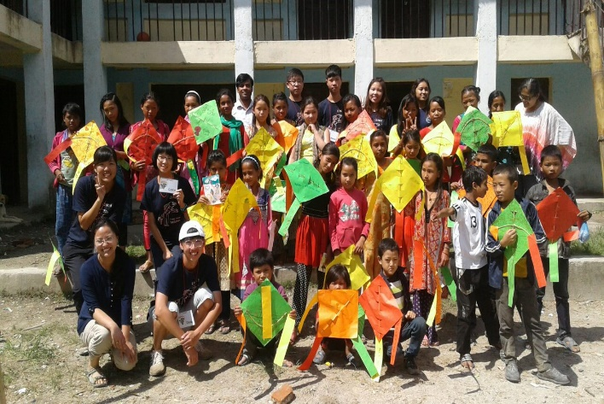

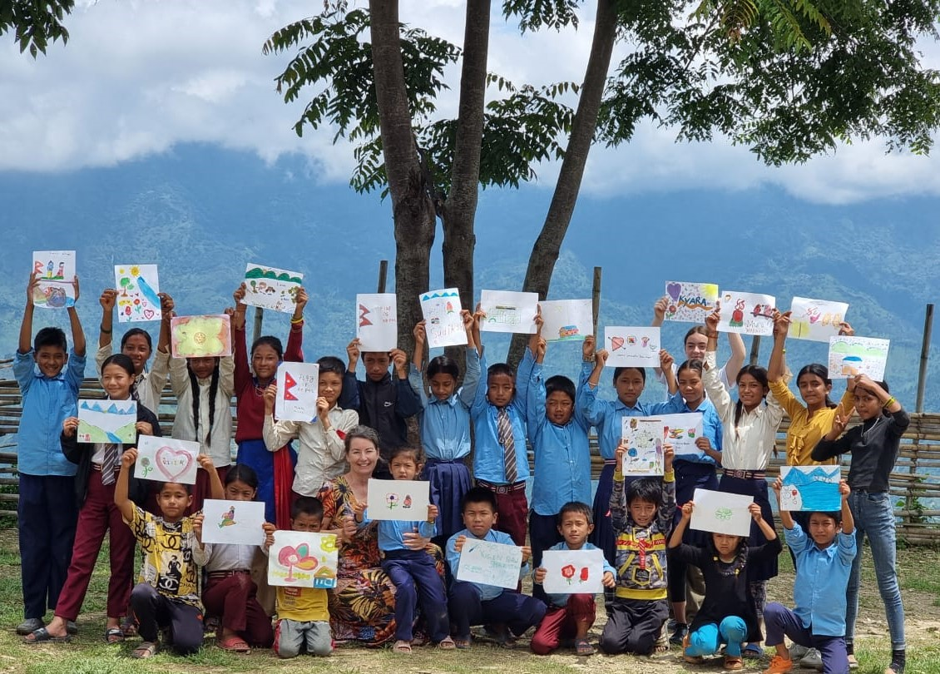

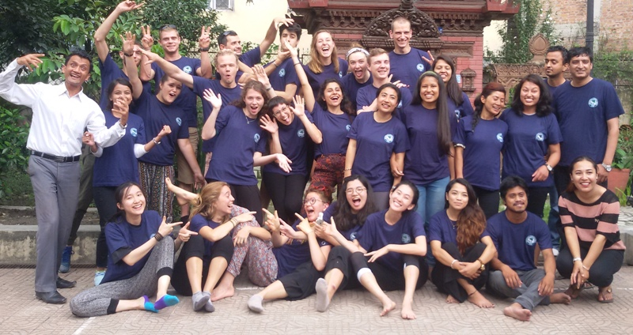

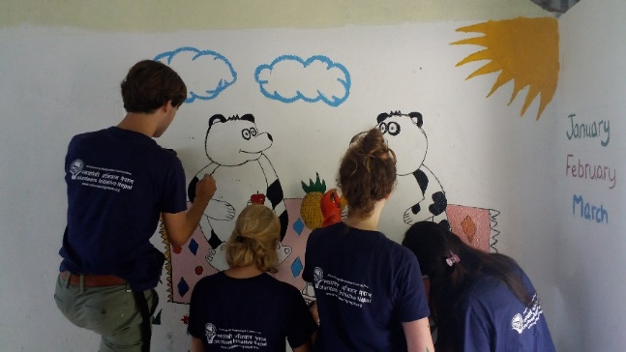 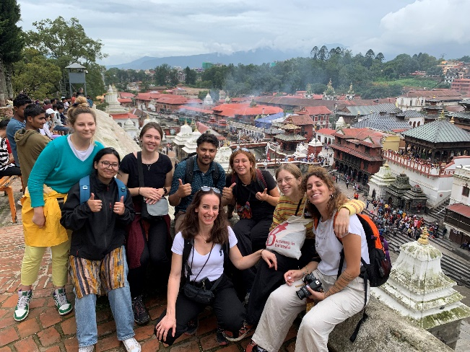

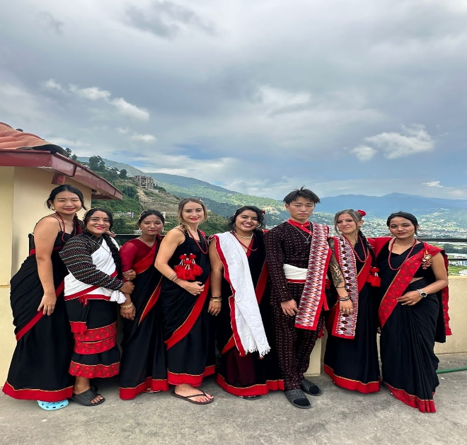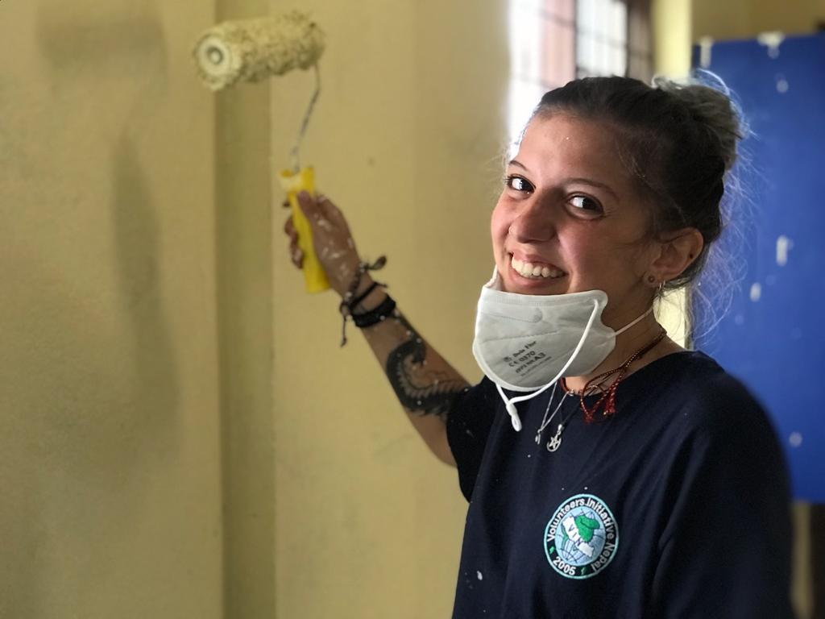

Thank you.