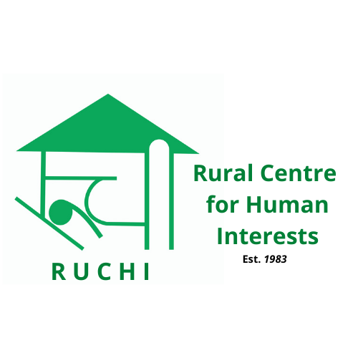

RUCHI

**Rural Centre for Human Interests**

**Volunteer India program**

**STV Projects Booklet (2025)**

*Correspondence:*

RUCHI

Technology Complex

Village Bandh, P.O. Bhaguri, Via Patta

Distt. Solan. H.P. - 173233

INDIA

*Contact info:*

Landline: +91-7560078500 (9Am to 5PM)

Mobile: +91-9459377111 (Mahip Dagar)

Email: [info@ruchi.org.in](mailto:info@ruchi.org.in)

Website: www.ruchi.org.in

**RUCHI - ABOUT**

Rural Centre for Human Interests (RUCHI) is a community development organization with ever increasing focus on youth development and intercultural learning through voluntary service.

RUCHI – INDIA

STV Program 220

WORKCAMPS

(June-December 2019)

Contact address:

Village Bandh, Dist. Solan, H.P.

Email: [info@ruchi.org.in](mailto:info@ruchi.org.in)

Web: [www.ruchi.org.in](http://www.ruchi.org.in)

Tel: +91 7560078500

RUCHI got registered in 1983, under Indian Societies Registration Act as a non-political, non-profit making voluntary organization.

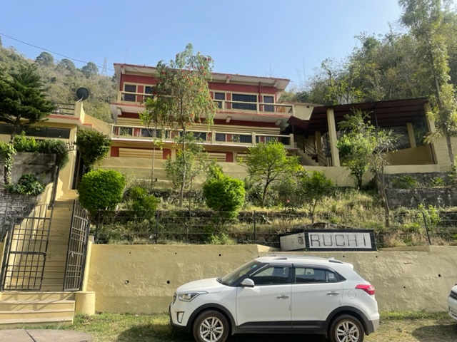

RUCHI was established keeping in mind the problems and restrictions that a remote community faces on day to day basis. These could be due to poverty, lack of knowledge, poor infrastructure or at times difficult terrain. As a result RUCHI has always implemented its project with people centered approach and gave priority to community development. With 40 years in this field, RUCHI has accumulated extensive knowledge in community development with project area ranging from semi-urban background to extremely remote communities requiring two days of walk certain time of the year.

Over time RUCHI has also developed and successfully implemented many low cost technologies. We are now acting as a resource organization for Indian Government and other NGO’s pursuing rural community development work.

**Our Aim**

Through Voluntary services, RUCHI aims to promote intercultural learning between individual, group and community, leading to better understanding and tolerance towards each-others culture. We believe achieving peace, harmony and working towards a world with fewer boundaries is a never ending process which can be achieved by increasing youth mobility through voluntary camps globally.

**Our Approach**

For the past 40 years RUCHI has committed its efforts and resources towards rural development. All our projects have a people centered approach and ongoing commitment with our projects and partners. Our workcamp offer a unique opportunity to gain global perspective for volunteer and local youth increasing their professional competencies. Voluntary service not only helps community projects but also provide a much needed overview and technical support. With work camp we provide a unique learning experience for volunteers while pursuing our organisational mission.

**Network and collaboration**

RUCHI is affiliated with international and national voluntary service networks. We have been in Executive Committee of Network of Voluntary Development in Asia (NVDA), It is also member of Coordinating Committee of International Voluntary Service (CCIVS) and holds Candidate member status with Alliance of European Voluntary service Organization (ALLIANCE).

**Our Program**

* Short Term Workcamp, STW (13days)
* Very Short Term Workcmps (VSTW) of 7 days
* Long – Medium Term Volunteer, LMTV (1-12months)
* Group Workcamp/Bilateral workcamps 10+ vols. (13days)

**Areas of Interests**

* Renovation/ maintenance.
* Environmental education and conservation.
* Waste UpCycling
* Non formal education.
* Community development.
* Construction.
* International Youth exchange.
* Agriculture/organic farming.
* Technology promotion.
* Culture, Arts and Sports

**RUCHI Short Term Work Camp - 2025**

**(Code: RC)**

|  |  |  |  |  |  |
| --- | --- | --- | --- | --- | --- |
| Code | Project / Theme | Location | Theme | Dates  2025 | Max.  Places |
| RC-01/25 | Holi – Festival of Colors | Solan-RUCHI | FEST/CUL | 03/03 – 15/03 | 10 |
| RC-02/25 | Tibetan Culture & Social Development | Dharamshala & Solan | SOC/CUL | 10/03 - 22/03 | 10 |
| RC-03/25 | Women Power | Baddi/Bandh | SOC | 30/06 - 12/07 | 10 |
| RC-04/25 | Tibetan Culture & Social Development | Dharamshala & Solan | SOC/CUL | 07/07 – 19/07 | 10 |
| RC-05/25 | Natural Farming | RUCHI Bandh | AGR/SOC | 14/07 – 26/07 | 10 |
| RC-06/25 | Tibetan Culture & Social Development | Dharamshala & Solan | SOC/CUL | 21/07 – 02/08 | 10 |
| RC-07/25 | Climate Justice- Be a climate hero | Bandh | ENV | 28/07 – 09/08 | 10 |
| RC-08/25 | Tibetan Culture & Social Development | Dharamshala & Solan | SOC/CUL | 04/08 – 16/08 | 10 |
| RC-09/25 | Waste UpCycling | Bandh | ENV/SOC | 11/08 – 23/08 | 10 |
| RC-10/25 | Tibetan Culture & Social Development | Dharamshala & Solan | SOC/CUL | 18/08 – 30/08 | 10 |
| RC-11/25 | Waste UpCycling | Baddi-Bandh | ENV/SOC | 25/08 – 06/09 | 10 |
| RC-12/25 | Tibetan Culture & Social Development | Dharamshala & Solan | SOC/CUL | 08/09 - 20/09 | 10 |
| RC-13/25 | Diwali - Festival of Light | Solan-RUCHI | FEST/CUL | 13/10 – 25/10 | 10 |
| RC-14/25 | Women Power | Baddi-Bandh | SOC/EDU | 10/11 – 22/11 | 10 |
| RC-15/25 | Natural Farming | Baddi/Bandh | ARTS | 08/12 - 20/12 | 10 |

**General Information:**

* All Short Term Camps (STC) last two weeks with fixed dates and led by a RUCHI Team Leader.
* Every project has an extra fee to cover their living and working costs. Volunteers take care of their own travel costs and bear all personal expenses during free time and leisure visits.
* Volunteers have to be 18 years or older and be prepared to live under simple conditions.
* No special skills are required; one has to be open minded and willing to adapt to challenging conditions.
* Volunteers’ contribution is always recognized and appreciated but they will have to accept the fact that they cannot change the world in two weeks.
* Volunteers must be willing to understand and respect local as well each other’s culture.
* Volunteers must be prepared to live in harmony with others and work as a team.
* Working hours will be 5-6 hours, 5 days a week.

**Why the extra fee?**

RUCHI with other NGO’s in India is not financially supported by government to host projects related to IVS. Hence all projects are self funded with a participation fee. Given the remote location and various complexities we have tried our best to make it as affordable as possible for volunteers. Being a non-profit organization we emphasize on transparency, below is how we spend collected participation fee.

* Food, accommodation and logistics of volunteer during workcamp.
* Project setup costs. (material and logistics cost)
* Running the camp. (wages of professional skilled mason, carpenter, plumber etc and training local youth supported by us.)
* Office running/admin expenses. (Internet, photocopy, stationary, electricity, phone, salaries, office equipment, tools and rent etc.)
* Supporting small community project.
* International travel costs to global conferences and network membership fees.

**Description of the Short Term Camps**

**Theme: Festival**

**RC-01/25 Solan/RUCHI Holi Mela-Festival of Colors 10 Vols. 03.03.25 – 15.03.25**

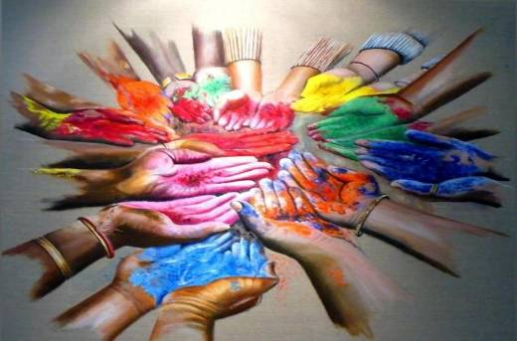

**Background:** One of the major festivals of India, Holi is celebrated with enthusiasm and gaiety on the **full moon day** in the month of **Phalgun** which is the month of March as per the Gregorian calendar. Holi is also called the **Spring Festival -** as it marks the arrival of spring the season of hope and joy. Entire country wears a festive look when it is time for Holi celebration. This year, main Holi festival (playing with colours) falls on 14thMarch, though celebrations in different forms start 4 days before the main festival. Market places get abuzz with activity as frenzied shoppers start making preparations for the festival. Heaps of various hues of colors can be seen on the roadside days before the festival. Womenfolk cook loads of **sweet dishes**  for the family and also for the relatives.

People light a bonfire at important crossroads, called Holika on the eve of Holi festival and celebrate the victory of good over evil.

***Location& leisure*:** The project site is Ruchi campus and the nearby Bandh village (1 km) in Solan district. It is 30 km from Kalka and 70 km from Chandigarh. The village is small with 40 odd families.

Self organized city tours and excursions. Old Sikh and Hindu temples in the near vicinity can be visited. Nearby Kasauli town is another hill station as a tourist

attraction. A visit to Shimla will offer an opportunity to

see high Himalayan Mountains.

**Work:** The Holi festival celebrates the onset of spring and renewal. Coming forth with the full flush of life, the invigorating air of Holi festivities spreads into the lives of people throughout the year.

Being a festival camp, the major focus of this camp is on leisure and enjoy festivities. However, with an initial orientation on festivals, you will get chance to participate in our ongoing humanitarian actions like Non formal education, women empowerment initiatives, environment conservation, waste upcycling, organic farming etc and have an interaction with local communities to encourage cross cultural exchanges and provide a deeper insight of our culture. The major festival will be attended to on 14th March when you will play with colors.

***Accommodation:*** Volunteers will stay at RUCHI campus on twin/triple sharing basis. Bed and beddings are provided. Simple basic amenities will be available; bringing personal sleeping bag is desirable. Asian squat type toilet & English WC with hot and cold showers are available. Our cook will serve authentic Indian vegetarian meals.

***International Terminal: New Delhi and*** Chandigarh

***Nearest railway station*:** Kalka (30 kms)

***Participation Fee:*** Euro 240/-

**RC-13/25 Solan-RUCHI Festival of Lights with Local Culture FEST/CUL 10 vol 13.10.25–25.10.25**



**Background:Diwali or** Festival of Lights is a national festival celebrated throughout the country with lot of zeal for 5 days. This main festival, falling on 21st October, 2025, is celebrated with a great fervor just like Christmas and goes on for 5 days. Diwali is followed by other local events like Budi Diwali, viswakarma puja, Bhaiya Dooj etc. In North India, as it is believed that it was on Diwali that Lord Rama along with his wife Sita and brother Lakshmana returned to Ayodhya after killing the Demon king Ravana in Lanka.

***Work:*** This camp is a great opportunity to learn and experience Indian culture and understand the diversity and unity it stands for. Therefore, be prepared to enjoy festivities and enjoy leisurely walks with easy pace and interacting with local communities. Besides, you shall be participating in our ongoing humanitarian actions like Non formal education, women empowerment initiatives, environment conservation, waste upcycling, organic farming etc and interacting with local people on daily basis leading to the festival.

With this project we aim to encourage cross cultural exchanges and provide a deeper insight of our culture. Months of October and November host two prominent Indian festivals of national importance. The dates are decided on yearly basis as per Hindu calendar. These camps are specially organized for those who are interested in Indian history and culture. This period is also supposed to be auspicious for marriages. Besides

local festivals, volunteers will have an opportunity to learn of Hindu traditions.

***Location& Leisure Time:***Baddi is a fast growing largest industrial hub in Solan district of Himachal Pradesh. It is 30 km north of Chandigarh city and 100 kms from Shimla town. Baddi offers a number of treks to tourists and a good majestic view of Kasauli range of mountains. The economy of the area depends on agriculture and industries.

The volunteers will have opportunity to visit Hanuman Temple in Shimla, the Naldehra Golf Club and a local zoo or the Rock Garden in Chandigarh.

***Accommodation& food:*** Volunteers will stay at RUCHI campus on twin/triple sharing basis. Bed and beddings are provided. Simple basic amenities will be available; bringing personal sleeping bag is desirable. Asian squat type toilet & English WC with hot and cold showers are available. Our cook will serve authentic Indian vegetarian meals.

**Requirements:** Interest in experiencing other cultures and participate with local communities in local/national festivals.

***International Terminal:***New Delhi and Chandigarh

***Nearest railway station*:**Kalka (50 kms)

***Participation Fee:*** Euro 240.

**Themes: CULTURE**

**RC-02/25 Tibetan Culture & Social Dev. Dharamshala & Solan SOC/CUL 10 Vols. 10.03.25 – 22.03.25**

**RC-04/25 Tibetan Culture & Social Dev. Dharamshala & Solan SOC/CUL 10 Vols. 07.07.25 – 19.07.25**

**RC-06/25 Tibetan Culture & Social Dev Dharamshala & Solan SOC/CUL 10 Vols. 21.07.25 – 02.08.25**

**RC-08/25 Tibetan Culture & Social Dev Dharamshala & Solan SOC/CUL 10 Vols. 04.08.25 – 16.08.25**

**RC-10/25 Tibetan Culture & Social Dev Dharamshala & Solan SOC/CUL 10 Vols. 18.08.25 – 30.08.25**

**RC-12/25 Tibetan Culture & Social Dev Dharamshala &Solan SOC/CUL 10 Vols. 08.09.25 – 20.09.25**

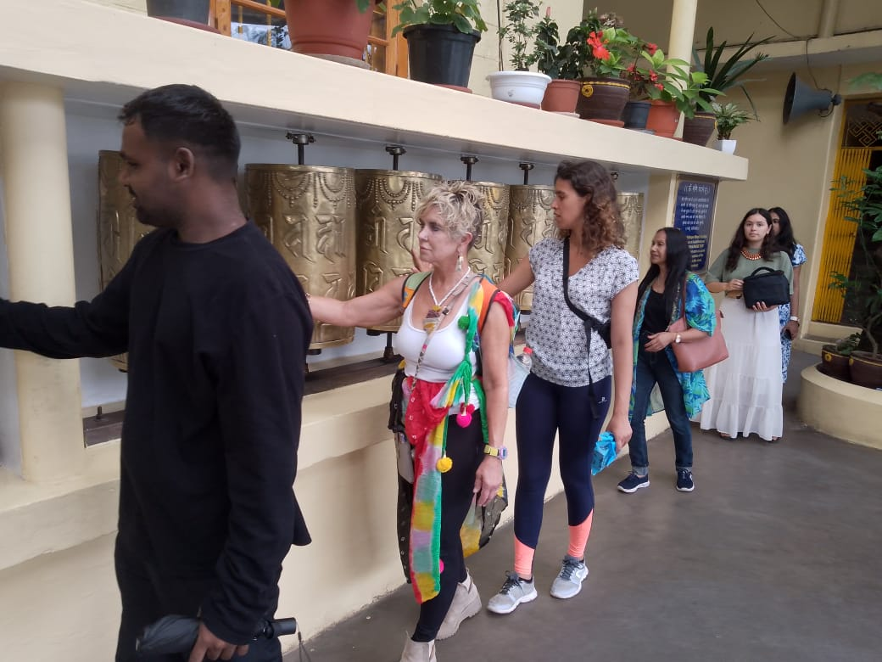

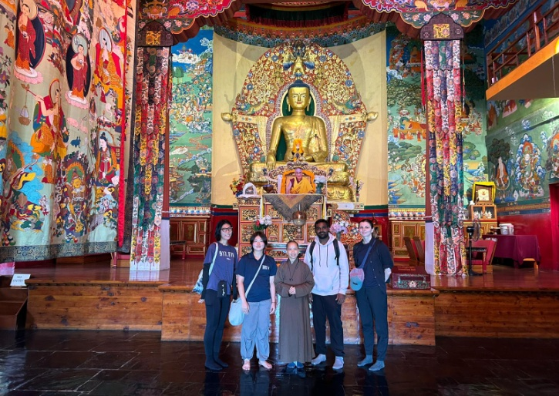****

**Background: T**hrough this project we aim to provide volunteers with an enriching (rural & urban) experience where they would participate in our ongoing rural community development initiatives aimed at uplift of marginalized people and later move to McLeodganj, Dharamshala where Tibetan Government in exile has its head quarters. Volunteers here would get chance to increase their understanding about Tibetan Culture, their movement and their ongoing struggle to keep their identity alive. Relates to SDG-11 (Sustainable cities and communities)

**Location &Leisure time:** (1st week) RUCHI Campus at village, Bandh of Solan district and (2nd week) in the town of Mcloedganj in Dharamshala, a tourist hub.

In the first week, Nearby Kasauli town is a major attraction.A visit to Shimla will offer an opportunity to see high Himalayan Mountains and British architecture.

During 2nd week, the volunteers will visit Dharamshala, the headquarters of Tibetan Government in exile. Opportunities will be there for short and long treks in the mountains. After the camp, if they like, volunteers may visit Golden Temple in Amritsar, Punjab.

***Work:*** During 1st week volunteers would join us in our headquarter which is based at a rural location where they have opportunity to live & experience a typical mountain village culture, their lifestyle and during process join our ongoing initiatives like NFE, women empowerment, NRM (Protection of fresh water sources), organic farming etc.

During 2nd week the group would move to Mcloedganj in Dharamshala which is a touristic town and also Secretariat of Tibetan Government in exile. Over here they would visit Tibetan, monasteries, museum, schools and join language classes with Tibetan monks. There is a likelihood that we may take up some cleanliness work or some other activity. Otherwise, this week will be more of touristic with leisurely walks and culture sharing.

***Accommodation and Food:*** Volunteers will live in shared accommodation in both places. The minimum basic amenities will be available. Vegetarian food will be served but in the town you will have access to non-vegetarian meals as well. A cook will be there but volunteers are expected to help him and occasionally cook their own meals and self-management is required.

***Requirements:*** Interest in understanding different life styles and issues with a sharing and learning ability, High motivation & open mindedness is a must.

***International Terminal:***New Delhi and Chandigarh

***Nearest railway station*:** Kalka

***Participation Fee:*** Euro 280

**Theme: SOCIAL**

**RC-03/25 Baddi/Bandh Women Power SOC/EDU 10 Vols 30.06.2025- 12.07.2025**

**RC-14/25 Baddi/Bandh Women Power SOC/EDU 10 Vols 10.11.2025- 22.11.2025**

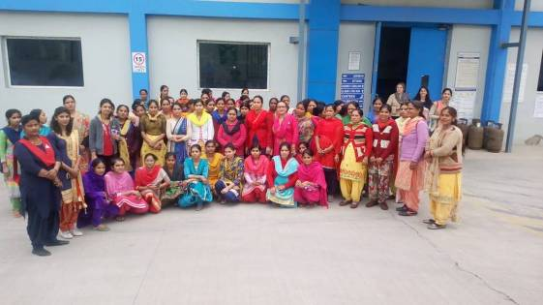

***Background:*** RUCHI always recognised women’s efforts and believes that, still a lot needs to be done to help them achieve the desired position within social perspective in our community. Surprisingly even after supporting her family in various ways she is mostly not consulted and involved in household decision making. Keeping that in mind RUCHI has initiated voluntary project facilitating cultural exposure and assisting women to overcome these odds. The camp relates to SDG-5 (Gender Equality) and SDG-10 (Reduced Ineqalities).

This projects aims to empower women and girls of all ages by helping them to gain confidence, recognize and demand their rights and most importantly start being recognized as an earning member of family.

***Location& Leisure Time*:** Ruchi campus which is located near Bandh village. It is 30 km from Kalka town and 60 km from Chandigarh city. The area offers a unique opportunity to live with nature in a peaceful environment.

Self organized city tours and excursions. Old Sikh and Hindu temples in the near vicinity can be visited. Nearby Kasauli town, a hill station, is a major tourist attraction.A visit to Shimla, the state capital, will offer an opportunity to see high Himalayan Mountains and British architecture.

***Work:*** Working closely with local communities we have mobilized women self help groups in villages. Through these groups we have nurtured and supported women

entrepreneurship initiatives to economically support their families and spread awareness within villages. We also work with teenage girls in public schools where we assist in development of their soft skills and critical health issues.

As a volunteer you will have an opportunity to exchange ideas, better understand the role a typical woman has in our society and join in their social & economic upliftment.

Volunteers are expected to be creative and skillful so they can implement need based workshop for girls about adolescence education, personality development, career counseling etc. They will also be attending meetings of Self-help Groups (SHGs) and interact with women to better understand their plight and assist them to be economically independent.

Additional activities will include learning of various developmental issues and solutions. They will visit various humanitarian projects and interact with the villagers.

***Accommodation & Food:***Volunteers will stay at RUCHI campus on twin/triple sharing basis. Bed and beddings are provided. Simple basic amenities will be available; bringing personal sleeping bag is desirable. Asian squat type toilet & English WC with hot and cold showers are available. Our cook will serve authentic Indian vegetarian meals.

***Requirements:*** Interest in gender related work and issues with a sharing and learning ability, High motivation.

***International Terminal:***New Delhi and Chandigarh

***Nearest railway station*:** Kalka (30 kms)

***Participation Fee:*** Euro 240

**Theme: Environment**

**RC-07/25 Bandh Climate Justice-Be a climate hero ENV 10 Vols. 28.07.25 – 09.08.25**

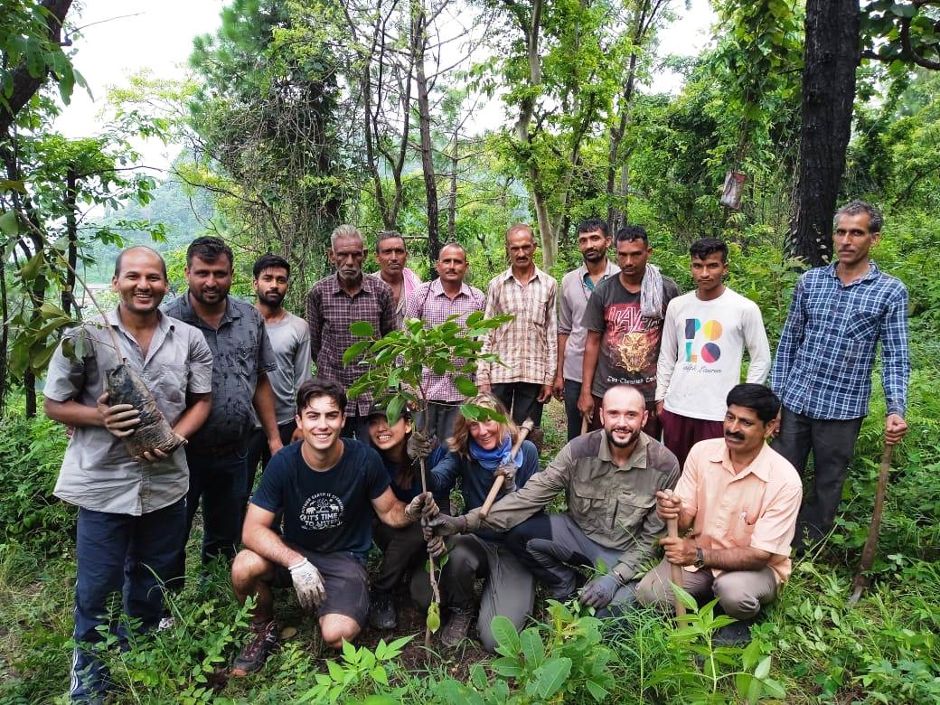

***Background:*** With this project we aim to do our bit to reverse climate change and preserve biodiversity of our surrounding through education and actions. Overtime we have assisted in planting more than 10,000 trees in last 5 years. Along with plantation we also educate local community about carbon emission and environmentally sustainable actions which one could apply. The project relates to SDG-13 (Climate Action) and SDG-15 (Life on Land).

***Location*&Leisure time:** Ruchi campus which is located near Bandh village. It is 30 km from Kalka town and 60 km from Chandigarh city. The area offers a unique opportunity to live with nature in a peaceful environment.

Self organized city tours and excursions. Old Sikh and Hindu temples in the near vicinity can be visited. Nearby Kasauli town, a hill station, is a major tourist attraction.A visit to Shimla, the state capital, will offer an opportunity to see high Himalayan Mountains and British architecture.

***Work:***Depending on the weather, volunteers would plant new trees,take care of already planted ones, remove dead saplings, chop firewood,do soil working, composting, clearing weeds and bushes, preparing holes for future plantation and make polythene green house fully operational.

Since environmental education and protection is the focus of the camp they will be expected to create awareness onissues like global warming, climate change, Carbon emission, sustainable lifestyle etc. while visiting local communities.

Besides tree plantation, volunteers will be given an exposure of other humanitarian projects, meeting with women groups, physical activity in RUCHI campus and work in communities or slums.

***Accommodation and Food:*** Volunteers will live in the RUCHI campus in shared accommodation. All minimum basic amenities will be available with library facilities. Vegetarian food will be served. A cook will be there but volunteers are expected to help him and occasionally cook their own meals and self-management is required. Sleeping bags are not necessary but required for personal hygiene.

***Requirements:*** Interest in environment and climate changing issues. Physical fitness, Flexibility and High level of motivation.

***International Terminal:*** New Delhi and Chandigarh

***Nearest railway station*:** Kalka

***Participation Fee:*** Euro 240

**RC-05/25 Baddi/Bandh Natural Farming ENV/AGR 10 Vols 14.07.2025 – 26.07.2025**

**RC-15/25 Baddi/Bandh Natural Farming ENV/AGR 10 Vols 08.12.2025 – 20.12.2025**

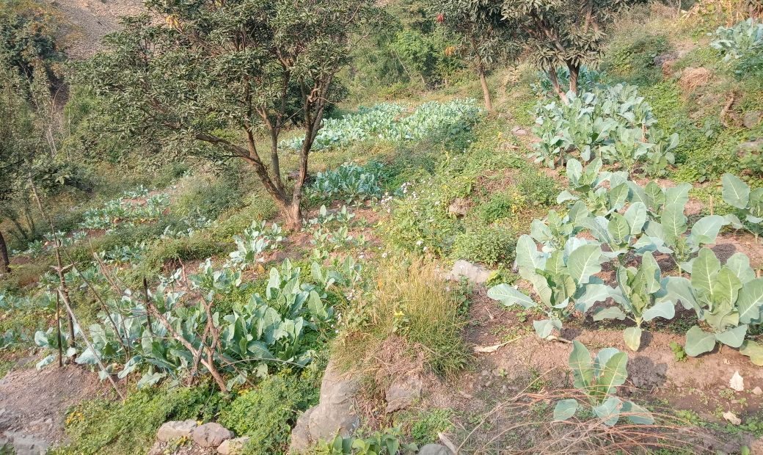

***Background:*** With this project we aim to reverse the process of inorganic farming and bring more and more farmers do natural farming, the way they had all along been doing traditionally. We are already making a small effort in our campus for demonstration purpose and would like to further promote and educate local communities on natural farming practices on increasing basis. The project relates to SDG-02 (Zero Hunger)

***Location* & Leisure time:** Ruchi campus, located near Bandh village. It is 30 km from Kalka town and 60 km from Chandigarh city. The area offers a unique opportunity to live with nature in a peaceful environment.

Self organized city tours and excursions. Old Sikh and Hindu temples in the near vicinity can be visited. Nearby Kasauli town, a hill station, is a major tourist attraction.A visit to Shimla, the state capital, will offer an opportunity to see high Himalayan Mountains and British architecture.

***Work:*** Depending on the weather, volunteers would do vegetable farming, remove weeds, make organic compost and put it to farms, renovate the trails to farm, prepare dung sprays and pesticides to grow healthy

crops. Be prepared to get your hands dirty and do physical work. Experienced or skilled volunteers can help communities to take to off season vegetables and go to dry land farming. Innovative ideas to promote natural farming are always welcome.

Besides natural farming, volunteers will be given an exposure of other humanitarian projects, meeting with women groupsand physical activity in RUCHI campus and work in communities or slums.

***Accommodation and Food:*** Volunteers will live in the RUCHI campus in shared accommodation. All minimum basic amenities will be available with library facilities. Vegetarian food will be served. A cook will be there but volunteers are expected to help him and occasionally cook their own meals and self-management is required. Sleeping bags are not necessary but required for personal hygiene.

***Requirements:*** Interest in agriculture, environment and healthy food. Physical fitness, Flexibility and High level of motivation is required.

***International Terminal:*** New Delhi and Chandigarh

***Nearest railway station*:** Kalka

***Participation Fee:*** Euro 240

**RC-09/25 RUCHI Waste UpCycling ENV/SOC 10 vols 11.08.25 – 23.08.25**

**RC-11/25 RUCHI Waste UpCycling ENV/SOC 10 vols 25.08.25 – 06.09.25**

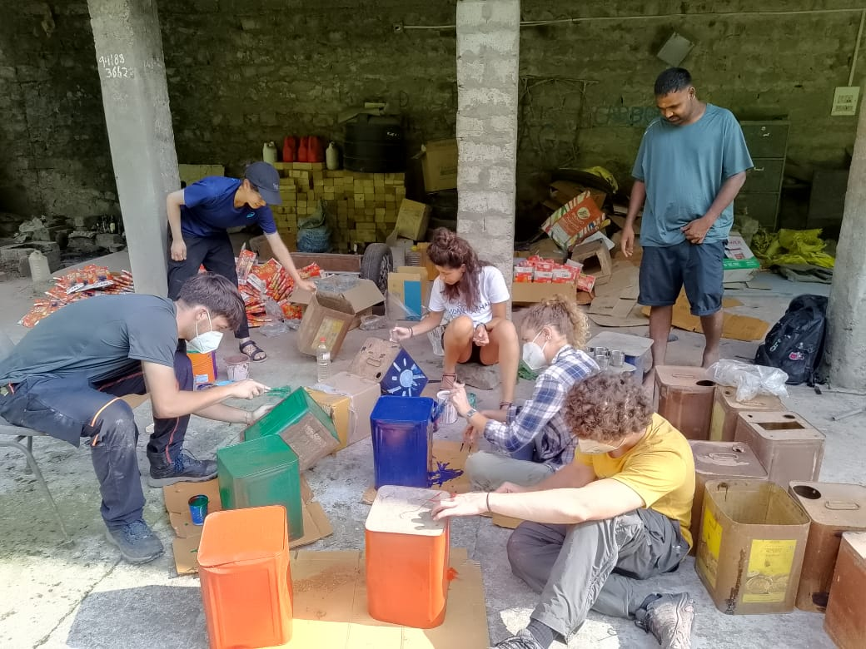

***Background:*** Upcycling is the process of turning waste materials or unwanted products into new, more valuable, or better quality items. It's also known as creative reuse. Upcycling is different from recycling, which is an industrial process that turns products into new materials of lesser quality.

Upcycling can help reduce the amount of waste in landfills and promote a more sustainable lifestyle.

***Location& Leisure*:** Ruchi campus is located near Bandh village. It is 30 km from Kalka and 60 km from Chandigarh. Bandh village is small located in interior mountainous area and the volunteers will have a unique opportunity to live with nature in a peaceful environment. RUCHI campus is one km. from the village.

Self organized city tours and excursions. Old Sikh and Hindu temples in the near vicinity can be visited. Nearby Kasauli town is another hill station as a tourist attraction.A visit to Shimla will offer an opportunity to see high Himalayan Mountains.

***Work:*** Volunteers will be working with waste products like polythene items, discarded vehicle tyres, water bottles, cans, old furniture, unused clothes, eco-bricks, farm waste and bamboos etc to recycle them and make products of uses. This will involve education and building entrepreneurial skills among staff and local communities. For over four years, RUCHI has already been involved in creative use of bye products, waste materials or unused/unwanted items into new usable materials.

In between you will also be participating in our ongoing humanitarian actions like Non formal education, women empowerment initiatives, environment conservation, waste upcycling, organic farming etc and interacting with local people on daily basis

***Accommodation& Food:*** Volunteers will live in the RUCHI campus. All basic amenities will be available with library facilities. Asian squat type toilet and English WC will be available. Vegetarian food will be served. A cook will be there but volunteers are expected to help him and occasionally cook their own meals. Self-management is required. Meantime volunteer can learn Indian cuisine (cooking). Sleeping bag is required.

***Requirements:*** Creative skills and Interest in minimizing waste generation and upcycling of waste to produce productive items and develop entrepreneurial skills and have a safe and hygienic environment conducive to human life.

***International Terminal:*** New Delhi and Chandigarh

***Nearest railway station*:** Kalka (30 kms)

***Participation Fee:*** Euro 240