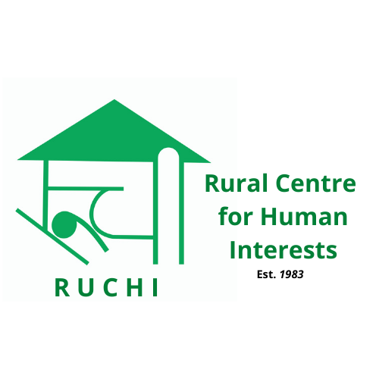  
RUCHI

**Rural Centre for Human Interests**

**Volunteer India program**

**LMTV Booklet (2025)**

*Correspondence:*

RUCHI

Technology Complex

Village Bandh, P.O. Bhaguri, Via Patta

Distt. Solan. H.P. - 173233

INDIA

*Contact info:*

Landline: +91-7560078500 (9Am to 5PM)

Mobile: +91-9805347557 (Mahip Dagar)

Email: [info@ruchi.org.in](mailto:info@ruchi.org.in)

Website: www.ruchi.org.in

**About RUCHI**

Rural Centre for Human Interests (RUCHI) is a community development organization with ever increasing focus on youth development and intercultural learning through voluntary service. RUCHI got registered in 1983, under Indian Societies Registration Act as a non-political, non-profit making voluntary organization.

RUCHI was established keeping in mind the problems and restrictions that a remote community faces on day to day basis. These could be due to poverty, lack of knowledge, poor infrastructure or at times difficult terrain. As a result RUCHI has always implemented its project with people centered approach and gave priority to community development. With 39 years in this field, RUCHI has accumulated extensive knowledge in community development with project area ranging from semi-urban background to extremely remote communities requiring two days of walk certain time of the year. Over time RUCHI has also developed and successfully implemented low cost technologies. We are now acting as a resource organization for Indian Government and other NGO’s pursuing community development.

RUCHI has been actively involved in International Voluntary Service sector since 2000 and has been offering short and long term volunteer placement projects with aim to provide visiting volunteers a grass root experiential learning opportunity fostering personal and community development.

**Our Approach**

Since inception, RUCHI has committed its efforts and resources towards rural development. All our projects have a people centered approach and ongoing commitment with our projects and partners. Our IVS projects offer a unique opportunity to gain global perspective for volunteer and local youth increasing their professional competencies. Voluntary service not only helps community projects but also provide a much needed overview and technical support.

**Network and collaboration**

RUCHI is affiliated with international and national voluntary service networks. RUCHI is a member of Network of Voluntary Development in Asia (NVDA), full member of Coordinating Committee of International Voluntary Service (CCIVS) and a candidate member of Alliance of European Voluntary service Organization (ALLIANCE).

Besides international networks RUCHI also cooperates with national organizations like Institute of Rural Management (IRMA), Delhi School of Social Works, Tata Institute of Social Science, Xavier Institute of Social Science (XISS) and students from University of Delhi, Kurukshetra, Allahabad, Kerala, Shimla, etc. RUCHI hosts students from these institutes and facilitates their experiential studies.

**Our Volunteer Program**

* Short Term Workcamp, STW (13days)
* Very short term workcamos of 7days
* Long - Medium Term Volunteer, LMTV (1-12months)
* Group/Bilateral Workcamp. 10+ vols. (13days)
* Internship.

**Areas of Interests**

* Construction, Renovation and maintenance.
* Environment/Climate Change/Global Warming.
* Waste UpCycling
* Non formal education.
* Community development
* Culture exposure.
* Children with disability
* Creative arts and crafts
* Health & Sanitation
* Waste Management

**RUCHI INDIA - LMTV Programme 2025 - Summary**

|  |  |  |  |  |
| --- | --- | --- | --- | --- |
| **Theme** | **CODE** | **Project** | **DATES (DD/MM/YYYY)** | **Placement** |
| **Environment** | RC-MTV-ENV-1/25 | Environmental Education & Waste upcycling | **Round the year** | Open |
| RC-MTV-ENV-2/25 | Water Conservation | **Round the year** | Open |
| RC-MTV-ENV-4/25 | Stop Climate Change | **August-October** | Open |
| **Education** | RC-MTV-EDU-3/25 | Non-Formal Education | **February –**  **December** | Open |
| **Community Development** | RC-MTV-HEALTH-5/25 | Health and Sanitation (WASH) | **Round the year** | Open |
| RC-MTV-CD-6/25 | Women Power | **Round the year** | Open |
| **IVS** | RC-MTV-CD-7/25 | IVS Programme management | **June-October** | Open |
| **Agriculture**  **(Food Security)** | RC-MTV-AGR-8/25 | Natural farming | **Round the year** | Open |

**Description of Middle & Long Term Projects:**

**General:**

* RUCHI involves volunteers in its humanitarian activities to facilitate cross culture exchanges & promote international solidarity.
* Our LMTV projects are ongoing and are executed across North. India. We accept volunteers each month (preferably 1st Monday) check dates when applying. Volunteers can stay as long as they want up to a maximum of one year. The minimum period of staying is **One Month**.
* Volunteers will have to follow the organization rules and culture and work with other staff as a team.
* No special skills are required, except dedication and commitment to a social cause to help rural communities.
* Volunteers have to take care of their own leisure travel costs and all personal expenses during free time. Project related travel expenses using public transport shall be reimbursed within a fixed cap.
* Volunteers have to be 18 years or older, bearing good moral character and respect local as well other culture.
* Alcohol drinking and smoking is not encouraged in public and villages.
* Living conditions will be simple. Volunteers must be prepared to live in harmony with others and work as a team. Medical/Personal Insurance is the responsibility of the volunteers themselves.
* Volunteer behavior will directly reflect RUCHI image within community therefore good work ethics are highly desired and expected.

**LMTV Programme:**

We encourage volunteers to apply and contribute to international youth exchange and community development through Medium and Long term placements of durations varying between 4 weeks to 24 weeks. **The volunteers under this programme are placed in on-going humanitarian local projects in rural or semi-urban areas. These placements are ideal to gain a deep understanding of grassroots situations while working with marginalized communities and contribute towards their uplift through self initiated micro actions.**

In contrast to short term workcamps, the pace of work here is slow. Therefore, matching expectations of volunteers is a constant challenge. One has to realize that they cannot change the world in such a short time but the placement certainly provides satisfaction and contentment to have really contributed to a cause with some visible results.

We offer flexibility to join our programs, but to regulate and better coordinate project activities we expect volunteer to join on first Monday of each month. Initial orientation to volunteers will be provided at RUCHI office, desired project outcomes and volunteer’s role and responsibility shall be shared on arrival.

**PARTICIPATION FEE:** The participation fees are as follows:

***Per month -* Euro 420/-** (Fee has to be paid in advance. The fee is worked out on monthly basis and not daily or weekly basis and hence it remains same even if one leaves the project a day or week earlier)

The participants are required to pay the fee to our bank account at least 15 days in advance. For a usual bank transfer it takes any time from 10-15 days to get the credit. The contribution covers all basic expenses, e.g. accommodation, gas, water, electricity, food, staff salaries and for materials used in projects/activities. Alcoholic drinks are not included. Alcohol drinking and smoking is not encouraged in public and villages.

Project related travel expenses shall be reimbursed to volunteer each month with a maximum cap of rupees 800. Leisure travel and personal expenses during free time are not covered in participation fee.

**Why the extra fee?**

RUCHI, like other NGO’s in India, is not financially supported by government to host projects related to IVS. Hence all projects are self funded with a participation fee. Given the remote location and various complexities we have tried our best to make it as affordable as possible for volunteers. Being a non-profit organization we emphasize on transparency, below is how we spend collected participation fee.

* Food, accommodation and logistics of volunteer during workcamp.
* Project setup costs. (material and logistics cost)
* Running the camp. (wages of professional like mason, carpenter, plumber etc and training local youth supported by us.)
* Office running/admin expenses. (Internet, photocopy, stationary, electricity, phone, salaries, office equipments, tools and rent etc.)
* Supporting small community project.
* International travel costs to annual global conferences and membership fee for networking.

**Visa:**

All volunteers are required to get Indian visa to enter the country. As per the new regulations an **employment visa** is required for their placement with Indian NGOs. For details kindly refer to [www.indianvisaonline.gov.in/visa](http://www.indianvisaonline.gov.in/visa). RUCHI will be happy to assist you with required documents.

**Project No.: RC-MTV-ENV-1/25: Environmental Education & Waste-Upcycling**

**Period: Any time during the year**

Age: 18+

Location: Solan- Rural and Slum Communities around Baddi township

Placement: Placement is offered for 3 months to up to 6 months.

Joining dates: Any Monday (preferable) during the project cycle.

**Background:** The existence of life on planet is possible only because of the suitable environment we live in.

Over the past few decades our human thirst for development has taken its toll on environment and its effect has been seen and felt by us all in recent past. Through this project we want to emphasize on importance of environmentally sustainable action that are needed to be incorporated in our lives on daily basis to reduce further damage. We would also like to take this opportunity and target waste material as it is one of the biggest environmental challenge that we face today.

**Work:** The project aims to educate local communities, both formal and non-formal, on environmental concerns like Global warming, floods, droughts, depletion of natural resources, lack of waste management etc. and take up protective measures with a possibility of organizing micro community actions.

In specific work will include:

* **Creating Environmental awareness to preserve biodiversity among kids and other community based groups.**
* **Promoting sustainable lifestyle changes to have minimum green house gas emission on our environment. (eg. Reducing usage of plastics, choosing energy efficient devices etc)**
* **Up-cycling of waste and other discarded items into something meaningful and usable.**
* **Promote Upcycled products as a entrepreneurial activity among local community.**

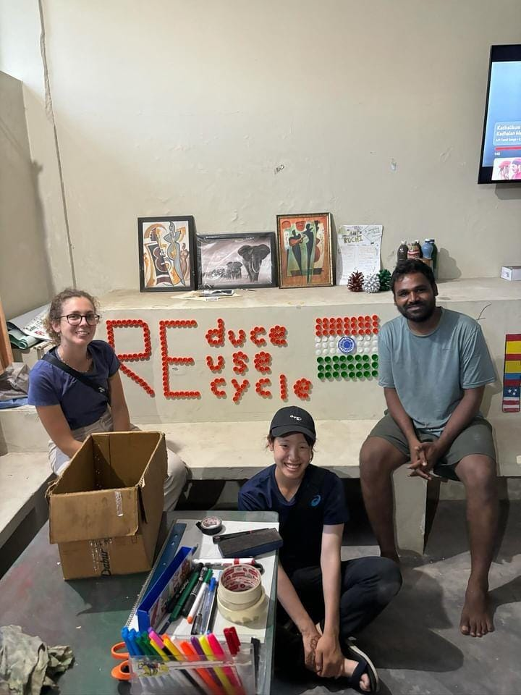

We believe, innovation is key to success

Therefore volunteers with prior experience in related work are welcome to bring in new ideas.

**Accommodation:** Basic, simple, safe & clean accommodation will be provided either at host family or RUCHI campus on sharing basis (Twin or triple) with common toilets and bath.

**Food:** Food offered will be simple authentic Indian vegetarian and freshly cooked. Three meals a day will be served. Assistance while cooking is desired and self cooking can be organized by volunteers.

**International Airport:** New Delhi

**Meeting Point:** Kalka railway station

**Project No.: RC-MTV-ENV-2/25: Water Conservation (NRM)**

**Period: Any time during the year**

Age: 18+

Location: Baddi villages (Solan)

Placement: Placement is offered for upto 6 months.

Joining dates : Any Monday (preferable) during the project cycle

**Background:** The project area gets ample rainfall but still there is a perpetual shortage of water in dry months. The problem is more of management and not availability. Every drop of water needs to be conserved.

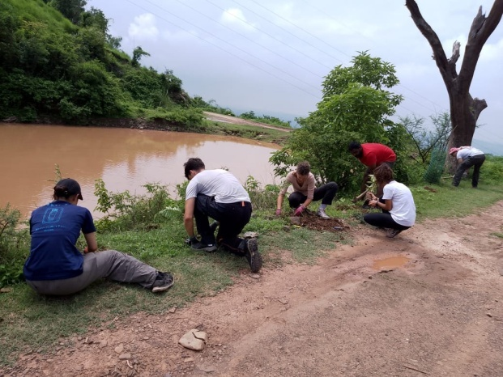

Since ages, the mountain people depend on natural spring to meet their fresh water requirements. The area has abundance of fresh water natural springs. These resources are under tremendous pressure due to environmental degradation, human negligence paired with his rapid thirst for urbanisation.

RUCHI has worked towards protection and development of these fresh water springs for more than 20 years, but still a lot has to be done.

**Work:** The volunteers will work closely with local community members and perform following tasks:

* **Protection & conservation** of our natural resources.
* Devise methodology **to protect and replenish these fresh water sources** using traditional methods and locally available resources.
* Create **awareness on conserving every drop of water** through all possible means for drinking, household uses, agriculture and overall environment.
* Join RUCHI team and communities in **cleaning these fresh water sources**
* Plant trees around the sources.
* Perform the most difficult task of sustaining interest of communities in their maintenance.
* Make **short video clips for education**

**Accommodation:** Basic, simple, safe & clean accommodation will be provided either at host family or RUCHI campus on sharing basis (Twin or triple) with common toilets and bath.

**Food:** Food offered will be simple authentic Indian vegetarian and freshly cooked. Three meals a day will be served. Assistance while cooking is desired and self cooking can be organized by volunteers.

**International Airport:** New Delhi

**Meeting Point:** Kalka railway station

**Project No.: RC-MTV-EDU-3/25: Non-formal Education**

**Period: During February to December**

Age: 18+

Location: Nearby private school running for needy children

Placement: Placement is offered for 3-6 months.

Joining dates : Any Monday (preferable) during the project cycle.

**Background:** In rural areas quality education is still a distant dream. We have government schools and other institutions catering to various age group but they strictly lack infrastructure and staff required to provide quality learning for students. We regularly cooperate with various educational institutions in our close proximity and deliver need based lessons for their kids with assistance from our participants. Our aim with this project is to reduce rural, urban education divide in order for kids to have an equal start in their career.

Since schools have to complete their curriculam, the volunteer are advised to understand that they will get less time during school hours to deal with children informally.

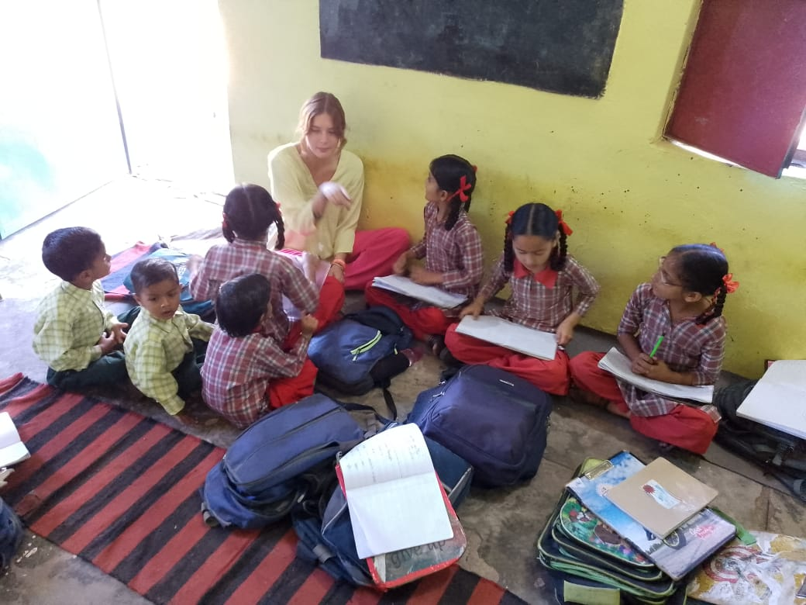

**Work:** The volunteers are required to educate not only children but rural communities on various issues like:

* Basic reading, writing and speaking English lessons.
* Proper pronunciation of English words and improve on their grammer.
* Personality development,

communication skills, creative interests.

* Child rights protection policy, Good touch, Bad touch, Gender equality, Respecting women, active

citizenship etc.

* Teenage life, adulthood, puberty, drug abuse, Violence, student life career guidance.
* Importance of digital education and responsible use of gadgets.
* Handling smart phones for productive uses and learn of their full functionality.

**Accommodation:** Basic, simple, safe & clean accommodation will be provided either at host family or RUCHI campus on sharing basis (Twin or triple) with common toilets and bath.

**Food:** Food offered will be simple authentic Indian vegetarian and freshly cooked. Three meals a day will be served. Assistance while cooking is desired and self cooking can be organized by volunteers.

**International Airport:** New Delhi

**Meeting Point:** Kalka railway station

**Project No.: RC-MTV-ENV-4/25: Stop Climate Change (SCC)**

**Period:** 01-08-2025 to 31-10-2025

Age: 18+

Location: Villages around Patta

Placement: Placement is offered for uptp 3 months

Joining dates: Any Monday (preferable) during project cycle.

**Background:** Stop Climate Change is an ambitious initiative started by our partner organization (NICE Japan) in 2015 with the aim to find solutions and reduce carbon footprint on environment. At RUCHI we have now incorporated it into our yearly activity as we have since incorporation believed in community development with environmentally sustainability actions.

**Work:**

With this initiative we at RUCHI want to create awareness regarding carbon emission and seek practical solutions to reduce it within our capacity and with limited available resources.

Working closely with local communities Volunteers will undertake following tasks:

* Take up tree plantation or growing plant nurseries where ever possible.
* Remove weeds and feed compost to trees.
* Soil working and watering plants for their higher survival rate.
* Educate communities and schools about carbon dioxide emission and its effects on lives.
* Critically evaluate alternative sources of renewable energy. (Solar, Hydro, coal, Nuclear, wind)
* Recommending energy efficient solutions depending upon local lifestyle.
* Promote sustainable lifestyle among youth and community residents.
* Exploring on micro initiatives to reduce carbon foot print.
* Conserve water and stop water wastage.

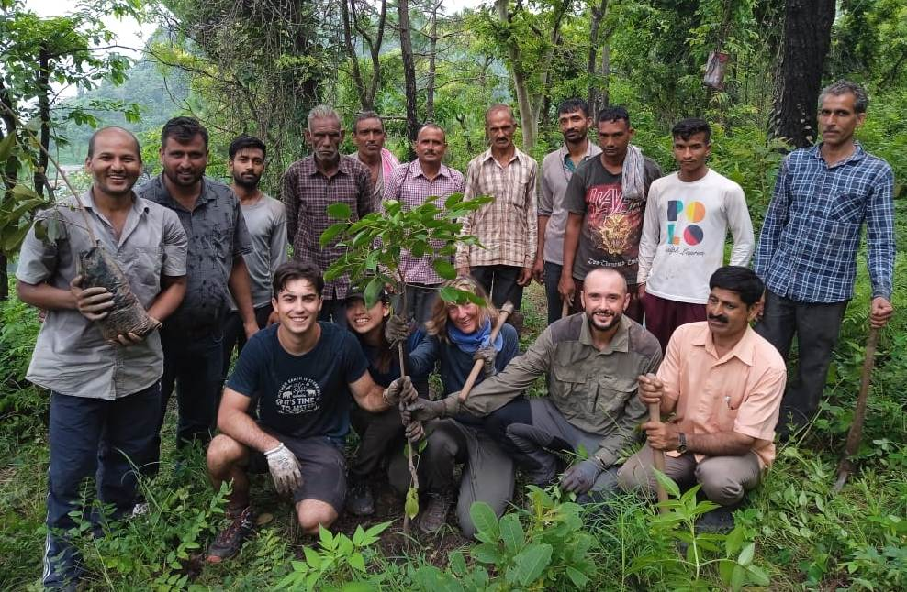

**Accommodation:** Basic, simple, safe & clean accommodation will be provided either at host family or RUCHI campus on sharing basis (Twin or triple) with common toilets and bath.

**Food:** Food offered will be simple authentic Indian vegetarian and freshly cooked. Three meals a day will be served. Assistance while cooking is desired and self cooking can be organized by volunteers.

**International Airport:** New Delhi

**Meeting Point:** Kalka railway station

**Project No.: RC-MTV-Health-5/25: Health and Sanitation (WASH)**

**Period: Open round the year**

Age: 18+

Location: 10 villages in Dharampur Development Block

Placement: Placement is offered for 3 to 6 months.

Joining dates: Any Monday (preferable) during project cycle.

**Background:** Adequate sanitation, together with good hygiene and safe water, are fundamental to good health and as well as social and economic development. The Sustainable Development Goal target 6.2 calls for adequate and equitable sanitation for all. **Sanitation** and hygiene are critical to **health**, survival, and development. Lack of these facilities leave people at risk for water, sanitation, and hygiene (WASH)-related diseases. Garbage disposal is another serious problem and adversely impacts environment and their health. A movement through education and campaigning on WASH needs to be built up.

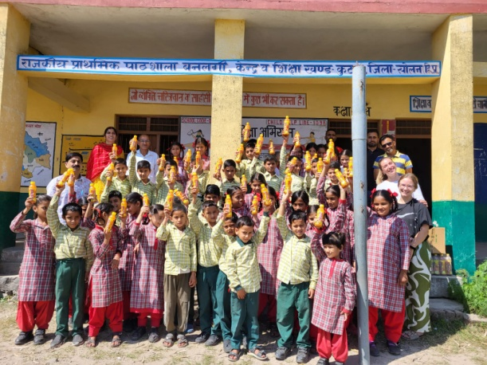

**Work:** The volunteers will help to educate and create awareness involving youth and rural people on water, sanitation, hygiene and health standards(WASH) as well as future pandemic management. The volunteers are expected to be innovative so that they can design and use their own tools in consultation with RUCHI team with regard to their appropriateness and local needs.

The volunteers are expected to:

* Educate people on safe water and water borne diseases.
* Create awareness on WASH components at schools and community level.
* Organise cleanliness drives at school and community level.
* Research and explore waste management solutions at individual and community level.
* Volunteers can use creative mediums like charts, slogans, posters, banners, t-shirts, quotes, videos, films, photographs and discussions to educate villagers about WASH elements.

**Accommodation:** Basic, simple, safe & clean accommodation will be provided either at host family or RUCHI campus on sharing basis (Twin or triple) with common toilets and bath.

**Food:** Food offered will be simple authentic Indian vegetarian and freshly cooked. Three meals a day will be served. Assistance while cooking is desired and self cooking can be organized by volunteers.

**International Airport:** New Delhi

**Meeting Point:** Kalka railway station

**Project No.: RC-MTV-CD-6/25: Women Power**

**Period: Open round the year**

Age: 18+

Location: Villages around Patta

Placement: Placement is offered for 3 to 6 months.

Joining dates: Any Monday (preferable) during project cycle.

**Background:** RUCHI believes ”community development” cannot be achieved until women in our society are empowered and are respected within our society. A women plays many roles within Indian society; a daughter, a wife, a mother, a home maker and even labourer to earn wages if need arises. Surprisingly after supporting her family in various ways she is mostly not consulted and involved in household decision making.

RUCHI always recognised women’s efforts and believes that, educating a women educates whole family & therefore keeping that in mind RUCHI has initiated voluntary project facilitating cultural exposure and assisting women to overcome these odds.

**Work:** This projects aims to empower individual women and groups from rural communities we work with by understanding and identifying their needs and assisting them to overcome them. Most importantly encouraging them to start being an earning member of family and achieve social status she rightfully deserves.

Working closely with our community youth worker they will undertake following tasks:

* Actively participate in women self help group meetings and understand their functioning & activities.
* Evaluate current needs of groups and individuals in SHG and organise capacity building training for them.
* Promoting women entrepreneurship, business building at individual or group level.
* Educate on digital literacy, personal hygiene, good parenting, sanitary pads, domestic violence etc.

Resourceful volunteers with new ideas, strong determination and high motivation level are highly desired.

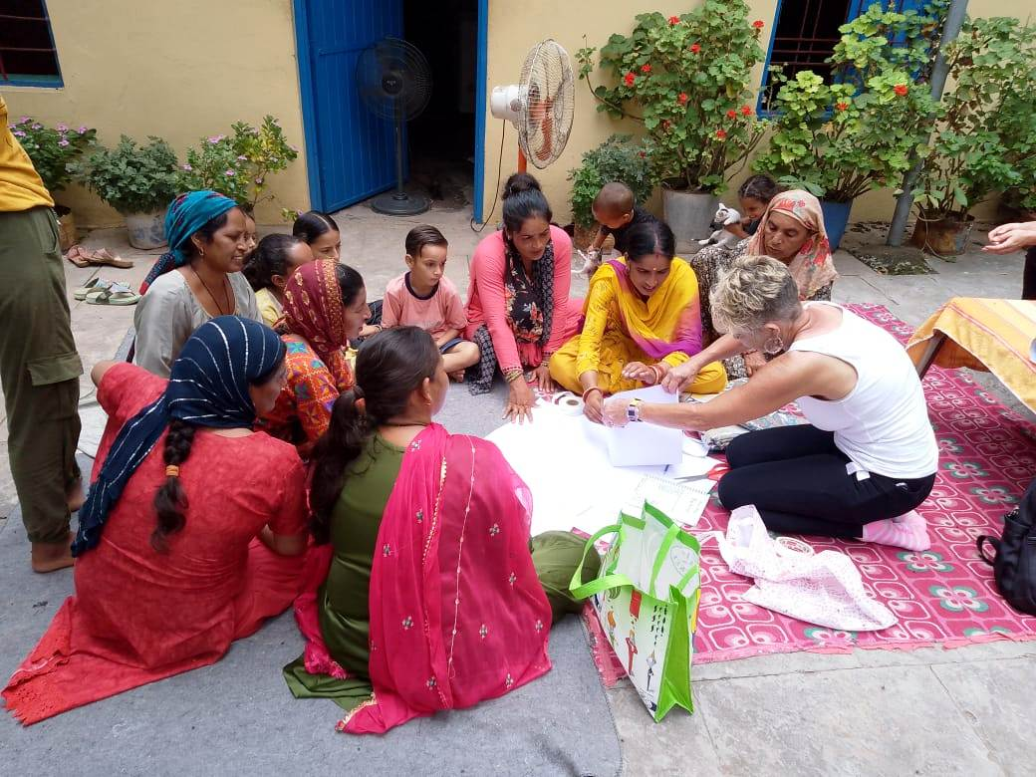

**Accommodation:** Basic, simple, safe & clean accommodation will be provided either at host family or RUCHI campus on sharing basis (Twin or triple) with common toilets and bath.

**Food:** Food offered will be simple authentic Indian vegetarian and freshly cooked. Three meals a day will be served. Assistance while cooking is desired and self cooking can be organized by volunteers.

**International Airport:** New Delhi

**Meeting Point:** Kalka railway station

**Project No.: RC-MTV-CD-07/25: IVS Programme Management**

**Period: June to October**

No. of Volunteer: 2

Age: 21+

Location: RUCHI office in Bandh village (Solan)

Placement: Placement is offered for 3-5 months from June to October

Joining dates: Any Monday (preferable) during project cycle.

**Background:**

Working with a small team of social scientists some extra hands are always welcome between May and October each year to provide assistance to our IVS program and further promote it. Each year at RUCHI we organize nearly 15 Short term workcamps and have nearly 10 ongoing initiatives for Long tern volunteers and Interns to participate in where we host nearly 100-160 national and international youth per annum.

**Work:** Volunteers will be working closely with IVS coordinator, team leaders and other camp volunteers by providing assistance to ensure the quality of workcamp and project objectives are being reached. A committed volunteer with IT & web development, photography and video making skills will be highly desired.

Few tasks assigned for this role are:

* Assist in general administrative work related to incoming volunteers.
* Help administer and coordinate weekly plan during workcamp.
* Assist camp leaders during workcamp organisation and daily evaluation with volunteers.
* Assist in promoting our IVS projects to recruit more volunteers (Website development & promotion, social media promotion etc).
* Assist in promoting workcamp projects to recruit Indian volunteers.

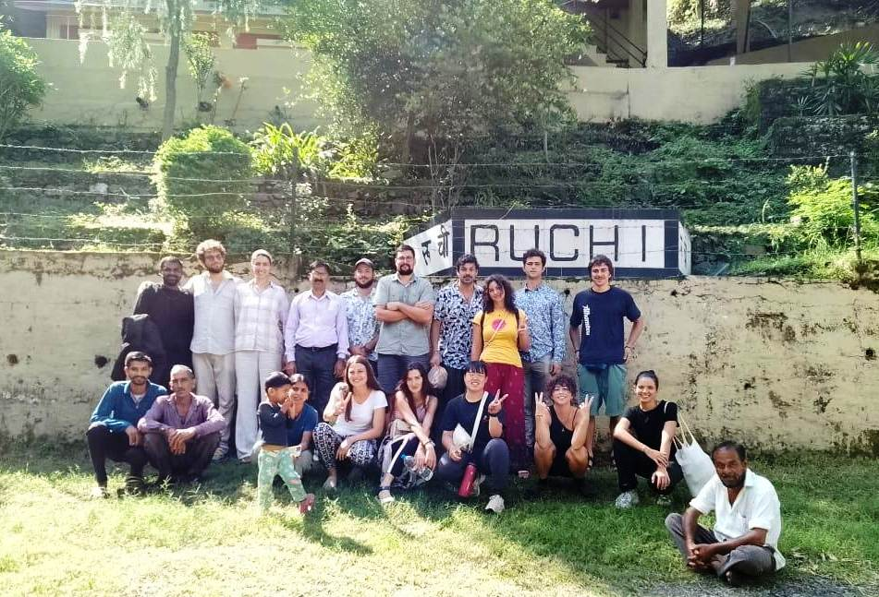

* Visiting camp and project sites during camps for guidance.

**Accommodation:** Basic, simple, safe & clean accommodation will be provided at RUCHI campus on sharing basis (Twin or triple) with common toilets and bath.

**Food:** Food offered will be simple authentic Indian vegetarian and freshly cooked. Three meals a day will be served. Assistance while cooking is desired and self cooking can be organized by volunteers.

**International Airport:** New Delhi

**Meeting Point:** Kalka railway station

**Project No.: RC-MTV-AGR-08/25: Natural farming**

**Period: Open round the year**

Age: 18+

Location: RUCHI (Solan)

Placement: Placement is offered for 3 to 6 months.

Joining dates: Any Monday (preferable) during project cycle.

**Background:** Himachal Pradesh is a mountainous area where the economy is pre-dominantly agriculture based. However, due to shortage of water and small terraces on sloppy land the agriculture is unsustainable and farm output is not sufficient keeping in mind economic value it gets. Also due to steep terrain and small terraces automated machines have limited usage here. As a result we fear food security problem in the future as many people are losing interest in agriculture.

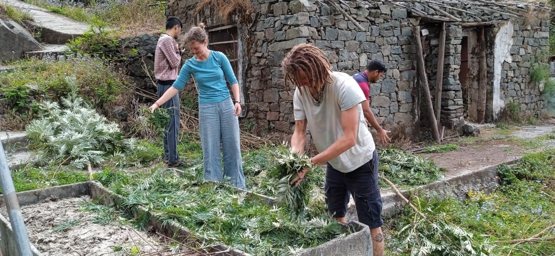

In order to sustain interest of people not only in agriculture but to enhance their farm production through natural faming, we give high importance to this project. At our campus, we have already demonstrated successfully making and uses of various form of natural composting, Kitchen Gardening, Agroforestry, floriculture, off season vegetables, orchard development here. At present we are preparing to install hydroponics system at our campus for demonstration, training and self sufficiency. In due course we would like to serve as demonstration centre for farmers.

**Work:** With this initiative we aim to educate and train farmers in nearby communities by acting as a resource and demonstration centre for sharing good practices among farmers.

The volunteers are required to assist us in following areas:

* daily maintenance of farm and make natural/organic sprays, pesticide and produce chemical free products.
* Actively assist our team to realise our dream to be self sufficient by producing majority of fruits, vegetable that we consume.
* Introduce or reinforce good farming practices and grow off season and low water consuming vegetable.
* Assist in installing a low cost hydroponics system at campus.

**Accommodation:** Basic, simple, safe & clean accommodation will be provided either at host family or RUCHI campus on sharing basis (Twin or triple) with common toilets and bath.

**Food:** Food offered will be simple authentic Indian vegetarian and freshly cooked. Three meals a day will be served. Assistance while cooking is desired and self cooking can be organized by volunteers.

**International Airport:** New Delhi

**Meeting Point:** Kalka railway station