

Volunteering in Germany in March and April

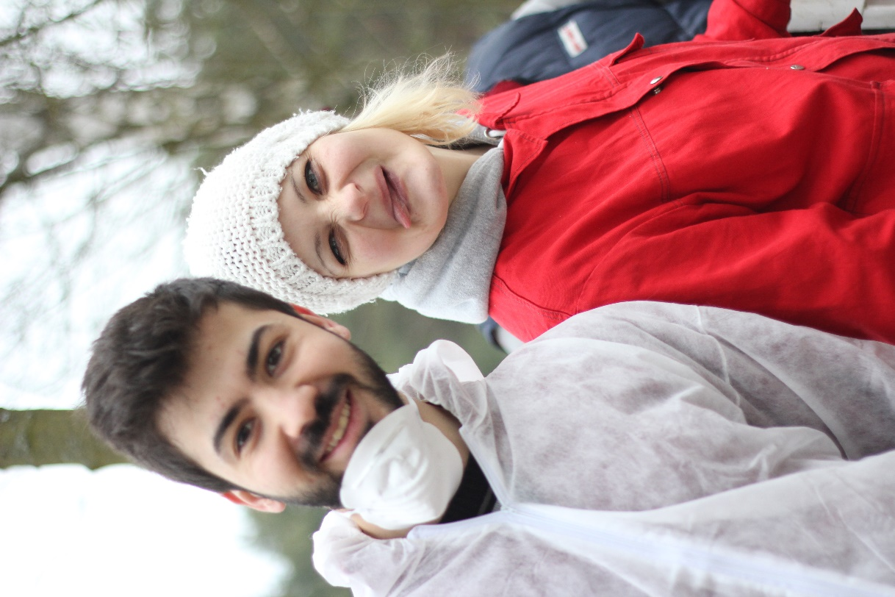

The Bauorden in Germany offers a six-week programme starting spring 2025: From 2nd of March until 12th of April you can take part in three different work camps in Germany and have an unforgettable experience! Volunteer tasks will be in renovation and building.

If you want to experience Germany in a non-touristic way and do something meaningful, you can apply. Just write an email to [info@bauorden.de](mailto:info@bauorden.de) with a few sentences about yourself and your motivation.

You can find more information on our website: <http://new.bauorden.de/ich-will-anpacken/6-wochen-programm/>

Or check out our Instagram account: [Instagram](https://www.instagram.com/internationaler_bauorden/)