

Try something new in 2025?

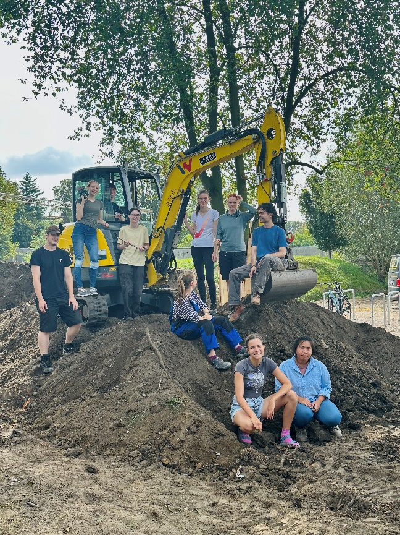

The Bauorden in Germany offers a unique programme next year: You will spend six weeks at three different work camps in Germany. You will live and work in international teams with young volunteers from all over Europe and help associations and organisations that want to build or renovate their facilities.

If you want to experience Germany in a non-touristic way and do something meaningful, you can apply. Just write an email to [info@bauorden.de](mailto:info@bauorden.de) with a few sentences about yourself and your motivation.

You can find more information on our website: <http://new.bauorden.de/ich-will-anpacken/6-wochen-programm/>

Or check out our Instagram account: [Instagram](https://www.instagram.com/internationaler_bauorden/)