SEEDS has an open ESC call for applicants from Austria, Bulgaria, Cyprus, Czechia, Estonia, France, Germany, Greece, Hungary, Italy, Lithuania, Poland, Portugal, Romania, Slovakia, or Spain.

What is SEEDS?
Founded in 2005, SEEDS Iceland is an Icelandic non-governmental, non-profit volunteer organisation designed to promote intercultural understanding, environmental protection and awareness through work on environmental, social and cultural projects within Iceland. SEEDS’ projects are structured on self-organisation and self-management providing a unique and enriching experience for all involved.

Duration
The project starts on the 2nd of September 2024 and lasts for 5 months (158 days).

Volunteer roles
There are 8 vacancies for Camp Coordinators and 3 for PR & Communications.
- Environment Camp Coordinator - volunteers who assist in coordinating and participating in the international Nature & Conservation workcamps around Iceland, and in the winter environment educational activities and virtual camps, as well as social solidarity projects in Reykjavík. They also act as a link between the Icelandic hosts and the international short-term volunteers.
- Photography Camp Coordinator - volunteers who assist in coordinating and participating in the international camps relating to photography, environmental awareness, and coordinating our arts and culture projects in Reykjavík. They also participate in our social solidarity projects in Reykjavík.
- Public Relations & Communications Volunteer - volunteers who are based in our office in Reykjavík and who assist in the creation and management of online content in SEEDS social media accounts; as well as keeping up-to-date quality and performance procedures; and participating in SEEDS artistic, cultural and educational activities. They also participate in our social solidarity projects in Reykjavík.

Volunteers in the role of Camp Coordinator lead teams of international volunteers for about 10-14 days.
Volunteers are based in Reykjavík, and occasionally travel to camps in other locations in Iceland (applicable during the summer season May-October).

This role is ideal if you are...
- Ready to work with international groups
- Interested in spending time with people from all over the world
- Positive and flexible
- Ready to work outdoors
- Interested in environmental issues

What is included
- Accommodation: shared house in Reykjavík, walking distance from the office/city centre. While in camps in the countryside, accommodation is provided by local hosts; facilities vary according to the accommodation available
- Food is provided by SEEDS, and volunteers help organise the weekly shopping. A plant-based diet is followed during SEEDS'S camps
- Monthly pocket money

- Health insurance for the duration of the project. Having a valid European Health Insurance Card before travelling to Iceland is mandatory
- Transportation costs from the supporting organisation’s address to the hosting organisation’s address (and and back) are covered by the project's budget up to Erasmus+ limits for a certain country, based on the Erasmus+ distance calculator. The participant usually buys their own ticket and gets reimbursed (up to the travel grant defined by distance) after the end of the project, and once their final report has been submitted. Check the amounts granted in the ESC guide.

How to apply
Please write to your supporting organisation (SO) and to SEEDS on mobility@seeds.is if you are from any of the countries above and are interested in becoming an ESC volunteer. Please send us via email the following documents in English to mobility@seeds.is:
- CV (Curriculum Vitae) – max two pages
- Completed SEEDS questionnaire – you can find it here.
In your application, clearly state which role and period you’re available for.
Note that you can only apply for this ESC if you are between 18-30 years old.

Deadline to apply is the 1st of July 2024 at 16.00 (GMT).
More details about SEEDS and our activities can be found on our website.

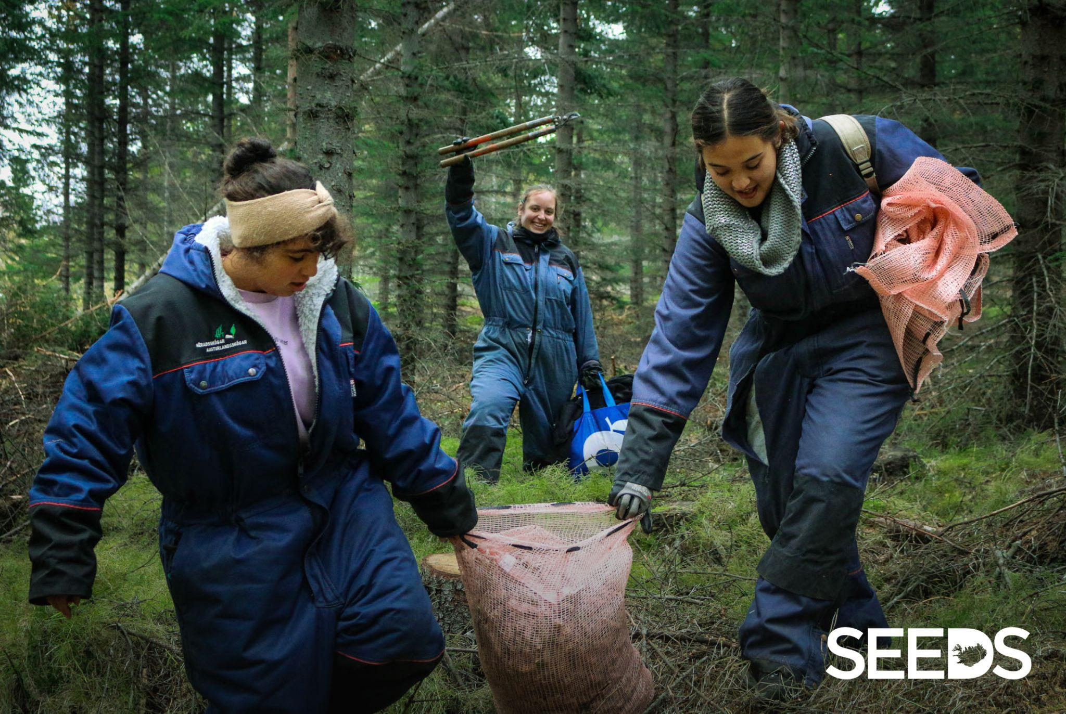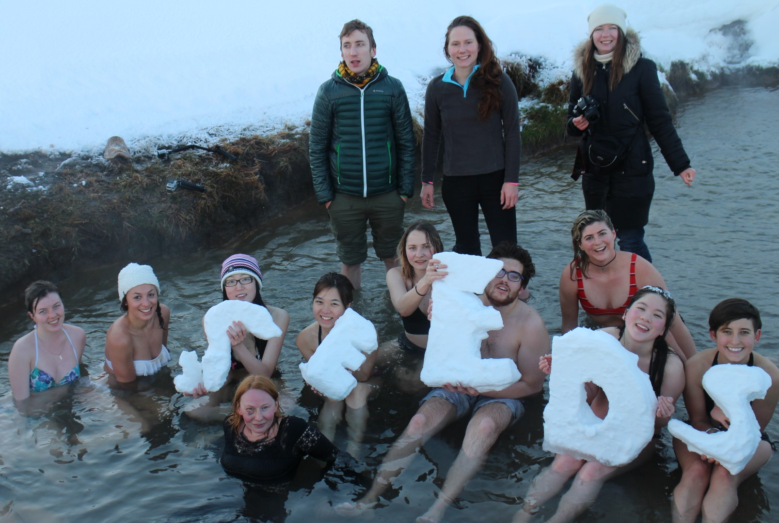
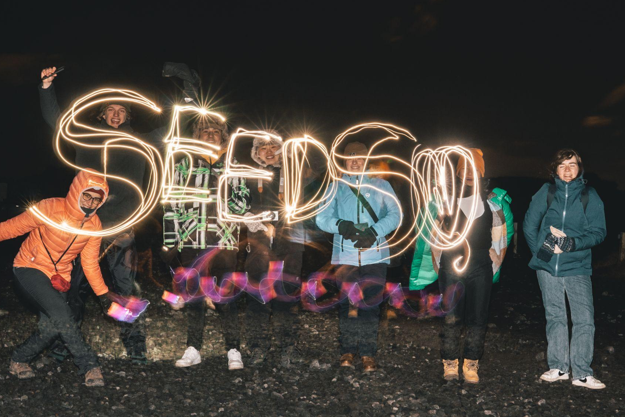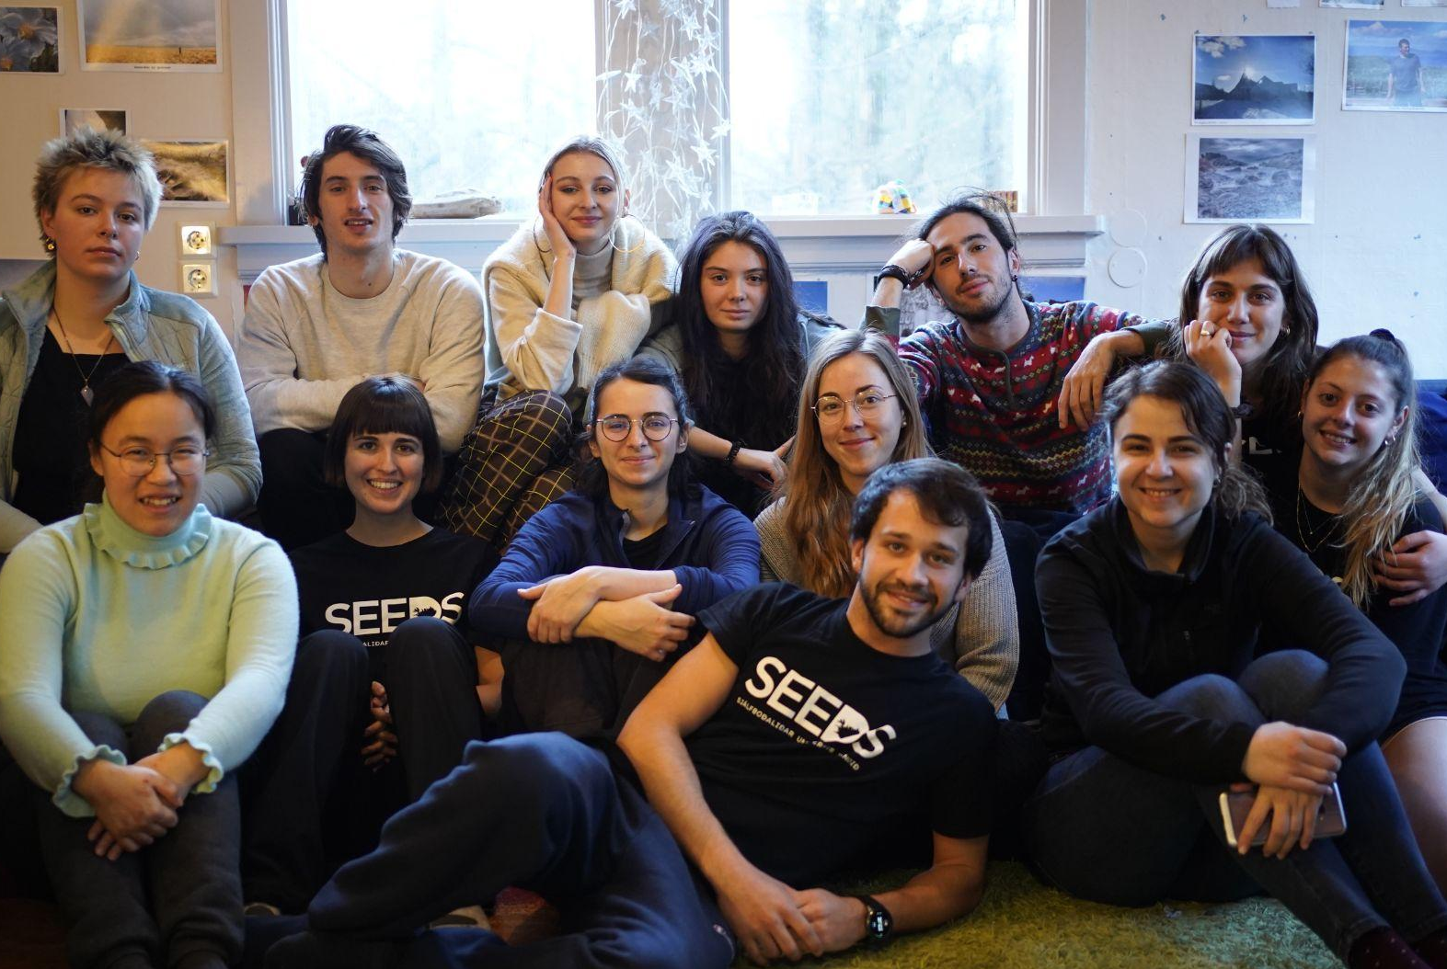

Current project partners
AHA (Austria, Vorarlberg), Jugend:info NÖ (Austria), Association of Ruse and Green School Village (Bulgaria), PlanBe, Plan it Be it (Cyprus), European Youth Centre Breclav (Czechia), EstYES (Estonia), Association CACIAURA and Concordia France, Freiwilligendienste and SFD Bremen e.V. (Germany), You in Europe (Greece), Hungarian Volunteer Sending Foundation HVSF, Associazione InformaGiovani and Comune di Cremona (Italy), Socialinis Veiksmas (Lithuania), Bona Fides Association (Poland), Agora Aveiro, Rota Jovem, and Y.U.P.I. Youth Union Of People with Initiative (Portugal), A.C.T.O.R. - Cultural Association for Theatre and Origami (Romania), Keric (Slovakia), COCAT and Ayuntamiento de Maracena (Spain).

Last updated 06.06.2024

