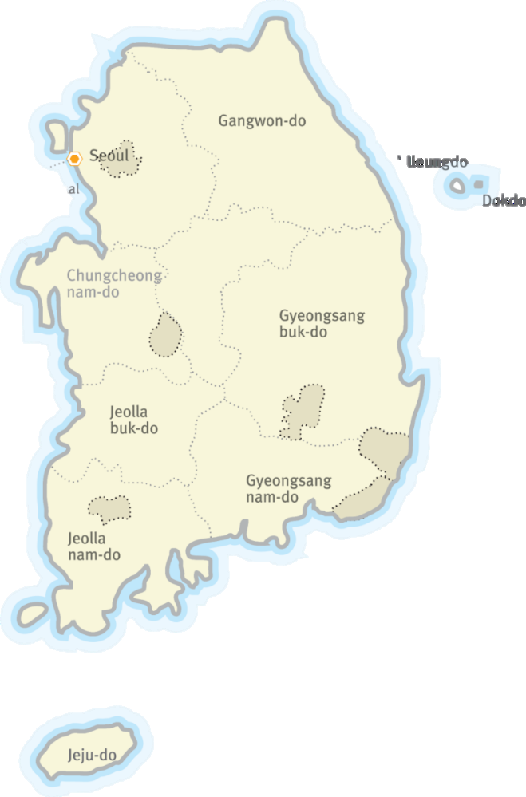

**1. Introduction about IWO**

IWO is a non-profit and non-governmental organization established in 1999 to promote world peace, global citizenship, youth and community development, and cultural exchange through international voluntary service. We had been an Executive committee member of CCIVS (Coordinating Committee for International Voluntary Service) at UNESCO Paris, and are a member of NVDA (Network for Voluntary Development in Asia), and a member of Alliance (Alliance of European voluntary service organizations).

**1.1 Our Vision**

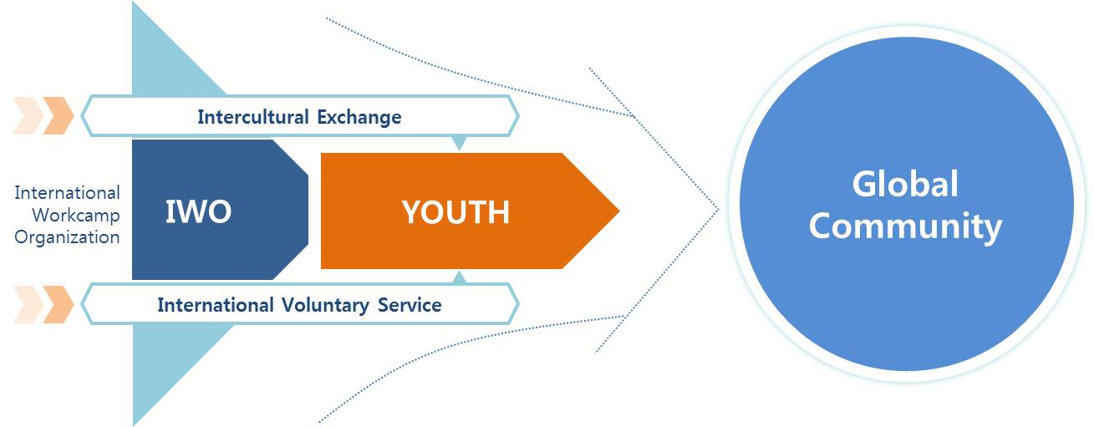

We believe that we can promote world peace by contributing to mutual respect and capacity for peaceful coexistence among all countries. We offer the youth of all countries the opportunities with international voluntary service projects to understand the cultural differences and diversity of each society. We believe that youth is our bright future in this world.

**1.2 Our Activities**

Our International Voluntary Service Projects offer young people opportunities to participate in community-based projects in over 70 countries worldwide. The projects differ widely ranging from nature conservation, restoration, education, and construction to projects that are more socially based including work with adults and children with special needs, teaching or organizing youth & children's holiday schemes. Our main activities include.

**\* GLOBAL Education \***

* **G**rowing and training youth and volunteers
* **L**eading a new paradigm in the field of non-formal education
* **O**rganizing international voluntary service projects
* **B**uilding intercultural programs
* **A**rranging international conferences and seminars
* **L**earning and understanding diverse culture

**1.3 Our Aims**

The main purpose of IWO STV and MTV projects is the so-called ‘**Glocalization**’ which is to bring the world to Korea and provide opportunities for international exposure. Hence, the projects may enhance the cultural interchange between the local residents and international volunteers and also influence positively the host organization and local community by actively fulfilling the missions of each project.

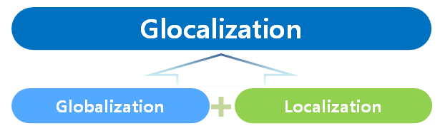

- To provide opportunities to locals so that they can understand other countries and

cultures by building friendship with volunteers.

- To help international volunteers understand Korean culture and learn to respect

differences and diversity.

- To empower the locals to support civil associations and non-governmental organizations.

- To encourage volunteers to have an active attitude toward responsibility for the

environment, youth and society.

- To promote voluntary service activities in cooperation with local communities and NGOs.

**2. General conditions of projects**

All projects cooperate with local NGOs, local governments, civil society and local volunteers. The locals are pleased with and welcome the international volunteers who have the different cultural, social and educational backgrounds.

**Short Term Volunteer Projects (Workcamps)**

**1) Number of Volunteers & Duration**

- IWO hosts 10-25 volunteers on each workcamp. Each project will have 4-10 Korean

participants (Including 1~2 Korean camp leaders) and 10-25 international participants.

- The number of volunteers may alter depending on each project.

- Duration of the project is 7 to 12 days.

**2) Project Coordinator**

-Each project has 1~2 camp leaders who have been trained by IWO. They will coordinate

the group to achieve the goals of each project. And, the Korean participants also

prepare for the project with IWO before the international participants arrive in Korea.

**3) Accommodation & Food**

- Meals and accommodation are provided during the project

- Rooms will be shared among participants and sleep on the floor with a mattress (Based on Korean culture)

- However, participants may have to cook by themselves on some project sites.

- Participants are responsible for keeping the accommodation clean during the project at

all times because there will be locals visiting the project sites often

-If volunteers have a unique dietary requirement, they should inform them in advance and they have to prepare for themselves in case the local can’t support them.

**4) Free Time**

-Participants are responsible for organizing their own free time with the camp leaders

during free days. Host organizations will share information about local attractions with

the participants.

**5) Insurance**

-IWO provides insurance for **accidents** **during the project only**. (No dental clinic, illness,

3rd party’s liability compensation). It covers only a percentage of the cost (co-pay) at

a maximum 40% as per the insurance regulation for foreigners in KOREA.

- Therefore, **participants MUST bring** their **insurance for health, travel and the 3rd**

**party’s liabilitycompensation.**

**6) Transportation**

-Korea has a convenient public transportation network over the country; therefore, all

participants are advised to arrive at **Incheon International Airport** regardless of the

location of their project site.

- By taking a subway and an airport bus, participants can conveniently arrive from the

airport to Seoul. There are many convenient public transportation systems from Seoul

to each project site.

**7) Participation fee**

- None

**8) Financial Support**

- Participant can get the transportation (Round-trip Ferry tickets) after the meeting point.

**8) General Requirements**

- The primary language is English.

- Be **motivated** and **open-minded to local cultures**.

- Be flexible and be ready for sudden changes in the program according to the local situation.

- Participants aged from 19 to 40 years are acceptable. Exceptions may be negotiated.

- Volunteers should be fully aware that this is **NOT a vacation trip** nor **cheap travel.**

- Verbal and physical sexual harassment and discrimination is a serious crime.

- Smoking is allowed only in a designated area in each project site.

- No illegal drugs are allowed in Korea.

- No drinking alcohol is allowed when you are with children or even in a youth centre.

**1. Workcamp Project List**

|  |  |  |  |  |  |  |  |
| --- | --- | --- | --- | --- | --- | --- | --- |
| **No.** | **Code** | **Title** | **Location** | **Date** | **Type** | **No. of**  **Vols.** | **Age**  **Limit** |
| **1** | **IWO-71** | Dochodo-WHV | Shinan | 15 JUL – 21 JUL | CULT/EDU | 25 | 19+ |
| **2** | **IWO-72** | Hajodo-WHV | Jindo | 15 JUL – 21 JUL | CULT/EDU | 25 | 19+ |
| **3** | **IWO-81** | Soando | Wando | 13 AUG – 19 AUG | CULT/EDU | 25 | 19+ |
| **4** | **IWO-81** | Geumodo | Yeosu | 19 AUG – 25 AUG | CULT/EDU | 25 | 19+ |

**2. Workcamp Description**

|  |  |  |  |  |  |
| --- | --- | --- | --- | --- | --- |
| **IWO-71** | **Dochodo-WHV** | **Shinan** | **15 – 21 JUL** | **CULT/EDU** | **25 vols** |
| **IWO-72** | **Hajodo-WHV** | **Jindo** | **15 – 21 JUL** | **CULT/EDU** | **25 vols** |

Did you know that there are about 3,000 islands in Korea? These islands are filled with various stories. For instance, it was an island where foreigners first visited Korea, and one of the presidents received the Nobel Peace Prize in Korea. Many people have considered islands as isolated places because they are separated from the mainland and historically seen as remote destinations. However, from a different point of view, we can consider islands as the first gateways in Korean history to accept foreign and diverse cultures. They were such open-minded places to embrace diverse cultures and values.

Here, we can discover the cultural heritage from a global-local perspective. From islands where foreign cultures were first embraced, we aim to promote global values and cultural heritage, and introduce the values brought by international volunteers to the island residents. Join us for a meaningful adventure!

**Work**: The main goal is to promote the hidden history and culture of the islands from an international perspective. To achieve this, we will organize a ‘Glocal (global-local) Island School Project’ with local students. As part of this program, we will hold lectures on the islands, share ideas about island life, and introduce participants' diverse traditions and cultures to local youth through experiential education.

Participants will engage students in games, share cooking recipes, showcase traditional clothing, and demonstrate dances and songs from their home countries. Through these activities, island youth will enhance their global competence and develop a sense of pride in island life.

Additionally, we will assist socially disadvantaged local residents by delivering meals and helping elderly individuals with household chores such as home repairs and maintenance. During this process, we will listen to their stories, share our own values, and invite them to share international cuisine with us.

Finally, we will host an island promotion competition to showcase the unique values and international aspects of the islands through creative projects and social media posts.

Through these experiences, we hope that you'll have the opportunity to immerse yourself in diverse cultures, experience real island life, and build meaningful connections with local residents.

**Accommodation and Food**: In the local guest house / Meals are provided & Cooked by participants

**Location**:

Dochodo: <https://goo.gl/maps/ELQGRtpCvSBEKP759>

Hajodo : https://maps.app.goo.gl/X7qxzQCDAGjg2WXZA

**Dochodo (Docho Island)**

Dochodo Island is a small island located in the southwestern corner of Korea, within Sinan region. It is known for its stunning tidal flats(Getbol) which are designated as World heritage sites in 2022. This site exhibits a complex combination of geological, oceanographic and climatological conditions that have led to the development of coastal diverse sedimentary systems.

**Hajodo (Hajo Island)**

Hajoodo Island is a beautiful place in the southwest part of Korea, within Jindo region. People say that in 1816, a British colonel visited Hajodo Island and thought it was one of the most amazing places in the world. He described it as “the peak of the world, the peak of the earth.” Like this, it is well-known for breathtaking scenery with crystal-clear and sparkling beaches, and pretty coastal roads. It's a peaceful place where you can take walks, go hiking in the hills, or just sit and enjoy the view.

**Transportation** Participants will meet at Mokpo KTX Station. The train or bus runs frequently from Seoul to Mokpo a day. It takes about 2 hours and a half by KTX train(Fast train). After gathering at the station, all participants will move together to the project site by the bus and ferry. The transportation fee from meeting point to project site by charted bus and ferry will be covered by the Host organization. It will take about 35 minutes by ferry from the port to the project site.

**General information of island**:

Dochodo: <https://youtu.be/dnHbCQRvOSU>

Hajodo : https://www.youtube.com/watch?v=QsH0FnsYaqA

|  |  |  |  |  |  |
| --- | --- | --- | --- | --- | --- |
| **IWO-81** | **Soando** | **Wando** | **13 – 19 Aug** | **CULT/EDU** | **25 vols** |

Did you know that there are about 3,000 islands in Korea? These islands are filled with various stories. For instance, it was an island where foreigners first visited Korea, and one of the presidents received the Nobel Peace Prize in Korea. Many people have considered islands as isolated places because they are separated from the mainland and historically seen as remote destinations. However, from a different point of view, we can consider islands as the first gateways in Korean history to accept foreign and diverse cultures. They were such open-minded places to embrace diverse cultures and values.

Here, we can discover the cultural heritage from a global-local perspective. From islands where foreign cultures were first embraced, we aim to promote global values and cultural heritage, and introduce the values brought by international volunteers to the island residents. Join us for a meaningful adventure!

**Work:** The main goal is to promote the hidden history and culture of the islands from an international perspective. To achieve this, we will organize a ‘Glocal (global-local) Island School Project’ with local students. As part of this program, we will hold lectures on the islands, share ideas about island life, and introduce participants' diverse traditions and cultures to local youth through experiential education.

Participants will engage students in games, share cooking recipes, showcase traditional clothing, and demonstrate dances and songs from their home countries. Through these activities, island youth will enhance their global competence and develop a sense of pride in island life.

Additionally, we will assist socially disadvantaged local residents by delivering meals and helping elderly individuals with household chores such as home repairs and maintenance. During this process, we will listen to their stories, share our own values, and invite them to share international cuisine with us.

Finally, we will host an island promotion competition to showcase the unique values and international aspects of the islands through creative projects and social media posts.

Through these experiences, we hope that you'll have the opportunity to immerse yourself in diverse cultures, experience real island life, and build meaningful connections with local residents.

**Accommodation and Food**: In the local guest house / Meals are provided & Cooked by participants

**Location**:

Soando: <https://maps.app.goo.gl/WPEqVjdSgwfCF9Nf8>

**Soan do (Soan Island)**

Soando Island, known for its role in the Independence Movement, is famous for its beautiful beach and evergreen forests. During the Japanese colonial period, it was a hub of opposition against Japanese rule. Despite its small population of only 6,000 people, Soando Island produced 88 independence activists, including 20 recognized as independence patriots.

To commemorate this historical significance, the island flies the Korean national flag throughout the year, reflecting on the patriotism of their ancestors. Additionally, a memorial hall for the independence movement has been built to spread the spirit of love for the country.

**Transportation:**

Participants will meet at Mokpo KTX Station. The train or bus runs frequently from Seoul to Mokpo a day. It takes about 2 hours and a half by KTX train(Fast train). After gathering at the station, all participants will move together to the project site by the bus and ferry. The transportation fee from meeting point to project site by charted bus and ferry will be covered by the Host organization. It will take about 35 minutes by ferry from the port to the project site.

**General information of island**:

Soando: https://www.youtube.com/watch?v=BA4ov8SrnoI

|  |  |  |  |  |  |
| --- | --- | --- | --- | --- | --- |
| **IWO-82** | **Geumodo** | **Yeosu** | **19 – 24=5 Aug** | **CULT/EDU** | **25 vols** |

Did you know that there are about 3,000 islands in Korea? These islands are filled with various stories. For instance, it was an island where foreigners first visited Korea, and one of the presidents received the Nobel Peace Prize in Korea. Many people have considered islands as isolated places because they are separated from the mainland and historically seen as remote destinations. However, from a different point of view, we can consider islands as the first gateways in Korean history to accept foreign and diverse cultures. They were such open-minded places to embrace diverse cultures and values.

Here, we can discover the cultural heritage from a global-local perspective. From islands where foreign cultures were first embraced, we aim to promote global values and cultural heritage, and introduce the values brought by international volunteers to the island residents. Join us for a meaningful adventure!

**Work:** The main goal is to promote the hidden history and culture of the islands from an international perspective. To achieve this, we will organize a ‘Glocal (global-local) Island School Project’ with local students. As part of this program, we will hold lectures on the islands, share ideas about island life, and introduce participants' diverse traditions and cultures to local youth through experiential education.

Participants will engage students in games, share cooking recipes, showcase traditional clothing, and demonstrate dances and songs from their home countries. Through these activities, island youth will enhance their global competence and develop a sense of pride in island life.

Additionally, we will assist socially disadvantaged local residents by delivering meals and helping elderly individuals with household chores such as home repairs and maintenance. During this process, we will listen to their stories, share our own values, and invite them to share international cuisine with us.

Finally, we will host an island promotion competition to showcase the unique values and international aspects of the islands through creative projects and social media posts.

Through these experiences, we hope that you'll have the opportunity to immerse yourself in diverse cultures, experience real island life, and build meaningful connections with local residents.

**Accommodation and Food**: In the local guest house / Meals are provided & Cooked by participants

**Location**:

Geumodo: <https://goo.gl/maps/Z34oG6XNxiF6yGx49>

Geumo do (Geumo Island)

Geumodo Island is a sizable island located off the southern coast of Yeosu, South Korea. Among the numerous islands in the Yeosu area, Geumodo Island stands out as a top choice for visitors due to its diverse attractions and natural beauty.

Featuring crystal-clear beaches, quiet camping spots, and picturesque coastal trails, Geumodo Island offers a range of leisure activities to enjoy. Whether you're seeking relaxation by the sea, adventure in the great outdoors, or cultural exploration, Geumodo Island has something for everyone.

**Transportation:**

Participants will meet at Yeosu Ferry Terminal. The train or bus runs frequently from Seoul to YEOSU EXPO KTX station in a day and meeting point is just 10min away by public bus. It takes about 2 hours and a half by KTX train(Fast train) from Seoul to Yeosu. After gathering at the meeting point, all participants will move together to the project site by ferry. The transportation from the meeting point to the project site by ferry will be provided. It will take about 90 minutes by a ferry from the port to the project site.

**General information of island**:

Geumodo: <https://www.youtube.com/watch?v=zFZIo5eQqjM>

|  |  |  |  |
| --- | --- | --- | --- |
| Roles | | Staffs | E-mail |
| **Outgoing** | STV, MTV | Mrs. Imagine | iwo@1.or.kr |
| **Incoming** | STV, MTV | Mr. Yonghan KIM | connect1@1.or.kr |
| **\* Emergency contact** : +82-(0)10-2205-5708 | | | |

**International Workcamp Organization**

**B-1710, 583 Yangcheon-ro, Gangseo-gu, Seoul, 07547, Republic of Korea**

**Tel : +82-(0)2-330-2419**

**Email :connect1@1.or.kr**

**Website :** [**www.workcamp.org**](http://www.workcamp.org)