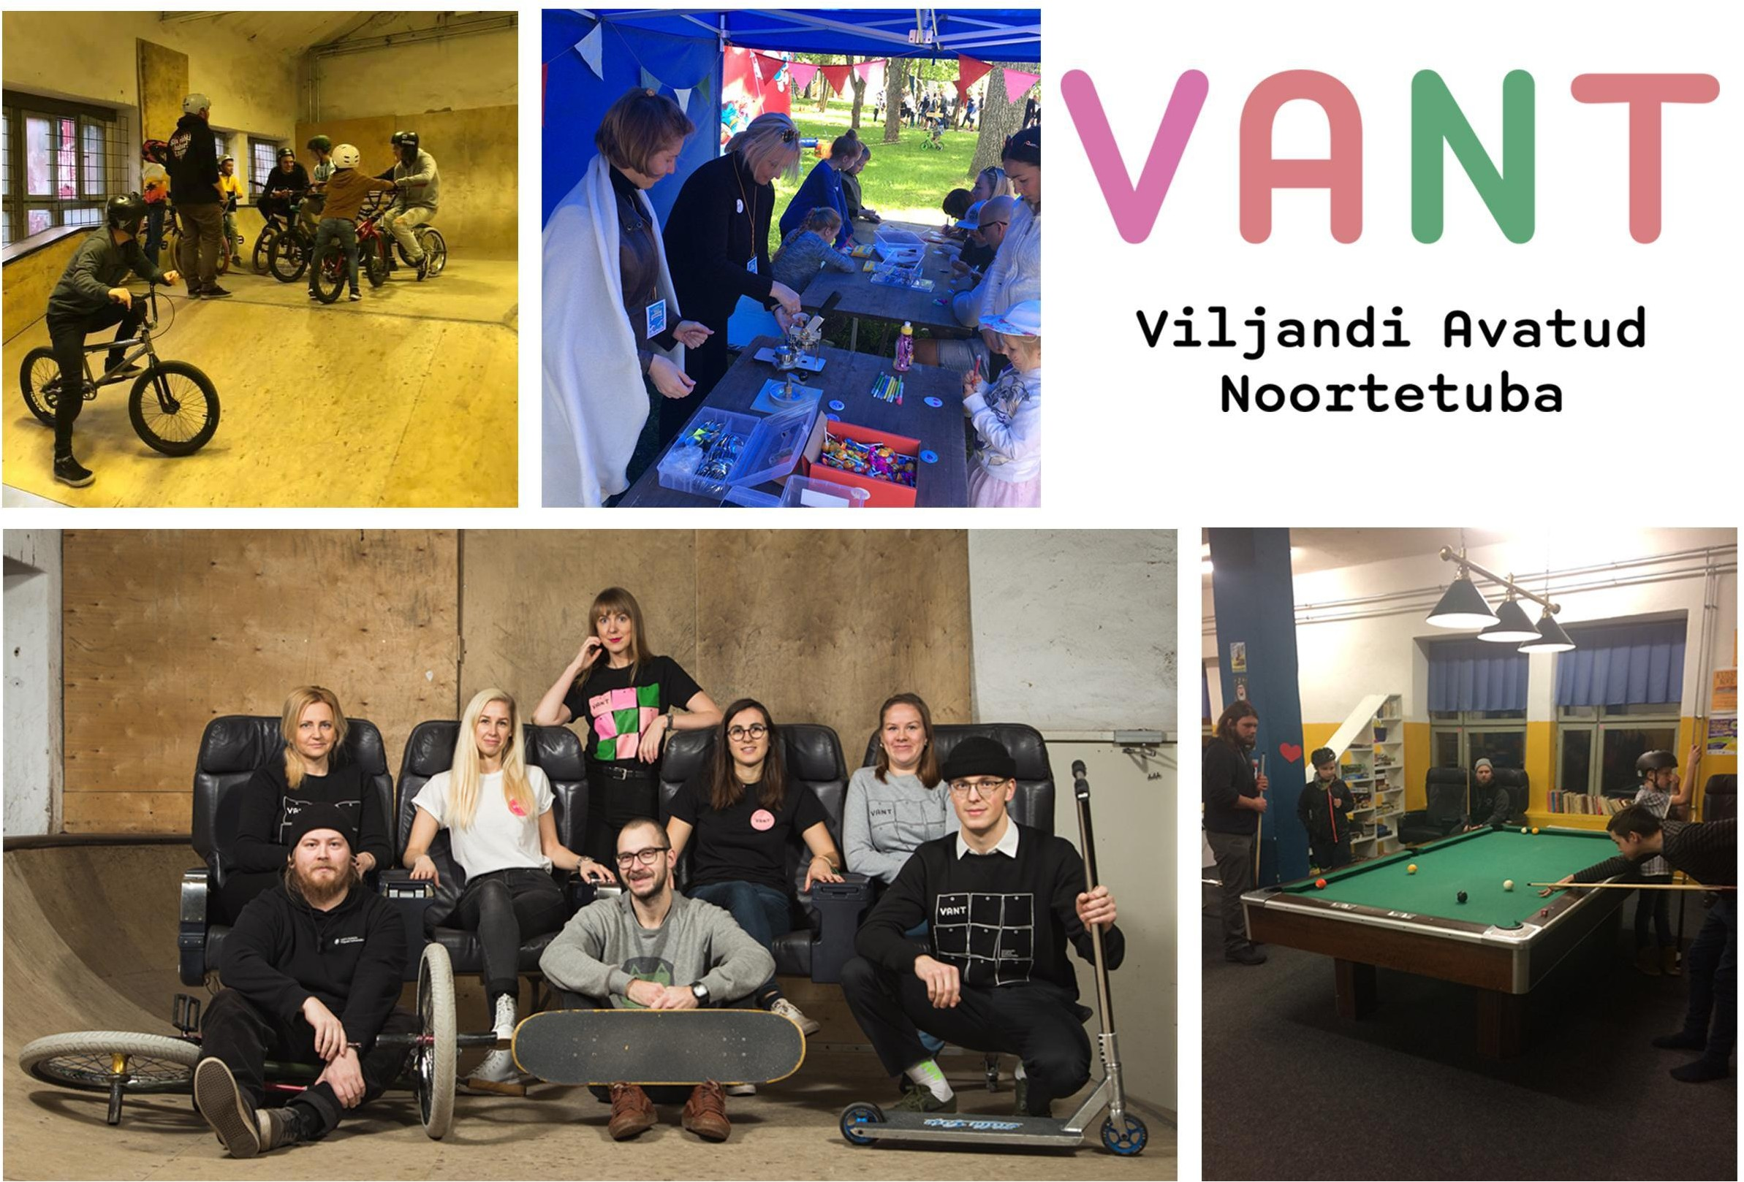

- Sakala Centre -
- Open Youth Centre of Viljandi –

The Hosting Organisation Sakala Centre / Sakala Keskus
Sakala Centre (Sakala Keskus) was opened in September 2012 as a modern community culture centre at the heart of Viljandi. Sakala Centre is operating under
Viljandi’s municipal government and its primary tasks include organising and developing local cultural life, youth work, pastime activities and creative economy. The centre provides opportunities for pastime activities and adds to the variety of cultural events in town while being either organiser or mediator.
Sakala Centre is also the manager of different institutions of Viljandi, as for example art gallery Kondase Keskus and Viljandi Open Youth Centre (VANT).
More information found www.sakalakeskus.ee

Open Youth Centre of Viljandi
Open Youth Centre of Viljandi (VANT) goal is to provide different open youth work services to give possibility to organise leisure time for young people
aged 7-26. In Open Youth Centre young people have possibility to play table tennis, billiard, table football, air hockey, different boardgames, console games and to use

inside extreme hall for skateboarding, BMX and scooter. A youth centre has a wide range of services of youth work. Open Youth Centre of Viljandi is based on the principle of open youth work. The aim of open youth work is to offer young people opportunities to participate on a voluntary basis in order to support their involvement in society and coping in social life. Through events, activities and hobby groups we create conditions for development. It is very important to support young people’s initiative. The youth centre also has a prevention function. We cooperate with different organizations in local area such as schools, police, hobby schools, library, local municipality, youth council, unemployment fund Töötukassa etc.
In the Open Youth Centre of Viljandi work 6 people – the volunteer, a youth centre manager, a project manager, a NEET youngsters specialist, youth workers and also 3 trainers for BMX, scooter and skateboard.
The Open Youth Centre of Viljandi is opened 6 days a week - on Monday until Thursday 14:00-20:00 and on Friday to Saturday 14:00-21:00. For some more information you may check our webpage www.viljandinoorteinfo.ee, Facebook page https://www.facebook.com/ViljandiANT/ or Instagram https://www.instagram.com/viljandiavatudnoortetuba/.

The volunteer & The volunteering

The volunteer can be involved in every activity of the youth centre. Of course the volunteer is more than welcome to take initiative and share her/his own ideas for the activities for young people.

Daily worklife
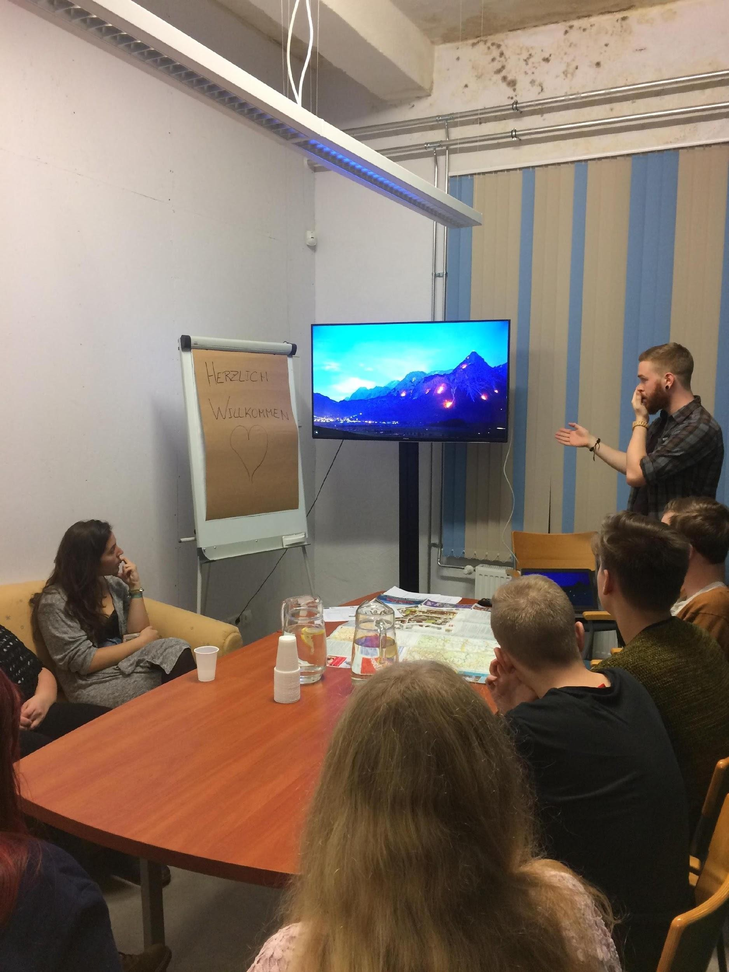
Getting a first impression of the new surrounding is very important to find a starting point, so the volunteer will have more than enough time to settle in and to observe. In general, the daily work of the volunteer is more or less completely up to the volunteer herself/himself, which means that the volunteer is responsible to find her/his own way of implementing herself/himself in the youth centre. This can happen through a big variety of ways, for example:

- Organising different activities for the young people
- Working on open youth work area (game room) of youth center (volunteer can play with the youngsters billiard, table tennis, air hockey, table football etc)
- Helping to prepare and organise different culture and youth events
- Leading a workshop, course or event
- Helping with projects
- Presenting her/his own country and culture
- Promoting ESK and other volunteering possibilities
- Communicating in a foreign language with young people, which would help them to understand the importance of learning languages
- Assisting youth workers in everyday activities
- Helps to manage the Youth Centers social media accounts and create content
- Writes regular blog posts

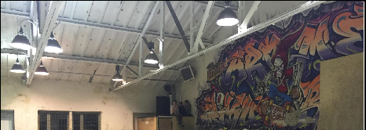Requirements for the volunteer
- Initiative
- Willing to work in team
- Willing to work with young people
- Open-minded and flexible
- Good at communication and starting conversations
- Digital skills (social media, blog posts)
- Self-motivating
- Adaptable
- Self-analysing
- Openness for creativity
- Openness for working from distance in case of government restrictions (covid-19)

Benefits of volunteering

- Leisuretime activities with team (birthdays, celebrating traditional holidays)
- Being part of organising events all over Viljandi
- Experience in Estonian culture and language
- Knowledge about open youth work in Estonia
- Experience in communicating with young people with different background and age groups, communication skills
- Experience in event planning and time management
- Experience in teamwork
- Improving self-reflection (individual meetings every month and weekly team meetings)

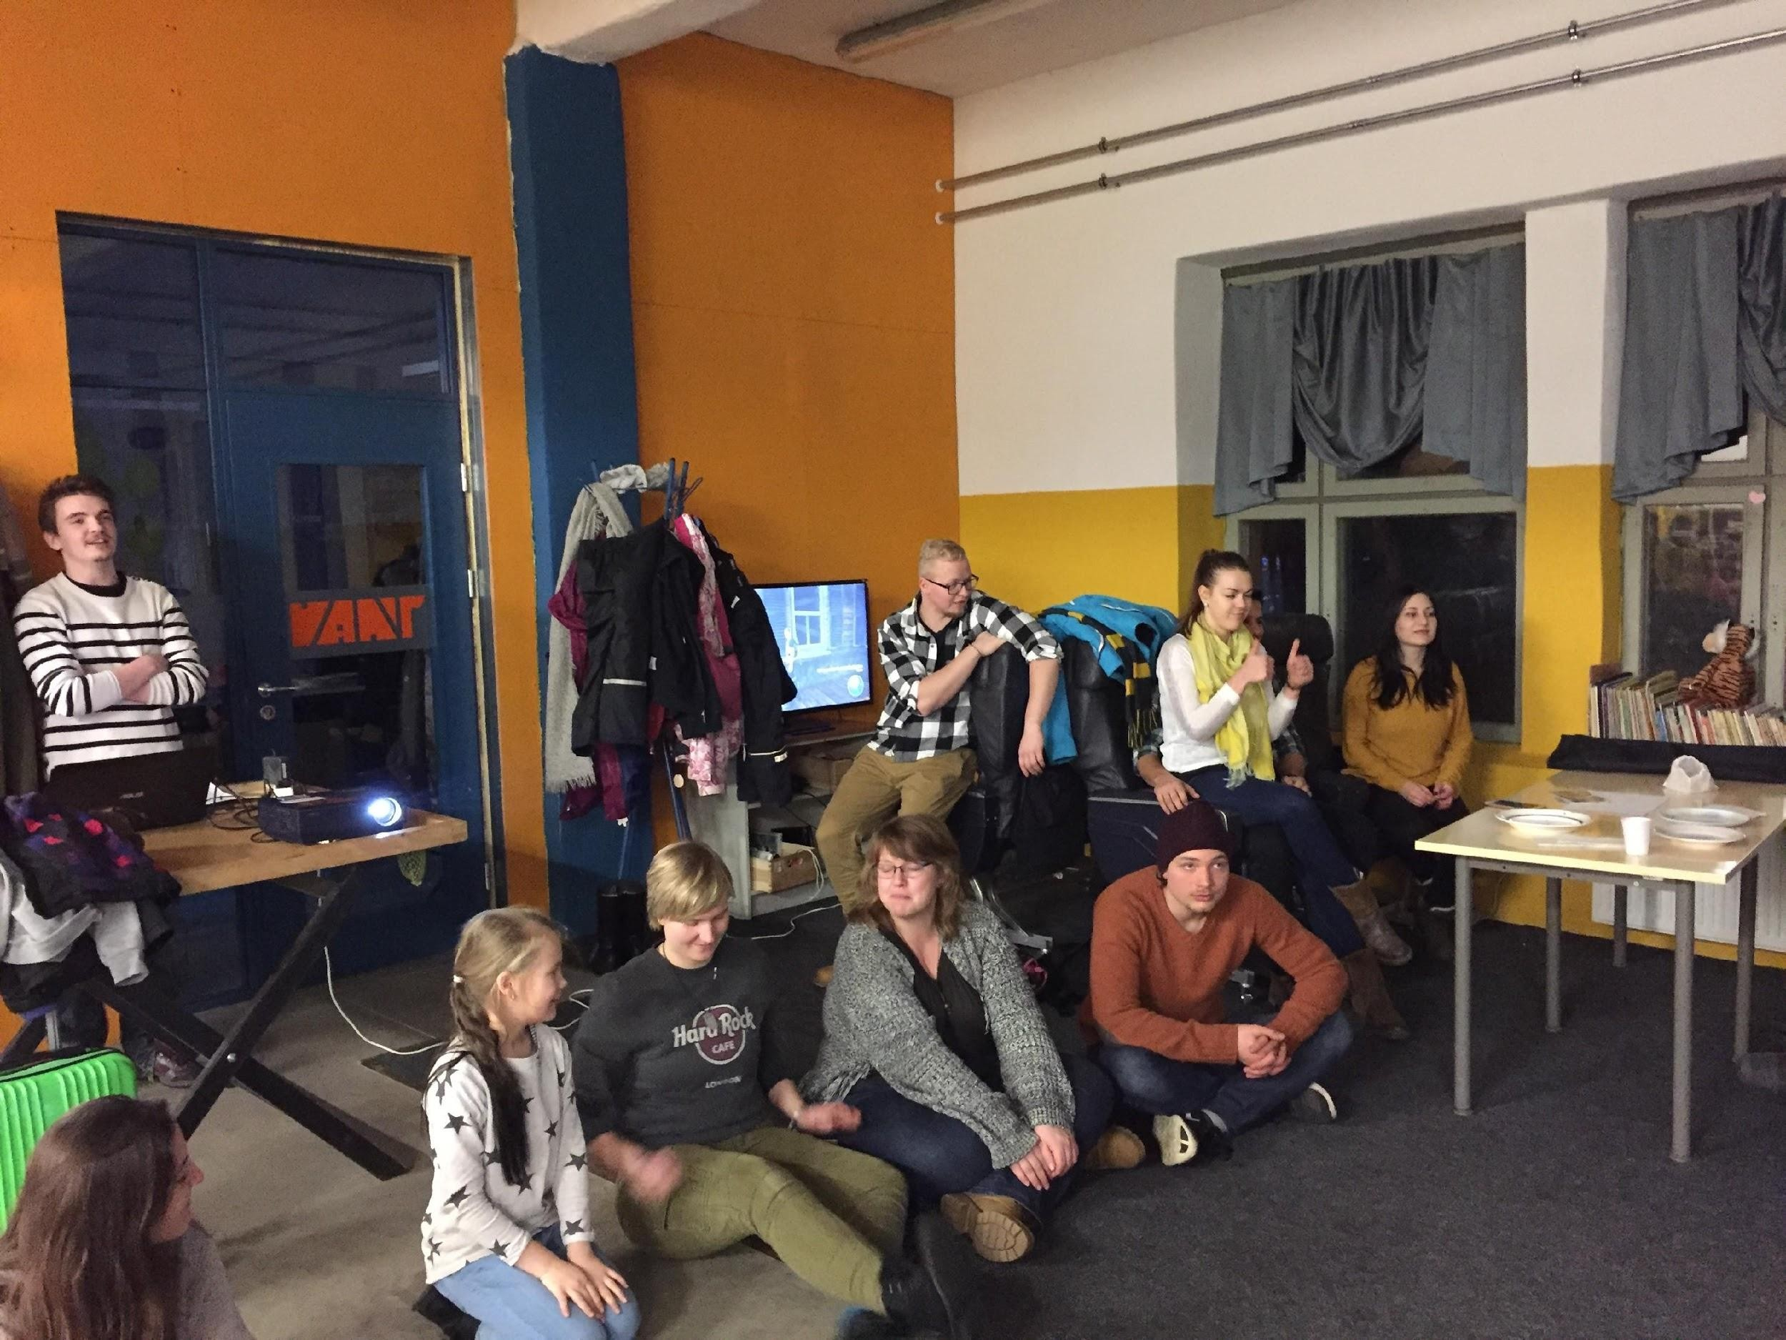
Through organizing her/his own activity schedule, the volunteer will develop certain knowledge about time management, event planning and team work. The volunteer will be included into the youth workers team like everyone else and will learn about open communication, solving problems and evaluation.

The volunteer will get to know the different roles and tasks that the youth workers have and also get the
chance to see other youth centres of the country, so she/he gets the possibility to see how open youth work in Estonia works.

Due to the fact that the youth centre is part of the culture centre of Viljandi, the volunteer will also get the chance to collaborate with the other institutions of the Sakala Centre, for example through art exhibitions, meetings and excursions or celebrations.

The working day will be around 7 hours; working week will not exceed 35 hours. The volunteer will have 2 days a week off, which is not necessarily on the weekends.

In general, there is a lot of space for personal development, but in the same place it’s a matter of taking and giving. The youth centre is generally open from Monday to Saturday and also some events can happen during the weekend or in the morning times, so the schedule can get a bit different from time to time. The volunteer should be flexible and show that she/he is willing to be a responsible part of the team.

A big part of the youth centre is the inside skate hall. Many youngsters’ main reason to visit the youth centre is to ride in the park, for some it’s their main focus, so an open character and good communication skills are definitely a big plus for the daily life in the youth centre and help a lot to find the contact to the youngsters. Some experience in working with youngsters is definitely a big advantage as well, but the volunteer will learn how to communicate with young people from different age groups and backgrounds.

The host organisation will ensure:
- that the volunteers’ work is safe and has been assessed for risk
- that every effort is made that the project meets high health and safety standards
- that the volunteer is trained and familiar with the volunteering work and has access to adequate safety equipment if needed
- that the volunteer will get all the practical and psychological support from the staff

The Coordinating Organization
We have a coordinating organisation NGO EstYES, which is a non-profit, non-political, non-governmental organisation. It was established in 1991 with the purpose of promoting youth and cultural exchanges for learning and better mutual understanding.
The volunteer will have a coordinator from EstYES which will be her/his contact person if the volunteer has questions or needs help. EstYES also organizes different events for their volunteers, for example hiking weekends. More information about EstYES can be found here: h ttp://www.estyes.ee/en/

Accommodation and Food
Accommodation for volunteers will be organised by our coordinating organization NGO EstYES: the volunteer will live in an apartment with convenient transport connectivity to the workplace, each volunteer either in a separate or shared room. The apartment is fully furnished with beds, bedclothes, bath/shower & equipped kitchen.

Food will be prepared by the volunteer at home, money will be provided by our coordinating organisation. In addition, volunteers will be paid a monthly allowance according to EVS financing rules.

Learning Estonian
There are many possibilities to learn Estonian: online courses, website https://www.keeleklikk.ee, communicating with the youngsters, speaking with locals, etc.

Tutor & Mentor

The volunteer will have a tutor, who will be her/his contact and guiding person through the EVS project. This person will be someone from her/his workplace. There will be regular meetings with the tutor to describe and to talk about how things are going, at work and in general. The volunteer as a member of the crew will be involved to the stuff meetings as well, which are twice a month.

Additional to the tutor, the volunteer will have a mentor as well. The mentor will be a person outside of the volunteers’ workplace and will help the volunteer to make the arrangements and contracts with the municipality (getting the Estonian ID-Card, opening an Estonian bank account etc.) and to get in contact with the local community.

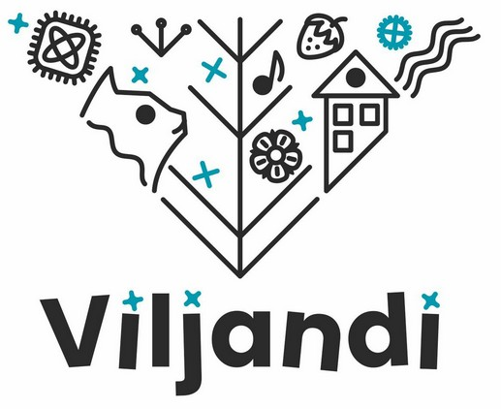
About Viljandi
Viljandi is the sixth largest town in Estonia with a population of 17 104 (Population registry data by 1st of January 2020). Area: 14,6 km². Location: South-Estonia, the uplands of Sakala. It is 161 km from Viljandi to Tallinn and 81 km to Tartu.
Viljandi is an ancient hilly city in South Estonia topped by impressive ruins of a once-powerful Livonian Order castle. Cobbled streets, ancient oak trees and a beautiful lake conjure up a very special atmosphere. A visit to Viljandi
means greenery, ancient trees, impressive hilltop ruins of a powerful Hanseatic castle, winding cobbled streets and a beautiful lake.

For many people Viljandi conjures up images of the Viljandi Folk Music Festival and University of Tartu Viljandi Culture Academy. This small city is the “capital of folk music” for most Estonians. The Viljandi Folk festival runs for 4 days on the last weekend in July. More than 100 concerts take place in Viljandi castle’s ruins, churches, and other venues throughout Viljandi. It is the largest annual music festival in Estonia. Viljandi not only appeals to folk music and culture lovers but also to people who enjoy parks, where you can hear the nightingale sing, beautiful views and an atmosphere which is both ancient and modern at the same time. Today Viljandi is moving in a rhythm that makes living here an experience in itself. Viljandi is a place where parents walk to school with their children and then go to work themselves. It is a place where people discuss how to improve their community. It is a place where talented individuals can form their ideas into products that bring joy to those who live far beyond our borders. In Viljandi both the nightclub-loving party-goer and the midnight chess-match-seeker can find something to do.

Viljandi hosts many events and several international festivals throughout the year. The Early Music Festival, Hanseatic Days, Young Dance Festival, Mulgi Rally, the “Theatre in Suitcase”, puppet theatre festival etc. Since 1928, a run around Lake Viljandi has taken place on the first day of May every year.
For more information www.viljandi.ee
http://www.visitestonia.com/en/holidaydestinations/city-guides/viljandi

The volunteering History
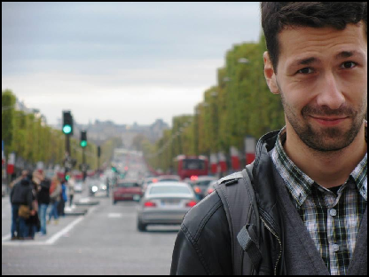
The Viljandi Youth Centre started to be a Hosting Organization for EVS volunteers in 2016 and is eager to continue to work with international volunteers in the future.

Jakub Zygmunt
Home Country: Poland
September 2016 – September 2017

"My EVS project in Viljandi Open Youth Centre was one of the best choices in my young life. This project is the best option for these who like to learn a lot about youth work, writing projects and handling with
nowadays' youth problems. The team working there was for me very supportive and empathic about all my accommodation to Estonian culture standards. I really admire every single point of my work in VANT from job atmosphere to challenging moments. Despite working time, I travelled a lot and experienced Estonia on my own as much as possible. It is sure for me that this country will be my second Motherland for longer time in my heart."

Dominik Galehr
Home Country: Austria
October 2017 – September 2018

“The Viljandi Youth Centre is a great place to spend ones EVS. It offers many possibilities to become a part of the youth centre and the local community. Leading workshops, helping with preparations or simply spending time with youngsters and play some billiard, for me it was a good mix of challenges and cosy lifestyle. The team is very motivated and eager to do its best, I was very happy to work together with them and I learned a lot about open youth work, organizing
workshops, open communication and much more. Viljandi also offers many possibilities to involve oneself in the local community and was the best possible town for me to live in. I met a lot of great people and travelled as much as I could inside and outside of Estonia. With all its aspects, the good and bad ones, this EVS was one of
the best choices I’ve ever made.”

Julia Savchuk
Home Country: Ukraine October 2018 – October 2019

“I decided to change my life when I was 27. I chose the project and went as a volunteer to Estonia.
Every day I think how happy I am and how lucky I was to make such a right choice. Viljandi Open Youth Centre is the best place to try something new in your life. Great team that helps you feel part of it: enough time to look around and decide what exactly you can do and be useful here. Rhythm of the city thanks to which you can enjoy calm and slow life and have plenty of places to have fun.
I wanted to understand what kind of work with young people is, what challenges does it face before you and whether I can handle it. The experience VANT helped me to figure it out.”

Maria
Home Country: Ukraine October 2019 – August 2020

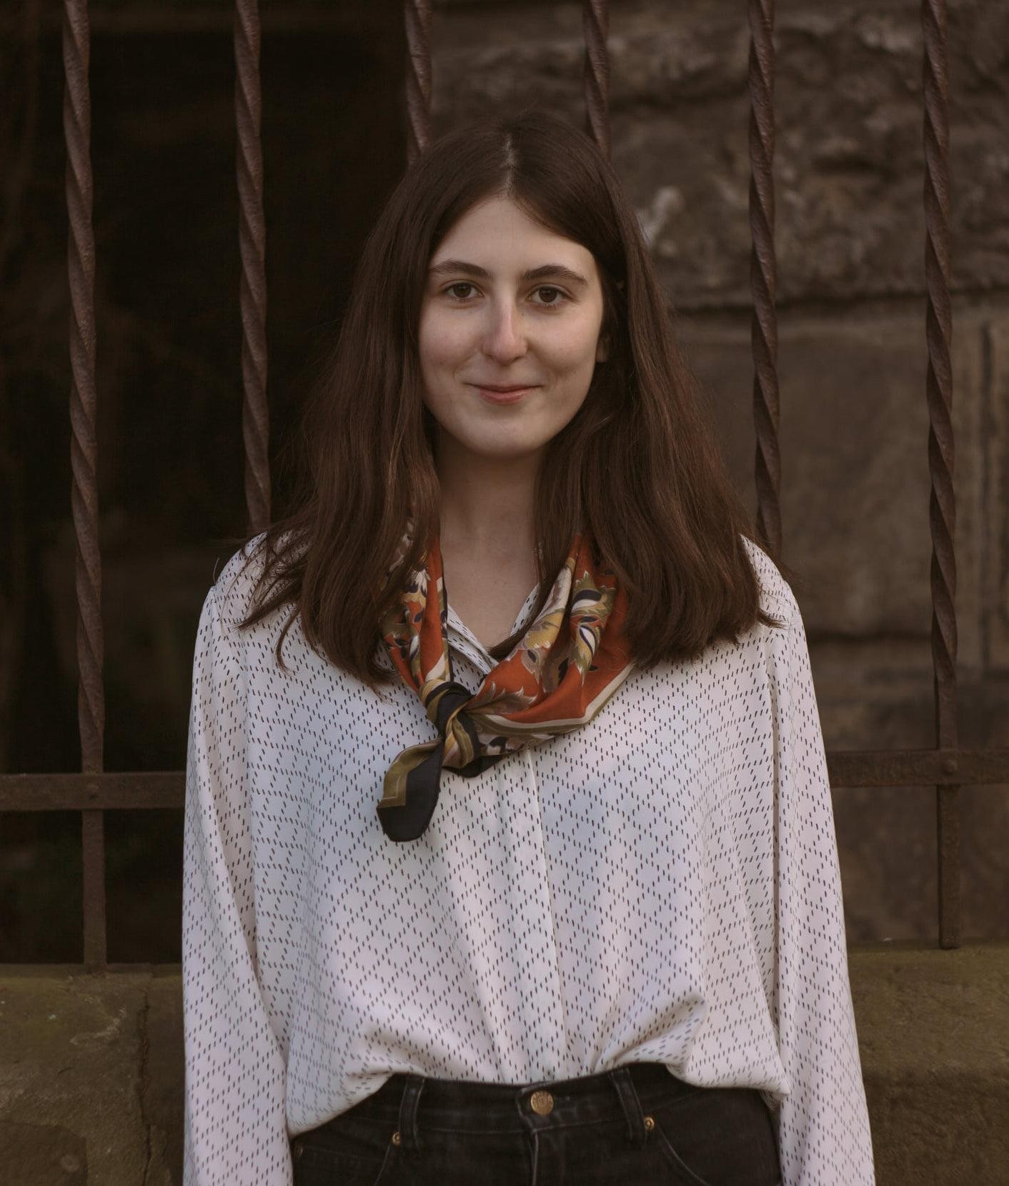
VANT is definitely an incredibly interesting place, where you can learn so much about people and, more importantly, yourself. I had all the freedom to engage in any activity or implement any idea and, at the same time, got immense support from the team: I never felt alone. It is a place where I became braver, more confident, and simply had so much fun. I will always think of Viljandi as my second home. A cozy little town, where you can still do so many things, from hiking around the lake to going to a poetry evening in the bar. Viljandi has its unique spirit and VANT is a place where you can get a lot of it. I am so thankful for once being a part of such a fantastic team!

