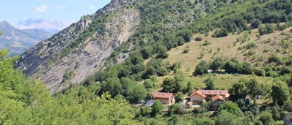
Mountain Wonders IV

Call for participants
European Adults Youth Exchange
From May 9th to 29th 2021

Estonia, France, Greece, Romania

CONTEXT
In the heart of the Hautes Alpes, our association “Les Villages des Jeunes” has been managing, livening up and renovating the reception centre of the Faï since 1990. It is a former agriculture domain situated at an altitude of 1000 meters where fruit trees and lavender used to be cultivated. Although our actual project is rather “social” than “environmental”, we want to optimise the natural ressources of the site, process our products and raise awareness about the added value of such activities in very rural places. The youth exchange will be the opportunity to share this activity with other young people and reinforce links with the local farmers.

OBJECTIVES AND ACTIVITIES OF THE PROJECT
1/ Land art creation
As participants, you will contribute to embellish the place by making artistic creations with an experienced artist. Materials will only come from nature and the group will have to think about what can be used in this season. During the project you will visit differents land art projects as the famous CAIRN art Project in Dignes-les-bains. Let’s go and express your creativity and imagination by playing with colors, shapes and materials!

2/ Exchange and practice around "social transformation".
You will experiment with some participative's methods to live together. Organising together the collective life with the help of a facilitator, will be the first practical exercice. You will also participate to some workshops about know-how exchanges and debates around society's subjects (ecology, discriminations...)

3) Organization of an event to present the project to the local population.
To shed light on your art pieces you are offered to organize an inauguration, to prepare workshops for the visitors, and to organize the different aspects of such an event (communication, program, logistics .. .)

VENUE
At le Faï, from April to December, the association organizes inclusion projects for local people who are faced with social and professional difficulties and host teenagers and young adults experiencing family, health or professional difficulties in order to give them a possibility to get professional experience. In the summer, the Faï is also a place where professional artists and musicians come to work in and with this extraordinary place. Together, they create and perform at the yearly festivals that take place at the Faï. The European youth exchanges organized at the Faï contribute to make this place something “extra”, where people in different ages, from different countries and cultures, employees and volunteers, artists and tourists, live and work together for some days or several months

THE TEAM
The youth exchange will be led by our long term volunteers and permanent staff, with the help of the group leaders. One land art artist will propose the land art workshop

LOCATION
Faï is situated at 12km from the village of Veynes, 30 km from the city of Gap, 200km from Marseille (and more than 2 hours from the sea side…)

ACCOMODATION
The old buildings of le Faï farm have been developed into small apartments and group accommodations. Participants will be accommodated in bedrooms of 2 to 3 people and will have at their disposal all the facilities of the center (dining room, kitchen, showers and toilets).

DAILY LIFE
For the duration of the exchange the group will live autonomously. The daily tasks (meals, cleaning etc) are shared by all volunteers.

PARTICIPANTS
Participants should be aged 18 to 30. There is no age limit for group leaders. The group will be composed of 16 to 20 persons from 4 different nationalities. Each group is composed of 4 participants and 1 leader.
No specific skills are required to take part in this project, just a strong motivation to experience a multicultural collective life and work together on the artistic project.
Participants having experience in this field and willing to share their knowledge are welcome!

TRANSPORTS

Financial conditions:

- Travel costs will be covered based on the unit costs of the program (Romania and Greece 275euros, Estonia 360 euros)

- 100% housing and food covered

All the travel costs will be reimbursed the earliest 3 months after the end of the youth exchange. Please note that the process of reimbursement will be carried out directly with the applicant organizations and not with you. We kindly remind all participants to keep the original tickets.
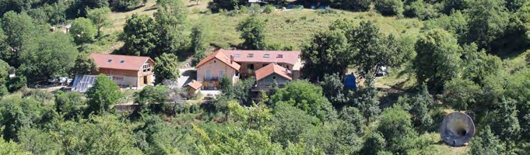

CONTaCT
Please contact directly your sending organization: NAME + N°of telephone + email

www. facebook . com/ v i l lage sde s jeu nes/ ww w. v i l l agesdesjeu nes. org

