Erasmus+ volunteeringwith SCI Switzerland in Bern(Switzerland) – 2020/21

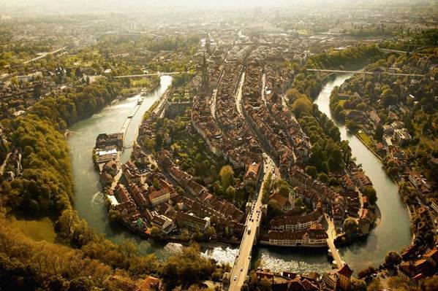

SCI Switzerland is part of the international network Service Civil International (SCI). It organizes volunteer projects around the world that contribute to peace in a broad sense: social justice, sustainable development, equality, solidarity and non-violent conflict resolution.

The project starts the 1rst of September 2020 and is for 12 months. It is part of the Erasmus+ program “European Voluntary Service (EVS)”. More info about the EVS program you findhere.

Activities

As a long-term EVS volunteer you will work in the office of SCI Switzerland in Berne.

Your tasks will involve:
- Assistance with the program eastwards and communication tasks
- Organization, promotion & realization of public events
- Help to contact new project partners in Switzerland as well as Russia and Ukraine
- Coordination of our regular event “Living Library” in Bern (3x per year)
- Support the fundraiser in tasks of her/his interests
- Volunteer Management (contact with SCI volunteers, mobilization of volunteers, coordination and co-facilitation of seminars and trainings)

During the workcamp season, there is also the opportunity to take part in 1-2 workcamps (short-term projects) as a campcoordinator. This role will provide you with skills in conflict management, organizational skills, as well as skills in the field of animation of young people.

Furthermore, you will have the opportunity to get used to informal learning methods and you can develop your own projects/ research/ activities on a specific topic according to your skills & interests.

There will be a second EVS volunteer in our office who is in charge of placing new participants in our SCI projects. More information about our branch SCI Switzerland can be found in German, French & Italian online: www.scich.org.

Requirements
You are between 18-29 years old and available during the full project duration. You share the SCI values, are motivated to work with young people and volunteers from different cultures and you want to work in an office!

Basic conditions offered to long-term volunteers

- Accommodation and all meals:You will have your own room at a campus in Bern (10min walking distance from the centre) andyou will receive a budget to buy your own food.Lunch during the week is usually prepared by the team in the SCI office
- Erasmus+ Program provides health insurance and travel expenses, plus training seminars at arrival and mid-term.
- Weekly German lessons (optional)
- 250 CHFPocket money
- Continuous mentoring and support since arrival and throughout all the stay.
- Final certification about the work done and competences acquired.
- The practical and logistic matterswill be handled by your sending organisation. SCI Switzerland will organize all administrative matters like insurance and visa.

Please write to evs@scich.org if you are interested in becoming an Erasmus+ volunteer or if you have some questions. Please note that you can only apply if you are between 18-30 years old and if you have not volunteered through the Erasmus+ before.
Send your application via email to your Sending Organisation with the subject EVS-Application SCI-Switzerland Sept-August 2020/21, Switzerland, and include all the following documents in English:
1) CV, Curriculum Vitae
2) Specific motivation letter for the project
Deadline for the application: as fast as possible

Erasmus+ volunteering with Ecole d’Humanité in Hasliberg (Switzerland)– 2020/21

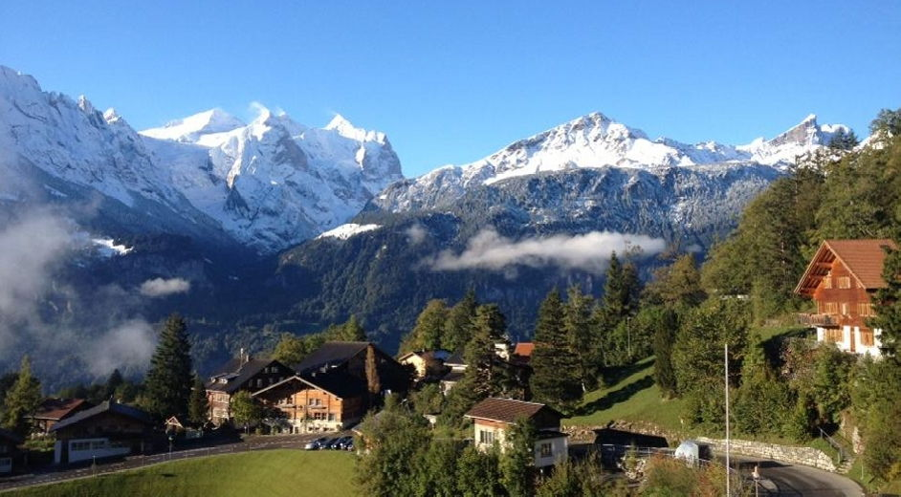

The Ecole d’Humanité is a progressive, international boarding school in the heart of the Swiss Alps (in the winter ski area Meringen-Hasliberg) that fosters the discovery and development of individual talents in an atmosphere that encourages self-determination, innovation, and tolerance. 120 Students and 50 teachers from over 20 different countries live together in a dynamic community overflowing with academic, artistic, practical, athletic, and social opportunities. Whether admiring the beauty of a poem, projectile motion in a calculus-based physics class, performing an original piece of guerilla theatre or summiting a 4000 meter peak, Ecole students are challenged to actively discover and pursue their passions, and share them with others.

The project starts the 1rst of September 2020 and is for 11 months. It is part of the Erasmus+ program “European Voluntary Service (EVS)”. More info about the EVS program you findhere.

Activities

As an EVS volunteer, you will have the position as “Artist in Residence”. Therefore, you get the chance to work as an artist at the Ecole d’Humanité and be at the same time a part of the Ecole-community and take part in the community life within the so called “Ecole Families” (consisting of 2-3 teachers and 4-10 students, who live and interact with each other under one roof).

The Ecole offers you a great infrastructure to use. By mutual agreement, your work could be in the following areas:
- work as artist (metal & wood studios, stage and practicing studios , graphics studio)
- work pedagogically: giving afternoon classes in a certain topic depending on your talents or work in so called “intense weeks” together with small groups of students
- networking: among the network of former students of the Ecole, there is a great amount of artists, working in different areas, who are often willing to cooperate for projects
- communications: work in the public relation activities of the Ecole
- manual work (garden work, caring for the pets, housework)
- intercultural dimension: The daily interaction with community members from over 20 countries helps to learn more about interculturality, in which we offer also professional trainings

Accommodation
Rooms are doubles and are simply and purposefully outfitted. Living together closely can mean both welcome support and unexpected challenges. Sometimes lifelong friendships are formed, sometimes only bonds of convenience. In the small unit of the room social learning plays an important role. When conflicts arise, the teachers (who supervise the Ecole Families) are there to help resolve them.
We eat our daily meals together in a communal dining hall. Students, teachers and volunteers share things like cleaning duties in the Ecole. The beautiful surroundings of the Ecole offer great outdoor activity possibilities (hiking, skiing, climbing, biking).

Requirements
Participants are motivated to live and work in a rather remotely located place within an existing community consisting of teachers, international students and other volunteers. You should not mind living in a shared bedroom and you are willing to integrate within the structures of the community.

Basic conditions offered to long-term volunteers

- Accommodation and all meals.
- Basic Accidents and Liability Insurance.
- Erasmus+ Program provides health insurance and travel expenses, plus training seminars at arrival and mid-term.
- Weekly German lessons (optional)
- Pocket money
- Continuous mentoring and support since arrival and throughout all the stay.
- Final certification about the work done and competences acquired.
- The practical and logistic matterswill be handled by your sending organisation. SCI Switzerland will organize all administrative matters like insurance and visa.

Please write to evs@scich.org if you are interested in becoming an Erasmus+ volunteer. Please note that you can only apply if you are between 18-30 years old and if you have not volunteered through the Erasmus+ before.
Send your application via email to your Sending Organisation with the subject EVS-Application Ecole d’Humanité, Switzerland, and include all the following documents in English:
1) CV, Curriculum Vitae
2) Specific motivation letter for the project
Deadline for the application: as fast as possible

Erasmus+ volunteering with Läbenschuel / school of life in Steckborn (Switzerland)– 2020/21

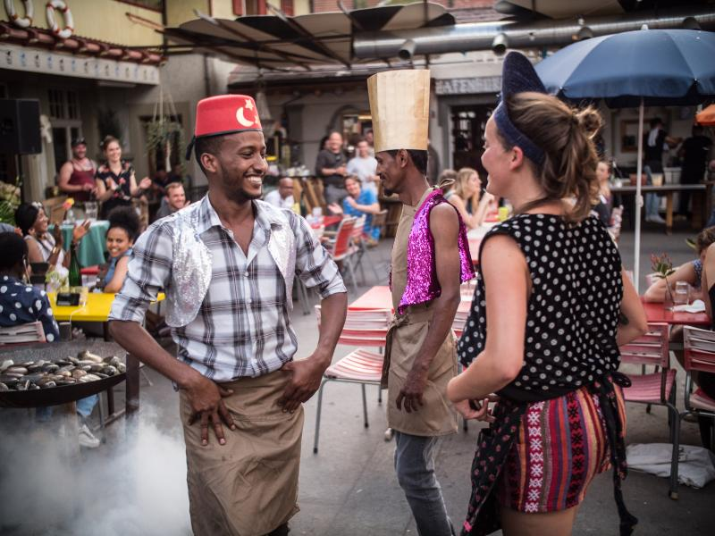

The Läbesschuel / School of life is a project within the community of Schloss Glarisegg. The Läbesschuel started in August 2016 with 15 children, in 2019 we had 37 children registered. There is a Waldkindergarten for children from 4 up to 5 years old and then there is 1st to 9th class (from 6 until 16 years old). The idea of welcoming EVS in our project comes from the wish to open the project to different cultures for the children and the team to get them to know people from all over Europe. As we work with non-formal education and self-reflection we think the Läbesschuel is perfect match to the EVS program.

The project starts the 1rst of August 2020 and is for 12 months. It is part of the Erasmus+ program “European Voluntary Service (EVS)”. More info about the EVS program you findhere.

Activities

You will be able to participate in all the different classes if you wish. As you prefer, you can also choose to work more with small children or to work more profoundly with our teenagers.
Main activity within the EVS is to support accompanying the children in their learning journey. All the activities take place at Schloss Glarisegg community. We have different places within the community, we sometimes work outside (forest, beach, neighbour farm or garden), sometimes in the ‘Montessori’ room, other times in the main school building where we have a kitchen, a workshop, a library, a technic room and a main room. The smallest children are mostly spending their time in the forest. One day a week, the children go to Mammern (neighbouring village) by bicycle to do sports in the gym of the local school.
As a volunteer in this project, you will meet, cook together and even live in the same flat as the other 2 volunteers from Schloss Glarisegg. You will attend the same weekly community circle and have the possibility to have a closer look at the other's project.
As we use alternative methods of teaching, you will learn a lot about non-formal education, for example also working with emotions and the body. The team of the school will help you to discover your competencies and strengths. You will be given opportunities to choose and/or propose activities that you would like to do with the children.
You will also be able to learn more about technical tools from different pedagogies (inspired by Montessori, Freinet, Waldorf, André Stern, Gerald Hüther). Within this frame, you will learn a lot about yourself and others in the frame of education but also in the field of teamwork, relationships and social and emotional topics. During the time when the children are not in school, you'll be able to work on your own project, developing your own personal tools. The team will be present to help you to find out about the goals and means of your project. It could be a particular subject that you would like to deepen. Then you and the team will find out how, when, how long, which content, and so on it contains.
Requirements
Participants are motivated to live and work in a rather remotely located place within an existing community consisting of teachers, international students and other volunteers. Since you will be working with children, basic German language skills are very important for this position.

Basic conditions offered to long-term volunteers

- Accommodation and all meals.
- Erasmus+ Program provides health insurance and travel expenses, plus training seminars at arrival and mid-term.
- Weekly German lessons (optional)
- Pocket money
- Continuous mentoring and support since arrival and throughout all the stay.
- Final certification about the work done and competences acquired.
- The practical and logistic matterswill be handled by your sending organisation. SCI Switzerland will organize all administrative matters like insurance and visa.

Please write to evs@scich.org if you are interested in becoming an Erasmus+ volunteer. Please note that you can only apply if you are between 18-30 years old and if you have not volunteered through the Erasmus+ before.
Send your application via email to your Sending Organisation with the subject EVS-Application Läbensschuel, Switzerland, and include all the following documents in English:
1) CV, Curriculum Vitae
2) Specific motivation letter for the project
Deadline for the application: as fast as possible

Erasmus+ volunteering for half a year in the Swiss mountains – 2020/21

For two young adults: Start of the program in September/october 2020.
Are you between 18 and 30 years old and up for an adventure in the Swiss mountains? Do you love to work outdoors and are you motivated to learn traditional handcrafts? Would you like to explore Swiss culture? Do you love winter sports and want to learn how to ski?
Then we have the perfect volunteer experience for you!
Who are we?
Verein Naturkultur is an organisation for intercultural youth exchanges in Switzerland and abroad. The exchanges always have an intercultural as well as a nature component and the aim is to get to know the natural environment of the exchange location and its locals. Through the EVS program, it would like to give 1-2 young adults the opportunity to experience nature and culture in the Swiss mountains.
What are your tasks?

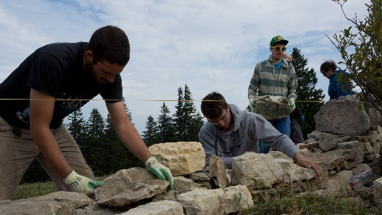
Work in Gantrisch Nature Parc in the Swiss Mountains:
- Improvement of hedges, forest edges or riverbeds
- Improve the habitat of countless animals and plants
- Help to organize school and company projects together with the Nature Parc locals
- Help out on and off the slopes for cross country and skiing (winter)
- Build hiking and bike trails (summer)
- Help out on local farmers
- For one month you get the chance to know the Solothurn Jura as a second mountain area of Switzerland and to renovate a dry stone wall as a traditional cultural heritage with professionals

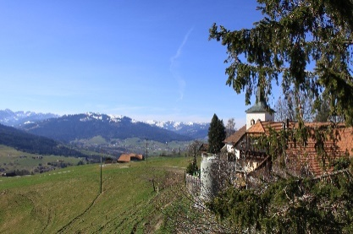
Region and benefits of this program
You are going to live in an area in the Swiss alps called Gantrisch region and in the region of Solothurn.
The areas are known for loads of outdoor sports: hiking, biking, skiing, cross country skiing, climbing and more

Travelling around in Switzerland: the organization will pay for a half-fare travelcard, which allows reduced fares for public transport

German language course: you will get a language course for free in order to get to know the culture even better
You will get the chance to coo-coordinate of our intercultural projects weeks
Accommodation: For your accommodation, the association will look for a host family so that you are in contact with the local people from the very beginning. Depending on your assignment, the association could also rent you a room in a local accommodation. In addition, you get a budget for food. The organization is also going to take care of your flight and insurance expenses and you will get some pocket money for every month.
Requirements: You are between 18-30 years old and available for the full 6 months. You have good knowledge in English and ideally in German. You are motivated to work outdoors in all weathers and would like to get to know the Swiss mountains and their culture.

Basic conditions offered to long-term volunteers

- Accommodation and all meals.
- Erasmus+ Program provides health insurance and travel expenses, plus training seminars at arrival and mid-term.
- German lessons (optional)
- Pocket money
- Continuous mentoring and support since arrival and throughout all the stay.
- Final certification about the work done and competences acquired.
- The practical and logistic matterswill be handled by your sending organisation. SCI Switzerland will organize all administrative matters like insurance and visa.

Please write to evs@scich.org if you are interested in becoming an Erasmus+ volunteer. Please note that you can only apply if you are between 18-30 years old and if you have not volunteered through the Erasmus+ before.
Send your application via email to your Sending Organisation with the subject EVS-Application Verein Naturkultur, Switzerland, and include all the following documents in English:
1) CV, Curriculum Vitae
2) Specific motivation letter for the project
Deadline for the application: as fast as possible
More information about the project you find here: www.nakultur.ch

Erasmus+ volunteering with Läbenschuel / school of life in Steckborn (Switzerland)– 2020/21

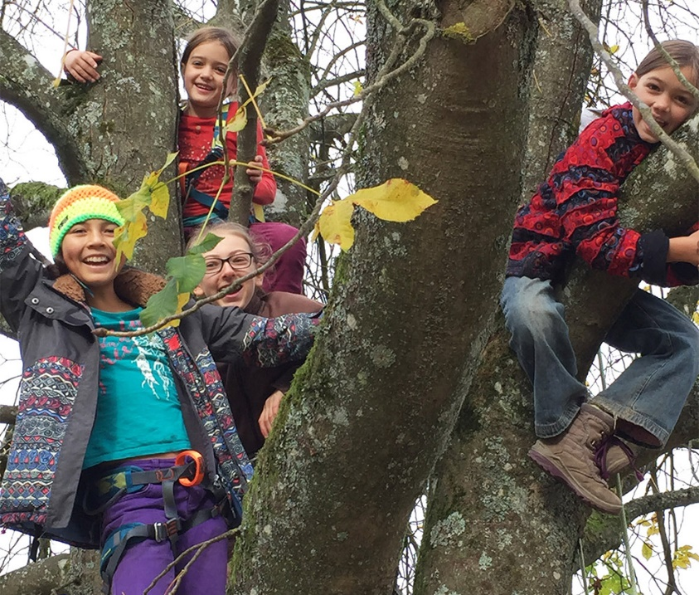

The Läbesschuel / School of life is a project within the community of Schloss Glarisegg. The Läbesschuel started in August 2016 with 15 children, in 2019 we had 37 children registered. There is a Waldkindergarten for children from 4 up to 5 years old and then there is 1st to 9th class (from 6 until 16 years old). The idea of welcoming EVS in our project comes from the wish to open the project to different cultures for the children and the team to get them to know people from all over Europe. As we work with non-formal education and self-reflection we think the Läbesschuel is perfect match to the EVS program.

The project starts the 1rst of August 2020 and is for 12 months. It is part of the Erasmus+ program “European Voluntary Service (EVS)”. More info about the EVS program you findhere.

Activities

You will be able to participate in all the different classes if you wish. As you prefer, you can also choose to work more with small children or to work more profoundly with our teenagers.
Main activity within the EVS is to support accompanying the children in their learning journey. All the activities take place at Schloss Glarisegg community. We have different places within the community, we sometimes work outside (forest, beach, neighbour farm or garden), sometimes in the ‘Montessori’ room, other times in the main school building where we have a kitchen, a workshop, a library, a technic room and a main room. The smallest children are mostly spending their time in the forest. One day a week, the children go to Mammern (neighbouring village) by bicycle to do sports in the gym of the local school.
As a volunteer in this project, you will meet, cook together and even live in the same flat as the other 2 volunteers from Schloss Glarisegg. You will attend the same weekly community circle and have the possibility to have a closer look at the other's project.
As we use alternative methods of teaching, you will learn a lot about non-formal education, for example also working with emotions and the body. The team of the school will help you to discover your competencies and strengths. You will be given opportunities to choose and/or propose activities that you would like to do with the children.
You will also be able to learn more about technical tools from different pedagogies (inspired by Montessori, Freinet, Waldorf, André Stern, Gerald Hüther). Within this frame, you will learn a lot about yourself and others in the frame of education but also in the field of teamwork, relationships and social and emotional topics. During the time when the children are not in school, you'll be able to work on your own project, developing your own personal tools. The team will be present to help you to find out about the goals and means of your project. It could be a particular subject that you would like to deepen. Then you and the team will find out how, when, how long, which content, and so on it contains.
Requirements
Participants are motivated to live and work in a rather remotely located place within an existing community consisting of teachers, international students and other volunteers. Since you will be working with children, basic German language skills are very important for this position.

Basic conditions offered to long-term volunteers

- Accommodation and all meals.
- Erasmus+ Program provides health insurance and travel expenses, plus training seminars at arrival and mid-term.
- Weekly German lessons (optional)
- Pocket money
- Continuous mentoring and support since arrival and throughout all the stay.
- Final certification about the work done and competences acquired.
- The practical and logistic matterswill be handled by your sending organisation. SCI Switzerland will organize all administrative matters like insurance and visa.

Please write to evs@scich.org if you are interested in becoming an Erasmus+ volunteer. Please note that you can only apply if you are between 18-30 years old and if you have not volunteered through the Erasmus+ before.
Send your application via email to your Sending Organisation with the subject EVS-Application Läbensschuel, Switzerland, and include all the following documents in English:
1) CV, Curriculum Vitae
2) Specific motivation letter for the project
Deadline for the application: as fast as possible

