ORGANIZED BY:
Fundación Proyecto Ecológico Chiriboga
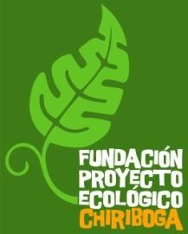Puruha Oe2-781 y Epiclachima Ciudadela San José- La Magdale4na Quito- Ecuador
C.P. EC170111
Teléf.: + 593 2 4504435
Email: ecoproye@gmail.com

2019 WORKCAMPS

- WORKCAMP from November 24th to December 8th 2019
Códe to apply: EC-CHI- 11- 2019

Country: Ecuador
Location: Otavalo
Topic: 12. Art, culture and local history
Main theme of the camp: cultural heritage, manual restoration of the infrastructure
, renovation, agriculture
Language (required): Basic Spanish knowledge is required
Duration: 15 days
Start Date: November 24th 2019
End Date: December 8th 2019
Number of volunteers: 6 – 3 males and 3 females
Include: Lodging and food 3 meals per day
Not include: Transportations
Age: 18-55
Extra fee: USA $ 225
Spoken language: English, Spanish

INFORMATION SHEET

The Chiriboga Foundation received the proposal of helping a “Living Museum” who is interested to contribute in the conservation and revitalization of the tangible and intangible cultural heritage of the Kichwa Otavalango people, through research, tourism development and cultural education.

This museum is managed by 22 families of the
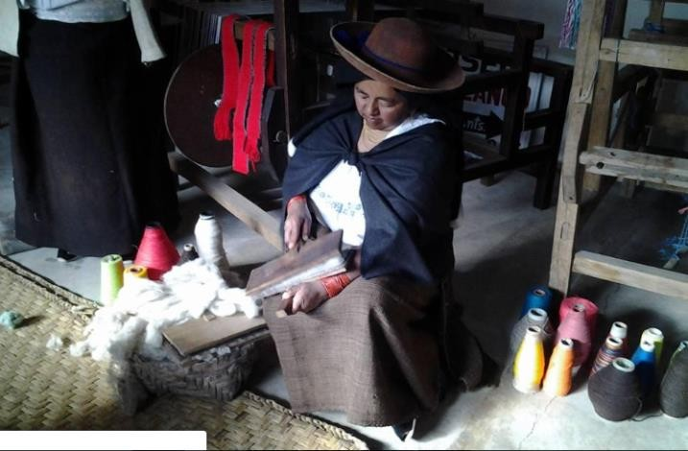Otavalo’s community, who bought the property,
in order to conserve their history, in this building in the past there was an “Obraje” a fabric factory.

“ OBRAJES” were factories of woolen, cotton and cabuya fabrics, in which espadrilles, sacks, wicks, saddles, hats, gunpowder, etc. were also manufactured. and where the natives were forced to work, day and night, many times to
death.

«Each Indian worked 312 days a year, and the most he could earn at that time, were
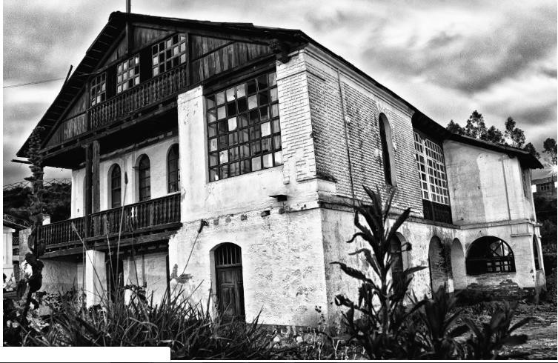40 pesos of 8 reais ... In each Obraje there was jail, stocks, crickets and whips. The children were mistreated with cruelty. From his salary the tax rate and the synod pension of the priest were taken out. The Indian was paying for his food and clothing; and many times he was deducted from his miserable wage, even the medicines, which were very expensive for them, even when the excess of work prostrated them with a disease ... The Indians finished shortly: the work they were not accustomed to, it was the cause that many died ”(Roberto Andrade.- History of Ecuador, volume I p. 109).

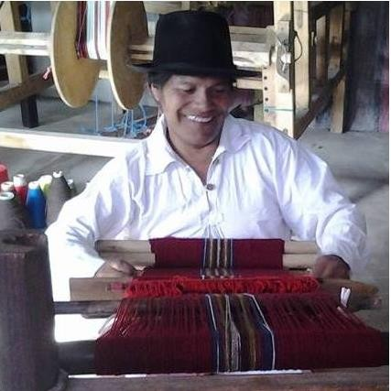Description: The Museo Viviente is a fascinating place. It is located in an old textile factory where from 1851 to
1998 (!) Members of the local indigenous group Kichwa had to work under terrible circumstances. In 2011, a group of Kichwa families managed to buy the place to create a cultural Centre including a museum of Kichwa culture and a space for cultural and social events and Kichwa language classes. The space has a lot of potential, but needs some help to be rebuilt.

Work: The work in the Museum includes working with tools such as shovels, hoes and others, that means being ready to get dirty! The participants are going to support
the families renovating and readjustment of the entrance, to repair the stairs of the pyramid- channel of water and the development of educational games for children about the art of weaving.,

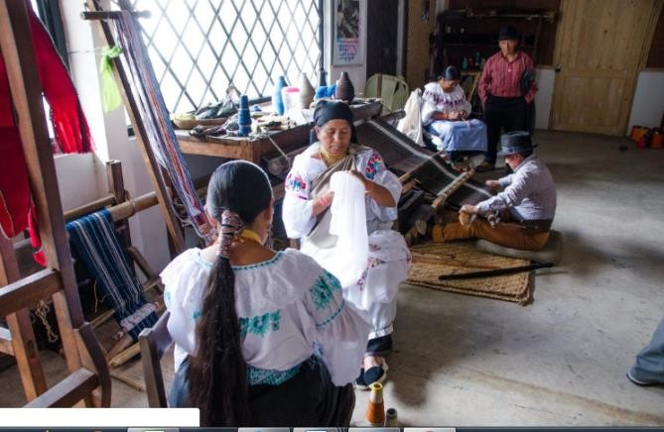The project is going carried out, with the help of the local community (families)

Study Theme: Local culture, community life, local history
Subject of study: Raise awareness about the importance of keeping the history of the Otavalo community, principally about the Obraje.

Accommodation: We are going to sleep, work and eat in the museum. The museum is located in walking distance from the vivid city Centre of Otavalo with its famous indigenous handicrafts market.

Language: Spanish and English

Approximate Location: Otavalo is a town two hours from the north of Quito by bus. It lays at the base of the volcano Imbabura and in its surroundings, you can find many beautiful lakes and waterfalls, possible destinations for excursions. The city is vibrating with energy and at the same time more relaxed and a lot safer than the metropolis Quito. Otavalo is an interesting place because of the significance of the indigenous culture with its festivities, clothes, handicrafts, music etc. As we are going to work in the museum, you are going to learn a lot about local culture.

LEISURE

Afternoons after work are free to do any kind of group activity such as sports, walking around, or simply enjoy the place.

WHAT TO BRING

• Bring clothes that you do not mind if they get damaged. It is preferable to wear long pants and long-sleeved shirts to protect yourself from mosquitoes or branches.
• Insect repellent
• Work gloves
• Light clothes but a couple of jackets (the weather is unpredictable)
• Medicines if you suffer from any particular condition.
• Raincoat
• Sandals and walking shoes
• Sunscreen
• Lantern
• Cap
• Towel and all your personal hygiene items
• Please bring a sleeping bag.

