Mulgi Municipality Government/Mulgi Vallavalitsus
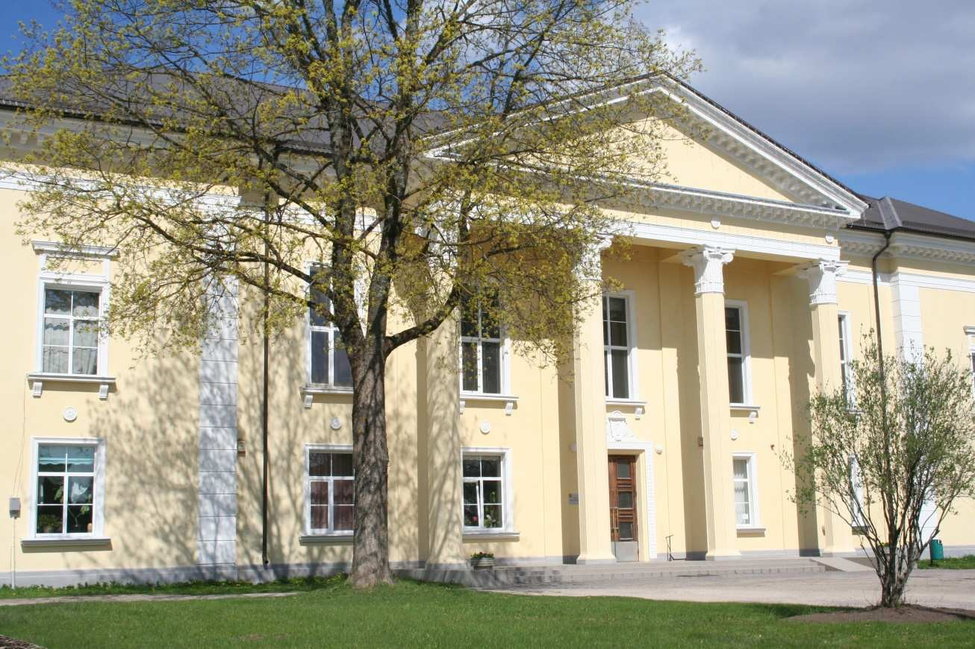
(Cultural Centre) ORGANISATION DESCRIPTION
Mulgi Rural Municipality is situated in the the southern part of Viljandi County. The Halliste River and Kariste Lake are located near the northern border of the rural municipality. The municipality shares its southern border with the Republic of Latvia. Population is 2232 citizens. At present, the rural municipality owns 29.019ha of land. It is divided into cultivated land 9.630ha, natural grassland 1.652ha, forest and 12.913ha, yard land 179ha, other land 3.587ha. The nature around us is amazing- surrounded by forests and lakes. Abja is very quiet countryside. In the parish we have high-school, kindergarten, sport hall, swimming pool, ambulance, many shops and eating places. This is great place to be for someone who assess nature.
PROPOSED ACTIVITIES
We would like to give for the volunteers various tasks which is linked with their creativity. We would like to encourage them to lead some activities with children, youngsters, adults and seniors. Through tasks we would like to give volunteers opportunity to try different tasks and get to know better our culture and our human nature. We want volunteer to feel that her/his presence is needed and her/his work gives a lot to the community.
The volunteers will be involved mostly in cultural and youth centers, but also in day-care center because that way the volunteer has opportunity to cooperate with all age groups. In the cultural center the volunteer will be part of local culture.

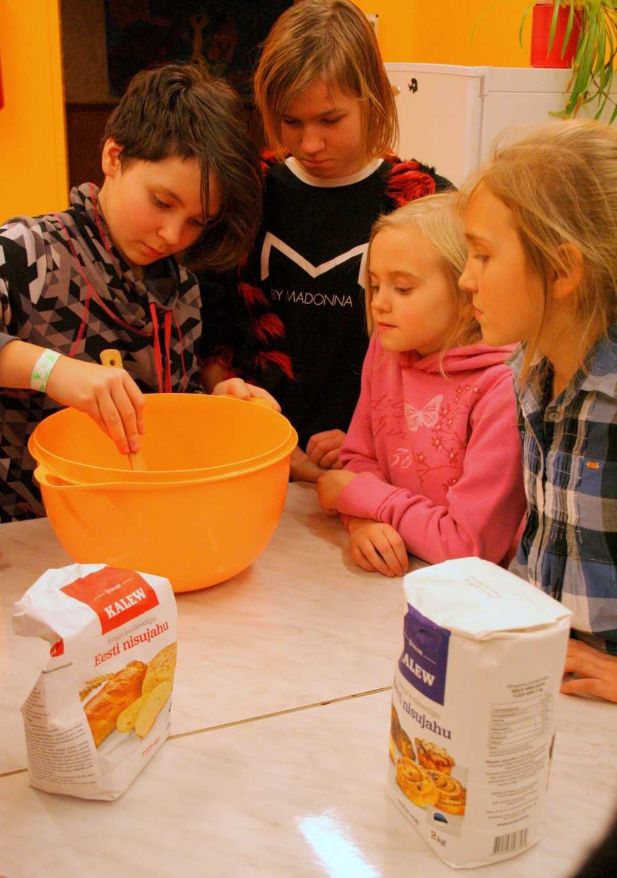
In Abja´s cultural center we have theater and movie nights, concert evenings, exhibitions, national evenings and events. Also we would like that the volunteer presents her/his culture. Volunteer has opportunity to use creativity by decorating the hall and house for different events. The volunteer can use her/his talent to mentor some course.
Abja´s Youth Center is located two different buildings from year 2009. This center is based on open youthwork and its open 32 hours per week. Abja´s youth center’s mission is to offer leisure-time opportunities, non-formal education and different courses and workshops to youngsters. We include youngsters also events preparing process and support their own initiative to organize events and workshops themselves. The workers support and guide them in the process. In the centre there are two youth workers and many course teachers. At the moment we have workshops and courses like ceramics, music, cookery, handicraft. Youngsters have opportunity to be part of youth organizations like Abja´s youth council, 4H club and A.N.O as opportunity to develop town’s life and to participate in decision-making process. At first the volunteers have opportunity to learn everything about the youth center and our work and be part of our workshops and courses. We introduce volunteers our work principles and support and courage them to communicate with youngsters. From the volunteer we expect initiative to leader some course or workshop. Also we would like to give volunteer

opportunity to be part of county youth workers meetings, cause this gives opportunity to understand better our country’s youth-work system.
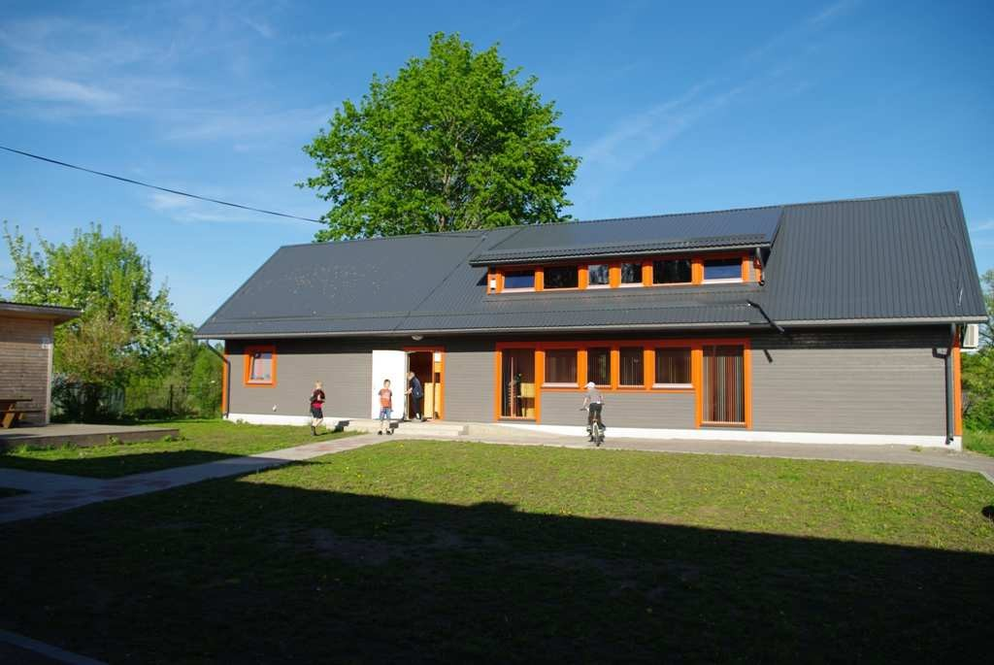
(Youth Centre)
Abja ´s Day-care Centre is for seniors and adults who have special needs and who can´t work daily because of their special needs. Day centre doings: - Weaving in loom (rugs, towels, national shawl aso). - Burning technique to the wood (cutting boards, clothes pegs, wood spoons aso.) - Sewing (national clothing, linen) - Cooking (national foods - Furniture restoration supported by professional - Events and meeting preparing for Association of People with Disabilities - everyday life support service – individuaal plans for each one, compliance of action plan, assessment Volunteer is going to be part of our litte family and can help seniors and disabled clients through workshop guidance. Also we would like to give volunteer opportunity to get know Estonian social system. The working time will be around 35 hours a week. Volunteer will have 2 days off per week either during week or at the weekends. According to the volunteers skills and project needs priority tasks and more detailed working schedule (including holidays and periods of breaks) will be worked out together with the head of project and staff. Volunteers will be working under supervision and with support of staff.
VOLUNTEER’S PROFILE
Future participant must be prepared to be in the middle of small community and readiness to live countryside. We will give volunteer a mentor who will be his/her trustee. We will introduce her/him our parish and opportunities. The volunteer will be living in boarding school surrounded by youngster, who staying there on school time. We support the volunteer as much as we can - cause we want that the volunteer feels welcome in our hometown.

