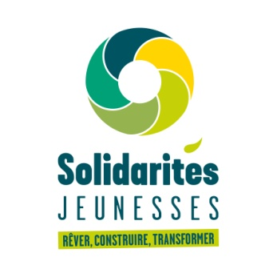

VOLUNTEER EXCHANGE FORM

European Youth Exchange

DON’T TOUCH MY FRIEND !

04 August 2019 → 24 August 2019 ( including travel day)

Le créneau - france

I - Identification of the European Youth Exchange

Title of the European youth exchange | Don’t touch my friend !
Host organisation | Address: Les Prureaux – 03 130 Montcombroux-les-mines  Phone number: +33 4 70 99 60 35  Email address: accueil.creneau@orange.fr  Website: https://www.solidaritesjeunesses.org/
Dates of the European youth exchange (including arrival and departure days) | 09-06-2019 → 29-06-2019

II - Identification of the participant

II.1. Contact details

Title (Mr/Ms) |  | First name
Family name
Address
Postcode |  | City
Country
Telephone 1 |  |  |  |  | Telephone 2
Mobile |  |  |  |  | Fax
E-mail address

II.2. Emergency contact details

Title (Mr/Ms) |  | First name
Family name
Telephone 1 |  |  |  | Telephone 2
Mobile |  |  |  | Fax
E-mail address

II.3. Other information

Date of birth / Age
Occupation (student, employed, unemployed, other)
Special requirements for travels and/or during the stay (mobility, dietary, medical, etc…)
Experience with former international activities (youth exchanges / international workcamps / other)
Motivation and expectations | Why are you interested in this European youth exchange? Do you have specific expectations? Is there any specific activity or theme you would like practice?
Languages spoken
Languages understood

Other information you would like to mention
Please send this application form duly completed by email to:
estyes@estyes.ee

