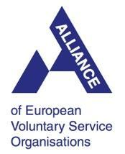 | 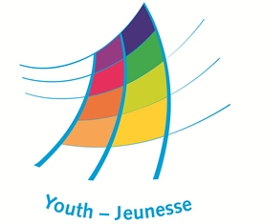 | 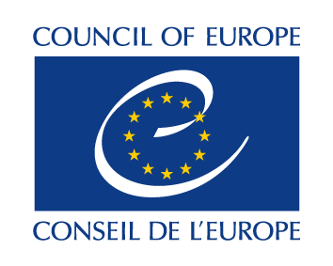 | 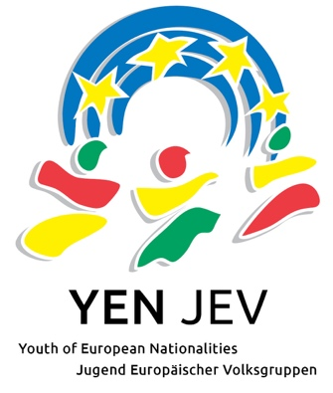

Study Session
“CONTRAPUNCTUS EUROPEUS - European Youth Against Populism and Xenophobia”

CALL FOR APPLICATIONS
Deadline to apply: 17 May 2019

23-29 June 2019

European Youth Center Budapest

CONTRAPUNCTUS EUROPEUS is a Study Session developed in cooperation between the Alliance of European Voluntary Service Organizations and Youth of European Nationalities.
Introduction
Europe has been struggling with several major issues in recent years, including the increased displacement of people, the rise of xenophobia and intolerance in society as well as a lack of possibilities and motivation of youth to participate. One of the aspects which provoke such negative phenomena is populism – a very popular way of communication and dealing with social issues among politicians and public leaders nowadays.
After a longstanding experience in the youth sector, trying to empower and train young people, providing them with skills and knowedge to assure their active participation in society, through promotion of respect of human and minority rights, democracy and intercultural understanding, 4 youth networks - Alliance, YEN, VYRE and Phiren Amenca - have gathered together in Durres, Albania during YEN's General Assembly and developed a common resolution, addressing the current situation in Europe, namely the rise of the far right, populism and xenophobia. As we all have closely related target audiences and common aims, we have partnered to collaborate for the promotion of youth participation, intercultural understanding, preservation and development of the rights of marginalised and vulnerable groups. We are striving to understand and offer solutions for the problems young people are facing in Europe. Therefore, Alliance and YEN have joined forces once again and decided to make a step further and build on this resolution, by designing an educational event in cooperation with the Youth Department of the Council of Europe, combining the experience and knowledge that the three partners involved in it have, so as to provide young people with specific and very concrete set of competences to address these alarming issues in the continent. For both networks, this resolution and its further development are part of the biannual plans of action, which not only include the development of the joint educational activity, but further lobbying and advocacy measures on national, regional and European level, which we started by promoting it in the European Youth Forum and by approving a joint resolution at the COMEM in November 2017.
Aim and objectives
The aim of the study session is to explore how youth workers can challenge xenophobic attitudes and raise awareness about the role of populism in forming them.
The study session has the following objectives:
- To increase awareness about systemic and systematic discrimination against national, ethnic, racial, religious and cultural minorities.
- To raise awareness about populism as the main mechanism behind xenophobia.
- To develop critical thinking skills as possible response to populism.
- To develop competences in human rights education as a tool which can be used in youth work to address issues of xenophobia.
- To create the guidelines on tackling the issue of xenophobic-based discrimination in international youth projects.
- To develop skills on how to implement an inclusive approach in daily activities with young people and how to work with those youngsters facing discrimination,

The main expected outcome of the Study Session will be decreasing different kinds of discrimination in international youth projects.
Program
The program consists from 3 modules:
- E-learning preparatory phase (2 units)
- Study Session itself (7 working days)
- Follow-up activities (practical phase, where participants will use the knowledge in their work with young people, trying new methods and approaches – will be planned at the last stages of the Study Session)
Profile of the participants
This event is designed for youth workers, youth leaders, staff and board members, members of working groups and trainers that have experience in working with marginalized youth or dealing with issues of discrimination against national, ethnic, racial, religious and cultural minorities.
The Study Session will bring together 30 participants: 15 representing the Alliance network and 15 representing the YEN network. The program will be facilitated by the Course Director and 3 trainers, with support of an Educational Advisor of the CoE as well as 2 international experts.
We welcome participants motivated to disseminate the outcomes of the Study Session in their organizations and community and to use it in their daily work.
Age of participants: 18-30 (if older, consult your organization, we can accept some number of participants 30+).
Participants should be able to attend the whole duration of the Study Session and work in English.
Participants should be residents of the countries that are signatures of the European Cultural Convention and three countries outside of the Council of Europe membership (Mexico, Japan, South Korea).
Venue
The study session will take place at the European Youth Center in Budapest, Hungary https://www.coe.int/en/web/youth/eyc-budapest). It is located at the very centre of the city close to all the main attractions and having beautiful views from its window to the Parliament.
Accommodation will be provided and covered by the Youth Department of the Council of Europe at the European Youth Center Budapest. Participants will be accommodated in double rooms.
Visa and travel costs
Participants who require visa to travel to Hungary will be supported by the invitation letter. Visa costs will be reimbursed.
Travel costs will be reimbursed during the Study Session, if all necessary documents will be provided.
Language and dates
Official language of the study session is English.
Dates of the study session are 23-29 June, 2019 excluding arrival and departure. Participants should arrive on 22 June evening and depart on 30 June, 2019.
Application procedures and deadline
The candidates should send their applications no later than 16 May, 2019 to the email estyes@estyes.ee
They will be notified on the selection results by 22 May 2019.

Alliance of European Voluntary Service Organizations: http://www.alliance-network.eu/about-us/
Youth of European Nationalities: http://www.yeni.org

