“A Breath of Art”

Youth Exchange from July, 1 to July, 15

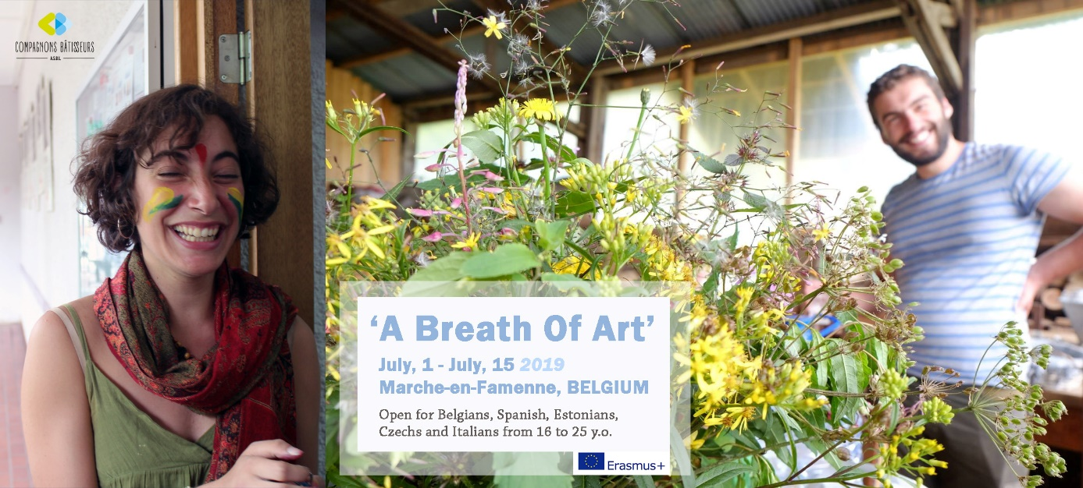
Who? 5 groups of 5 participants from 16 to 25 years old from Belgium, Spain, Estonia, Italy and Czech Republic

When? From 01/07 to 15/07

Where? Marche-en-Famenne, Belgium

To do what?
The aim of this youth exchange is to raise awareness of young people about the richness of the environment that surrounds them (the nature) by using eco-artistic techniques and in such a way expressing themselves (the culture).

The activity period will be divided between field visits, non-formal education workshops such as presentation of experiences existing in each country represented, visiting creative initiatives taking place in rural and urban areas, meetings with different people with specific expertise and artistic workshops. The workshops will be led by a professional artist working with re-use materials and experimented in land art / vegetal sculptures.

Each person will contribute to the project by bringing his/her own skills while learning from other participants of the socially and culturally diversified group. This youth exchange should enable young people to initiate a collective and personal thinking about the importance of promoting the values of sustainable way of living and promoting the biodiversity and creativity.

Through the use of non-formal education and artistic methods, participants will develop their critical mind, learn about how these topics are treated in different countries and get a source of inspiration to create together.

Living conditions and accommodation:
Participants will be accommodated in a former boarding school at the complex Saint-François and will share double or triple bedrooms. They will have a kitchen, a big meeting room and an outdoor terrace.

Expectations towards the participants:
By signing in for this project, we ask you to:
- Be prepared to exploit your imagination and express your creativity;
- Ready to do things with your own hands;
- Ready to live experiences with a heterogeneous group, share your realities and learn from the experiences of other participants;
- Ready to invest in a collective dynamic;
- Prepared to live an experience in which you will make the difference…

