Terrain d’Aventure du Péri

Theme 1: Creativity and Culture
Theme 2: Inclusion-Equity
Theme 3: Rural development and urbanization

Project period
ESC activity will start on 01/02/2019 for a duration of 12 months

The Hosting Organisation
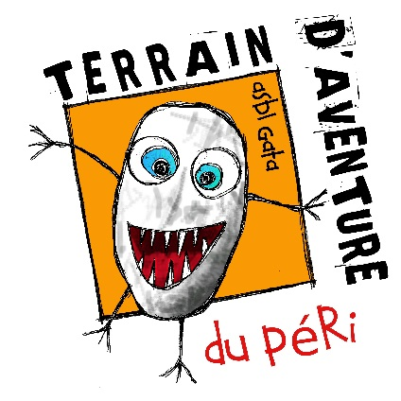
Le Terrain d’Aventure du Péri (The Adventure Playground of Péri) has been created in 1977, thanks to the involvement of passionate people, parents and neighbours, for whom it was important to offer children a new space of freedom as an alternative to the technical progress and modernity they judged socially unfair.
The adventure playground is open to all young people, from 5 to 26 years old. It is a place dedicated to the self-development and the community life, a place where children can learn and experiment without pressure.
Nearly every day, between 10 and 60 children gather there to share a lot of activities: outdoor games, table games, sheds building, do-it-yourself, cooking workshops, artistic workshops, and gardening. All these activities must help them to develop their autonomy, responsibility, critical sense and solidarity.
There is no obligation to be active and there is no result/production to reach in the adventure playground. The most important is to share and to exchange with the other ones.
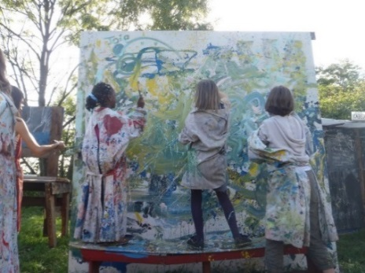
In order to avoid any exclusion for socio-economical reason, the access to the adventure playground is totally free of charge.
The playground is recognised as youth center by the French community of Belgium. It follows a mission of education to an active and responsible citizenship. Seven youth workers are employed by the organisation, most of them at part time job.

EVS (Erasmus+) and now European Solidarity Corps experience
Since many years The Adventure Playground hosts EVS/ESC volunteers from all Europe. Volunteers are completely integrated in the staff; they have the chance to learn animation techniques, to develop personal skills, to discover another way of entertaining children and young people. Volunteers are warmly encouraged to bring new ideas and energy.

Location
The Adventure Playground is located in Liège, the second biggest city of the French Community of Belgium (community that includes the regions of Wallonia and Brussels). In Liège there are 190 000 inhabitants, and almost 450 000 more in its surrounding. Liège is known to be one of the most attractive and lively Belgian cities. The city benefits from a very dynamic cultural life thanks to its various artists and associations.
Liège is an old industrial city that is changing a lot in its adaptation to the 21st century. Well renovated historical areas are mixed with old industrial buildings and very modern architectural projects.
It is located on the border of the river “La Meuse”, close by the German and the Dutch borders.
The Adventure Playground in itself is a wonderful green area of 8 000 m² located on the top of the city, not far from the city center. The playground is full of grass, trees and sheds build by several generations of children.

The project
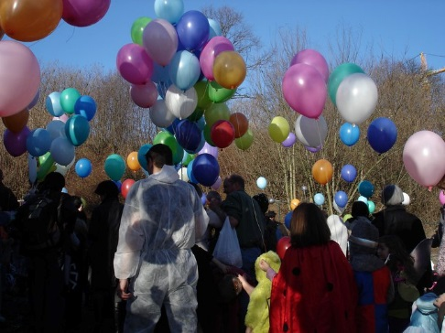
In our project, the volunteer will be all the time in contact with children and young people. S/he will launch, lead and follow several activities. These ones can be various and will depend of his/her ideas, wishes and skills. They will always suppose a democratic participation of the children who have the right to choose and make proposals.
Usual activities in the Adventure Playground are: Artistic workshops (painting, sculptures, serigraphy…); Creative/participative workshops (cooking, sewing, handicraft, shed buildings, storytelling, wild plants preparations…); Games (outdoor games, sport games, table games…); Outdoor activities (nature discovering, gardening…).
The volunteer will also help us in the maintenance of the Playground (small reparations, painting, grass cutting). S/he will also help us when we’ll participate in special events and/or organise punctual projects with other partner organisations: carnival, city fest, shed symposium, international work camp.

During winter time the Playground is open 4 days per week:
Wednesday: 12h - 18h;
Thursday: 15h30 - 21h (since 18h and only for children 12+);
Friday: 15h30 - 21h (since 18h and only for children 12+); on the 3rd Friday of each month we organize a “welcome parents night” until 22h;
Saturday : 10h - 17h.
During the school holidays it is open 5 days per week, from Monday to Friday, from 10 am to 17 pm.

The volunteer will have a very flexible schedule: our working times depend on children free time from school: during the winter there are more “dead periods” instead of in the summer when the activities increase and we have A LOT, A LOT to do!!!

Profile of the volunteer
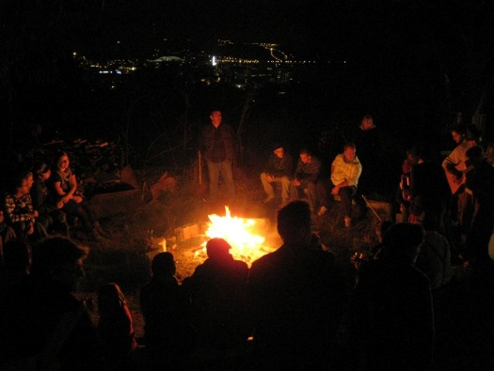
Our project is open to anybody motivated by volunteering and who wishes to be involved in our organisation and work with children and youngsters, regardless to their nationality, religion, believes, diploma, professional experience.
We expect the volunteer to want to build an atmosphere of confidence and security with the children; be ready to involve him/herself in the several activities we do; be able to work together with the staff; be interested in the topic of young people entertainment; agree with our philosophy; to be enthusiast and bring new ideas. As told above it’s also important to be very flexible, wishful to implement workshops and activities for children and youngsters and to able to take initiatives!

Number of ESC volunteers hosted
One

How to apply
In the frame of the new program of the European Commission, the European Solidarity Corps, you first need to create a profile on the new data base: https://europa.eu/youth/solidarity_en (“JOIN THE CORPS”). Then, find the project and click on “apply”. It will send us a contact request.

Send the following documents written in FRENCH or ENGLISH to Morgane (evs@compagnonsbatisseurs.be ) until 27th September 2018 00h00.

-A specific motivation letter
-A CV
-The filled questionnaire (see page 5 of this document)

The application of those who will send their motivation letter and CV later than this date won’t be taken into consideration.
After 27th September, the pre-selected volunteers will be contacted for a skype interview the week after.

Responsibilities and practical arrangements
Responsibilities: The ESC volunteer will always work under the responsibility of youth workers of TERRAIN D’AVENTURE. S/he will have the autonomy s/he’ll need to develop his/her own initiatives and personal projects, but s/he won’t be responsible of an activity on its own.
S/he will always get the advice and support of a youth worker.
Preparation meetings will allow the staff to inform the ESC volunteer about the rules to respect, about all in risks prevention and safety.
Accommodation: In Liège the volunteer will have his/her own “studio” where s/he will live alone. This apartment is in the same building where a worker of the Adventure playground lives. The apartment is 3 kilometres far from the city centre. To arrive to the adventure playground and to the city centre in general, the volunteer will use the public transportation or, if s/he prefers to go by foot, s/he will have to walk more or less half an hour. S/he could also go by bike, riding more or less 15 minutes. For the night life lovers it’s also important to know that the night buses stop around midnight.
The volunteer will receive a monthly allowance and will take care of the meals by her/himself.
Risks and crisis prevention: Risks prevention is firstly linked to a good preparation. We will provide the volunteer with complete and true information before s/he will join our project. The sending organization will be in charge to follow the volunteer during the pre-departure process, to inform him/her about the ESC program, about the rights and responsibilities of the different actors involved, about the administrative obligations the volunteer has to respect before to leave his/her country, etc.
When arrived in Belgium, the volunteer will participate in the on-arrival seminar and the mid-term evaluation organized by the French speaking National Agency.
At the very beginning of the project, we'll especially take care to welcome the volunteer, to show him/her interesting places of our town and Belgium and to present him/her to other young people.
We'll also check that everything is in order with the insurance.
The ESC volunteer will participate in our weekly meeting in order to be integrated in the team and to have the chance to talk about the difficulties s/he lives.
An evaluation of the ESC experience will be made on regular basis with his/her mentor. If there is a problem, a meeting with the project coordinator will be held in order to solve it.
In case of crisis/emergency, we'll require the intervention of the specialized services required, according to the situation.
As we are the hosting organization in this project we are in charge, together with our Coordinating organization Compagnons Bâtisseurs and our national agency, to provide the resources that can help in case of any serious casual problems.

Contacts
Name | Morgane HAZARD
Organisation | Association des Compagnons Bâtisseurs asbl
Address | 9 Place du Roi Albert Marche-en-Famenne 6900 Belgique
E-mail | evs@compagnonsbatisseurs.be | Internet | http://www.compagnonsbatisseurs.be/en/evs-with-cbb/
Telephone | +32 84 31 44 13 | Fax | +32 84 31 65 20

European Solidarity Corps volunteering activity with
« Terrain d’aventure du Péri »
Marche-en-Famenne

Questionnaire for the candidate volunteer

To be filled electronically in and sent by email together with your motivation letter and CV to evs@compagnonsbatisseurs.be
NOT later than Thursday 27th September 2018 at 00h00

Personal data :
By filling the information below, you provide us with personal information. You are aware of the fact and agree that the pieces of information will be used in the frame of the call for candidates for the Erasmus+ volunteering project. Your personal data will be used by the persons in charge of the selection of volunteers in the sending and coordinating/hosting organizations. Each part mentioned takes the responsibility of erasing the documents containing your personal data once the selection procedure is over.

Name and surname
Birthdate
Current address
Phone number
Email address
Availability period for the project
(preference will be given to the volunteers able to join the project from beginning of February 2019 for 12 months)

Have you ever taken part in a volunteering project under ERASMUS+?
!!!VERY IMPORTANT!!!
Sending organization
(Name, Accreditation or PIC number, post address, phone number, contact person’s name and email address)

What are your (long term) travel experiences?

Feel free to complete this questionnaire in French language.

- According to you what is the role of a youth service as “Terrain d’Aventure du Péri”?

- What are, for you, the qualities of an employee of this organization?

- What did you understand about our project? How do you see your role, as volunteer, within these activities?

- Which are your weaknesses and qualities for this project?

- Do you think you will be confronted with some difficulties? If yes, which ones? If no, why?

- Do you have some special skills in animation/groups leading? Which ones?

- How would you feel in case you should manage a crisis?

- What are your qualities to work in team?

- What would like to know about our organization and activities? Do you have any questions or doubts before to accept to be volunteer in our project?

- What do you like to do in your free time? What do you think about living in a semi-rural town?

THANK YOU VERY MUCH FOR HAVING FILLED THIS QUESTIONNAIRE IN
WE WILL CONTACT YOU BETWEEN 1st and 8th October TO GIVE YOU OUR FEEDBACK!

In case of any doubt, do not hesitate to email us

For CBB,
Coordinating and hosting organization

Morgane HAZARD
evs@compagnonsbatisseurs.be

