CFP Famenne-Ardenne

Theme 1: Access for disadvantaged
Theme 2: Environment and climate changing

Project period
ESC activity will start on 01/02/2019 for duration of 12 months

The Hosting Organization
The CFP (Centre de formation professionnelle –Professional Training Centre) Famenne Ardenne is a non-profit organisation recognised and financed by the “Walloon agency for the inclusion of disabled people” and supported by the “European Social Fund”.
Our aim is to help our “trainees” in finding a job and to foster their inclusion in our society.
Our target public is not only made up by people with disabilities (most of our centre users do not have any visible handicap) but also by lots of people who can’t find a job and are in risk of exclusion for many different reasons.
We work for and with weak, excluded, sick, disabled and poor people and people who have in general difficulties in looking for a job in nowadays labour market.
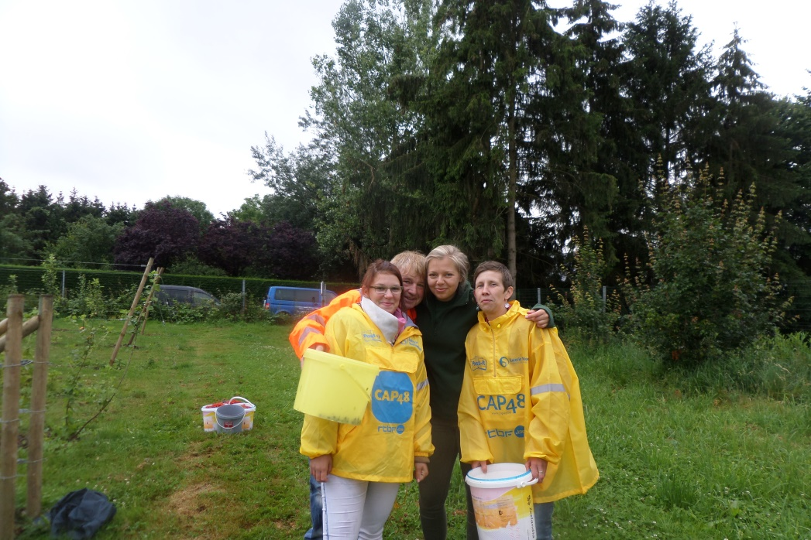
The CFP offers its users a professional training, both theoretical and practical, according to each one’s personality, preferences, interests, abilities and needs. Thanks to a multidisciplinary staff composed by social workers, psychologists and technical trainers, we can offer our beneficiaries professional trainings in these specific fields: professional cleaning, laundry, car wash, gardening and agriculture.

EVS (Erasmus+) and now European Solidarity Corps experience
This will be the third time that CFP will host an ESC volunteer.
Actually we are not alone in this adventure: we are supported by our coordinating organization, the association of Compagnons Bâtisseurs, which has a strong experience in the ESC program. We really believe that our centre aims, functions and working methods fit very well with the philosophy and values of the ESC program as respect, inclusion, youngsters skills development, responsible and active citizenship, non-formal education.

Location of the project
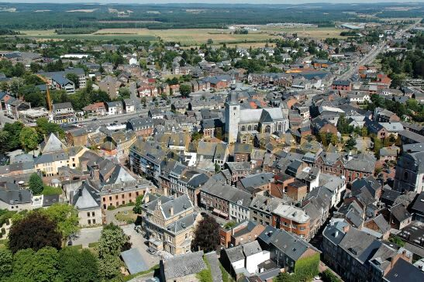
Our centre is located in Marloie, in a semi-rural area. The closest town, the one where the volunteer will live, is Marche-en-Famenne, 5 kilometres away from Marloie.
Marche-en-Famenne is a small town situated in the south French speaking part of Belgium. With about 17 000 Inhabitants, the municipality of Marche counts with numerous villages: Hollogne, Waha, Verdenne, Champlon-Famenne, Grimbiémont, Lignières, Roy, On.
The volunteer will be in contact with all the other ESC volunteers being hosted in the other projects in the municipality of Marche-en-Famenne.
Even if Marche offers all the modern facilities, it is however IMPORTANT to know that the town it’s very quiet and that it’s not the best place to stay for the urban life-style lovers.
The nightlife here is less vivid than in bigger towns.
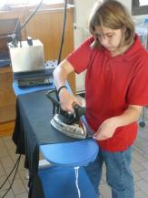
Nevertheless, Liège, Namur or Brussels are not far from Marche which has very good train connection.

The project
We mainly expect from our ESC volunteer to accompany, support and help our technical trainers in organizing and leading all the trainings (professional cleaning, laundry, car wash, gardening, agriculture…) we offer to our public. At the beginning the volunteer will take the time to discover all what we do in CFP and then s/he will choose the activities s/he will be more interested in!
The volunteer will have many practical learning opportunities. Her/his work in CFP will be mostly practical/manual.
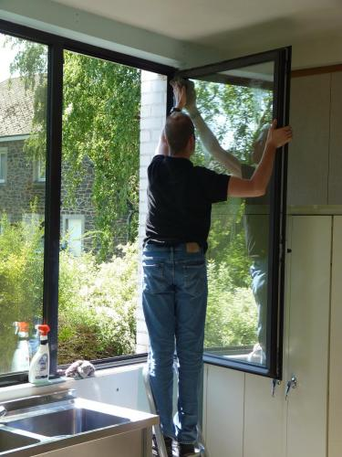
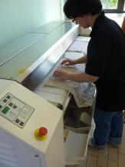
For example, by taking part in our trainings of ‘gardening and agriculture’ the volunteer will learn about the techniques of preparation of soils, seeding and plantations; taking part in the training ‘blanchisserie’ s/he will learn how to run professional laundry and ironing activities and so on…
No matter which activities the volunteer will chose to do, s/he will for sure acquire skills in working with disabled and disadvantaged people.
The volunteer will be completely integrated in our team; s/he will mainly support us in the organization of the trainings but also in the implementation and promotion of leisure activities such as journeys, games, outdoor activities and cultural events for the users of our center.
If desired the volunteer will take part in our educational meeting; s/he will help us in the evaluation of our trainees’ development.

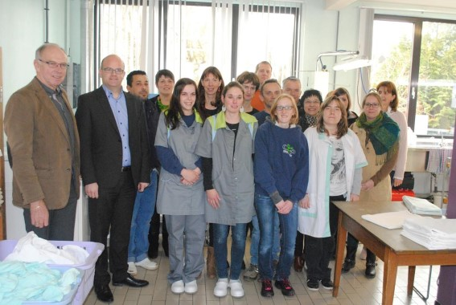
The aim of his/her presence in our center is to offer our people the possibility to open themselves to another culture, another dimension.
The volunteer is expected to help us in improving the group cohesion, bringing new ideas and working actively for a stronger inclusion of our people. To reach this goal s/he will be warmly encouraged to collaborate with the other young people who volunteer in CBB projects, focused on the topic of disabled people inclusion.
During the project the volunteer will receive all the support needed: s/he will have a mentor who will help him/her in opening a bank account, finding a French course, enrolling him/herself to the city hall and s/he will have of course also technical support during the work.

Collective activities with other ESC volunteers
The ESC activity within CFP Famenne-Ardenne is part of an ESC group project that aims to increase European awareness among youth in the town of Marche-en-Famenne and to improve a closer collaboration between the local social services. For this reason, some activities will be run with other ESC volunteers (hosted by three other local organizations).
The volunteers are encouraged to work together especially during specific youth events organized once a year in Marche-en-Famenne: Rock festival, Carnival, youth services opening day... The volunteers will help to prepare and follow-up these events. In some occasions, they can hold an information stand presenting ESC program and youth exchange opportunities. We would also like to organize a “European night” in the local youth house to give volunteers the possibility to present their country and traditions.

Profile of the volunteer
Our project is open to anybody motivated by volunteering and who wishes to be involved in our organisation, regardless to his/her nationality, religion, believes, diploma, professional experience. Because our public doesn’t speak any other language than French, we require that the volunteer have some basic skills in communicating in French.
We expect the volunteer to be open to the difference and ready to build an atmosphere of confidence and security with the centre users; be ready to involve him/herself in the several tasks we do with them; be able to work together with the staff; be interested in the topic of disabled people inclusion; agree with our philosophy of equality and openness to the difference; willing to listen, communicate and care about the young adults in risk of exclusion.

!!!We ask the volunteer to provide a certificate of good conduct (CGC)!!!

Number of ESC volunteers hosted
One on this project but s/he will have daily contacts with the other ESC volunteers hosted in Marche-en-Famenne municipality (6 in total).

How to apply
In the frame of the new program of the European Commission, the European Solidarity Corps, you first need to create a profile on the new data base: https://europa.eu/youth/solidarity_en (“JOIN THE CORPS”). Then, find the project and click on “apply”. It will send us a contact request.

Send the following documents written in FRENCH or ENGLISH to Morgane (evs@compagnonsbatisseurs.be ) until 27th September 2018 00h00.

-A specific motivation letter
-A CV
-The filled questionnaire (see page 6 of this document)

The application of those who will send their motivation letter and CV later than this date won’t be taken into consideration.
After 27th September, the pre-selected volunteers will be contacted for a skype interview the week after.

Risks prevention, protection and safety
Responsibilities: The ESC volunteer will always works under the responsibility of the CFP staff.
S/he will have the autonomy s/he’ll need of to develop his/her own initiatives and personal projects, but s/he won’t be responsible of an activity on its own. S/he will always get the advice and support of a youth worker. The activities s/he will take part in will always be prepared with the whole staff. Preparation meetings will allow the staff to inform the EVS volunteer about the rules to respect, about all in risks prevention and safety.
At the centre we make sure that all the safety rules are always respected: we provide our trainees appropriate working equipment; fire extinguishers are present in all rooms; all vehicles are provided with a first-aid kit. Their content is regularly verified.
An evacuation exercise is held once every year.
Furthermore the CFP is affiliated to the “Service of prevention et protection at work” and all the trainees and trainers are subjected to an examination once per year.
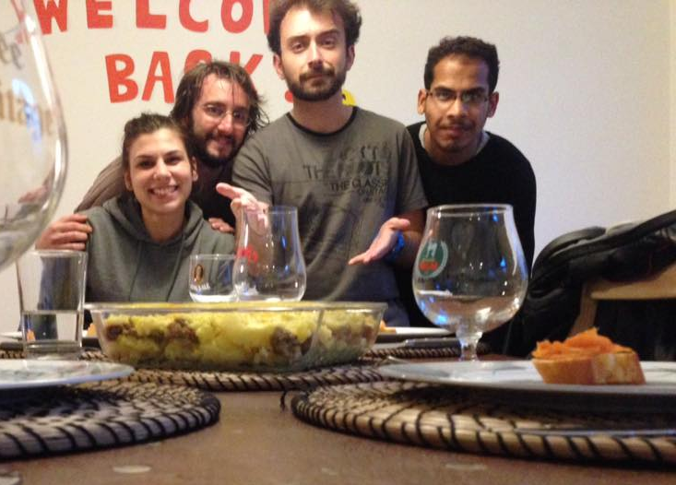
Accommodation: The volunteer will be hosted in a house that s/he will share with other people. The house will be located in the centre of Marche-en-Famenne and will have all the modern facilities. The volunteer will receive a monthly allowance and will take care of the meals by herself/himself.

Risks and crisis prevention: Risks prevention is firstly linked to a good preparation. We will provide the volunteer with complete and true information before s/he will join our project. The sending organisation will be in charge to follow the volunteer during the pre-departure process, to inform him/her about the ESC programme, about the rights and responsibilities of the different actors involved, about the administrative obligations the volunteer has to respect before to leave his/her country, etc.
When arrived in Belgium, the volunteer will take part in the on-arrival and mid-term seminars organized by the French speaking National Agency. The seminars will be organized in French. At the starting of the project, we'll especially take care to welcome the volunteer, to show him/her interesting places of our town and Belgium and to present him/her to other young people. We'll also check that everything is in order with the insurance.
The EVS volunteer will participate in our staff meeting in order to be integrated in the team and to have the chance to talk about the difficulties s/he lives. An evaluation of the ESC experience will be made on regular basis with his/her mentor. If there is a problem, a meeting with the project coordinator will be hold in order to solve it.
In case of crisis/emergency, we'll require the intervention of the specialize services required, according to the situation.

Our coordinating organization and our national agency in charge of the ESc programme are resources that can help in case of any serious casual problems.

Contacts
Name | Morgane HAZARD
Organisation | Association des Compagnons Bâtisseurs asbl
Address | 9 Place du Roi Albert Marche-en-Famenne 6900 Belgique
E-mail | exchanges@compagnonsbatisseurs.be | Internet | http://www.compagnonsbatisseurs.be/en/evs-with-cbb/
Telephone | +32 84 31 44 13 | Fax | +32 84 31 65 20

European Solidarity Corps volunteering activity with
« CFP »
Marche-en-Famenne

Questionnaire for the candidate volunteer

To be filled electronically in and sent by email together with your motivation letter and CV to evs@compagnonsbatisseurs.be
NOT later than Thursday 27th September 2018 at 00h00
Personal data :
By filling the information below, you provide us with personal information. You are aware of the fact and agree that the pieces of information will be used in the frame of the call for candidates for the Erasmus+ volunteering project. Your personal data will be used by the persons in charge of the selection of volunteers in the sending and coordinating/hosting organizations. Each part mentioned takes the responsibility of erasing the documents containing your personal data once the selection procedure is over.

Name and surname
Birthdate
Current address
Phone number
Email address
Availability period for the project
(preference will be given to the volunteers able to join the project from beginning of February 2019 for 12 months)

Have you ever taken part in a volunteering project under ERASMUS+?
!!!VERY IMPORTANT!!!
Sending organization
(Name, Accreditation or PIC number, post address, phone number, contact person’s name and email address)

What are your (long term) travel experiences?

If you want, feel free to complete this questionnaire in French language.

- According to you what is the role of a service as “CFP”?

- What are, for you, the qualities of an employee of this organization?

- What did you understand about our project? How do you see your role, as volunteer, within these activities?

- Which are your qualities and weaknesses in relation to this project?

- Do you think you will be confronted with some difficulties? If yes, which ones? If no, why?

- Do you have some special skills in animation/groups leading? Which ones?

- How would you feel in case you should manage a crisis? (between volunteers, disabled people...)

- What are your qualities to work in team?

- What would like to know about our organization and activities? Do you have any questions before to accept to be volunteer in our project?

- What do you like to do in your free time? What do you think about living in a semi-rural town?

THANK YOU VERY MUCH FOR HAVING FILLED THIS QUESTIONNAIRE IN
WE WILL CONTACT YOU BETWEEN 1st and 8th October TO GIVE YOU OUR FEEDBACK!

In case of any doubt, do not hesitate to email us

For CBB,
Coordinating and hosting organization

Morgane HAZARD
evs@compagnonsbatisseurs.be

