Britanica Huvikool NGO

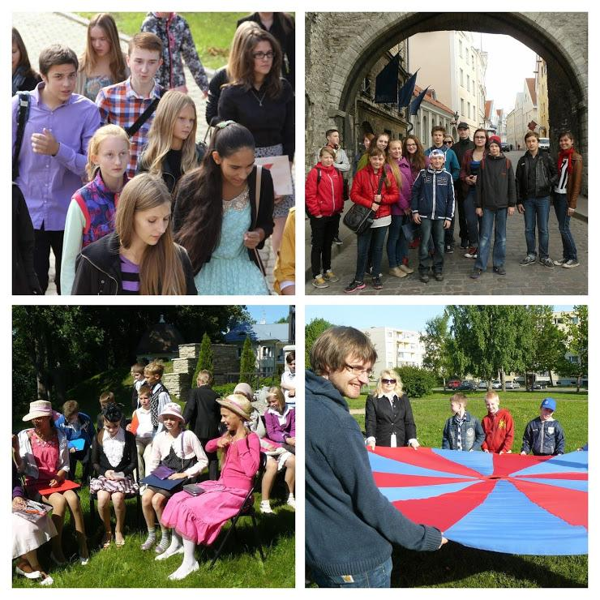

To get a better idea of our organisation, activities, and previous volunteers’ experience with us, you are welcome to visit our blog and Facebook page:

http://britanicaenglish.blogspot.com

https://www.facebook.com/britanica.school/

ORGANISATION DESCRIPTION

Huvikool Britanica is a non-profit organisation, created to integrate children of Estonia into the European society. It was established in 2004. The main objective of the club is to provide local children with an environment which enables them speak at least two European languages (English and German) by using formal and informal methods.

Britanica has an aim to promote international understanding, solidarity and dialogue between young people and children all over the world. The key to this process is the language as a communication tool. On a contrary the project provides informal language practice through meeting young people from abroad and having common activities with them.

Britanica has been hosting organisation for EVS volunteers since 2005. With the help of an international volunteer, we will create an opportunity for the young people to learn more about Europe and other continents, not just the languages but also culture, customs, food, music, etc. In this way, the project will have a strong intercultural learning impact on the children, but also on the staff and the parents.

PROJECT CONTEXT

Britanica unites 50-80 children aged between 8 and 17. The mother tongue of the children of the club is Russian, thus the project is dealing with the integration of ethnic minority group in Estonia. Intercultural learning and foreign language experience will be integrated into the daily activities of children such as art workshops (drawing, making seasonal handicraft), attending cultural events in the town, and so on. The choice of activities depends on wish of participants and their age. In the working plan of the lub there are visits and excursions, teamwork, etc. Also, formal language lessons are in our working plan. The choice of activities depends on participants’ age and needs. In the working plan there are visits and excursions, teamwork, Reading Club, Conversation Club. The staff of Britanica consists of three people.

PROPOSED ACTIVITIES

There is a member of the staff or project leader with whom the volunteer is working. The place of work is comfortable. It has got a staffroom, lavatory and three rooms for activities. It has got all necessary equipment.

The roles and tasks of the volunteer are to plan activities for the following day, to help stuff to prepare supplementary materials, to play with kids, to help children with their homework and check their works, to read with kids, to support a Conversation Club, to assist during the formal lessons, to update school’s blog, Facebook page, to accompany kids and the staff during outdoor activities. Volunteers will stay at school from 14.00-18.00.

Britanica’s project would bring following learning points to the volunteer: work with children of different culture background, project would give basic skills of the ESOL teacher, build team work, project would support personal initiative.

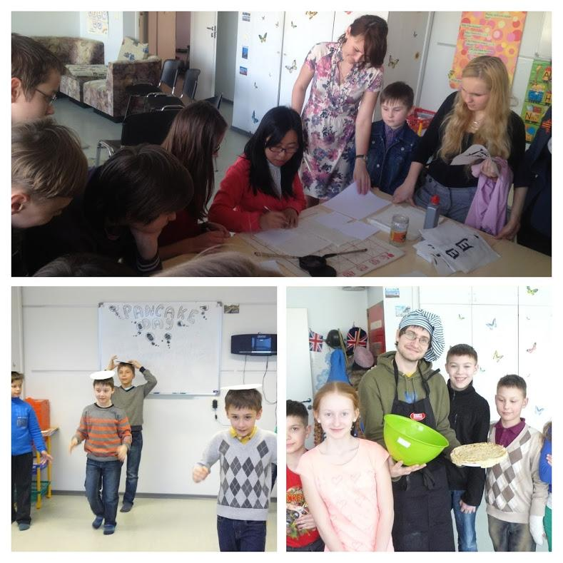

Profile of Volunteer and Recruitment Process

You have to be really motivated to work with kids. Experience in work with children is an advantage. Your ideas and actual preparation to do the activities for kids are essential. We expect active volunteers with a good knowledge of history and culture of their country as well as with an ability and wish to present it to others in a creative way.

Selection of volunteers will be done by our school in cooperation with our coordinating organisation MTÜ Noortevahetuse Arengu Ühing EstYES. Coordinating organisation MTÜ EstYES will make the primary selection among volunteer candidates. All volunteer applications approved by EstYES will be forwarded to Britanica so that we could do the final selection based on Skype interviews.

Risk Prevention, Protection and Safety

Our working environment is very friendly and supporting and the volunteer will have support from his/her tutor, mentor and coordinating organisation. Britanica Huvikool NGO will ensure:
− that the volunteer work is safe and it has been assessed for risk
− that every effort is made that project meets high health and safety standards
− that the volunteer is trained and familiar with the volunteering work and have access to adequate safety equipment when needed
− provide a mentor for volunteer, to whom she can turn in case of problems, doubts, concerns, etc.
− ensure regular meetings with project supervisor to discuss the course of EVS project and see where the shortcomings are and how potential problems can be resolved.
− that the volunteer will get all the practical and psychological support from the organisation’s staff or from professionals − that in case of crises it will be dealt at once with full seriousness on high professional level with the use of all previous experiences collected during decade of dealing with EVS projects.

