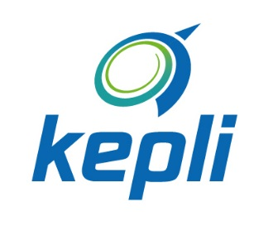
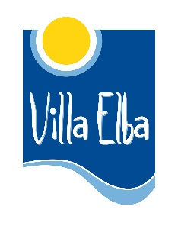
YOUTH CAN DO IT!
GROUP EVS-PROJECT 2.7-10.8.2018
Youth Centre Villa Elba in cooperation with Kokkola Cup and Kepli

GROUP-EVS PROJECT, KOKKOLA & KALAJOKI
Youth can do it! is a short-term EVS-project gathering 12 persons from around Europe to Central-Ostrobothnia 2.7-10.8.2018.
Project activities:

YOUTH CENTRE VILLA ELBA
• • •
Villa Elba is a National Youth Centre supported and observed by the Ministry of Education. We are specialised in youth work and our function is to develop the methods used in the field of youth work. We work under the Finnish law covering youth work and by the Ministry of Education.
Our goal is to offer youngsters the possibilities of learning in multicultural environment and finding their own strengths and abilities through international activity.
Our work consists of international camps and programs, education, practical training and voluntary work for young people, information and guidance about international programmes, projects and EVS co-ordination for hosting organisations.

During this project, the volunteers help to prepare for two events: preparation and implementation of the Kokkola Cup youth football tournament and Juku children’s sport camp.
Kokkola Cup is a football tournament gathering over 10 000 football enthusiasts for 4 days and it is one of the biggest children’s football events in Finland. It gathers football teams from many other countries, so it is also an international event.
Tasks: Helping with arranging the football tournament means that volunteers help with: maintenance of the football fields: cut grass, put up signs, help to organize accommodation spaces at local schools, help to organize the kiosk.
Juku-camp is a versatile sport camp with long traditions. The camp has been organized by Central Ostrobothnia Sport Federation (Kepli) since 1993. The purpose of the camp is to inspire children to move, to give experiences and to familiarize them with healthy lifestyle. Participants in event camp are offered the opportunity to have a high quality daily exercise for their own sport event. In the past few years there have been about 380 participants (age 8-14) and about 70 instructors in Juku-camp.
Tasks: At Juku-camp the volunteers help with setting up the camp, assists staff in catering, in first aid and in information center, helps the leaders to organize and lead sport activities and other programmes. After the camp the volunteers help to clean the area, pack stuff and other practical work.

Contact information:
Youth Centre Villa Elba
Sannanrannantie 60, 67100 Kokkola, Finland
tel: +358 6 8313 400
www.villaelba.fi
Contact persons: Kati Paasila, kati.paasila@kokkola.fi, +358 44 5325160
Ritva Saarikettu, ritva.saarikettu@kokkola.fi +358 500 902 330
Profile of participants:
The participants are young people seeking new possibilities to their lives. You can be unemployed, face educational, economic or social challenges or have low language skills. Volunteers should be interested in working with children and sport activities. Work is physical and outdoors. There is no need of previous experiences, just the interest to try it out and learn more!
We offer you:
- a chance to live in a new culture
- possibility to do volunteer work for the local community
- a chance for intercultural learning
- a project were you can use your skills to help to restore a nature path that has significant importance to local community

Be prepared for:
- physical outdoor work
- warmer and chillier weather, mosquitos, bright nights
- interacting with people from different backgrounds
- changes
- adventure

We expect from you:
- flexibility
- respect towards other people
- ability to follow the rules and schedule

Tips for travelling to Kokkola:
The participants can search for flights to Helsinki or directly to Kokkola. The best way to travel to Kokkola from Helsinki is train, timetables and prices at: www.vr.fi/en. There is also one very cheap bus connection http://www.onnibus.com/en/index.htm, but the ride is very long (approx. 7 hours). Villa Elba organizes transportation from Kokkola airport/ train /bus station to Villa Elba. This transport cost is covered from the travel grant.

What to bring with you:
- comfortable shoes and clothes for outdoor work
- backpack to be used during working days
- personal items like hygiene products, medication, mosquito repellents, sun cream
- European health card (very important, you will needed if you need to go to health Centre/hospital!)
- personal medication and hygiene products
- Swimming suits if they want to wear them in sauna or want to go to swim
- Something typical from your country to present your culture (music, songs, dances, something to eat etc.)

On-arrival training:
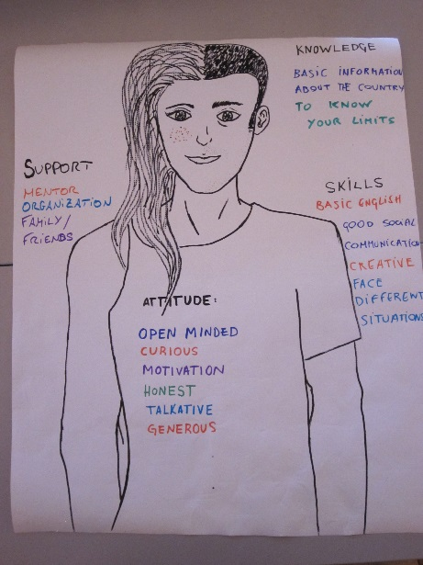
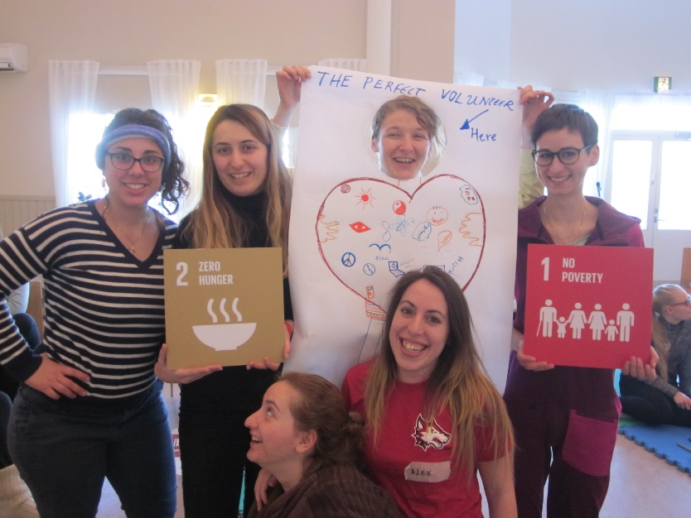
First week of the project will be on-arrival training in Youth Centre Villa Elba. The aim of the training is to get to know the other participants and understanding for EVS. We will also tell about the aim of the project, intercultural learning and about their rights and responsibilities. There will be Finnish language lessons to learn basic words and sentences.

Working hours and holidays:
The volunteers work 5 days a week, approximately 35 hours.
Working for Kokkola Cup means that some days are shorter and some days are longer. Working hours can be between 8-22 and the exact working hours are determined closer to the event. When organising a big event, surprises can occur, so it is important that the volunteer is flexible regarding the working hours. The total working hours will be still be 35 € / week, but some week might be more and the other less.
During Juku-camp, volunteers work in the same conditions as Finnish workers and participate in the program from early morning to evening fulfilling tasks given by the work leader. This means that there are no specific work schedule for the camp days, so volunteers live and work according to the camp schedule.
The volunteers earn 2 holidays during the project.

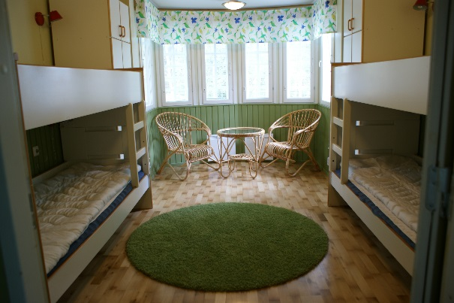
Accommodation and meals:
During the on-arrival training, the volunteers live in Youth Centre Villa Elba. The accommodation is in a farm house called Lassela, where is one room for girls and one room for boys, a common kitchen and bathroom.
Meals are served in Villa Elba during on arrival training. Villa Elba provides bed sheets and towels.
After the on arrival, volunteer get lunch on working days, and food money to buy food to prepare other meals of the day. The food money is paid as a lump sum to the whole group, and the volunteers plan and budget the shopping together.
During Juku-camp, the volunteers accommodate in tents and eats readymade food together campers. The meal times during the camp is typical Finnish meal times, and there are no possibilities to change these times! Volunteers get tents, sleeping bag and mattress from Villa Elba. In this video, you can see the area: https://www.youtube.com/watch?v=royD_wVayHU
Support measures:

Extra support is available for volunteers 24/ 7 during the whole project. The support persons help with everyday issues (living together, cleaning, shopping if needed), to get familiar with local community and culture, help in difficult situations and supports the volunteers to reflect on their learning outcomes. There will be organized mentor meetings weekly and volunteers are entitled to take part in the mentoring meetings.

Each sending organisation can, if needed, send a support person to escort the volunteers to Kokkola 20-23.8.2018. We provide board and lodging for the support persons and travel costs are reimbursed fully up to 500 €.
Financial issues:
Travel grants are issued according to the funding rules of Erasmus+:

10 – 99 km | 20 €
100 – 499 km | 180 €
500 –1999 km | 275 €
2000 – 2999 km | 360 €
3000 – 3999 km | 530 €
4000 – 7999 km | 820 €
8000 –> km | 1500 €

Volunteers get pocket money 225 €. The pocket money is paid in cash in three parts.
Each sending organisation has the possibility to send a support person along with their volunteers for 2-5.7.2018. Costs for board and lodging are covered and travel costs are covered up to 500 € / person.
Other issues:
Photography and social media:
As volunteers work with children, it is very important to understand, that they cannot publish any pictures taken of children without permission from the guardians, so volunteers should not post pictures with children that can be recognized in social media.

More information about Juku-camp:

Jukuleiri

Jukuleiri (Juku-camp) is a versatile sport camp with long traditions. The camp has been organized by Central Ostrobothnia Sport Federation (=Kepli) since 1993. The purpose of the camp is to inspire children to move, to give experiences and to familiarize them with healthy lifestyle.

Jukuleiri includes Hippoleiri (Hippo-camp) and about ten Event camps, for example soccer, baseball, ice hockey and swimming. Hippo-camp contains different kind of physical action scenes. In Event camps participants will be exercise their own sport event and will also participate in action scenes. All participants in Jukuleiri have some common events such as camp disco, movie night and a visit to the water park and spa.

Participants in Lajileiri (Event camp) are offered the opportunity to have a high quality daily exercise for their own sport event. In the past few years there have been about 380 participants (age 8-14) and about 70 instructors in Jukuleiri.

The camp lasts four days and the overnight stay takes place in tents. The campsite is in Kalajoki Camping -area, which also has camping places, dining facilities, washing rooms and most of the activity areas. All of the camp's activity areas are within walking distance of the campsite. Some of the sites where the Lajileiri events are held are located in the city where participants travel by bus.

Instructors assignments in Jukuleiri

Jukuleiri offers a variety of job assignments, for example, as a Hippo-camp supervisor, Event camp supervisor, action scene instructor, in catering, in first aid and in information center. In the most responsible positions we expect the instructor to be 18 years of age. Younger (over 16 years) instructors can work in the Jukuleiri in assisting tasks in different assignments. Prerequisites for the instructor are that you get along with the children, you are positive, brisk and self-motivated. The camp leader is responsible for the orientation and training of camp instructors before the Jukuleiri.

Instructors duties also includes preparation and discharging of the camp area before and after the camp.

Camp Day 1 – Monday
Arrival to Juku camp (camping site) and accommodating into cottages/tents
Lunch
Opening ceremony
Action points / sports
Dinner
Movie night
Evening task + snack
Silence, good night!
Camp Day 2 – Tuesday
Wake-up-call, morning tasks, day opening
Breakfast
Action points / sports
Lunch
Action points / sports
Athlete visit
Fun at waterpark “JukuPark”
Dinner
Camp disco & magician
Evening snack
Silence, good night!
Camp Day 3 – Wednesday
Wake-up-call, morning tasks, day opening
Breakfast
Action points / sports
Lunch
Athlete visit
Action points / sports
Dinner
Team night + movie night
Evening snack + evening tasks
Silence, good night!
Camp Day 4 – Thursday
Wake-up, morning tasks, day opening
Breakfast
Action points / sports
Lunch
Final ceremony

