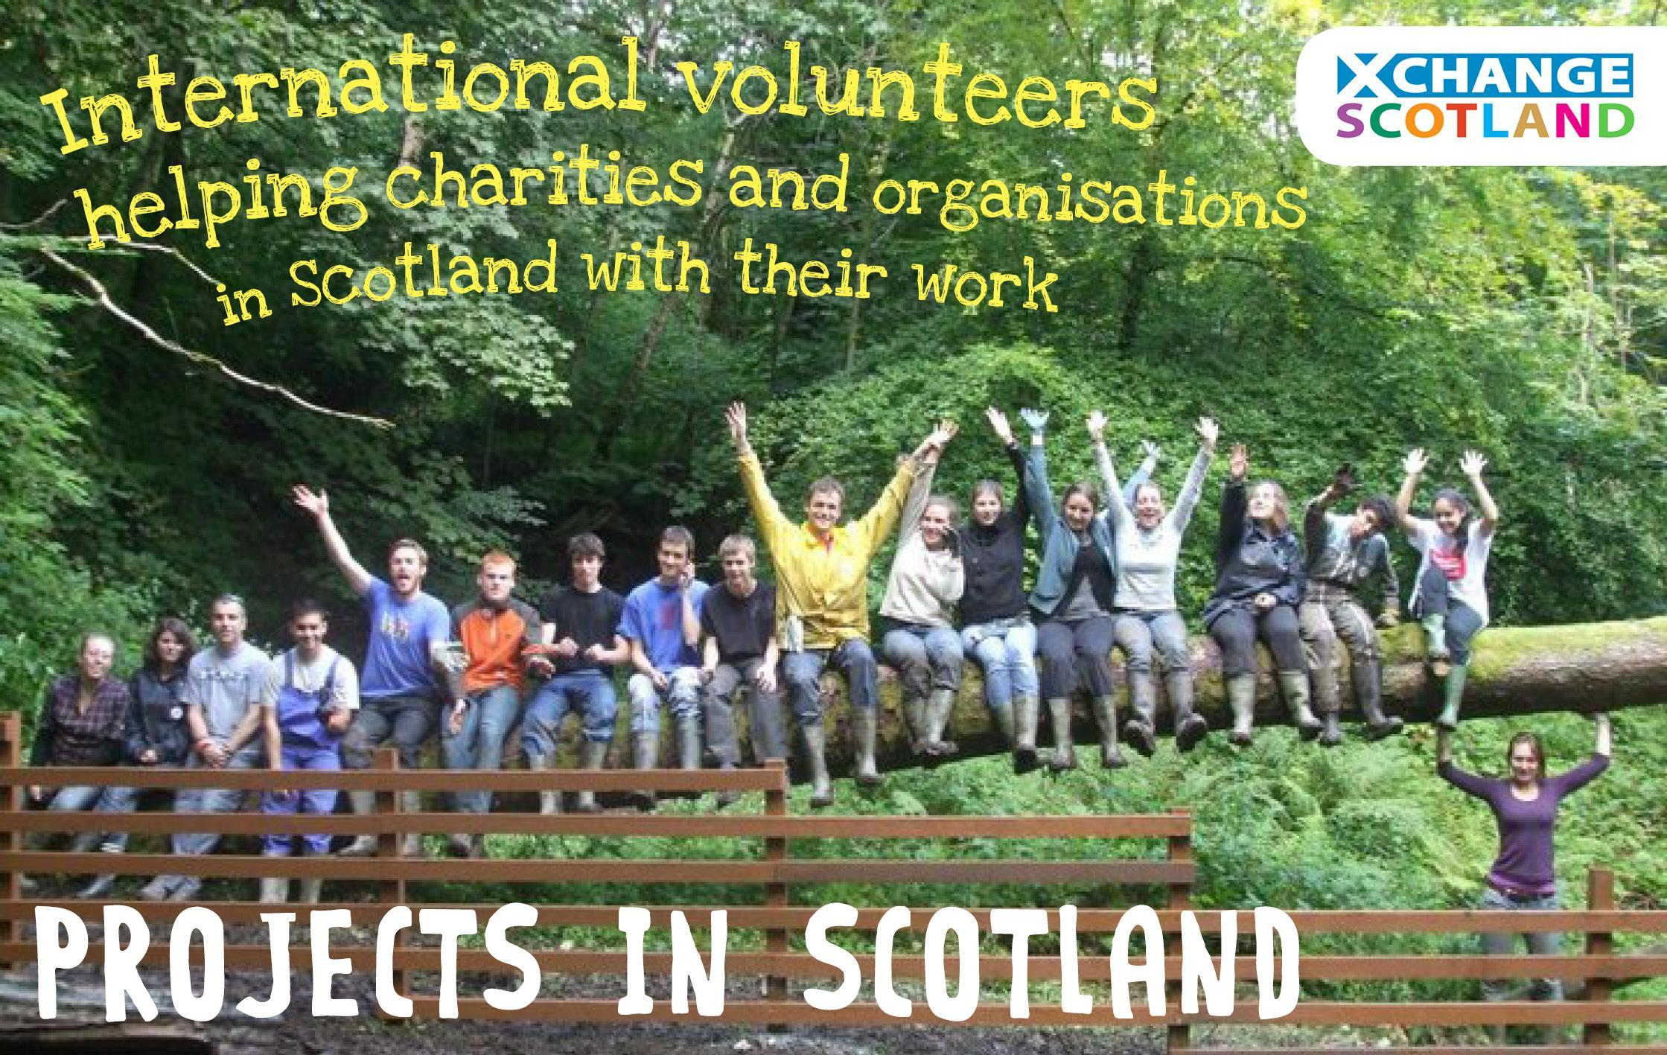
XS02 Dean Castle
About Xchange Scotland
Xchange Scotland is a youth-led charity developed by returned Scottish volunteers and others committed to making positive change in society. Since 2007, we have been deeply involved in a variety of international volunteering and education projects. Our aim is to connect individuals and organisations in Scotland to these exciting and accessible international opportunities. We want to bring as many people to Scotland for international volunteer projects and enable as many Scots to volunteer abroad as possible. We work with organisations like ourselves in two networks: The workshops in communities across Glasgow aimed at helping to create a safe space for communities and individuals to come together and discuss intra-Christian sectarianism and its impact.

Alliance of European Voluntary Service Organisations and the Coordinating Committee for International Voluntary Service (CCIVS).
As well as being involved in international volunteering we are also involved in a non-formal educational work on a number of topics. We are recipients of Scottish Government funding from their tackling sectarianism fund, this allows us to deliver a range of projects

About the Project
Code/Name | Location | Dates | Type | Volunteers
XS02 Dean Castle 2 | Kilmarnock | 05/08 – 15/08 | Environmental | 10

The local partner: Dean Castle Country Park covers over 200 acres, and is nestled in the heart of Kilmarnock. The Country Park boasts beautiful woodland walks, an adventure playground, urban farm, visitor centre, tearoom, shop and a fantastic 14th century castle housing world class collections including historic weapons, armour and musical instruments. You can explore the park using scenic paths and trails - each season brings with it ever changing plants and wildlife that you might spy along the way. With over 80 hectares of countryside within a very urban area, the park is a great place to get away from the stresses of everyday life and see some fantastic wildlife.
Sport Events: Our partner East Ayrshire Leisure works closely with Dean Castle Country Park and provides sporting opportunities to the local Kilmarnock area. You will also be joining Scotland Sports Future a committed partner whose mission it is to Use the power of sport to inspire young people to make positive lifestyle choices. They have special events planned for the European Championships which you will help support. Please see separate attachment for more info on sporting events.
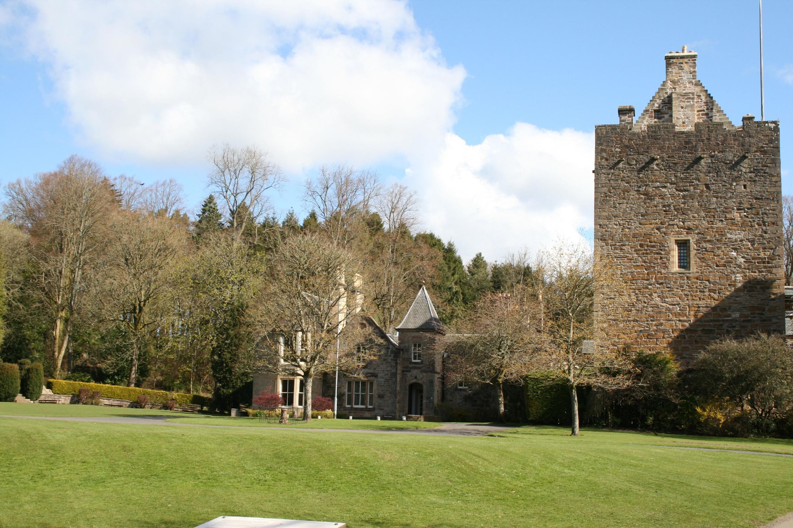
Work: At Dean Castle, you’ll be carrying out practical conservation work including footpath maintenance and invasive species management. This conservation work at Dean Castle Country Park and across their path network of East Ayrshire is helping improve access for outdoor activities for the community. Additionally, with East Ayrshire Leisure you’ll be volunteering at the Ayrshire Athletics Arena, helping run coaching sessions and summer boot camps.
We will be doing sports volunteering with partner Scotland Sports Futures when the European Championships comes to Glasgow this August. You will be involved showcasing
the incredible opportunities there are for people of all ages and abilities to get active or try a new sport. This will involve a variety of sporting events run at the iconic Glasgow Green!

Accommodation: The volunteers will be housed in a 4 bunk rooms in accommodation located in country park. There is a kitchen with cooking equipment available for the volunteers to use at the centre as well as a recreational space. There will also be showers available.
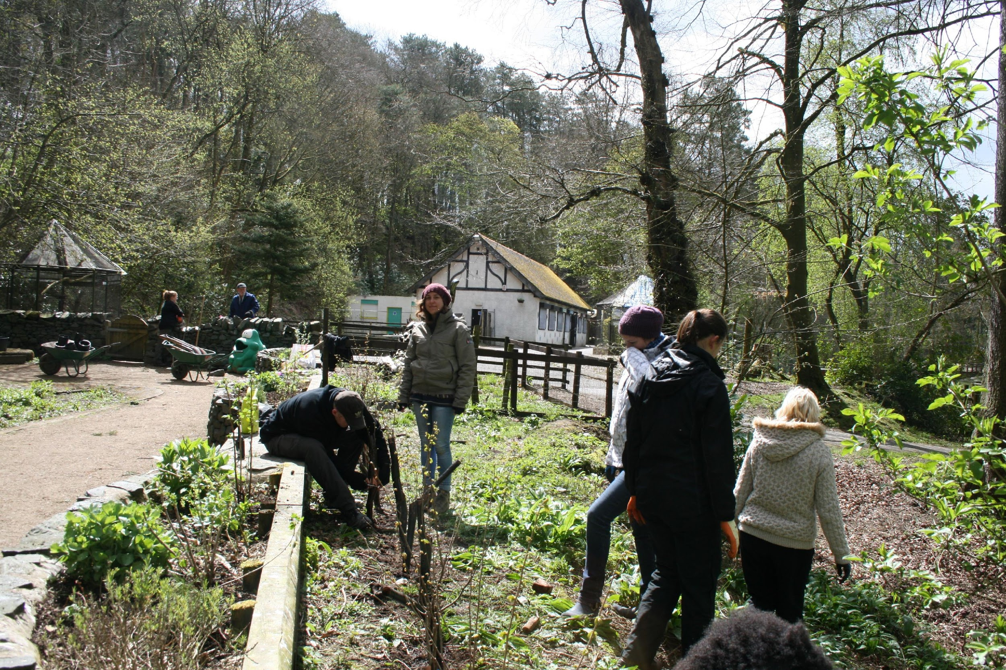
What you should bring
Sleeping bag, torch (head torch if you can), pillow and sleeping mat
Clothes for work that you don’t mind getting damaged/dirty and strong boots that cover the ankle
Waterproof trousers and waterproof jacket
Things from you own country such as food/games/photos/music
An open mind and lots of enthusiasm and energy

Weather
August s one of the warmer months in Scotland with average daily highs of 18.6°C in Kilmarnock. The weather in Scotland however can be very changeable so you should bring clothes suitable for all weathers.
Social Media
To find out more about Xchange Scotland and keep up to date you can follow us on social media through our Facebook and Twitter pages.
We will put you in touch with the other volunteers participating in the project either via our social media or by email.
A bit about Scotland
Scotland is a country that is part of the United Kingdom and covers the northern third of the island of Great Britain. It shares a border with England to the south, and is otherwise surrounded by the Atlantic Ocean, with the North Sea to the east and the North Channel and Irish Sea to the south-west. In addition to the mainland, the country is made up of more than 790 islands, including the Northern Isles and the Hebrides.
Edinburgh, the country's capital and second-largest city, was the hub of the Scottish Enlightenment of the 18th century, which transformed Scotland into one of the commercial, intellectual, and industrial powerhouses of Europe. Glasgow, Scotland's largest city, was once one of the world's leading industrial cities and now lies at the centre of the Greater Glasgow conurbation. Scottish waters consist of a large sector of the North Atlantic and the North Sea, containing the largest oil reserves in the European Union. This has given Aberdeen, the third-largest city in Scotland, the title of Europe's oil capital.
The Kingdom of Scotland emerged as an independent sovereign state in the Early Middle Ages and continued to exist until 1707. By inheritance in 1603, King James VI of Scotland became King of England and King of Ireland, thus forming a personal union of the three kingdoms. Scotland subsequently entered into a political union with England on 1 May 1707 to create the new Kingdom of Great Britain. The union also created a new Parliament of Great Britain, which succeeded both the Parliament of Scotland and the Parliament of England. The Treaty of Union was agreed in 1706 and enacted by the twin Acts of Union 1707 passed by the Parliaments of both countries, despite some popular opposition and anti-union riots in Edinburgh, Glasgow, and elsewhere. Great Britain itself subsequently entered into a political union with Ireland on 1 January 1801 to create the United Kingdom of Great Britain and Ireland.
Scotland's legal system has remained separate from those of England and Wales and Northern Ireland, and Scotland constitutes a distinct jurisdiction in public and private law. The continued existence of legal, educational and religious institutions distinct from those in the remainder of the UK have all contributed to the continuation of Scottish culture and national identity since the 1707 union. Following a referendum in 1997, a Scottish Parliament was re-established, this time as a devolved legislature with authority over many areas of home affairs. The Scottish National Party, which supports Scottish independence, won an overall majority in the 2011 general election. An independence referendum held on 18 September 2014 rejected independence by a majority of 55% to 45% on an 85% voter turnout. During the UK wide referendum on EU membership (‘Brexit’) in 2016 in which 52% of the UK voted to Leave and 48% to Remain, Scotland and Northern Ireland both had Remain majorities (62% and 56% respectively). As a result there is the prospect of a second referendum on Scottish independence before the Brexit talks are finalised. Brexit itself is a two year process and will not have an impact upon placements that Xchange Scotland is hosting here in that period.
Scotland is a member nation of the British–Irish Council, and the British–Irish Parliamentary Assembly. Scotland is represented in the European Union and the European Parliament with six MEPs.

We are very excited about you coming here and we look forward to seeing you in September!

