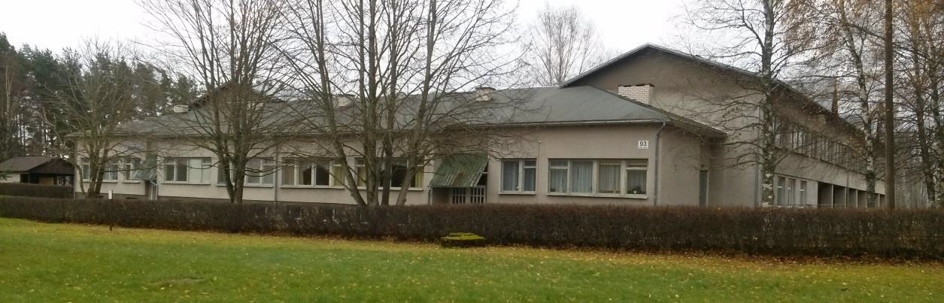

VILJANDI KINDERGARTEN MÄNNIMÄE
(VILJANDI LASTEAED MÄNNIMÄE)

ORGANISATION DESCRIPTION
Kindergarten Männimäe is situated in Viljandi, Estonia and provides pre-school education for about 200 children. Our vision is that in our kindergarten, we have happy children, satisfied parents and staff that is continuously developing. We have 11 groups of children (ages 2-7), 3 of them are groups for children with learning disabilities and various special needs. Our kindergarden is located close to lake Viljandi and next to hiking trail.
Our kindergarten is one of the biggest in the city. We have 11 groups of children and around 55 wonderful staff members. Our kindergarten has a nice indoor pool, big music hall, and gym. Although our kindergarten is old and needs renovation our rooms are big, bright and colorful. So are our children and people who work here: happy, very kind and with big smiles.
Kindergarten Männimäe is located one of the most beautiful places in the city: next to a hiking trail, overlooking the beautiful lake. The trail is 13.5 km long and it can be passed both on foot and on a bicycle. Next to the trail is also disc golf park.
Every autumn and spring we have events for families on the hiking trail. With families, we are celebrating Christmas, Mother's Day, Kindergarten birthday. 3-4 times in a year, various theaters visit our kindergarten. We have many interesting events for our staff also: visits to the spas, museums, theaters e.t.c. (In Viljandi is the theater Ugala and the puppet theater.)
Our kindergarten has joined an anti-bullying program "Kindergartens and schools free of bullying".

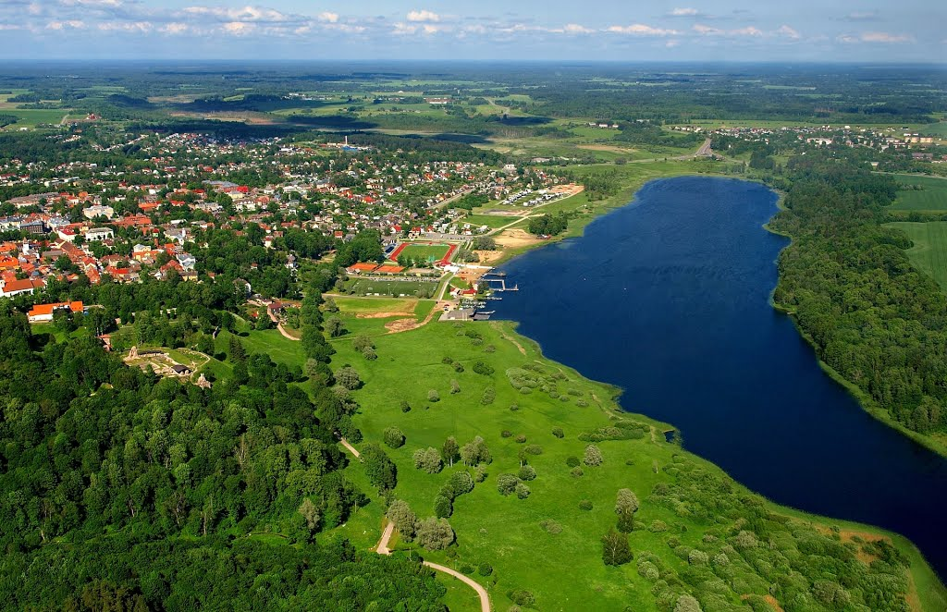

Project context
Viljandi is a small town in the central part of Estonia. Viljandi is a kind of capital of culture in Estonia, there is Viljandi Culture Academy that provides higher education in Estonian national culture, dance and musics and is very active in the community, organizing concerts, performances and study groups frequently, also international cultural events take place frequently.
Viljandi is known worldwide as the venue for the Viljandi Folk Music Festival. Every July, the festival brings together contemporary folk music from all over the world and ca 20 000 festival visitors – a mix that creates not-to-be-missed event! In winters people go skiing and iceskating.
The scenic views of the nearby lake and wooden architecture makes Viljandi a place of interest to both nature and culture lovers. Viljandi has a professional theatre, several venues that organize regular concerts and entertainment and cafés that serve the best coffee, food and service compared to anywhere in the world. We also have the Estonian Traditional Music Center, a modern cultural center, where concerts, performances, training, seminars, etc. are organized annually. There are many happy, open and peaceful people in Viljandi, including volunteers from different countries.
As our kindergarten is near the lake and next to the hiking trail, besides kindergarten, a lot of activities also take place outside, in the nature.
The medieval capital of Estonia, Tallinn, is about 185 km from Viljandi (2,5 h by public transportation - bus or train). There is very good bus and train connection with the capital and other cities.
The volunteer(s) would be accommodated in Viljandi Town in a rental apartment.

https://drive.google.com/open?id=0B-0ZR-iBDu98WGMxY3RXc1JYcHM
(Link to video of our kindergarden)

Proposed Activities
The typical tasks for the volunteer would be helping teachers in everyday indoor and outdoor activities participating and helping teachers in games or lessons with children and preparing lessons and materials for activity . The volunteer will participate in different activities of kindergarten: annual events (Christmas, New year, Easter and others), sports, musical events, theatrical actions, walks with children. He/she will introduce his/her country, nation and cultural traditions to our children, parents and personnel (e.g. easy games and dances for children, national food). The volunteer will participate in our traditional kindergarten events and folk calendar celebrations. When working with children volunteers will learn to be patient, develop their playing and acting skills. They can use their imagination to create something cool for kids. For the volunteer it should be a good opportunity to learn and practice the Estonian language and culture.
The working time for volunteers will be 30 to 35 h per week from Monday to Friday. The schedule could be different: in some days from 8 to 13 and other days 12 to 17.30. Volunteer can have the meal with children.

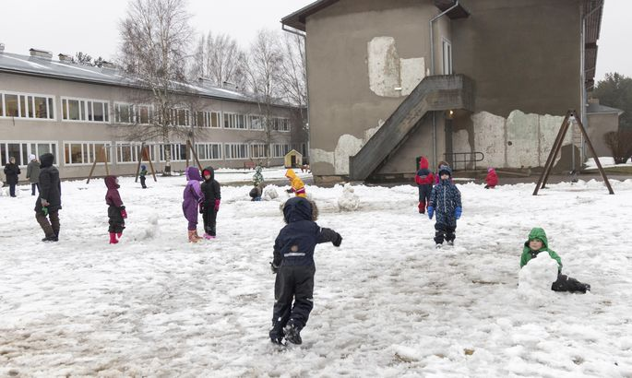

Support
Accomodation will be arranged by coordinating organisation MTÜ EstYES. Volunteer will be placed in flat that correspond to normal Estonian living standards. Volunteer will have either single or double room and common rooms: equipped kitchen, WC, shower/bathroom and living room. Volunteers are able to use local city transport to go to work. Volunteer will be provided with monthly pocket and food money and they will buy and prepare their own meals. The volunteers will receive orientation information before their arrival about volunteering in Estonia, practical information about the country and cultural advice. After arrival to their projects volunteers will be introduced their work and tasks by their tutor who will be providing task related support throughout the project. Volunteer will never work alone, he/she will be always guided by tutor, teachers or administration of the kindergarten.

Profile of Volunteer and Recruitment Process
The first priority is that the volunteer is motivated, interested and willing to work with children and children with special needs.
The volunteer should be active, energetic, creative, taking initiative, adaptable, openminded, sociable, positive, responsible and reliable. All sorts of artistic skills are welcome as they can be used kindergarten's educational activities. Volunteer will have tutor, who will always be ready to help (if there will be some difficulties or problems) or just give good advice about everyday life in our city and country. The tutor will make volunteer understand better about environment, new people and make her/him feel more comfortable.
We plan to cooperate with an experienced coordinating organisation (e.g. EstYES) that has an already working selection method. We do not have any preference for male/female candidates nor do we require any previous experience or related education to apply. We are open for candidates from all kinds of background, except for criminal background (we will need a notice from criminal records database from volunteer's homecountry). Every young person who is interested in volunteering in our organisation, will fill out the same application form and explain his/her motivation in it. Tutors together with support from other staff members, if necessary, will make a Skype interview with the candidates that seem most suitable for us and the final decision will be made together.

Risk Prevention, Protection and Safety
The host organisation will ensure that the volunteer's work is safe and been assessed for risk. Every effort is made that project meets high health and safety standards. The volunteer is trained and familiar with the volunteering work and have access to adequate safety equipment if needed. All staff in Kindergarten Männimäe will be informed and guided about tasks of the volunteer. In case of problems and conflicts, volunteer can always turn to his/her tutor. We welcome an open and honest discussion and also encourage the volunteer to discuss work-related problems or concerns with us openly from the very beginning.

