CALL FOR PARTNERS
KA 1- Learning Mobility of Individuals - Seminar
“Let the youth play the lead!”
From 19th to 26th November 2017
FRANCE

PROJECT
This seminar aims to gather different youth workers in order to share about the youth inclusion concepts in different socio-professional contexts.
All participants will put into practice methods of theatrical expression. The main objective of this seminar is to consider cultural practice as a socialization tool for young people.
Each workshop will be lead by theatrical professionals.

OBJECTIVES
- To allow the intercultural meeting between partner organizations and participants
- To develop and acquire theatrical expression skills
- To understand the value of using theater for the autonomy and social and cultural openness of young people
- To integrate methods of theatrical expression in your professional practice
- To develop knowledge about group dynamics and issues related to the integration of young people in the society
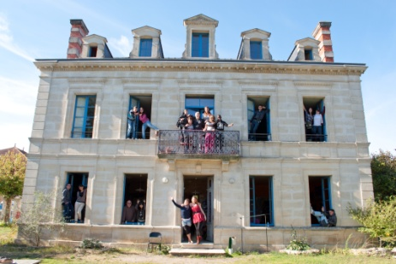
PARTICIPANTS
France and 7 countries
Each partner organization should send 2 representatives who are involved in activities for young people (mobility, education, youth project, employability…) in order to practice with them.
2 participants by country so 16 participants in total.

PRACTICAL INFORMATION
Date: From 19th November 2017 to 26th November 2017
during 8 days (2 travel days included)
Where: In the volunteers hosting organization “La Maison des Bateleurs”, association of the French movement Solidarités Jeunesses (17130 – Montendre, Poitou-Charentes, France)
Accommodation: The participants will be hosted in a typical regional house renovated during an international workcamp. Since 1995, “La Maison des Bateleurs” has been a hosting center for international volunteers. The organization welcomes around 8 volunteers per year so the participants will have the opportunity to spend time, live and share meals with them.
The participants will be accommodated in 2 dormitories of 8 people with bunk beds. There is a common bathroom with showers and toilets.

To learn more:
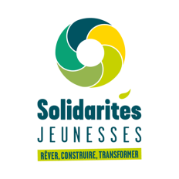
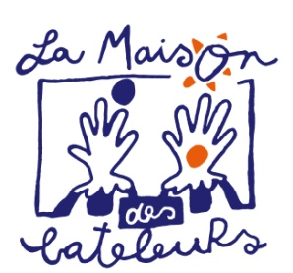
http://bateleurs.solidaritesjeunesses.org/ and http://www.solidaritesjeunesses.org/

