Tere-tere!
We invite you to have a look at amazing EVS project in Russia, Saint-Petersbourg, which is financed especially for a volunteer from ESTONIA!
WHEN?
01/08/2017 – 30/09/2018
WHERE?
Saint-Petersbourg, Russia
HOSTING ORGANIZATION?
Host organization’s name is “Shag navstrechu” (Step forward), here’s the web-site https://shag-navstrechu.ru/, FB page is here https://www.facebook.com/ShagNavstrechu.
"Shag Navstrechu" was created in 2004 in Saint-Petersburg, Russia to support disabled children who live in the 3rd building of the orphanage №4 in Pavlovsk.
Aims of our organization are:
-social support and care about disabled children and adults from the orphanage №4 (3rd building) in Pavlovsk, St Petersburg.
-assistance in finding families for the orphans,
-help children from the orphanage №4 (3rd building) in emotional, cultural and physical development through organization of regular events.
Our goals are:
-to teach disabled children main self-service skills to be ready for adult life,
-individual care and support of each of 85 children,
-mental and physical development through art and music classes, work with physical therapists, everyday classes etc,
-to make disabled people an equal part of the society,
-to widen society's knowledge about people with disabilities,
Our main goal is to give love and care, to compensate the lack of care and support for the orphans, who extremely need it and who haven’t any emotional contact with family or relatives.
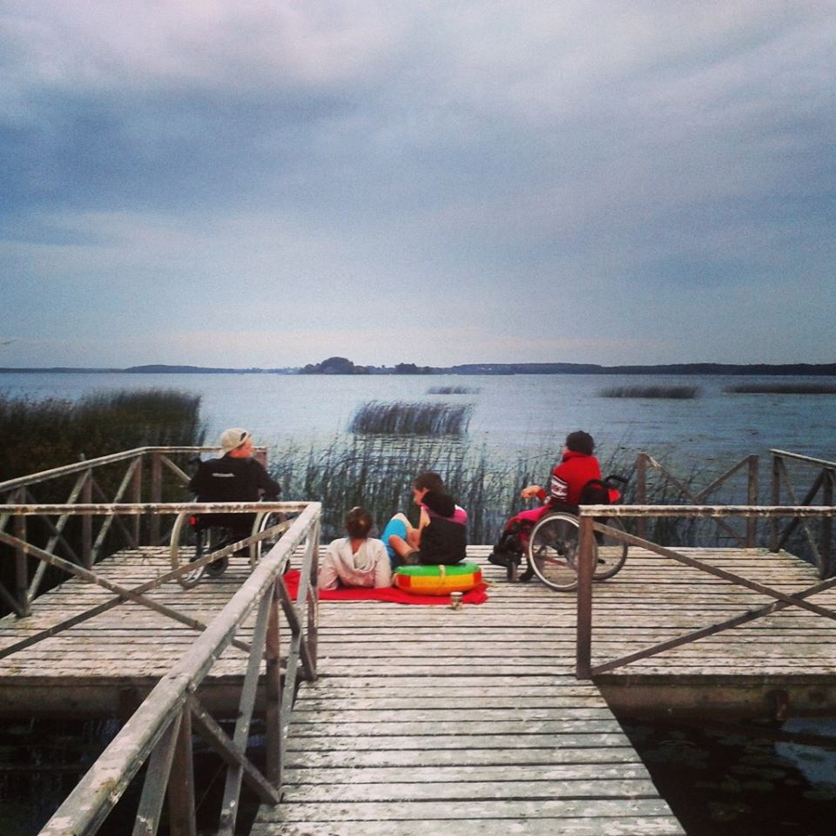

ACTIVITIES OF VOLUNTEER?
The volunteers will hold different ‘routine’ activities for and with the children every day, like language lessons, drawing, crafting classes, outdoors activities and songs, depending on the volunteer’s interest and fields of expertise and the children’s abilities and skills.
It is planned, that each volunteer will hold events of bigger scope on roughly monthly basis, f.e. exhibitions of art-work, friendly sport matches or performances that will enable them to get more into organisational and entrepreneurial ways of setting up an event and monitoring it.
Main activities, which volunteers will do, are:
• teaching kids how to eat, brush teeth, wash, get dressed etc. without assistance,
• helping the orphanage’s staff: for example a volunteer stays in a group and looks after kids while the nurse baths children, then help to get them dry and dress them,
• volunteer takes children to walks,
• volunteer looks after children for them to be clean and neat,
• plays educational games, learns numbers, letters etc.,
• has art classes (paint, pottery etc.)
• reads for children,
• accompanies children on excursions,
• participation in preparation of different events.
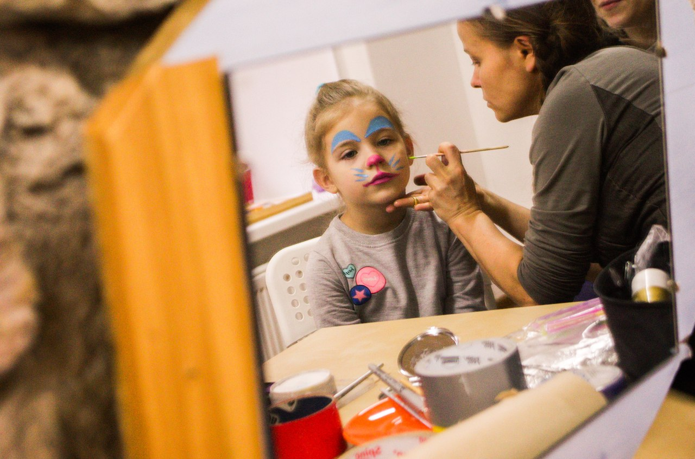

PRACTICAL ARRANGEMENTS
- Volunteer needs a visa to enter Russia. According to Russian legislation, with humanitarian type of visa you can’t stay in Russia longer than 90 days. Therefore, every 3 months you will have a chance to go back to Estonia and see your friends and family while waiting for the new visa. And the way to Estonia is pretty short, so it shouldn’t be hard for you ;) Visa costs and travel are included into budget and these days at home won’t be considered as your holiday.
- You will have co-volunteers from Belgium and Bulgaria and you’ll live together with them in a shared apartment!
- You will have a local mentor who will help you to integrate better into local culture.
- You will receive 100 euro per month for food, 55 euro for pocket money, your transport costs “home-work-home” will be covered, you will have language course of Russian language and strong medical insurance.
- You will have coordinator in hosting organization who will support you throughout whole project.
VOLUNTEER’S PROFILE?
- Open and ready for work with disabled people, experience is a plus. If you don’t have it, no problem, just be sure that you’re ready for it before applying
- Age 18-30
- Basic knowledge of Russian and eagerness to learn more is welcome
- Enthusiasm and initiativness is something you won’t survive without in this project ;)
If you want to take part in this project, please send your application form filled in by 20th of April to Evgenia at slav@shag-navstrechu.ru with topic “EVS in Shag navstrechu”. We will contact you shortly after that!
We hope that you will find our project interesting and you will apply for it – because you will get a chance to join wonderful and caring team, live in one of the best cities in the world and explore huge and mysterious Russia! If you want to get general impression about EVS projects all over Russia, read stories here, reasons to do your EVS in Russia are here. And some videos ;) First one you can find here and second one – here.

Looking forward to your applications!

